|  |  |
| --- | --- |
| logo ngan.png | **MINISTRY OF EDUCATION AND TRAINING** |

|  |
| --- |
| **FPT UNIVERSITY** |
| Capstone Project Document |
| Children's Toy Rental Service Website |
|  |
| |  |  | | --- | --- | | **Group 5** | | | **Group Members** | Nguyễn Ngọc Tường Vy – Team Leader – SE60891  Nguyễn Thị Ái Trinh – Team Member – SE60716  Hồ Quang Hưng – Team Member – 60429 | | **Supervisor** | Mr. Nguyễn Trọng Tài | | **Ext Supervisor** | N/A | | **Capstone Project Code** | CTS | |
| - Hồ Chí Minh City, September 2014 -  Table of Contents  1. Introduction 15  1.1 Project Information 15  1.2 Introduction 15  1.3 Current Comparison websites in Vietnam 15  1.3.1 Limitations of the existing system 15  1.3.2 Benefits of expected system 15  1.4 Problem Definition 16  1.5 Proposed Solution 16  1.5.1 Feature functions 16  1.5.2 Advantage and disadvantage 17  1.6 Role and Responsibility 17  2. Project Management Plan (PMP) 17  2.1 Problem Definition 17  2.1.1 Name of this Capstone Project 17  2.1.2 Problem Abstract 18  2.1.3 Project Overview 18  2.2 Project organization 20  2.2.1 Software Process Model 20  2.2.2 Roles and Responsibilities 21  2.2.3 Tools and Techniques 22  2.3 Project management plan 22  2.3.1 Tasks 22  2.3.2 Task sheet 25  2.3.3 All Meeting Minutes 25  2.4 Coding Convention 25  3. System Requirements Specifications (SRS) 25  3.1 User Requirement Specification 25  3.1.1 Guest requirement 25  3.1.2 General user requirement 26  3.1.3 Customer requirement 26  3.1.4 System requirement 26  3.1.5 Admin requirement 26  3.1.6 Staff requirement 27  3.2 System Requirement Specification 27  3.2.1 External Interface Requirements 27  3.2.2 Functional Requirements: 27  3.2.3 Non-Functional Requirements 148  3.3 Entity Relationship Diagram or Data Structures 148  3.4 Other material (if any) 150  4. Software Design Description 150  4.1 Design Overview 150  4.2 System Architectural Design 152  4.2.1 Choice of System Architecture 152  4.2.2 Discussion of Alternative Designs 153  4.2.3 Description of System Interface 153  4.3 Component Diagram 154  4.4 Detailed Description of Components 154  4.4.1 Class Diagram 154  4.4.2 Class Diagram Explanation 156  4.5 Sequence Diagram 167  4.5.1 Add Exchangeable Toy 167  4.5.2 Remove Exchangeable Toy 168  4.5.3 View All Exchangeable Toys 168  4.5.4 Send Exchange Request 169  4.5.5 View Exchange Request 170  4.5.6 Respond Exchange Request 170  4.5.7 Finish Exchange 171  4.5.8 Cancel Exchange 171  4.5.9 Assign Shipper For Exchange 172  4.5.10 Add To Cart 172  4.5.11 Update Cart 173  4.5.12 Remove Cart 173  4.5.13 View Cart 174  4.5.14 View Order History 175  4.5.15 Cancel Order 176  4.5.16 Cancel Rented Toy 177  4.5.17 Return Toy Soon 178  4.5.18 Login 178  4.5.19 Logout 179  4.5.20 View Toy Details 179  4.5.21 View Toy Categories 180  4.5.22 Checkout Payment Cash On Delivery 181  4.5.23 Checkout Payment Online 182  4.5.24 Return Toy 183  4.5.25 Advanced Search 185  4.5.26 Basic Search 185  4.5.27 Reserve Toy 185  4.5.28 View Suggested Toys 186  4.5.29 Extend Rent Time 187  4.5.30 Edit Customer Profile 190  4.5.31 Mobile Finish Deliver Order 190  4.5.32 Mobile Return Toy 192  4.5.33 Mobile Finish Exchange 193  4.6 User Interface Design 195  4.6.1 Login 195  4.6.2 View suggest toys 196  4.6.3 My Exchangeable List 198  4.6.4 Add exchangeable products 199  4.6.5 Other Customer Exchangeable List 200  4.6.6 Send Exchange Request – Select product 202  4.6.7 Send Exchange Request – Select new return date 203  4.6.8 Send Exchange Request – Confirm and send request 205  4.6.9 My sent exchange request 206  4.6.10 My receive exchange request 208  4.6.11 Exchange Request Details 209  4.6.12 Manage Exchange 212  4.6.13 Product Details 214  4.6.14 View statistic report by year 219  4.6.15 Mobile app menu 221  4.6.16 Mobile Assigned Orders 222  4.6.17 Mobile order details 224  4.6.18 Mobile product details 226  4.6.19 Mobile Assigned Exchange List 228  4.6.20 Mobile Exchange Details 230  4.6.21 Mobile Search Return Product Options 232  4.6.22 Rent Toy 232  4.6.23 View Order History 234  4.6.24 Extend Rent Time 235  4.6.25 View Cart 237  4.6.26 Check Out _ Choose payment way 240  4.6.27 Check Out _ Confirm information delivering 241  4.6.28 Check Out_ Confirm al information 242  4.6.29 View User Profile 245  4.6.30 Update User Profile 246  4.6.31 Information of Child 247  4.6.32 Add Child 248  4.6.33 Update Child 249  4.6.34 Manage Order 251  4.6.35 View Order Detail (staff) 252  4.6.36 View Order Detail (customer) 254  4.6.37 Return Back 256  4.6.38 Assign Shipper 257  4.6.39 Manage Promotion 258  4.6.40 Register 259  4.6.41 View Category 261  4.6.42 Advanced search 263  4.6.43 Manage Members 265  4.6.44 Add New Member 266  4.6.45 Update Member 267  4.6.46 Manage Toys 269  4.6.47 Toy Instance List 271  4.6.48 Add New Toy Instance 272  4.6.49 Update Toy Instance 273  4.6.50 Add New Toy 274  4.6.51 Update Toy 277  4.7 Database Design 279  4.7.1 Physical Database Diagram 279  4.7.2 Data Dictionary 281  4.8 Algorithms 293  4.8.1 Suggest products which rented by customers who rented current product 293  4.8.2 Suggest products appropriate for child 293  4.8.3 Suggest products by customer orders 294  5. System Implementation & Test (SIT) 298  5.1 Introduction 298  5.1.1 System Overview 298  5.1.2 Test Approach 298  5.2 Test Plan 299  5.2.1 Features to be tested 299  5.2.2 Features not to be tested 299  5.3 Test Cases 299  5.3.1 Basic Search 299  5.3.2 Advanced Search 300  5.3.3 View product details 303  5.3.4 View My Exchange List 304  5.3.5 Add Toy to Exchange List 304  5.3.6 Remove Toy out of Exchange List 306  5.3.7 View Exchange List of Other Customer 307  5.3.8 Send Exchange Request 308  5.3.9 View Detail of Exchange Request 311  5.3.10 Respond Exchange Request 313  5.3.11 Cancel Exchange Request (customer) 314  5.3.12 Staff Assign Shipper For Exchange 315  5.3.13 Cancel Exchange Request (staff) 317  5.3.14 Finish Exchange 318  5.3.15 View Statistic Report 319  5.3.16 Add To Cart 321  5.3.17 Edit Cart 323  5.3.18 Remove Cart 324  5.3.19 Add Promotion Item 325  5.3.20 Checkout And Online Payment 325  5.3.21 View Oder History 328  5.3.22 Cancel Order/Order Detail 328  5.3.23 Extend Rent Time 329  5.4 Checklists 330  5.4.1 Checklist of Validation 330  5.4.2 Submission Checklist 330  5.5 Other material 330  6. System User’s Manual 330  6.1 Installation Guide 330  6.1.1 Setting up environment at server side 330  6.1.2 Deployment at server side 331  6.1.3 Client side environment setting 334  6.2 User’s Guide 335  6.2.1 Admin –Staff Login 335  6.2.2 Staff 335  6.2.3 Customer 338  **List of Figures**  Figure 1: Waterfall Model 22  Figure 2: Use Case Overview 29  Figure 3: <Staff>Overview Use Case 30  Figure 4: <Staff>Manage Exchange 30  Figure 5: <Staff>Cancel Exchange 31  Figure 6: <Staff>Finish Exchange 33  Figure 7: <Staff>Manage Orders 35  Figure 8: <Staff>Cancel Order 35  Figure 9: <Staff>Cancel Order Detail 38  Figure 10: <Staff>Return Rent Toy 40  Figure 11: <Admin>Assign Shipper 42  Figure 12: <Admin>Done Delivering Order 44  Figure 13: <Staff>Manage Toys 46  Figure 14: <Staff>Add Toy 46  Figure 15: <Staff> Update Toy 51  Figure 16: <Staff> Delete Toy 56  Figure 17: <Staff>View Select Next Renter Result 58  Figure 18: <Staff>Process Rent Toy 59  Figure 19: <Staff>Process Return Toy 61  Figure 20: <Staff>Process Exchange 64  Figure 21: <Staff> Manage Promotion 66  Figure 22: <Staff>Add Promotion 66  Figure 23: <Staff>Update Promotion 69  Figure 24: <Staff>Delete Promotion 71  Figure 25: <Staff>Edit Discount Level 73  Figure 26: <Staff> View List Reservation 76  Figure 27: <Staff>Manage Categories 78  Figure 28: <Staff> Add Category 78  Figure 29: <Staff>Update Category 81  Figure 30: <Staff>Delete Category 83  Figure 31: <Customer>Overview Use Case 85  Figure 32: <Customer>View Suggested Toys 86  Figure 33: <Customer>Rent Toys 88  Figure 34: <Customer>Add To Cart 91  Figure 35: <Customer>View Cart 93  Figure 36: <Customer>Update Cart 95  Figure 37: <Customer>Exchange Toys 97  Figure 38: <Customer> View Others Exchangeable Toys List 99  Figure 39: <Customer>Edit Exchangeable Toys List 101  Figure 40: <Customer>Send Exchange Request 103  Figure 41: <Customer> Manage User Profile 105  Figure 42: <Customer>Edit User Profile 105  Figure 43: <Customer>View Order History 108  Figure 44: <Customer>Extend Rent Time 110  Figure 45: <Customer>Cancel Order 112  Figure 46: <Customer> Reserve Toy 114  Figure 47: <System>Overview Use Case 116  Figure 48: <System>Select Next Renter 117  Figure 49: <System> Send Notitication Mail 118  Figure 50: <System>Send Expire Date Remind Mail 119  Figure 51: <System> Send Selected Renter Notification Mail 120  Figure 52: <Admin> Overview Use Case 122  Figure 53: <Admin> View Statistics Reports 122  Figure 54: <Admin> Manage Members 124  Figure 55: <Admin> Add Member 124  Figure 56: <Admin> Update Member 127  Figure 57: <Admin> Ban Member 130  Figure 58: <General User>Overview Use Case 132  Figure 59: <General user>View Toy Details 133  Figure 60: <General User> Search 135  Figure 61: <General User> Basic Search 135  Figure 62: <General User> Advanced Search 137  Figure 63: <General User>View Toys Categories 139  Figure 64: <Customer, Admin, Staff>Logout 141  Figure 65: <Guest>Overview Use Case 143  Figure 66: <Guest>Register 143  Figure 67: <Guest>Login 146  Figure 68: Entity Relationship Diagram 150  Figure 69: MVC Architecture 153  Figure 70: 3 tiers architecture 154  Figure 71: Component Diagram 155  Figure 72: Class Diagram 156  Figure 73: Add Exchangeable Toy Sequence Diagram 168  Figure 74: Remove Exchangeable Toy Sequence Diagram 169  Figure 75: View All Exchangeable Toys 169  Figure 76: Send Exchange Request Sequence Diagram 170  Figure 77: View Exchange Request 171  Figure 78: Respond Exchange Request Sequence Diagram 171  Figure 79: Finish Exchange Sequence Diagram 172  Figure 80: Cancel Exchange Sequence Diagram 172  Figure 81: Assign Shipper For Sequence Diagram 173  Figure 82: Add To Cart Sequence Diagram 173  Figure 83: Update Cart Sequence Diagram 174  Figure 84: Remove Cart Sequence Diagram 174  Figure 85: View Cart Sequence Diagram 175  Figure 86: View Order History Sequence Diagram 176  Figure 87: Cancel Order Sequence Diagram 177  Figure 88: Cancel Rented Toy Sequence Diagram 179  Figure 89: Return Toy Soon Sequence Diagram 179  Figure 90: Login Sequence Diagram 179  Figure 91: Logout Sequence Diagram 180  Figure 92: View Toy Detail Sequence Diagram 180  Figure 93: View Toy Categories Sequence Diagram 181  Figure 94: Checkout Payment Cash On Delivery Sequence Diagram 182  Figure 95: Checkout Payment Online Sequence Diagram 183  Figure 96: Return Toy Sequence Diagram 185  Figure 97: Advanced Search Sequence Diagram 186  Figure 98: Basic Search Sequence Diagram 186  Figure 99: Reserve Toy Sequence Diagram 186  Figure 100: View Suggested Toy Sequence Diagram 187  Figure 101: Extend Rent Time Sequence Diagram 190  Figure 102: Extend Rent Time Sequence Diagram 191  Figure 103: Mobile Finish Deliver Order 192  Figure 104: Mobile Return Toy 193  Figure 105: Mobile Finish Exchange 194  Figure 106: Login 196  Figure 107: View Suggest Toys 197  Figure 108: My Exchangeable List 199  Figure 109: Add Exchangeable Products 200  Figure 110: Other Customer Exchangeable List 201  Figure 111: Send Exchange Request – Select Product 203  Figure 112: Send Exchange Request – Select new return date 204  Figure 113: Send Exchange Request – Confirm and send request 206  Figure 114: My Sent Exchange Request 207  Figure 115: My Receive Exchange Request 209  Figure 116: Exchange Request Details 210  Figure 117: Manage Exchange 214  Figure 118: Product Details 216  Figure 119: View Statistic Report 220  Figure 120: Mobile App Menu 222  Figure 121: Mobile Assigned Orders 223  Figure 122: Mobile Order Details 225  Figure 123: Mobile Product Details 227  Figure 124: Mobile Assigned Exchange List 229  Figure 125: Mobile Exchange Details 231  Figure 126: Mobile Search Return Product Options 233  Figure 127: Rent Toy 234  Figure 128: View Order History 235  Figure 129: Extend Rent Time 237  Figure 130: View Cart 239  Figure 131: Check out_ Choose payment way 241  Figure 132: Check out _ Confirm information delivering 242  Figure 133: Check Out_ Confirm all information 244  Figure 134: View User Profile 246  Figure 135: Update User Profile 247  Figure 136: Information of child 249  Figure 137: Add Child 250  Figure 138: Update Child 251  Figure 139: Manage Order 252  Figure 140: View Order Detail (staff) 254  Figure 141: View Order Detail 256  Figure 142: Return Back 257  Figure 143: Assign shipper 258  Figure 144: Manage Promotion 259  Figure 145: Register 261  Figure 146: View Category 262  Figure 147: Advanced Search 264  Figure 148: Manage Members 266  Figure 149: Add New Member 267  Figure 150: Update Member 269  Figure 151: Manage Toys 270  Figure 152: Toy Instance List 272  Figure 153: Add New Toy Instance 273  Figure 154: Update Toy Instance 274  Figure 155: Add New Toy 275  Figure 156: Update Toy 278  Figure 157: Physical Database Diagram 281  Figure 158: Extract Deployment Package 332  Figure 159: Connect to server 332  Figure 160: Open database script 333  Figure 161: Configure Server 333  Figure 162: Change Web.config connection string 334  Figure 163: Change App.config connection string 334  Figure 164: Deploy web application on server 335  Figure 165: Deploy web application on server 335  Figure 166: Admin - Staff Login Page 336  Figure 167 : View List Of Orders 337  Figure 168 : View Order Detail (Staff) 337  Figure 169 : Assign Shipper 338  Figure 170 : View Exchange Request List 338  Figure 171 : View Detail Of Exchange Request 339  Figure 172 : Cancel Exchange Request 339  Figure 173 : Add To Cart 340  Figure 174 : View Cart 340  Figure 175 : Edit Cart 341  Figure 176 : Check out_ step 1 341  Figure 177 : CheckOut_step 2 342  Figure 178 : CheckOut_step 3 343  Figure 179 : View Order History 344  Figure 180 : View Order Detail (Customer) 344  Figure 181 : Extend Rent Time 345  Figure 182 : Product Detail 346  Figure 183 : View Suggest Toy 347  Figure 184 : View Other Exchangeable Toy List 348  Figure 185 : Exchange Request _ Step 1 349  Figure 186 : Exchange Request_ step 2 350  Figure 187 : Exchange Request – step 3 351  Figure 188 : View Sent Exchange Request Of Customer 352  Figure 189 : View Receive Exchange Request Of Customer 353  Figure 190: View Exchange Request Details 354  **List Of Tables**  Table 1: <Staff>Cancel Exchange 31  Table 2: <Staff>Finish Exchange 33  Table 3: <Staff> Cancel Order 36  Table 4: <Staff>Add Order 39  Table 5: <Staff>Return Rent Toy 40  Table 6: <Staff>Assign Shipper 43  Table 7: <Staff>Done Delivering Order 45  Table 8: <Staff> Add Toy 50  Table 9: <Staff> Update Toy 54  Table 10: <Staff> Delete Toy 56  Table 11: <Staff>View Select Next Renter Result 58  Table 12: <Staff>Process Rent Toy 60  Table 13: <Staff>Process Return Toy 62  Table 14: <Staff>Process Exchange 64  Table 15: <Staff>Add Promotion 68  Table 16: <Staff> Update Promotion 70  Table 17: <Staff>Remove Promotion 72  Table 18: <Staff>Edit Discount Level 75  Table 19: <Staff> View List Reservation 76  Table 20: <Staff>Add Category 79  Table 21: <Staff>Update Category 81  Table 22: <Staff>Delete Category 83  Table 23: <Customer>View Suggested Toys 86  Table 24: <Customer>Rent Toys 89  Table 25: <Customer>Add To Cart 92  Table 26: <Customer>View Cart 94  Table 27: <Customer>Update Cart 95  Table 28: <Customer>Exchange Toys 98  Table 29: <Customer>View Others Exchangeable Toys List 99  Table 30: <Customer>Edit Exchangeable Toys List 102  Table 31: <Customer>Send Exchange Request 104  Table 32: <Customer>Edit User Profile 107  Table 33: <Customer>View Order History 109  Table 34: <Customer>Extend Rent Time 111  Table 35: <Customer>Cancel Order 113  Table 36: <Customer> Reserve Toy 115  Table 37: <Customer>View Suggested Toys 117  Table 38: <System>Send Expire Date Remind Mail 119  Table 39: <System> Send Selected Renter Notification Mail 121  Table 40: <Admin> View Statistics Reports. 123  Table 41: <Admin> Add Member 126  Table 42: <Admin> Update Member 129  Table 43: <Admin> Ban Member 131  Table 44: <Guest> View Toy Details 133  Table 45: <General User>Basic Search 135  Table 46: <General User> Advanced Search 138  Table 47: <General User>View Toys Categories 139  Table 48: <Customer, Admin, Staff>Logout 141  Table 49: <Guest> Register 145  Table 50: <Guest>Login 148  Table 51: Entity Data Dictionary 150  Table 52: Entity Data Dictionary 281  Table 53: Data Dictionary of Role 282  Table 54: Data Dictionary of Account 282  Table 55: Data Dictionary of Child 283  Table 56: Data Dictionary of ChildHobby 283  Table 57: Data Dictionary of Hobby 283  Table 58: Data Dictionary of AccountProfile 284  Table 59: Data Dictionary of Notification 284  Table 60: Data Dictionary of Toy 286  Table 61: Data Dictionary of Image 286  Table 62: Data Dictionary of ToyInstance 287  Table 63: Data Dictionary of Category 287  Table 64: Data Dictionary of AppropriateHobby 287  Table 65: Data Dictionary of WishList 287  Table 66: Data Dictionary of Promotion 288  Table 67: Data Dictionary of DiscountLevel 288  Table 68: Data Dictionary of OrderDetail 289  Table 69: Data Dictionary of Order 290  Table 70: Data Dictionary of PaymetMethod 290  Table 71: Data Dictionary of Reservation 291  Table 72: Data Dictionary of ReservationGroup 291  Table 73: Data Dictionary of ExchangeRequest 292  Table 74: Basic Search Test_Case 300  Table 75: Advanced Search Test_Case 303  Table 76: View Product Details Test_Case 304  Table 77: View My Exchange List Test_Case 304  Table 78: Add Toy To Exchange List Test_Case 306  Table 79: Remove Toy From Exchange List Test_Case 307  Table 80: View Exchange List Of Other Customer Test_Case 307  Table 81: Send Exchange Request Test_Case 311  Table 82: View Details Of Exchange Request Test_Case 313  Table 83: Respond Exchange Request Test_Case 314  Table 84: Cancel Exchange Request (Customer) Test_Case 315  Table 85: Staff Assign Shipper For Exchange Test_Case 317  Table 86: Cancel Exchange Request (Staff) Test_Case 318  Table 87: Finish Exchange Test_Case 318  Table 88: View Statistic Report Test_Case 321  Table 89: Add To Cart Test_Case 322  Table 90: Edit Cart Test_Case 324  Table 91: Remove Cart Test_Case 325  Table 92: Add Promotion Item Test_Case 325  Table 93: Checkout And Online Payment Test_Case 327  Table 94: View Order History Test_Case 328  Table 95: Cancel Order Test_Case 329  Table 96: Extend Rent Time Test_Case 330  Table 97: Login Step 335  Table 98: View List Of Orders 336  Table 99: View Order Detail (Staff) 336  Table 100: Assign Shipper 337  Table 101: View Exchange Request List 337  Table 102: View Detail Of Exchange Request 338  Table 103: Cancel Exchange Request 338  Table 104: Add To Cart 339  Table 105: View Cart 339  Table 106: Edit Cart 340  Table 107: Check out_ step 1 341  Table 108: CheckOut_step 2 341  Table 109: CheckOut_step 3 342  Table 110: View Order History 343  Table 111: View Order Detail (Customer) 343  Table 112: Extend Rent Time 344  Table 113: Product Detail 345  Table 114: View Suggest Toy 346  Table 115: View Other Exchangeable Toy List 347  Table 116: Exchange Request _ Step 1 348  Table 117: Exchange request _ step 2 349  Table 118: Exchange Request – step 3 350  Table 119: View Sent Exchange Request Of Customer 351  Table 120: View Receive Exchange Request Of Customer 352  Table 121: View Exchange Request Details 353 |

# Introduction

## Project Information

* Project name: **Children’s Toy Rental Service Website**
* Project Code: **CTS**
* Product Type: **Website Application**
* Start Date: **September 9th, 2014**
* End Date: **December 17th, 2014**

## Introduction

Nowadays, society is developing quickly and the quality of life is become higher and higher. The demand for people entertainment is having more and more attention, especially for children. All parents want to find toys that make their children feel interested and help them develop comprehensively and creatively. However, children often get bored with their toys quickly, and parents cannot buy all the toys that children require. This system is to solve these problems, help parents have more choices and saving cost of toys, the child have more toys to play with.

## Current Comparison websites in Vietnam

There are some current websites in Vietnam such as chothuedochoi.org, www.metramy.com, www.toys4rent.vn, etc. All of them have some limited.

### **Limitations of the existing system**

* Not support renting toys online.
* Not allow selecting duration for rent.
* Rent duration is counted by week or month
* Not support suggesting appropriate toys for children.
* Not support exchanging toys after rent.
* Not just focus on only toys rental.
* Toys information are too vague.

### **Benefits of expected system**

Our system is developed to focus on toys rental service, with the target to provide a reliable place for parents to rent toys for their children. And parents can also exchange toy to get new one for their children when they get bored but the rent time is still remain. The system also provide flexible rental and payment methods which help customers save time, and transportation costs.

Come to our system, customer can be suggested for toys that suitable for their children, be provided sufficient information to select appropriate toys and process online toys rental. When customer’s children get bored with rent toys, they can process an exchange with other customer to get new toy for your children.

## Problem Definition

Nowadays, the quality of life increase higher and higher. Every parents want their children to have as much toys as possible. So that their children can grow up comprehensively, both physically and mentally. But today, there are so many problem about buying toys for children.

Firstly, there are so many kind of toys in the market now, including both toys with good and bad quality. There even have many toys with toxic chemical that harm to children health. So it’s very difficult to choose good toys for children.

Secondly, because of quality of toys, parents often want to choose well-known brands for more assurance. But those toys are often much more expensive. So it’s hard for some parents to pay for toys for their children.

Thirdly, children are easy to like some toys but also quickly to get bored with those toys. So buying all toys that children want is wasted of money.

Finally, toys need some spaces in house to store them. The more toys children have, the more space they need to store their toys. So it’s wasted of space for children’s toy, especially for toys that children have already get bored with.

## Proposed Solution

The system support customer to select appropriate toys for their children and process toy rental and toys exchange online. The system also support staff to manage and track their business.

### **Feature functions**

* Guest can view details of toys and add toys to cart if they intend to rent. Besides that, they can view toys promotions and search for toys with appropriate criteria. If guest want to rent toys, they can register to become member.
* Login is required for guest if they want to rent products.
* Customer can rent one or more toys at once, making order and cancel that if they don’t want to rent anymore. Two customers can exchange toys by select toy from exchangeable toys list and send request to the other. Moreover, they can reserve toys that they want to rent but don’t available in stock at that time. They can also extend rent time to keep toys for a longer time. Customer can also manage their profile, including their order history, their information and their children’s information.
* A unique admin account represent for the manager role. This account will be responsible for management process including manage members of system and view statistic reports.
* The system also provides accounts for staffs for business managements. Staff can manage orders process, exchanges process, reservation, products, categories, and promotions.
* The system will send mail to notify to customers when toys that they reserved are available, remind them about due date of rental or when they have request for exchanging toys.
* The system also suggest toys that suitable for each child base on child’s sexual, age, and favorites, and suggest toys base on customer’s orders. Moreover, system can select next renter for available toy according to reservation priority.

### **Advantage and disadvantage**

The advantages and disadvantages of the proposed solution:

* Advantages:
* Customer can be support to find appropriate toys for theirs children.
* Customers can exchange toys to get other one for their children.
* Staff is supported to manage orders, exchanges process, and other terms easily and effectively.
* User friendly interface
* Flexible renting and payment
* Disadvantages:
* Not support online complaint as having online payment problems
* Area is limited in HCM city.
* Support online payment using only Paypal.

## Role and Responsibility

|  |  |  |  |  |
| --- | --- | --- | --- | --- |
| **No** | **Full Name** | **Role** | **Position** | **Contact** |
| 1 | Nguyễn Trọng Tài | Project Manager | Instructor | [taint@fpt.edu.vn](mailto:taint@fpt.edu.vn) |
| 2 | Nguyễn Ngọc Tường Vy | Developer | Team Leader | [vynntse60891@fpt.edu.vn](mailto:vynntse60891@fpt.edu.vn) |
| 3 | Nguyễn Thị Ái Trinh | Developer | Team Member | [trinhntase60716@fpt.edu.vn](mailto:trinhntase60716@fpt.edu.vn) |
| 4 | Hồ Quang Hưng | Developer | Team Member | [hungqh60429@fpt.edu.vn](mailto:hungqh60429@fpt.edu.vn) |

# Project Management Plan (PMP)



## Problem Definition



### **Name of this Capstone Project**

|  |  |
| --- | --- |
| **Official name** | Children's toy rental service website. |
| **Vietnamese name** | Website dịch vụ cho thuê đồ chơi trẻ em. |
| **Abbreviation** | CTS |

### **Problem Abstract**

Nowadays, society is developing quickly and the quality of life is become higher and higher. All parents want to find all best toys for their children to help them develop comprehensively and creatively. However, children often get bored with their toys quickly, and parents cannot buy all the toys that children require. This system is to solve these problems, help parents have more choices and saving cost of toys, the child have more toys to play with.

### **Project Overview**

The idea of this project is developing a toy’s rental service system for customer who want to rent toys for children. Moreover, the system is developed for those parents who want to exchange rented toys anytime when their children get bored.

#### **The Current System**

There are some current websites in Vietnam such as chothuedochoi.org, www.metramy.com, www.toys4rent.vn, etc. All of them have some limited.

* Not support renting toys online.
* Not allow selecting duration for rent.
* Not support suggesting appropriate toys for children.
* Not support exchanging toys after rent.
* Not just focus on only toys rental.
* Toys information are too vague.

#### **The Proposed System**

Our system is developed to focus on toys rental service, with the target to provide a reliable place for parents to rent toys for their children. And parents can also exchange toy to get new one for their children when they get bored but the rent time is still remain. The system also provide flexible rental and payment methods which help customers save time, and transportation costs.

Come to our system, customer can be suggested for toys that suitable for their children, be provided sufficient information to select appropriate toys and process online toys rental. When customer’s children get bored with rent toys, they can process an exchange with other customer to get new toy for your children.

The system has 6 roles: general user, guest, customer, staff, administrator, and system.

**The CTS’s roles:**

* **Guests:** Unauthorized customer can:
* Register account to be customers
* Login
* **General User**:
* Search products
* View categories and promotions.
* View product details
* Add products to cart and view, update this cart.
* **Customers (Members):** guests had an authorized account can login to the CTS website to:
* Be suggested appropriate toys consistent with child’s gender, age and interest.
* Rent toys
* Manage user’s profile and user’s orders
* Reserve toy when it’s not available for rent
* Exchange rented toy with other customer.
* Log out
* View orders history
* Extend rent time
* **Administrator**: manager of the CTS can:
* Manage the system members
* View statistic reports of business.
* Log out
* **Staff**: staff of the toy store can:
* Manage the sale, including manage toys, categories, orders, reservations, exchange, promotion, edit discount level
* Manager process delivering, return back, excgange toys, cancel order.
* Log out
* **System:**
* Select next renter in reservation process.
* Send notification mail for customer when reserved toy is available

#### **Boundaries of the System**

* The system is intended for customers such as: the corporate, preschools, family home, who want to rent toys for children.
* The language of the system is Vietnamese
* The complete product includes:
  + The website, for admin, staff, customers and guest to interactive with the system.
  + Mobile application for staff to process order and exchange.
  + All the process involved document.
* This is not an accounting system.

#### **Development Environment**

* **Hardware requirement for server computer**

|  |  |  |
| --- | --- | --- |
| Windows | Minimum Requirements | Recommended |
| Internet Connection | 512Kbps | 8 Mbps |
| Operating System | Window XP, Vista, 7, 8 | Window 7, 8 |
| Computer Processor | Intel® Core 2 Duo | Intel® Core(TM) i5 CPU , M 460 @ 2.53GHz |
| Computer Memory | 2GB RAM | 3GB or more |

* **Hardware Requirement for Web User**

|  |  |  |
| --- | --- | --- |
| **Web** | **Minimum Requirements** | **Recommended** |
| **Internet Connection** | 2Mbps | 4Mbps |
| **Web Browser** | Chrome 20 | Chrome 31 |

All computers must be connected to the Internet.

* **Software requirements**
  + Operating system: Windows 7, or above;
  + Framework: .NET Framework 4.5;
  + Modeling Tool: Software ideas modeler
  + IDE: Visual Studio 2013;
  + DBMS: SQL Server 2012;
  + Source Control: Team foundation server.
  + Skype: communication and meeting.

## Project organization



### **Software Process Model**

The project is developed using waterfall model.

Requirement Specifications

System and Software Designs

Implementation and Unit Testing

Integration and System Testing

Operation and Maintenance

**Figure 1: Waterfall Model**

For more information: <http://www.tutorialspoint.com/sdlc/sdlc_waterfall_model.htm>

### **Roles and Responsibilities**

|  |  |  |  |
| --- | --- | --- | --- |
| **No** | **Full name** | **Role in Group** | **Responsibilities** |
| **1** | Nguyễn Trọng Tài | Supervisor/ Project manager | * Specify user requirement. * Support technical and business analysis. * Control the development process. * Review document and product application. |
| **2** | Nguyễn Ngọc Tường Vy | Team Leader, Developer, Tester | * Monitor process * Create project plan and distribute tasks * Clarify requirements. * Design project database. * Prepare documents. * GUI Design. * Implement coding. * Perform testing. * Deploy final product. |
| **3** | Nguyễn Thị Ái Trinh | Developer, Tester | * Clarify requirements. * Prepare documents. * Review Database. * GUI Design. * Implement coding. * Perform testing. |
| **4** | Hồ Quang Hưng | Developer, Tester | * Clarify requirements. * Prepare documents. * Review Database. * GUI Design. * Implement coding. * Perform testing. |

### **Tools and Techniques**

* *Front-end*: CSS3, HTML5, JavaScript, JQuery, Ajax, Java Android, Cordova.
* *Back-end*: ASP.NET MVC4, .Net Framework 4.0.
* *Web Server*: Microsoft IIS 8.
* *Developing Tool*: Microsoft Visual Studio 2013, Eclipse, JetBrains WebStorm 7.0.3.
* *Database Management System:* Microsoft SQL Server 2012.
* *Source Control:* Team Foundation Server.
* *Modeling Tool*: Software Ideas Modeler.
* *Document Tool*: Microsoft Office 2013.

## Project management plan



### **Tasks**

Below are all the major tasks that need to be performed sequentially during the development of the system.

#### **Task 1: Initiating**

|  |  |
| --- | --- |
| **Task name** | Initiating |
| **Descriptions** | Research and compare some current websites, especially websites in Vietnam. Infer the advantage and disadvantage of current websites. Point out the proposed solution. |
| **Deliverables** | Report 1 – Introduction |
| **Resources needed** | All team members; 6 days |
| **Dependencies and constraints** | N/A |
| **Risks** | Requirement may not clear. Each solutions will have different advantages and disadvantages. Comparing and selecting between solutions to point out proposed solution may be difficult. |

#### **Task 2: Planning**

|  |  |
| --- | --- |
| **Task name** | Planning |
| **Descriptions** | Overview expected system, determine project organization. Create project management plan. |
| **Deliverables** | Report 2 – Project Management Plan |
| **Resources needed** | All team members; 6 days |
| **Dependencies and constraints** | Base on completion of Project Introduction.  The project must be planned to finish in 13 weeks |
| **Risks** | Team leader lack of experience in managing software projects. Team members have different skills and experience leading to difficulty in creating project plan. |

#### **Task 3: Specifying requirements**

|  |  |
| --- | --- |
| **Task name** | Specifying requirements |
| **Descriptions** | Clarify software requirement. |
| **Deliverables** | Report 3 – Software Requirement Specification |
| **Resources needed** | All team members; 14 days |
| **Dependencies and constraints** | Base on completion of Project Management Plan |
| **Risks** | Misunderstood or unclear user’s requirement and lack of practical experience leading to unreasonable software design. |

#### **Task 4: Designing database**

|  |  |
| --- | --- |
| **Task name** | Designing database |
| **Descriptions** | Design the database including conceptual, logical and physical database design. |
| **Deliverables** | Database design and database script. |
| **Resources needed** | All team members; 3 days |
| **Dependencies and constraints** | Base on requirement collected in Software Requirement Specification |
| **Risks** | SRS is not detailed or unclear and lacking of design experience may lead to unreasonable or inappropriate database design. |

#### **Task 5: Creating Software Design Description**

|  |  |
| --- | --- |
| **Task name** | Creating Software Design Description |
| **Descriptions** | Decide software architect and clarify software detail design. |
| **Deliverables** | Report 4 – Software Design Description |
| **Resources needed** | All team members; 13 days |
| **Dependencies and constraints** | Base on requirement collected in Software Requirement Specification |
| **Risks** | Inappropriate or unreasonable design may lead to difficulty in implementing and maintenance. |

#### **Task 6: Implementing**

|  |  |
| --- | --- |
| **Task name** | Implementing |
| **Descriptions** | Implement all functions of system. |
| **Deliverables** | The implemented system |
| **Resources needed** | All team members; 30 days |
| **Dependencies and constraints** | Base on Software Requirement Specification and Software Design Description.  Coding must follow coding convention. |
| **Risks** | Members skills is different can lead to behind schedule.  Unit test may not perform throughout leading to more effort spending for testing phrase. |

#### **Task 7: Testing**

|  |  |
| --- | --- |
| **Task name** | Testing |
| **Descriptions** | Create test plan and perform integration test and system test. |
| **Deliverables** | Report 5 – System Implementation & Test |
| **Resources needed** | All team members; 15 days |
| **Dependencies and constraints** | Implementation is finished |
| **Risks** | Lack of testing experience leading to lack of test cases. Not enough time for performing test |

#### **Task 8: Creating User’s Manual**

|  |  |
| --- | --- |
| **Task name** | Creating User’s Manual |
| **Descriptions** | Create system user’s manual to instruct the users using system. |
| **Deliverables** | Report 6 – System User’s Manual |
| **Resources needed** | All team members; 4 days |
| **Dependencies and constraints** | Finished testing |
| **Risks** | User’s manual may be difficult for user to understand and confuse. |

### **Task sheet**

Refer to TasksheetFinal file.

### **All Meeting Minutes**

Refer to Meeting Minutes folder.

## Coding Convention

Follow Microsoft Recommendation of C# Coding Conventions: <http://msdn.microsoft.com/en-us/library/ff926074.aspx>

# System Requirements Specifications (SRS)

## User Requirement Specification

The system has five actors including: guest, customer, staff, admin and system.

|  |  |
| --- | --- |
| **Actor** | **Description** |
| General User | Person who want to view and refer toys for children. |
| Guest | Person join to website but not login into system. |
| Customer | Person who want to rent toys and logged into system. |
| Admin | Administrator, who monitor and configured the system. |
| Staff | Person who manage the business of system such as: manager toys, orders, reservation…. |
| System | System is also an actor, do every automatic functions according to set up. |

### **Guest requirement**

* **Register:** Guest need to register to become member of system.
* **Login**: Guest uses email and password to login into the system to rent or exchange toys.

### **General user requirement**

* **Search:** User can search for toys by basic search or advanced search.
* **View toy categories:** View all toy categories of store, group by kind of toys or grouped by age
* **View promotion:** guest without login can see promotion on events, holidays of store.
* **View toy details:** User can view all details of toy, including: manufacturer, origin, description, size, rental price, deposit price,…
* **Add to cart/ Update cart/ View Cart:** User can choose toys want to rent, and add them to shopping cart, update, and remove a product out of cart. Guest can view theirs cart but can’t check out.

### **Customer requirement**

* **Logout**: When finish all activities at website they can log out of system.
* **Exchange Toys**: A customer can exchange toys with other customers when they have rented product and they don’t want to use anymore while rental duration is still not end.
* **Rent toys**: Customer can rent toys by check out theirs order.
* **Reserve toy**: Customer can book toys they want to rent but that toy is not available for rent.
* **Manager User Profile:** Customer can change information of profile about name, address, phone number… They can add child to their profile so the system can suggest appropriate toy for their child. And they can view orders history, cancel orders or extend rent time for toys that they want to rent in longer times.
* **View suggested toys:** Customer will be suggested toys that suitable with customer’s children and they can view suggest list.

### **System requirement**

* **Send notification mail** : System will be sent notification mail for customer to notify when reserved toy is available. And system will also sent mail to customer about select next renter result.
* **Suggest toy:**
  + suggest toys that suitable with children according to age, sexual, favorite…
  + suggest toys that often rented by customers who rented current toy
  + suggest toys by customer’s order history
* **Select next renter:** auto check and select next rent base on reservation priority.

### **Admin requirement**

* **Logout:** When finish all activities at website they can log out of system.
* **View statistics Reports:** view and print statistic reports.
* **Manager member:** Admin can add, edit, remove or active/ inactive account

### **Staff requirement**

* **Logout:** When finish all activities at website they can log out of system.
* **Manager promotion:** Add/Edit/Remove promotion, Edit discount level.
* **Manager order:** Cancel/ Assign shipper for order, finish deliver order, return order
* **Manager reservation:** View/Remove reservation.
* **Manager exchanges:** Cancel/Assign shipper for exchange, finish deliver exchange.
* **Manager toys:** Add/Edit/Remove toys and toy instances.
* **Manager category:** Add/Edit/Remove category.

## System Requirement Specification

### **External Interface Requirements**

#### **User Interfaces**

* User interface must be user friendly, easy to use.
* All functions are arranged and displayed clearly, don’t make user confuse when using.
* User interface should be attractive and colorful to be appropriate for toy’s service purpose.
* All the alert, notification, warning, display error shouldn’t make user feel afraid, confuse or annoyed.

#### **Hardware Interfaces**

* The system will use the standard hardware and data communications resources.

#### **Software Interfaces**

* The website run in Firefox and Chrome browsers.

#### **Communications Protocol**

* The website uses:
* HTTP/HTTPS protocol for communication between the web browser and the web server.
* TCP/IP network protocol for communication with HTTP protocol

### **Functional Requirements:**

#### **System Use Case Overview**

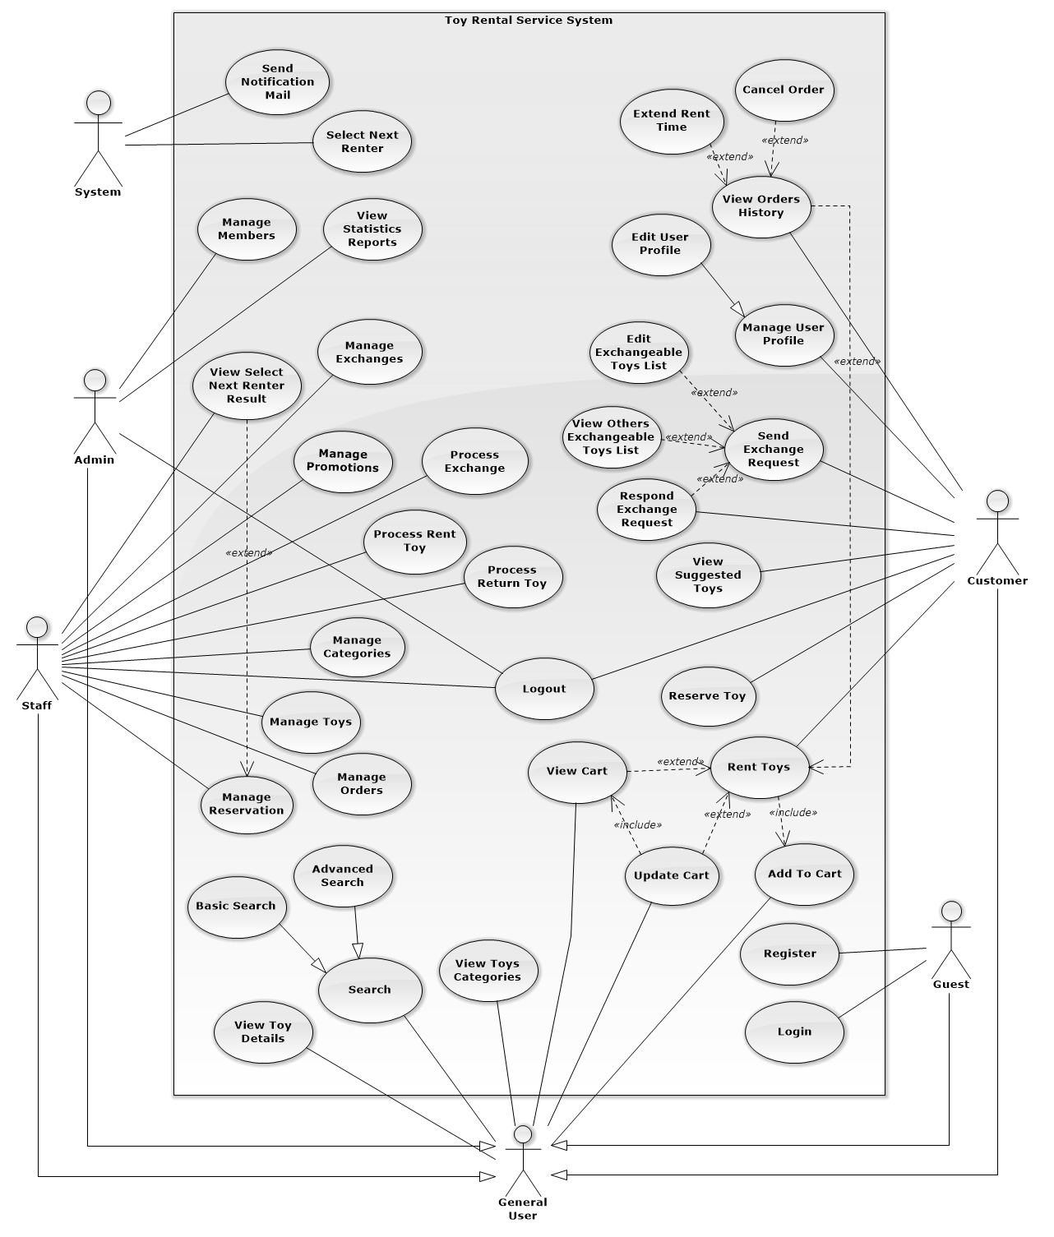

Figure 2: Use Case Overview

#### **List Of Use Case**

##### **<Staff>Overview Use Case**

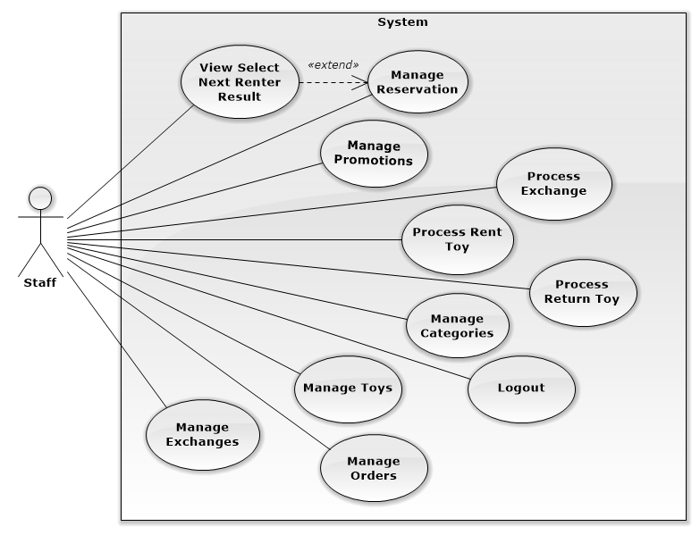

Figure 3: <Staff>Overview Use Case

##### **<Staff>Manage Exchanges**

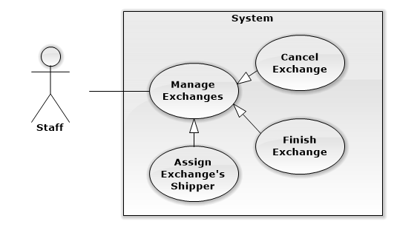

Figure 4: <Staff>Manage Exchange

###### **<Staff>Cancel Exchange**

**Use Case Diagram**

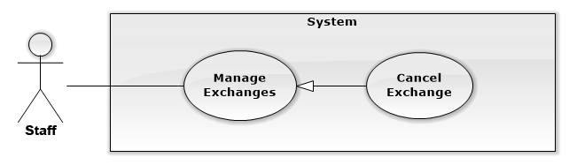

Figure 5: <Staff>Cancel Exchange

**Use Case Specification**

|  |  |  |  |
| --- | --- | --- | --- |
| **USE CASE CANCEL EXCHANGE** | | | |
| **Use Case No.** | UC001 | **Use Case Version** | 1.0 |
| **Use Case Name** | Cancel Exchange | | |
| **Author** | Nguyễn Ngọc Tường Vy | | |
| **Date** | 13/09/2014 | **Priority** | Normal |
| **Actor:**   * Staff   **Summary:**   * This use case allows staff to cancel exchange.   **Goal:**   * Staff can cancel an exchange process.   **Triggers:**   * From the sidebar:   + Select “Quản lý trao đổi” menu.   + Select “Trao đổi đã xác nhận” or “Trao đổi đang tiến hành” sub menu   + Clicks “Hủy” button on details of exchange he want to cancel   **Preconditions:**   * User must log in the system with Staff role. * Staff wants to cancel exchange.   **Post Conditions:**   * **Success:** Exchange’s status is update to “cancelled”. * **Fail:** Exchange’s status isn’t updated in database.   **Main Success Scenario:**   |  |  |  | | --- | --- | --- | | Step | Actor Action | System Response | | 1 | Clicks “Hủy” button on details of exchange he want to cancel | Display warning popup to confirm Staff’s action:   * “Bạn có chắc chắn muốn hủy yêu cầu trao đổi này không?” message * “Có” button * “Không” button | | 2 | Clicks “Có” button to confirm [Alternative 1] | Update that exchange’s status to “cancelled”.  Display success message: “Yêu cầu trao đổi đã được hủy”  [Exception 1] |   **Alternative Scenario:**   |  |  |  | | --- | --- | --- | | No | Actor Action | System Response | | 1 | Clicks “Không” button to cancel. | Close warning popup and do nothing. |   **Exceptions:**   |  |  |  | | --- | --- | --- | | No | Actor Action | System Response | | 1 | Cannot update exchange’s status due to database connection. | Display error message: “Không thể hủy trao đổi. Vui lòng thử lại sau” |   **Relationships:** Manage Exchanges  **Business Rules:**   * Exchange with finished status, which staff has finished exchange cannot be canceled. * Staff should notify to customers before cancel their exchange. | | | |

Table 1: <Staff>Cancel Exchange

###### **<Staff>Finish Exchange**

**Use Case Diagram**

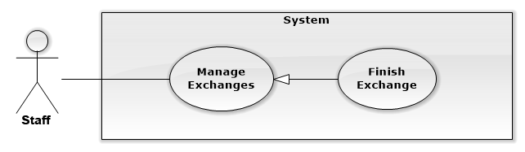

Figure 6: <Staff>Finish Exchange

**Use Case Specification**

|  |  |  |  |
| --- | --- | --- | --- |
| **USE CASE FINISH EXCHANGE** | | | |
| **Use Case No.** | UC002 | **Use Case Version** | 1.0 |
| **Use Case Name** | Finish Exchange | | |
| **Author** | Nguyễn Ngọc Tường Vy | | |
| **Date** | 13/09/2014 | **Priority** | Normal |
| **Actor:**   * Staff   **Summary:**   * This use case allows staff to close an exchange process when shipper exchange 2 toys successfully.   **Goal:**   * Staff can finish exchange process.   **Triggers:**   * From the sidebar:   + Select “Quản lý trao đổi” menu.   + Select “Trao đổi đang tiến hành” submenu.   + Clicks “Hoàn tất” button on the row of exchange he want to finish   **Preconditions:**   * Staff has finished exchange toys for 2 customers * User must log in the system with Staff role.   **Post Conditions:**   * **Success:** Exchange’s status is changed to “finished”. * **Fail:** Exchange’s status isn’t updated in database.   **Main Success Scenario:**   |  |  |  | | --- | --- | --- | | Step | Actor Action | System Response | | 1 | Clicks “Hoàn tất” button on the row of exchange he want to finish | Display warning popup to confirm Staff’s action:   * “Bạn có chắc chắn muốn hoàn tất trao đổi này không?” message * “Có” button * “Không” button | | 2 | Clicks “Có” button to confirm [Alternative 1] | Update that exchange’s status to “done”.  Display success message: “Trao đổi đã được hoàn tất.”  [Exception 1] |   **Alternative Scenario:**   |  |  |  | | --- | --- | --- | | No | Actor Action | System Response | | 1 | Clicks “Không” button to cancel. | Close warning popup and do nothing. |   **Exceptions:**   |  |  |  | | --- | --- | --- | | No | Actor Action | System Response | | 1 | Cannot update exchange’s status due to database connection. | Display error message: “Không thể kết thúc trao đổi. Vui lòng thử lại sau” |   **Relationships:** Manage Exchanges  **Business Rules:**   * Only exchange with delivering status and has been assigned shipper can be finished. * Staff should only finish exchange after process exchange 2 toys for customers | | | |

Table 2: <Staff>Finish Exchange

###### **<Staff>Assign Exchange’s Shipper**

**Use Case Diagram**

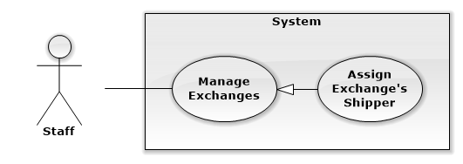

Figure 7: <Admin>Assign Exchange’s Shipper

**Use Case Specification**

|  |  |  |  |
| --- | --- | --- | --- |
| **USE CASE ASSIGN SHIPPER** | | | |
| **Use Case No.** | UC003 | **Use Case Version** | 1.0 |
| **Use Case Name** | Assign Exchange’s Shipper | | |
| **Author** | Nguyễn Ngọc Tường Vy | | |
| **Date** | 16/09/2014 | **Priority** | Normal |
| **Actor:**   * Staff   **Summary:**   * This use case is used to assign staff to handle and process exchange for customers.   **Goal:**   * Staff can assign shipper for exchange, who handle and process exchange.   **Triggers:**   * From the sidebar:   + Select “Quản lý trao đổi” menu.   + Select “Trao đổi đang tiến hành” submenu.   **Preconditions:**   * User must be logged in the system with Staff role. * Staff want to assign shipper to handle and process exchange.   **Post Conditions:**   * **Success:** Assigned shipper is updated for exchange successfully * **Fail:** Can’t assign shipper for exchange and display error message.   **Main Success Scenario:**   |  |  |  | | --- | --- | --- | | Step | Actor Action | System Response | | 1 | Click “Phân công” button on details of exchange he want to assign | Show popup:   * List of all staffs of system * “Chọn giao” button * “Đóng” button | | 2 | Select staff to assign and click “Chọn giao” button  [Alternative 1] | Update shipper for exchange [Exception 1]  Show popup:   * “Yêu cầu trao đổi đã được bàn giao vận chuyển” message * “Đóng” button | | 3 | Click “Đóng” button | Close popup assign shipper. |   **Alternative Scenario:**   |  |  |  | | --- | --- | --- | | No | Actor Action | System Response | | 1 | Click to “Đóng” button | Close popup assign shipper and do nothing |   **Exceptions:**   |  |  |  | | --- | --- | --- | | No | Actor Action | System Response | | 1 | Cannout assign shipper for exchange due to database connection | Display error message “Không thể bàn giao nhân viên giao hàng. Vui lòng thử lại sau.” |   **Relationships:** Manager Exchanges  **Business Rules:**   * Staff can only assign shipper for exchange with delivering status. * After assigned shipper, if that shipper is busy, staff can re-assign another shipper for exchange | | | |

Table 3: <Staff>Assign Exchange’s Shipper

##### **<Staff>Manage Orders**

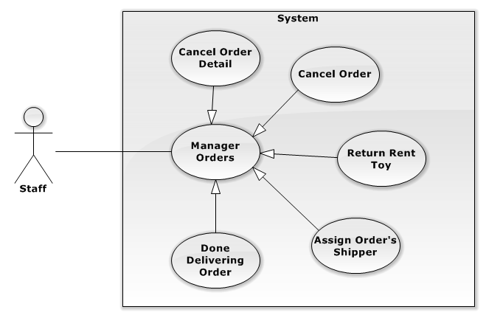

Figure 8: <Staff>Manage Orders

###### **<Staff>Cancel Order**

**Use Case Diagram**

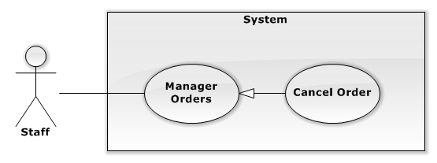

Figure 9: <Staff>Cancel Order

**Use Case Specification**

|  |  |  |  |
| --- | --- | --- | --- |
| **USE CASE CANCEL ORDER** | | | |
| **Use Case No.** | UC004 | **Use Case Version** | 1.0 |
| **Use Case Name** | Cancel Order | | |
| **Author** | Nguyễn Thị Ái Trinh | | |
| **Date** | 13/09/2014 | **Priority** | Normal |
| **Actor:**   * Staff   **Summary:**   * This use case allows staff to cancel an order   **Goal:**   * Staff can cancel an order after customer rents.   **Triggers:**   * Click “Quản lí đơn hàng” menu * Click “Đang chờ xác nhận” or “Đang giao hàng” submenu. * Click icon trash button in the row of order that he want to cancel.   **Preconditions:**   * User must log in the system with Staff role. * Staff want to cancel order   **Post Conditions:**   * **Success:** Cancel an order successful. * **Fail:** Can’t cancel or have message error when to click cancel order.   **Main Success Scenario:**   |  |  |  | | --- | --- | --- | | Step | Actor Action | System Response | | 1 | Click icon trash button in the row of order that he want to cancel | Show a popup:   * “Bạn có chắc muốn hủy đơn hàng này?” message * “Có” button * “Không” button | | 2 | Click “Có” button  [Alternative 1] | Show popup:   * “Đã Hủy Đơn Hàng Thành Công” message * “Đóng” button   [Exception : 1] | | 3 | Click “Không” button | Update that order’s status to “cancel”.  Reload manage order page. |   **Alternative Scenario:**   |  |  |  | | --- | --- | --- | | No | Actor Action | System Response | | 1 | Click to “Đóng” button | Close current popup and do nothing |   **Exceptions:**   |  |  |  | | --- | --- | --- | | No | Actor Action | System Response | | 1 | Cannot cancel order due to database connection. | Display error message: “Không thể hủy đơn hàng. Vui lòng thử lại sau” |   **Relationships:** Manage Orders  **Business Rules:**   * Staff should only cancel order when status of order is waiting or paying. * In special case, staff can also cancel order when order is delivering but there is some problem with product, deliver process or customer want to cancel. | | | |

Table 4: <Staff> Cancel Order

###### **<Staff>Cancel Order Detail**

**Use Case Diagram**

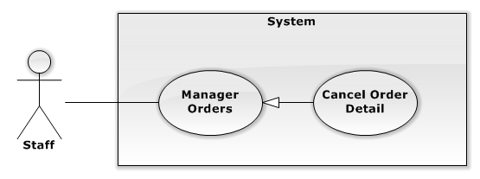

Figure 10: <Staff>Cancel Order Detail

**Use Case Specification**

|  |  |  |  |
| --- | --- | --- | --- |
| **USE CASE CANCEL ORDER DETAIL** | | | |
| **Use Case No.** | UC005 | **Use Case Version** | 1.0 |
| **Use Case Name** | Cancel Order Detail | | |
| **Author** | Nguyễn Thị Ái Trinh | | |
| **Date** | 16/09/2014 | **Priority** | Normal |
| **Actor:** Staff  **Summary:**   * This use case is used to cancel a product that rented in the system.   **Goal:**   * Staff can cancel a product that customer doesn’t want to rent.   **Triggers:**   * Click “Quản lí đơn hàng” menu * Click “Đang chờ xác nhận” or “đang vận chuyển” submenu. * Click “Chi Tiết” button in Manager Orders page. * Click trash button on the row of product he want to cancel.   **Preconditions:**   * User must be logged in the system with Staff role. * Staff want to cancel one ordered product of order.   **Post Conditions:**   * **Success:** Cancel an order detail successful. * **Fail:** Can’t cancel order detail. Redirect error page.   **Main Success Scenario:**   |  |  |  | | --- | --- | --- | | Step | Actor Action | System Response | | 1 | Click trash button on the row of product he want to cancel | Show popup:   * “Bạn có chắc muốn hủy món hàng của đơn hàng này?” * “Có” button * “Không” button | | 2 | Click to “Có” button  [Alternative 1] | Show popup:   * “Đã hủy thuê sản phẩm thành công” message * “Đóng” button.   [Exception : 1] | | 3 | Click to “Không” button | Update that order detail’s status to “cancel”.  Reload manage order page. |   **Alternative Scenario:**   |  |  |  | | --- | --- | --- | | No | Actor Action | System 1Response | | 1 | Click to “Đóng” button | Close current popup |   **Exceptions:**   |  |  |  | | --- | --- | --- | | No | Actor Action | System Response | | 1 | Cannot cancel order detail due to database connection. | Display error message: “Không thể hủy thuê sản phẩm này. Vui lòng thử lại sau” |   **Relationships:** Manager Orders  **Business Rules:**   * Only product with waiting status that hasn’t been delivered can be canceled * When last product of order is cancel, order’s status will also be updated to cancel | | | |

Table 5: <Staff>Add Order

###### **<Staff>Return Rent Toy**

**Use Case Diagram**

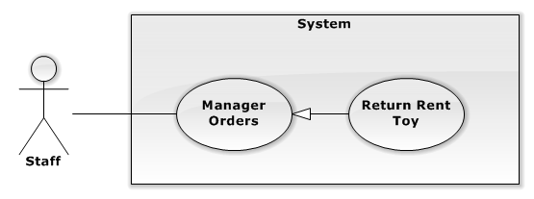

Figure 11: <Staff>Return Rent Toy

**Use Case Specification**

|  |  |  |  |
| --- | --- | --- | --- |
| **USE CASE RETURN RENT TOY** | | | |
| **Use Case No.** | UC006 | **Use Case Version** | 2.0 |
| **Use Case Name** | Return Rent Toy | | |
| **Author** | Nguyễn Thị Ái Trinh | | |
| **Date** | 16/09/2014 | **Priority** | Normal |
| **Actor:** Staff  **Summary:**   * This use case allows staff to process receive back rented product from customer   **Goal:**   * Staff can process receive back rented product from customer.   **Triggers:**   * Click “Quản lí đơn hàng” menu * Click “Đang vận chuyển” or “Đã hoàn tất” submenu. * Click “Chi Tiết” button to view detail of an order.   **Preconditions:**   * Customer has returned product to store * User must be logged in the system with Staff role   **Post Conditions:**   * **Success:** Return rented toy successfully. * **Fail:** Cannot return rented toy and display error   **Main Success Scenario:**   |  |  |  | | --- | --- | --- | | Step | Actor Action | System Response | | 1 | Click “Trả hàng” button on the row of returned product | Show popup:   * Rent price: label * Deposit: label * Total price return back/ surcharge: label * “Trả hàng” button * “Đóng” button | | 1 | Click “Trả hàng” button  [Alternative 1] | Update status of order detail to returned [Exception 1]  Show popup:   * “Đã trả hàng thành công” message * “Đóng” button | | 2 | Click “Đóng” button | Close current popup |   **Alternative Scenario:**   |  |  |  | | --- | --- | --- | | No | Actor Action | System Response | | 1 | Click to “Đóng” button in popup return rent toy | Close current popup |   **Exceptions:**   |  |  |  | | --- | --- | --- | | No | Actor Action | System Response | | 1 | Cannot return product due to database connection | Display error message: “Không thể trả sản phẩm này. Vui lòng thử lại sau” |   **Relationships:** Manager Orders  **Business Rules:**   * Button “Trả Hàng” only display when product is renting, hasn’t been returned. * Payment when return toy will include returning deposit money and surcharge when rent time is overdue or returning rent price if customer return toy soon. * With product that is returned soon, customer can only receive 80% of rent price of returned time. * With product that is returned late, if customer has assigned new return date when rent time is remained, rent price will be calculated by old price as customer has rented at beginning * With product that is returned late, if customer not assigned new return date for product or assign when rent time is overdue, rent price will be calculated by new price as current rent price of system. * Staff has to check product’s condition to decide to take fine fee if product is broken. * Staff only finish return product when checked product and done further payment with customer | | | |

Table 6: <Staff>Return Rent Toy

###### **<Staff>Assign Order’s Shipper**

**Use Case Diagram**

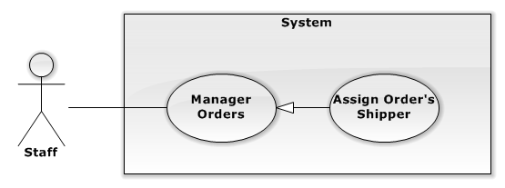

Figure 12: <Admin>Assign Order’s Shipper

**Use Case Specification**

|  |  |  |  |
| --- | --- | --- | --- |
| **USE CASE ASSIGN SHIPPER** | | | |
| **Use Case No.** | UC007 | **Use Case Version** | 2.0 |
| **Use Case Name** | Assign Order’s Shipper | | |
| **Author** | Nguyễn Thị Ái Trinh | | |
| **Date** | 16/09/2014 | **Priority** | Normal |
| **Actor:** Staff  **Summary:**   * This use case is used to assign a staff to process and deliver order.   **Goal:**   * Allowed staff to assign a shipper to process and deliver order.   **Triggers:**   * Click “Quản lí đơn hàng” link in menu bar on the left * Click “Đang chờ xác nhận” or “Đang giao hàng” submenu. * Click “Giao hàng” in “Đang chờ xác nhận” page. Or click “Phân công” in “Đang giao hàng” page.   **Preconditions:**   * User must be logged in the system with Staff role.   **Post Conditions:**   * **Success:** Assign shipper for order successfully. * **Fail:** Can’t assign shipper and display error message   **Main Success Scenario:**   |  |  |  | | --- | --- | --- | | Step | Actor Action | System Response | | 1 | Click “Giao hàng” button in “Đang chờ xác nhận” page or “Phân công” button in “Đang giao hàng” page. | Show popup:   * List of all staffs of system * “Chọn giao” button * “Đóng” button | | 2 | Choose staff to assign and click “Chọn giao” button  [Alternative 1] | Update shipper for order [Exception 1]  Show popup:   * “Đã bàn giao người giao hàng” message * “Đóng” button | | 3 | Click “Đóng” button | Close popup assign shipper and reload page |   **Alternative Scenario:**   |  |  |  | | --- | --- | --- | | No | Actor Action | System Response | | 1 | Click to “Đóng” button | Close popup assign shipper and do nothing |   **Exceptions:**   |  |  |  | | --- | --- | --- | | No | Actor Action | System Response | | 1 | Cannot assign shipper for order due to database connection | Display error message “Không thể bàn giao nhân viên giao hàng. Vui lòng thử lại sau.” |   **Relationships:** Manager Order  **Business Rules:**   * Only order with delivering status or order with waiting status that has been ready for deliver can assign shipper. * After assigned shipper, if that shipper is busy, staff can re-assign another shipper for order | | | |

Table 7: <Staff>Assign Order’s Shipper

###### **<Staff>Done Delivering Order**

**Use Case Diagram**

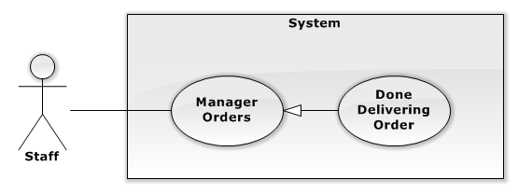

Figure 13: <Admin>Done Delivering Order

**Use Case Specification**

|  |  |  |  |
| --- | --- | --- | --- |
| **USE CASE DONE DELIVERING ORDER** | | | |
| **Use Case No.** | UC008 | **Use Case Version** | 2.0 |
| **Use Case Name** | Done Delivering Order | | |
| **Author** | Nguyễn Thị Ái Trinh | | |
| **Date** | 16/09/2014 | **Priority** | Normal |
| **Actor:** Staff  **Summary:**   * This use case is used to confirm done delivering order.   **Goal:**   * Staff can confirm that order has been delivered.   **Triggers:**   * Click “Quản lí đơn hàng” menu * Click “Đang giao hàng” submenu.   **Preconditions:**   * Order has been finished delivering. * User must be logged in the system with Staff role.   **Post Conditions:**   * **Success:** Confirm done deliver order successfully. * **Fail:** Can’t confirm done deliver order or system redirect to error page.   **Main Success Scenario:**   |  |  |  | | --- | --- | --- | | Step | Actor Action | System Response | | 1 | Click “Hoàn Tất” button on the row of done deliver order  [Alternative 1] | Update status of order to done  Show popup:   * “Đã hoàn tất giao hàng” message * “Đóng” button   [Exception 1] | | 3 | Click “Đóng” button | Close current popup and reload page. |   **Alternative Scenario:**   |  |  |  | | --- | --- | --- | | No | Actor Action | System Response | | 1 | Click “Hoàn Tất” button of order that hasn’t assign shipper | Show popup:   * “Không thể hoàn tất đơn hàng chưa có người giao hàng” message * “Đóng” button |   **Exceptions:**   |  |  |  | | --- | --- | --- | | No | Actor Action | System Response | | 1 | Cannot done deliver order due to database connection | Display error message “Không thể hoàn tất giao hàng. Vui lòng thử lại sau.” |   **Relationships:** Manager Orders  **Business Rules:**   * Staff can confirm done delivering for entire order or confirm done for each delivered product of order. * When all products of order is marked as delivered, order’s status will be changed to done. | | | |

Table 8: <Staff>Done Delivering Order

##### **<Staff>Manage Toys**

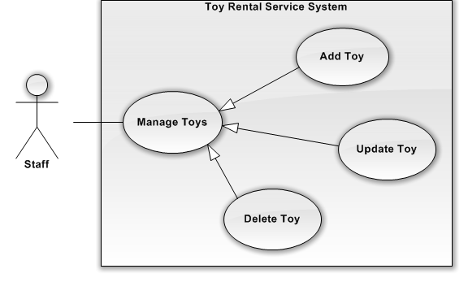

Figure 14: <Staff>Manage Toys

###### **<Staff> Add Toy**

**Use Case Diagram**

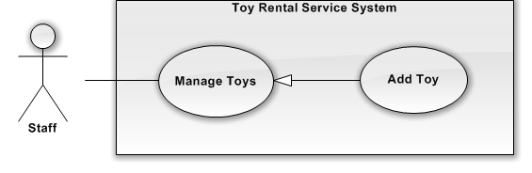

Figure 15: <Staff>Add Toy

**Use Case Specification**

|  |  |  |  |  |
| --- | --- | --- | --- | --- |
| **USE CASE – ADD TOY** | | | | |
| **Use-case No.** | UC009 | **Use-case Version** | | 2.0 |
| **Use-case Name** | Add Toy | | | |
| **Author** | Hồ Quang Hưng | | | |
| **Date** | 18/09/2014 | **Priority** | Normal | |
| **Actor:**   * Staff   **Summary:**   * This usecase allow staff to create a new toy.   **Goal**:   * Staff can add new toy to system.   **Triggers:**   * Click “Quản lý sản phẩm” menu. * Click “Thêm mới sản phẩm” button   **Preconditions:**   * User logged in successfully with Staff role.   **Post Conditions:**   * **Success:** A successful message will be displayed, new toy will be added. After reloaded [Manage Toy Page], new row of toy will be inserted to [Manage Toy] table. * **Fail:** Cannot add new toy to database and display error message.   **Main Success Scenario:**   |  |  |  | | --- | --- | --- | | Step | Actor Action | System Response | | 1 | Clicks “Thêm mới sản phẩm” button on [ManageToy] page. | Show the page with title “Thêm mới sản phẩm”. The [AddToy] page includes:   * Mã sản phẩm: Text box (Code of toy, min length: 3, max length: 6, required) * Tên sản phẩm: Text box (Name of toy, min length: 3, max length: 6, required) * Hình ảnh: Button (Images of toy, required] * Mô tả sản phẩm: Text area (Description of toy, required) * Chiều rộng: Text box (Width of toy, required) * Chiều dài: Text box (Length of toy, required) * Chiều cao: Text box (Height of toy, required) * Tiền đặt cọc sản phẩm: Text box (Deposit of toy, required) * Xuất sứ: Drop-down-list (Origin of toy, required) * Hãng sản xuất: Text box (Manufacture of toy, required) * Giới tính: Drop-down-list (Appropriate sex, required) * Độ tuổi phù hợp từ: Text box (Min appropriate age, required) * Độ tuổi phù hợp đến: Text box (Max appropriate age, required) * Giá thuê theo ngày: Text box (Day price, required) * Giá thuê theo tuần: Text box (Week price, required]) * Giá thuê theo tháng: Text box (Monthly price, required) * Số ngày tối đa cho thuê: Text box * (Max rental day, required) * Số ngày tối thiểu cho thuê: Text box (Min rental day, required) * Ngày chờ thuê: Text box (The duration receipt toy, required) * Sở thích: Check box (Name of hobby, required) * Tạo mới: button * Xóa: button | | 2 | Inputs information into all fields and clicks “Tạo mới” button  [Alternative 1] | [Exceptions 1, 2, 3, 4, 5, 6, 7, 8, 9, 10, 11, 12, 13, 14, 15, 16, 17, 18, 19, 20, 21, 22]  Show successfully message: “Đã thêm mới sản phẩm thành công!” and redirect to [AddInstance] page. |   **Alternative Scenario:**   |  |  |  | | --- | --- | --- | | No | Actor Action | System Response | | 1 | Staff clicks “Xóa” button. | The data in all fields will be reset. |   **Exceptions:**   |  |  |  | | --- | --- | --- | | No | Actor Action | System Response | | 1 | “Mã sản phẩm”, “Tên sản phẩm”, “Hình ảnh”, “Mô tả sản phẩm”, “Chiều rộng”, “Chiều dài”, “Chiều cao”, “Tiền đặt cọc sản phẩm”, “Hãng sản xuất”, “Đột tuổi từ”, “Độ tuổi đến”, “Ngày tối thiểu cho thuê”, “Ngày chờ thuê”,”Sở thích” are empty. | Shows error message “Vui lòng nhập đầy đủ thông tin yêu cầu!” | | 2 | Code of toy is already exists. | Shows error message “Mã sản phẩm đã tồn tại!” | | 3 | Code of toy with more than 5 characters. | Shows error message “Mã sản phẩm từ 1 đến 5 ký tự!” | | 4 | Name of toy is less than 6 characters or more than 100 characters. | Shows error message “Tên sản phẩm từ 6 đến 100 ký tự!” | | 5 | Description of toy is less than 50 characters and more than 500 characters. | Shows error message “Mô tả sản phẩm từ 50 đến 500 ký tự!” | | 6 | Size of toy is smaller than 1 and greater than 500 cm. | Shows error message “Kích thước trong khoản từ 1 cm đến 500 cm!” | | 7 | Name of toy is less than 3 characters and more than 100 characters. | Shows error message “Hãng sản xuất trong khoản từ 3 đến 100 ký tự!” | | 8 | From Age is smaller than 0 or greater than 15. | Shows error message “Tuổi từ trong khoản từ 0 tuổi đến 15 tuổi!” | | 9 | To Age is smaller than From Age or greater than 15. | Shows error message “Tuổi từ trong khoản từ … tuổi đến 15 tuổi!” | | 10 | Max rented days of toy is smaller than 50 and greater than 1000 days. | Shows error message “Thời hạn sử dụng sản phẩm trong khoản 50 này đến 1000 ngày!” | | 11 | Min rent days is smaller than 1 or greater than 10 days. | Shows error message “Ngày tối thiểu cho thuê từ 1 ngày đến 10 ngày!” | | 12 | Max spending days is smaller than 1 or greater than 10 days. | Shows error message “Ngày chờ thuê từ 1 ngày đến 10 ngày!” | | 13 | Width of toy is not a number. | Shows error message “Kích thước chiều rộng không hợp lệ!” | | 14 | Length of toy is not a number. | Shows error message “Kích thước chiều dài không hợp lệ!” | | 15 | Height of toy is not a number. | Shows error message “Kích thước chiều cao không hợp lệ!” | | 16 | Deposit of toy is not a number. | Shows error message “Giá đặt cọc bạn nhập không hợp lệ!” | | 17 | From Age of toy is not a number. | Shows error message “Độ tuổi phù hợp không hợp lệ!” | | 18 | To Age of toy is not a number. | Shows error message “Độ tuổi phù hợp không hợp lệ!” | | 19 | Days, week, month price rent of toy is not a number. | Shows error message “Giá thuê không hợp lệ!” | | 20 | Min rent day rent of toy is not a number. | Shows error message “Ngày tối thiểu cho thuê không hợp lệ!” | | 21 | Max pending days of toy is not a number. | Shows error message “Ngày chờ nhận hàng tối đa không hợp lệ!” | | 22 | Cannot add new toy | Display error message “Không thể thêm mới sản phẩm. Vui lòng thử lại sau” |   **Relationships:** Manage Toys  **Business Rules:**   * Staff can add new product to system when store has import new product. * Product name should be different from existed product of system * Product information should be clearly and easy to understand. | | | | |

Table 9: <Staff> Add Toy

###### **<Staff> Update Toy**

**Use Case Diagram**

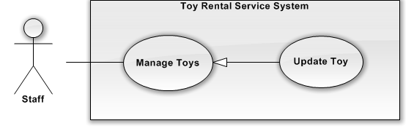

Figure 16: <Staff> Update Toy

**Use Case Specification**

|  |  |  |  |  |
| --- | --- | --- | --- | --- |
| **USE CASE – UPDATE TOY** | | | | |
| **Use-case No.** | UC010 | **Use-case Version** | | 2.0 |
| **Use-case Name** | Update Toy | | | |
| **Author** | Hồ Quang Hưng | | | |
| **Date** | 18/09/2014 | **Priority** | Normal | |
| **Actor:**  Staff  **Summary:**   * This usecase allow staff to update information of toy and toy instance.   **Goal:**   * New information of toy and toy instance will be updated into database.   **Triggers:**   * Click “Sản phẩm” button on “Cập nhật” column of toy he want to update.   **Preconditions:**   * User must log in the system with Staff role.   **Post Conditions:**   * **Success:** A successfull message “Đã cập nhật sản phẩm thành công!” will be show on screen. New information of toy updated into databse. * **Fail:** Information of toy update unsuccessful.   **Main Success Scenario:**   |  |  |  | | --- | --- | --- | | Step | Actor Action | System Response | | 1 | Click “Sản phẩm” button on “Cập nhật” column of toy he want to update | Show the page“Cập nhật thông tin sản phẩm” on screen. Page includes:   * Mã sản phẩm: Text box (Code of toy, length [3, 6], required) * Tên sản phẩm: Text box (Name of toy, length [3, 6], required) * Hình ảnh: Button (Images of toy, required] * Mô tả sản phẩm: Text area (Description of toy, required) * Chiều rộng: Text box (Width of toy, required) * Chiều dài: Text box (Length of toy, required) * Chiều cao: Text box (Height of toy, required) * Tiền đặt cọc sản phẩm: Text box (Deposit of toy, required) * Xuất xứ: Drop-down-list (Origin of toy, required) * Hãng sản xuất: Text box (Manufacture of toy, required) * Giới tính: Drop-down-list (Appropriate sex, required) * Độ tuổi phù hợp từ: Text box (Min appropriate age, required) * Độ tuổi phù hợp đến: Text box (Max appropriate age, required) * Giá thuê theo ngày: Text box (Day price, required) * Giá thuê theo tuần: Text box (Week price, required) * Giá thuê theo tháng: Text box (Monthly price, required) * Số ngày tối đa cho thuê: Text box * (Max rental day, required) * Số ngày tối thiểu cho thuê: Text box (Min rental day, required) * Ngày chờ thuê: Text box (The duration receipt toy, required) * Sở thích: Check box (Name of hobby, required) * “Lưu” button. * “Xóa” button. | | 2 | Staff clicks on “Lưu” button.  [Alternative 1] | [Exceptions : 1, 2, 3, 4, 5, 6, 7, 8, 9, 10, 11, 12, 13, 14, 15, 16, 17, 18, 19, 20, 21, 22]  Show the popup and message is displayed “Đã cập nhật sản phẩm thành công!” |   **Alternative Scenario:**   |  |  |  | | --- | --- | --- | | No | Actor Action | System Response | | 1 | Click “Xóa” button. | The data in all fileds will be clear. |   **Exceptions:**   |  |  |  | | --- | --- | --- | | No | Actor Action | System Response | | 1 | “Mã sản phẩm”, “Tên sản phẩm”, “Hình ảnh”, “Mô tả sản phẩm”, “Chiều rộng”, “Chiều dài”, “Chiều cao”, “Tiền đặt cọc sản phẩm”, “Hãng sản xuất”, “Độ tuổi từ”, “Độ tuổi đến”, “Ngày tối thiểu cho thuê”, “Ngày chờ thuê”,”Sở thích” are empty. | Show error message “Vui lòng nhập đầy đủ thông tin yêu cầu!” | | 2 | Code of toy is already exists. | Show error message “Mã sản phẩm đã tồn tại!” | | 3 | Code of toy is more than 5 characters characters. | Show error message “Mã sản phẩm từ 1 đến 5 ký tự!” | | 4 | Name of toy is less than 6 characters and more than 100 characters characters. | Show error message “Tên sản phẩm từ 6 đến 100 ký tự!” | | 5 | Description of toy is less than 50 characters and more than 500 characters characters. | Show error message “Mô tả sản phẩm từ 50 đến 500 ký tự!” | | 6 | Staff fills size of toy is smaller than 1 and greater than 500 cm. | Show error message “Kích thước trong khoảng từ 1 cm đến 500 cm!” | | 7 | Staff fills name of toy is less than 3 characters and more than 100 characters characters. | Show error message “Hãng sản xuất trong khoảng từ 3 đến 100 ký tự!” | | 8 | Staff fills “age from” is smaller than 0 or greater than 15. | Show error message “Tuổi từ trong khoảng từ 0 tuổi đến 15 tuổi!” | | 9 | Staff fills “age to” is smaller than 0 or greater than 15. | Show error message “Tuổi từ trong khoảng từ 0 tuổi đến 15 tuổi!” | | 10 | Staff fills max rented days of toy is smaller than 50 and greater than 1000 days. | Show error message “Thời hạn sử dụng sản phẩm trong khoản 50 này đến 1000 ngày!” | | 11 | Staff fills min rent days is smaller than 1 or greater than 10 days. | Show error message “Ngày tối thiểu cho thuê từ 1 ngày đến 10 ngày!” | | 12 | Staff fills max spending days is smaller than 1 or greater than 10 days. | Show error message “Ngày chờ thuê từ 1 ngày đến 10 ngày!” | | 13 | Staff fills width of toy is not a number. | Show error message “Kích thước chiều rộng không hợp lệ!” | | 14 | Staff fills length of toy is not a number. | Show error message “Kích thước chiều dài không hợp lệ!” | | 15 | Staff fills height of toy is not a number. | Show error message “Kích thước chiều cao không hợp lệ!” | | 16 | Staff fills deposit of toy is not a number. | Show error message “Giá đặt cọc bạn nhập không hợp lệ!” | | 17 | Staff fills age from of toy is not a number. | Show error message “Độ tuổi phù hợp từ không hợp lệ!” | | 18 | Staff fills age to of toy is not a number. | Show error message “Độ tuổi phù hợp đến không hợp lệ!” | | 19 | Staff fills days, week, month price rent of toy is not a number. | Show error message “Giá thuê không hợp lệ!” | | 20 | Staff fills min rent day rent of toy is not a number. | Show error message “Ngày tối thiểu cho thuê không hợp lệ!” | | 21 | Staff fills max pending days of toy is not a number. | Show error message “Ngày chờ thuê không hợp lệ!” | | 22 | Staff clicks on the “Thêm mới sản phẩm” button. | Display message “This page is not available” |   **Relationships:** Manage Toys  **Business Rules:** **:**   * Name of toy should be different from other toy * Other information of toy should be clear and easy to understand | | | | |

Table 10: <Staff> Update Toy

###### **<Staff> Discontinue Toy**

**Use Case Diagram**

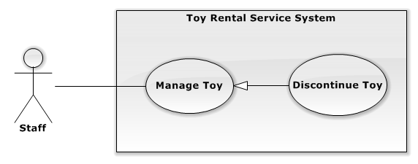

Figure 17: <Staff> Discontinue Toy

**Use Case Specification**

|  |  |  |  |  |
| --- | --- | --- | --- | --- |
| **USE CASE – DISCONTINUE TOY** | | | | |
| **Use-case No.** | UC011 | **Use-case Version** | | 2.0 |
| **Use-case Name** | Discontinue Toy | | | |
| **Author** | Hồ Quang Hưng | | | |
| **Date** | 18/09/2014 | **Priority** | High | |
| **Actor:**  Staff  **Summary:**   * This use case allowes user dicountinue a toy.   **Goal:**   * Staff can discontinue a toy.   **Triggers:**   * Click “Ngưng kinh doanh” button at “Thao tác” column of list toys table on Available Toy Page.   **Preconditions:**   * User must log in the system with role staff .   **Post Conditions:**   * **Success** : Toy is selected that is discountinued in the system. * **Fail:** No change. Toy is selected to discountinue that not change   **Main Success Scenario:**   |  |  |  | | --- | --- | --- | | Step | Actor Action | System Response | | 1 | Click “Ngưng kinh doanh” button on “Thao tác” colums of list toys table. | Show confirm popup includes:   * Thông báo: label. * Message: “Bạn muốn ngưng kinh doanh sản phẩm này!” label. * “Có”: button * “Đóng”: button | | 2 | Click “Có” button.  [Alternative 1] | Show successful message “Đã chuyển trạng thái!” on screen.  [Exceptions 1] |   **Alternative Scenario:**   |  |  |  | | --- | --- | --- | | No. | Actor Action | System Response | | 1 | Click “Đóng” button. | Close pop up confirm stattus. |   **Exceptions:**   |  |  |  | | --- | --- | --- | | No. | Actor Action | System Response | | 1 | Click “Có” button and system can’t connect internet. | Display message “This page is not available” |   **Relationships:** Manage Toys  **Business Rules:**   * When store start to business this toy again. Staff can click to “Kinh Doanh” button * When there is customer renting this toy, toy can’t be discontinue. | | | | |

Table 11: <Staff> Discontinue Toy

##### **<Staff>View Select Next Renter Result**

**Use Case Diagram**

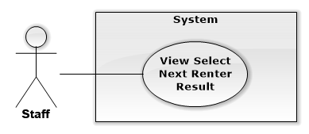

Figure 18: <Staff>View Select Next Renter Result

**Use Case Specification**

|  |  |  |  |
| --- | --- | --- | --- |
| **USE CASE VIEW SELECT NEXT RENTER RESULT** | | | |
| **Use Case No.** | UC012 | **Use Case Version** | 1.0 |
| **Use Case Name** | View Select Next Renter Result | | |
| **Author** | Nguyễn Ngọc Tường Vy | | |
| **Date** | 13/09/2014 | **Priority** | Normal |
| **Actor:**   * Staff   **Summary:**   * This use case allows staff to view the result of selecting next customer who can rent toy between reserved customers.   **Goal:**   * Staff can view result of select next renting customer.   **Triggers:**   * From the sidebar:   + Choose “Quản lý đặt trước” menu.   **Preconditions:**   * User must log in the system with Staff role. * Staff wants to view result of select next renting customer.   **Post Conditions:**   * **Success:** New Select Next Renter result is displayed. * **Fail:** Cannot load Select Next Renter result   **Main Success Scenario:**   |  |  |  | | --- | --- | --- | | Step | Actor Action | System Response | | 1 | Open Manage Reservation page | Display all reservation with status and highlight results that haven’t been seen. [Alternative 1] [Exception 1] |   **Alternative Scenario:**   |  |  |  | | --- | --- | --- | | No | Actor Action | System Response | | 1 | Open Manage Reservation page | Display message: “Không có yêu cầu đặt trước nào.” |   **Exceptions:**   |  |  |  | | --- | --- | --- | | No | Actor Action | System Response | | 1 | Cannot view reservation list | Display error message: “Không thể tải danh sách đặt trước.” |   **Relationships:** Manage Reservation  **Business Rules:**   * List of reservation is sorted by reserved date with the newest on top of list. | | | |

Table 12: <Staff>View Select Next Renter Result

##### **<Staff>Process Rent Toy**

**Use Case Diagram**

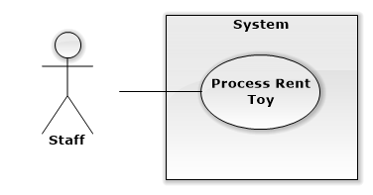

Figure 19: <Staff>Process Rent Toy

**Use Case Specification**

|  |  |  |  |
| --- | --- | --- | --- |
| **USE CASE PROCESS RENT TOY** | | | |
| **Use Case No.** | UC013 | **Use Case Version** | 1.0 |
| **Use Case Name** | Process Rent Toy | | |
| **Author** | Nguyễn Ngọc Tường Vy | | |
| **Date** | 13/09/2014 | **Priority** | Normal |
| **Actor:**   * Staff   **Summary:**   * This use case allows staff to process assigned orders by mobile application   **Goal:**   * Staff can finish delivering assigned order.   **Triggers:**   * Click on “Hoàn tất” button of order details page.   **Preconditions:**   * User must log in the system with Staff role. * Staff is assigned for process deliver order.   **Post Conditions:**   * **Success:** Order status is updated as done delivering. * **Fail:** Cannot update order status   **Main Success Scenario:**   |  |  |  | | --- | --- | --- | | Step | Actor Action | System Response | | 1 | Click “Hoàn tất” button | Display popup with success message: “Cập nhật trạng thái đơn hàng thành công” [Exception 1, 2] |   **Alternative Scenario:** N/A  **Exceptions:**   |  |  |  | | --- | --- | --- | | No | Actor Action | System Response | | 1 | Cannot update order’s status due to internet connection | Display error message: “Không thể cập nhật trạng thái đơn hàng. Vui lòng kiểm tra kết nối mạng.” | | 2 | Cannot update order’s status due to other problem | Display error message: “Không thể cập nhật trạng thái đơn hàng. Vui lòng thử lại.” |   **Relationships:** N/A  **Business Rules:**   * Staff has to deliver all rented products of order to customer before finishing order | | | |

Table 13: <Staff>Process Rent Toy

##### **<Staff>Process Return Toy**

**Use Case Diagram**

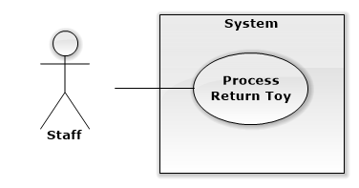

Figure 20: <Staff>Process Return Toy

**Use Case Specification**

|  |  |  |  |
| --- | --- | --- | --- |
| **USE CASE PROCESS RETURN TOY** | | | |
| **Use Case No.** | UC014 | **Use Case Version** | 1.0 |
| **Use Case Name** | Process Return Toy | | |
| **Author** | Nguyễn Ngọc Tường Vy | | |
| **Date** | 13/09/2014 | **Priority** | Normal |
| **Actor:**   * Staff   **Summary:**   * This use case allows staff to process return toy using mobile application   **Goal:**   * Staff can process return toy and update status of order.   **Triggers:**   * Click on “Xử lý trả hàng” menu   **Preconditions:**   * User must log in the system with Staff role. * Customer want to return rented toy.   **Post Conditions:**   * **Success:** Return process is done and order’s status is updated. * **Fail:** Cannot done return process and update order’s status.   **Main Success Scenario:**   |  |  |  | | --- | --- | --- | | Step | Actor Action | System Response | | 1 | Clicks “Quét mã sản phẩm” [Alternative 1] | Open camera to scan QR code [Exception 1]  Search and display order detail result [Alternative 2][Exception 2] | | 2 | Edit payment amount and clicks “Trả” button | Display payment popup with total amount customer has to pay or receive back [Exception 3] | | 3 | Clicks “Tiếp tục” button [Alternative 3] | Display success message: “Tiến hành trả hàng thành công” [Exception 4] |   **Alternative Scenario:**   |  |  |  | | --- | --- | --- | | No | Actor Action | System Response | | 1 | Clicks “Tìm đơn hàng theo SĐT”  Enter customer phone and click search button  Select order  Edit payment amount and clicks “Trả” button  Clicks “Tiếp tục” button [Alternative 3] | Display search box to search order  Search and display orders list result [Alternative 2][Exception 2]  Display order details  Display payment popup with total amount customer has to pay or receive back [Exception 3]  Display success message: “Tiến hành trả hàng thành công” [Exception 4] | | 2 | Scan wrong QR code or enter wrong phone number | Display message: “Không tìm thấy đơn hàng nào phù hợp” | | 3 | Click “Đóng” button | Close popup and do nothing |   **Exceptions:**   |  |  |  | | --- | --- | --- | | No | Actor Action | System Response | | 1 | Cannot open camera | Display error message: “Không thể mở camera để quét mã. Vui long thử lại” | | 2 | Cannot search order | Display error message: “Không thể tải đơn hàng. Vui lòng kiểm tra kết nối mạng.” | | 3 | Cannot calculate total money | Display error message: “Không thể tính tổng tiền thanh toán. Vui lòng thử lại!” | | 4 | Cannot return order | Display error message: “Không thể tiến hành trả hàng. Vui lòng thử lại!” |   **Relationships:** N/A  **Business Rules:**   * Payment when return toy will include returning deposit money and surcharge when rent time is overdue or returning rent price if customer return toy soon. * With product that is returned soon, customer can only receive 80% of rent price of returned time. * With product that is returned late, if customer has assigned new return date when rent time is remained, rent price will be calculated by old price as customer has rented at beginning * With product that is returned late, if customer not assigned new return date for product or assign when rent time is overdue, rent price will be calculated by new price as current rent price of system. * Staff has to check product’s condition to decide to take fine fee if product is broken. * Staff only finish return product when checked product and done further payment with customer | | | |

Table 14: <Staff>Process Return Toy

##### **<Staff>Process Exchange**

**Use Case Diagram**

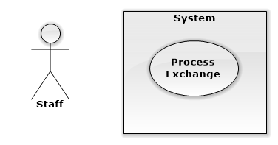

Figure 21: <Staff>Process Exchange

**Use Case Specification**

|  |  |  |  |
| --- | --- | --- | --- |
| **USE CASE PROCESS EXCHANGE** | | | |
| **Use Case No.** | UC015 | **Use Case Version** | 1.0 |
| **Use Case Name** | Process Exchange | | |
| **Author** | Nguyễn Ngọc Tường Vy | | |
| **Date** | 13/09/2014 | **Priority** | Normal |
| **Actor:**   * Staff   **Summary:**   * This use case allows staff to process assigned exchange   **Goal:**   * Staff can process and finish exchange   **Triggers:**   * Clicks “Hoàn tất” button in exchange detail page   **Preconditions:**   * User must log in the system with Staff role. * Staff is assigned for processing exchange and done his job.   **Post Conditions:**   * **Success:** Staff finish exchange and exchange’s status is updated * **Fail:** Cannot finish exchange or update exchange’s status   **Main Success Scenario:**   |  |  |  | | --- | --- | --- | | Step | Actor Action | System Response | | 1 | Clicks “Hoàn tất” button | Display popup with success message: “Cập nhật trạng thái trao đổi thành công” [Exception 1, 2] |   **Alternative Scenario:** N/A  **Exceptions:**   |  |  |  | | --- | --- | --- | | No | Actor Action | System Response | | 1 | Cannot update exchange’s status due to internet connection | Display error message: “Không thể cập nhật trạng thái trao đổi. Vui lòng kiểm tra kết nối mạng.” | | 2 | Cannot update exchange’s status due to other problem | Display error message: “Không thể cập nhật trạng thái trao đổi. Vui lòng thử lại.” |   **Relationships:** N/A  **Business Rules:**   * Staff must done exchanging 2 products for 2 customers and done payment between 2 customers and system before update exchange’s status as finished * Payment between 2 customers includes different in deposit price of 2 products. Customer also has to pay fee if he want to return soon the toy he receive in exchange. That fee is 20% of rent price in return soon time. * Staff have to check product’s condition when exchanging. If product is broken, staff can ask customer to pay fine fee for that product. | | | |

Table 15: <Staff>Process Exchange

##### **<Staff> Manager Promotion**

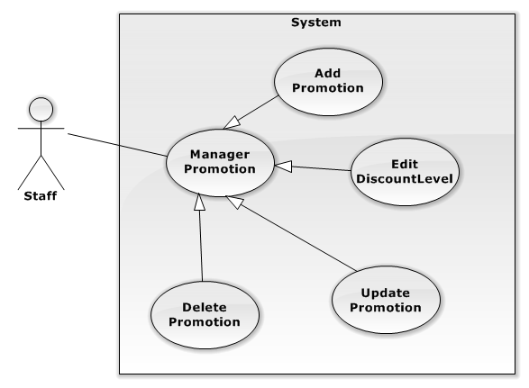

Figure 22: <Staff> Manage Promotion

###### **<Staff>Add Promotion**

**Use Case Diagram**

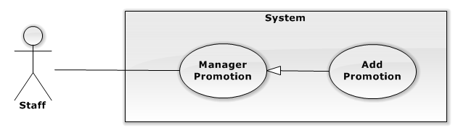

Figure 23: <Staff>Add Promotion

**Use Case Specification**

|  |  |  |  |
| --- | --- | --- | --- |
| **USE CASE ADD PROMOTION** | | | |
| **Use Case No.** | UC016 | **Use Case Version** | 1.0 |
| **Use Case Name** | Add Promotion | | |
| **Author** | Nguyễn Thị Ái Trinh | | |
| **Date** | 16/09/2014 | **Priority** | Normal |
| **Actor:**   * Staff   **Summary:**   * This use case is used to add a new promotion.   **Goal:**   * Staff can add a new promotion to system.   **Triggers:**   * Click “Quản lí Khuyến Mãi” menu * Click “Danh Sách Sự Kiện” submenu. * Click “Thêm Mới” button.   **Preconditions:**   * User must be logged in the system with Staff role.   **Post Conditions:**   * **Success:** New promotion is added to system successfully. * **Fail:** Can’t add new promotion and display error message.   **Main Success Scenario:**   |  |  |  | | --- | --- | --- | | Step | Actor Action | System Response | | 1 | Clicks on “Thêm Mới” button. | Display a new row on promotion table to add promotion:   * “Ngày bắt đầu khuyến mãi” : date time picker * “Ngày kết thúc khuyến mãi”: date time picker * “Phần trăm khuyến mãi”: textbox   [Only input number]   * Thao tác sửa : “Lưu” button * Thao tác xóa : “Hủy” button | | 3 | Fills form and clicks on “Lưu” button  [Alternative 1] | [Exception 1, 2, 3]  Create a new promotion in database  Display pop-up shows :   * Message “Đã tạo mới thành công” * Button : “Đóng” | | 4 | Clicks on “Đóng” button | Close popup |   **Alternative Scenario:**   |  |  |  | | --- | --- | --- | | No | Actor Action | System Response | | 1 | Clicks on “Hủy” button | Remove added row |   **Exceptions:**   |  |  |  | | --- | --- | --- | | No | Actor Action | System Response | | 1 | “Ngày kết thúc khuyến mãi” < “Ngày bắt đầu khuyến mãi” | Show popup:   * “Ngày kết thúc khuyến mãi không được trước ngày bắt đầu khuyến mãi” message. * “Đóng” button | | 2 | “Phần trăm giảm giá” < 0 or “Phần trăm giảm giá” >100 | Show popup:   * “Phần trăm giảm giá từ 0 tới 100” message * “Đóng” button | | 3 | Not input all fields | Show popup:   * “Vui lòng điền đầy đủ thông tin.” message * “Đóng” button |   **Relationships:** Manager Promotion  **Business Rules:**   * Start date of promotion must be equal or later than create date | | | |

Table 16: <Staff>Add Promotion

###### **<Staff>Update Promotion**

**Use Case Diagram**

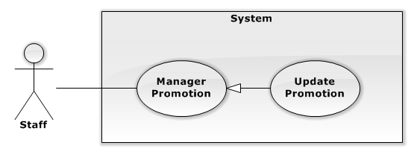

Figure 24: <Staff>Update Promotion

**Use Case Specification**

|  |  |  |  |
| --- | --- | --- | --- |
| **USE CASE UPDATE PROMOTION** | | | |
| **Use Case No.** | UC017 | **Use Case Version** | 1.0 |
| **Use Case Name** | Update Promotion | | |
| **Author** | Nguyễn Thị Ái Trinh | | |
| **Date** | 16/09/2014 | **Priority** | Normal |
| **Actor:**   * Staff   **Summary:**   * This use case is used to edit information of a promotion.   **Goal:**   * Staff can edit information of a promotion.   **Triggers:**   * Click “Quản lí Khuyến Mãi” menu. * Click “Danh Sách Sự Kiện” submenu * Click edit button of promotion row that he want to edit   **Preconditions:**   * User must be logged in the system with Staff role.   **Post Conditions:**   * **Success:** New information of promotion is updated * **Fail:** Cannot update information of promotion.   **Main Success Scenario:**   |  |  |  | | --- | --- | --- | | Step | Actor Action | System Response | | 1 | Clicks on edit button on the row of promotion he want to edit | Enable editing on that row:   * Ngày bắt đầu khuyến mãi : date time picker * Ngày kết thúc khuyến mãi: date time picker * Phần trăm khuyến mãi: textbox   [Only input number]   * Thao tác sửa : “Lưu” button * Thao tác xóa : “Hủy” button | | 3 | Edit information and clicks on “Lưu” button  [Alternative 1] | [Exception 1, 2, 3]  Update information of promotion  Show popup:   * “Đã cập nhập thành công” message * “Đóng” button | | 4 | Clicks on “Đóng” button | Close current popup |   **Alternative Scenario:**   |  |  |  | | --- | --- | --- | | No | Actor Action | System Response | | 1 | Clicks on “Hủy” button | Disable editing and cancel all changes. |   **Exceptions:**   |  |  |  | | --- | --- | --- | | No | Actor Action | System Response | | 1 | “Ngày kết thúc khuyến mãi” < “Ngày bắt đầu khuyến mãi” | Show popup:   * “Ngày kết thúc khuyến mãi không được trước ngày bắt đầu khuyến mãi” message. * “Đóng” button | | 2 | “Phần trăm giảm giá” < 0 or “Phần trăm giảm giá” >100 | Show popup:   * “Phần trăm giảm giá phải từ 0 tới 100” message * “Đóng” button | | 3 | Not input all fields | Show popup:   * “Vui lòng nhập đầy đủ thông tin.” message * “Đóng” button |   **Relationships:** Manager Promotion  **Business Rules:**   * Start date of promotion must be equal or later than create date. | | | |

Table 17: <Staff> Update Promotion

###### **<Staff>Delete Promotion**

**Use Case Diagram**

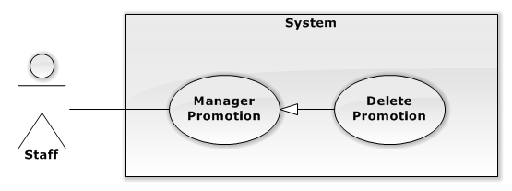

Figure 25: <Staff>Delete Promotion

**Use Case Specification**

|  |  |  |  |
| --- | --- | --- | --- |
| **USE CASE DELETE PROMOTION** | | | |
| **Use Case No.** | UC018 | **Use Case Version** | 1.0 |
| **Use Case Name** | Delete Promotion | | |
| **Author** | Nguyễn Thị Ái Trinh | | |
| **Date** | 16/09/2014 | **Priority** | Normal |
| **Actor:**   * Staff   **Summary:**   * This use case is used to remove promotion of system.   **Goal:**   * Staff can remove promotion of system   **Triggers:**   * Click “Quản lí Khuyến Mãi” menu. * Click “Danh sách sự kiện” submenu * Click on trash button.   **Preconditions:**   * User must be logged in the system with Staff role.   **Post Conditions:**   * **Success:** Promotion is removed from database * **Fail:** Cannot remove promotion and display error message.   **Main Success Scenario:**   |  |  |  | | --- | --- | --- | | Step | Actor Action | System Response | | 1 | Clicks on trash button of promotion that he want to remove | Show popup:   * “Bạn có chắc muốn xóa ” * “Có” button. * “Không” button” | | 2 | Click “Có” button  [Alternative 1] | Delete that promotion in database.  Show popup:   * “Đã xóa khuyến mãi thành công” message * “Đóng” button   [Exception 1] | | 3 | Click “Đóng” button | Close current popup. |   **Alternative Scenario:**   |  |  |  | | --- | --- | --- | | No | Actor Action | System Response | | 1 | Clicks on “Không” button | Close current popup |   **Exceptions:**   |  |  |  | | --- | --- | --- | | No | Actor Action | System Response | | 1 | Cannot remove promotion due to database connection | Display error message: “Không thể xóa khuyến mãi. Vui long thử lại sau.” |   **Relationships:** Manager Promotion  **Business Rules:**   * Promotion that is taking place should be considered before remove. To remove taking place promotion, staff has to drop promotion of all applied toys and toy instances before remove promotion. | | | |

Table 18: <Staff>Remove Promotion

###### **<Staff>Edit Discount Level**

**Use Case Diagram**

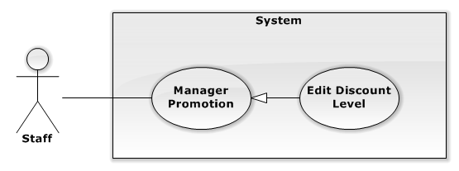

Figure 26: <Staff>Edit Discount Level

**Use Case Specification**

|  |  |  |  |
| --- | --- | --- | --- |
| **USE CASE EDIT DISCOUNT LEVEL** | | | |
| **Use Case No.** | UC019 | **Use Case Version** | 1.0 |
| **Use Case Name** | Edit Discount Level | | |
| **Author** | Nguyễn Thị Ái Trinh | | |
| **Date** | 16/09/2014 | **Priority** | Normal |
| **Actor:**   * Staff   **Summary:**   * This use case is used to edit information of discount for each plus point level   **Goal:**   * Staff can edit information of a discount level   **Triggers:**   * Click “Quản lí Khuyến Mãi” menu. * Click “Tỉ Lệ Khuyến Mãi” submenu.   **Preconditions:**   * User must be logged in the system with Staff role.   **Post Conditions:**   * **Success:** New information of discount level is updated. * **Fail:** Cannot update information of discount level   **Main Success Scenario:**   |  |  |  | | --- | --- | --- | | Step | Actor Action | System Response | | 1 | Clicks on edit button on the row of discount level that he want to edit | Enable editing on that row:   * Điểm tích lũy: textbox   [Only input number]   * Phần trăm khuyến mãi: textbox   [Only input number]   * Thao tác sửa : “Lưu” link * Thao tác xóa : “Hủy” : link | | 3 | Edit information and clicks on “Lưu” button  [Alternative 1] | [Exception 1, 2]  Update information to database  Show popup:   * “Đã cập nhập thành công” message * “Đóng” button | | 4 | Clicks on “Đóng” button | Close popup |   **Alternative Scenario:**   |  |  |  | | --- | --- | --- | | No | Actor Action | System Response | | 1 | Clicks on “Hủy” button | Disable editing and cancel all edited fields |   **Exceptions:**   |  |  |  | | --- | --- | --- | | No | Actor Action | System Response | | 1 | “Phần trăm giảm giá” < 0 or “Phần trăm giảm giá” >100 | Show popup:   * “Phần trăm giảm giá từ 0 tới 100” message * “Đóng” button | | 2 | Not input all fields | Show popup:   * “Vui lòng điền đầy đủ thông tin” message * “Đóng” button |   **Relationships:** Manager Promotion  **Business Rules:**   * Discount percent must be between 0 and 100 * Discount percent for each level point should be different * Higher point level should have higher discount percent | | | |

Table 19: <Staff>Edit Discount Level

##### **<Staff> View List Reservation**

**Use Case Diagram**

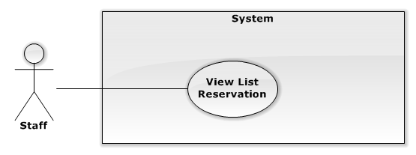

Figure 27: <Staff> View List Reservation

**Use Case Specification**

|  |  |  |  |  |
| --- | --- | --- | --- | --- |
| **USE CASE – VIEW LIST RESERVATION** | | | | |
| **Use-case No.** | UC020 | **Use-case Version** | | 2.0 |
| **Use-case Name** | View List Reservation | | | |
| **Author** | Nguyễn Thị Ái Trinh | | | |
| **Date** | 18/09/2014 | **Priority** | High | |
| **Actor:** Staff  **Summary:**   * This use case is used to view list of reservation of customer.   **Goal:**   * Allowed user view list reservation of store.   **Triggers:**   * Click “Quản lí Đặt Trước” menu.   **Preconditions:**   * User must be logged in the system with Staff role.   **Post Conditions:**   * **Success:** Load all list reservation successful. * **Fail:** Can’t load list reservation or system redirect to error page.   **Main Success Scenario:**   |  |  |  | | --- | --- | --- | | Step | Actor Action | System Response | | 1 | Clicks on “Quản lí đặt trước” menu. | Show table:  + Hiển thị: label  + Number of row : drop down list  + dòng 1 trang : label  +Tìm kiếm: label  +Result : textbox  +Table:   * Stt * Tên Khách Hàng * Thời gian gửi mail * Thời gian đặt hàng * Trạng thái   + Paging  [Exception : 1] |   **Alternative Scenario: N/A**  **Exceptions:**   |  |  |  | | --- | --- | --- | | No | Actor Action | System Response | | 1 |  | Can’t load list reservation  Or System redirent to error page |   **Relationships:** N/A  **Business Rules:**   * Staff only view list reservation. | | | | |

Table 20: <Staff> View List Reservation

##### **<Staff> Manage Categories**

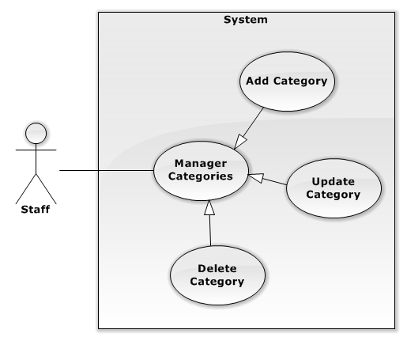

Figure 28: <Staff>Manage Categories

###### **<Staff> Add Category**

**Use Case Diagram**

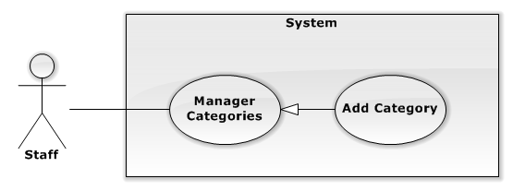

Figure 29: <Staff> Add Category

**Use Case Specification**

|  |  |  |  |
| --- | --- | --- | --- |
| **USE CASE ADD CATEGORY** | | | |
| **Use Case No.** | UC021 | **Use Case Version** | 1.0 |
| **Use Case Name** | Add Category | | |
| **Author** | Nguyễn Thị Ái Trinh | | |
| **Date** | 16/09/2014 | **Priority** | Normal |
| **Actor:** Staff  **Summary:**   * This use case is used to create a new toy category   **Goal:**   * Staff can add new category.   **Triggers:**   * Click “Quản lí Chủng Loại” menu. * Click “Thêm Mới” button.   **Preconditions:**   * User must be logged in the system with Staff role.   **Post Conditions:**   * **Success:** New category is added to system * **Fail:** Cannot add new category to system.   **Main Success Scenario:**   |  |  |  | | --- | --- | --- | | Step | Actor Action | System Response | | 1 | Clicks on “Thêm Mới” button. | Display a new row to add promotion:  Show a new row:   * Tên chủng loại : textbox * Thao tác sửa : “Lưu” button * Thao tác xóa : “Hủy” : button | | 3 | Fill forms and clicks on “Lưu” button  [Alternative 1] | Add new category to database  Display pop-up shows :   * Message “Đã tạo mới thành công” * Button : “Đóng”   [Exception 1] | | 4 | Clicks on “Đóng” button | Close popup |   **Alternative Scenario:**   |  |  |  | | --- | --- | --- | | No | Actor Action | System Response | | 1 | Clicks on “Hủy” button | Remove added row and cancel all changes |   **Exceptions:**   |  |  |  | | --- | --- | --- | | No | Actor Action | System Response | | 1 | Not input all fields | Show popup:   * “Vui lòng điền đầy đủ thông tin” message * “Đóng” button |   **Relationships:** Manager Categories  **Business Rules:**   * Staff shouldn’t add new category having same name with existed category | | | |

Table 21: <Staff>Add Category

###### **<Staff> Update Category**

**Use Case Diagram**

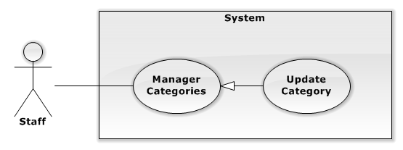

Figure 30: <Staff>Update Category

**Use Case Specification**

|  |  |  |  |
| --- | --- | --- | --- |
| **USE CASE UPDATE CATEGORY** | | | |
| **Use Case No.** | UC022 | **Use Case Version** | 1.0 |
| **Use Case Name** | Update Category | | |
| **Author** | Nguyễn Thị Ái Trinh | | |
| **Date** | 16/09/2014 | **Priority** | Normal |
| **Actor:** Staff  **Summary:**   * This use case is used to edit information of a category.   **Goal:**   * Staff can edit information of a category.   **Triggers:**   * Click “Quản lí Chủng Loại” menu. * Click on edit button   **Preconditions:**   * User must be logged in the system with Staff role.   **Post Conditions:**   * **Success:** New information of category is updated to database * **Fail:** Cannot update information of category   **Main Success Scenario:**   |  |  |  | | --- | --- | --- | | Step | Actor Action | System Response | | 1 | Clicks on edit button | Show all input in that row to edit information of that category:   * Tên chủng loại : textbox * Thao tác sửa : “Lưu” button * Thao tác xóa : “Hủy” : button | | 3 | Edit information and clicks on “Lưu” button  [Alternative 1] | Update information of category to database  Show popup:   * “Đã cập nhập thành công” message * “Đóng” button   [Exception 1] | | 4 | Clicks on “Đóng” button | Close popup |   **Alternative Scenario:**   |  |  |  | | --- | --- | --- | | No | Actor Action | System Response | | 1 | Clicks on “Hủy” button | Return table can’t edit |   **Exceptions:**   |  |  |  | | --- | --- | --- | | No | Actor Action | System Response | | 3 | Not input all fields | Show popup:   * “Vui lòng điền đầy đủ thông tin” message. * “Đóng” button. |   **Relationships:** Manager Category  **Business Rules:**   * Category name should be easy to understand and different from other categories | | | |

Table 22: <Staff>Update Category

###### **<Staff> Delete Categories**

**Use Case Diagram**

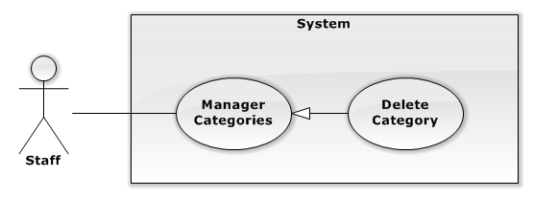

Figure 31: <Staff>Delete Category

**Use Case Specification**

|  |  |  |  |
| --- | --- | --- | --- |
| **USE CASE DELETE CATEGORY** | | | |
| **Use Case No.** | UC023 | **Use Case Version** | 1.0 |
| **Use Case Name** | Delete Category | | |
| **Author** | Nguyễn Thị Ái Trinh | | |
| **Date** | 16/09/2014 | **Priority** | Normal |
| **Actor:**   * Staff   **Summary:**   * This use case is used to remove toy category.   **Goal:**   * Staff can remove toy category of system   **Triggers:**   * Click “Quản lí Chủng Loại” menu. * Click trash button.   **Preconditions:**   * User must be logged in the system with Staff role.   **Post Conditions:**   * **Success:** Remove category successful. * **Fail:** Can’t remove category or system redirect to error page.   **Main Success Scenario:**   |  |  |  | | --- | --- | --- | | Step | Actor Action | System Response | | 1 | Clicks on trash button of category that he want to remove | Show popup:   * “Bạn có chắc muốn xóa chủng loại này?” * “Có” button. * “Không” button” | | 2 | Clicks on “Có” button  [Alternative 1] | Remove category from database  Show popup:   * “Đã xóa thành công” message * “Đóng” button   [Exception 1, 2] | | 3 | Clicks on “Đóng” button | Close current popup. |   **Alternative Scenario:**   |  |  |  | | --- | --- | --- | | No | Actor Action | System Response | | 1 | Clicks on “Không” button | Close current popup. |   **Exceptions:**   |  |  |  | | --- | --- | --- | | No | Actor Action | System Response | | 1 | Cannot remove category due to database connection | Display error message: “Không thể xóa chủng loại này. Vui lòng thử lại sau.” | | 2 | Cannot remove category because there are toys in that category | Display error message: “Hiện đang có sản phẩm thuộc chủng loại này. Vui lòng thay đổi chủng loại của các sản phẩm sang loại khác trước khi xóa chủng loại.” |   **Relationships:** Manager Categories  **Business Rules:**   * Category can only be remove when there is no toys belong to that category | | | |

Table 23: <Staff>Delete Category

##### **<Customer>Overview Use Case**

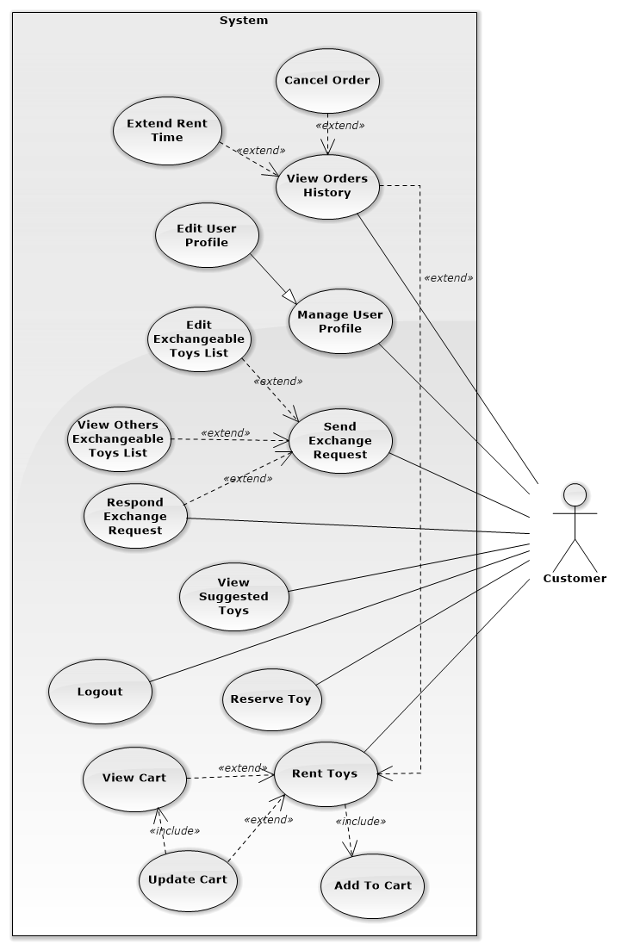

Figure 32: <Customer>Overview Use Case

##### **<Customer>View Suggested Toys**

**Use Case Diagram**

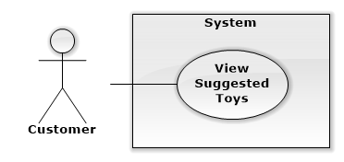

Figure 33: <Customer>View Suggested Toys

**Use Case Specification**

|  |  |  |  |
| --- | --- | --- | --- |
| **USE CASE VIEW SUGGESTED TOYS** | | | |
| **Use Case No.** | UC024 | **Use Case Version** | 1.0 |
| **Use Case Name** | View Suggested Toys | | |
| **Author** | Nguyễn Ngọc Tường Vy | | |
| **Date** | 13/09/2014 | **Priority** | High |
| **Actor:**   * Customer   **Summary:**   * This use case allows customer to view all appropriate toys that is suggested to him/her.   **Goal:**   * All suitable toys can be suggested and displayed to customer base on his/her children’s information and his/her orders   **Triggers:**   * From the menu bar:   + Choose “Gợi ý sản phẩm” menu.   **Preconditions:**   * User must log in the system with customer role. * Customer wants to view suggested toys.   **Post Conditions:**   * **Success:** Appropriate toys is selected and displayed to customer. * **Fail:** Cannot load suggested toys list.   **Main Success Scenario:**   |  |  |  | | --- | --- | --- | | Step | Actor Action | System Response | | 1 | Clicks on “Gợi ý sản phẩm” menu | Display suggest result includes:   * Child information:   + child gender: textview   + child age: textview   + child hobbies: tags * Suggested toys list for child:   + Product name: link to product page   + Product image: image   + Product rent price: textview * Suggest toys list by customer’s order history:   + Product name: link to product page   + Product image: image   + Product rent price: textview   [Alternative 1, 2] [Exception 1] | |  |  |  |   **Alternative Scenario:**   |  |  |  | | --- | --- | --- | | No | Actor Action | System Response | | 1 | Clicks on “Gợi ý sản phẩm” menu, with no suggest for orders | Display suggest result includes:   * Child information:   + child gender: textview   + child age: textview   + child hobbies: tags * Suggested toys list for child:   + Product name: link to product page   + Product image: image   + Product rent price: textview * “Không thể gợi ý sản phẩm vì có quá ít thông tin thuê hàng” message | | 2 | Clicks on “Gợi ý sản phẩm” menu, with no child to suggest | Display suggest result includes:   * “Vui lòng thêm thông tin của trẻ để được gợi ý sản phẩm phù hợp” message * Suggest toys list by customer’s order history:   + Product name: link to product page   + Product image: image   + Product rent price: textview |   **Exceptions:**   |  |  |  | | --- | --- | --- | | No | Actor Action | System Response | | 1 | Cannot view suggested toys. | Display error message: “Không thể tải danh sách gợi ý. Vui lòng thử lại sau” |   **Relationships:** N/A  **Business Rules:**   * Suggested products for child is based on child age, gender and hobbies * Suggested products for each child is displayed in each group, and display only top 5 products. To view more suggested products for that child, customer can click on “Xem tất cả” button of that group. * List of products suggested for child is sorted by order of most matched number of hobbies. * Suggested toys based on similar customer’s order is display in one group, and display only top 5 products. To view more suggested products by orders, customer can click on “Xem tất cả” button of that group. * List of products suggested by customer’s orders is sorted by order of highest rank point of recommendation algorithms * Each product is display with product name, one image, and rental prices. Customer can view more product details by clicking on that product. | | | |

Table 24: <Customer>View Suggested Toys

##### **<Customer>Rent Toys**

**Use Case Diagram**

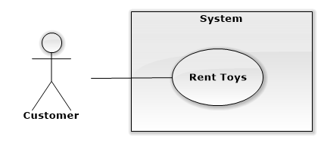

Figure 34: <Customer>Rent Toys

**Use Case Specification**

|  |  |  |  |
| --- | --- | --- | --- |
| **USE CASE RENT TOYS** | | | |
| **Use Case No.** | UC025 | **Use Case Version** | 1.0 |
| **Use Case Name** | Rent Toys | | |
| **Author** | Nguyễn Thị Ái Trinh | | |
| **Date** | 15/09/2014 | **Priority** | High |
| **Actor:**   * Customer   **Summary:**   * This use case allows customer to process checkout cart.   **Goal:**   * Customer can checkout to process rent toys.   **Triggers:**   * Click “Thanh toán” button in view cart page   **Preconditions:**   * User must log in the system with customer role. * Customer’s cart must have at least 1 product in cart.   **Post Conditions:**   * **Success:** Checkout success and order is saved in database * **Fail:** Cannot save order to database.   **Main Success Scenario:**   |  |  |  | | --- | --- | --- | | Step | Actor Action | System Response | | 1 | Click “Thanh toán” button | Display checkout popup with 3 steps | | 2 | Select payment online method, edit delivery information and confirm order details.  Clicks on “Thuê” button.  [Alternative 1] | Show popup :   * “Đơn hàng đã được xác nhận. Bạn có muốn thanh toán ngay bây giờ” message * “Paypal” button * “Thoát” button   [Exception 1] | | 3 | Clicks “Paypal” button [Alternative 2] | Redirect PayPal page | | 4 | Process payment in PayPal page and return to home page | Update status of order in database  Show popup:  -“Bạn Đã Thanh Toán Online Thành Công” message  - “OK” button  [Exception 2] | | 5 | Clicks on “OK” button | Close current popup |   **Alternative Scenario:**   |  |  |  | | --- | --- | --- | | No | Actor Action | System Response | | 1 | Select payment cost on delivery method, edit delivery information and confirm order details.  Clicks on “Thuê” button. | Show popup   * “Đã tiến hành thuê thành công” message * “Ok” button   [Exception: 1] | | 2 | Click “Đóng” button | Close button and redirect to home page |   **Exceptions:**   |  |  |  | | --- | --- | --- | | No | Actor Action | System Response | | 1 | Cannot save order to database | Display error message “Không thể tiến hành xác nhận thuê hàng. Vui lòng thử lại.” | | 2 | Process payment in PayPal occur error | Show popup:   * “Thanh toán online không thành công” message * “Ok” button |   **Relationships:** N/A  **Business Rules:**   * Customer can only checkout products that are available in stock. If after added to cart, products is rented by other customer. This customer will be notify when checkout. Customer will select to reserve that toy or not. * Customer has one next day to do payment if selected online payment method or the order will be canceled. Customer will be notified each time he logged into the system. After finished payment, order’s status will be change to delivering. * With order that selected to be paid on delivering, customer has one next day to cancel order. After that day, order’s status will be changed to delivering and customer cannot cancel by himseft, he has to contact with staff to cancel order if it hasn’t been delivered | | | |

Table 25: <Customer>Rent Toys

##### **<Customer>Add To Cart**

**Use Case Diagram**

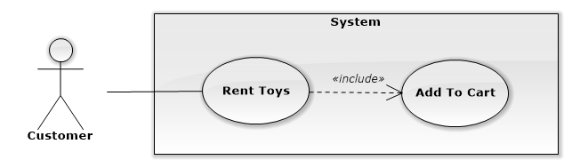

Figure 35: <Customer>Add To Cart

**Use Case Specification**

|  |  |  |  |
| --- | --- | --- | --- |
| **USE CASE ADD TO CART** | | | |
| **Use Case No.** | UC026 | **Use Case Version** | 1.0 |
| **Use Case Name** | Add To Cart | | |
| **Author** | Nguyễn Thị Ái Trinh | | |
| **Date** | 15/09/2014 | **Priority** | High |
| **Actor:**   * Customer, Guest   **Summary:**   * This use case allows customer to add toys that he/she want to rent to cart.   **Goal:**   * Customer can add toy to cart.   **Triggers:**   * Click “Thuê” button in Profuct detail page or popup rent toy   **Preconditions:**   * Selected toy is available for rent.   **Post Conditions:**   * **Success:** Selected toy is added to customer’s cart. * **Fail:** Cannot selected toy to cart.   **Main Success Scenario:**   |  |  |  | | --- | --- | --- | | Step | Actor Action | System Response | | 1 | Select rent time and rent amount.  Clicks on “Thuê” button. | Add selected product to cart.  Show popup:   * “Đã Thêm Vào Giỏ Hàng ” message * “OK” button   [Exception 1, 2, 3, 4, 5] | | 2 | Clicks on “OK” button | Close current popup |   **Alternative Scenario:**  N/A  **Exceptions:**   |  |  |  | | --- | --- | --- | | No | Actor Action | System Response | | 1 | RentToDate < RentFromDate | Error message “Ngày trả không được nhỏ hơn ngày bắt đầu thuê” | | 2 | RenToDate < MinRentedDate | Error message “Số ngày thuê tối thiểu là …” | | 3 | Amount > number available in store | Error message “Chỉ còn… sản phẩm này trong kho” | | 4 | Not input all fields | Error message “Vui lòng chọn thời gian và số lượng để thuê” | | 5 | Cannot add product to cart | Display error message “Thêm vàm giỏ hàng không thành công. Vui lòng thử lại.” |   **Relationships:** Rent Toys  **Business Rules:**   * Only available product can be addted to cart. * If product have promotion, promotion item will be added to cart first * Earliest start rent date is 2 days after order date * Lastest start rent date is specified for each product * Each product have minimum rent time that customer has to rent at least these number of days * Customer can rent same product with different dates by adding that product to cart many time with different selected date. * Rent price is calculate by getting rent time multiply with rent price. | | | |

Table 26: <Customer>Add To Cart

##### **<Customer>View Cart**

**Use Case Diagram**

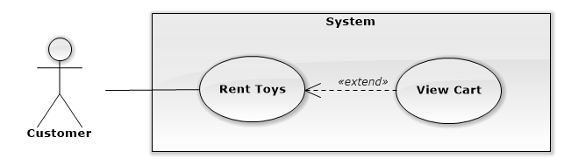

Figure 36: <Customer>View Cart

**Use Case Specification**

|  |  |  |  |
| --- | --- | --- | --- |
| **USE CASE VIEW CART** | | | |
| **Use Case No.** | UC027 | **Use Case Version** | 1.0 |
| **Use Case Name** | View Cart | | |
| **Author** | Nguyễn Thị Ái Trinh | | |
| **Date** | 15/09/2014 | **Priority** | Normal |
| **Actor:**   * Customer, Guest   **Summary:**   * This use case allows customer to view his/her cart.   **Goal:**   * Customer can review his/her cart before process checkout or to edit cart.   **Triggers:**   * Customer wants to view cart. * Customer clicks “Giỏ hàng” link.   **Preconditions:** N/A  **Post Conditions:**   * **Success:** Customer’s cart is displayed to customer. * **Fail:** Cannot display customer’s cart.   **Main Success Scenario:**   |  |  |  | | --- | --- | --- | | Step | Actor Action | System Response | | 1 | Clicks on “Giỏ hàng” button | Display cart with all added products. [Alternative 1] [Exception 1] |   **Alternative Scenario:**   |  |  |  | | --- | --- | --- | | No | Actor Action | System Response | | 1 | Clicks on “Giỏ hàng” button | Display “Giỏ hàng chưa có sản phẩm nào.” |   **Exceptions:**   |  |  |  | | --- | --- | --- | | No | Actor Action | System Response | | 1 | Cannot view cart. | Display error message “Không thể tải giỏ hàng, vui lòng thử lại.” |   **Relationships:** Rent Toys  **Business Rules:**   * Added toys is listed in table with main product’s information and renting information. * Customer can view and update renting information of each added product. * Same product with different rent time or different promotion will be displayed in different rows. | | | |

Table 27: <Customer>View Cart

##### **<Customer>Update Cart**

**Use Case Diagram**

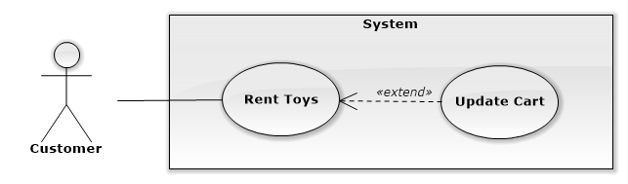

Figure 37: <Customer>Update Cart

**Use Case Specification**

|  |  |  |  |
| --- | --- | --- | --- |
| **USE CASE UPDATE CART** | | | |
| **Use Case No.** | UC028 | **Use Case Version** | 1.0 |
| **Use Case Name** | Update Cart | | |
| **Author** | Nguyễn Thị Ái Trinh | | |
| **Date** | 15/09/2014 | **Priority** | Normal |
| **Actor:**   * Customer, Guest   **Summary:**   * This use case allows customer to update cart.   **Goal:**   * Customer can update his/her cart.   **Triggers:**   * Customer clicks “Giỏ hàng” button. * Edit renting information * Click “Cập Nhập” button in cart page   **Preconditions:** N/A  **Post Conditions:**   * **Success:** Cart’s products and renting information are updated. * **Fail:** Cannot update cart’s products and renting information.   **Main Success Scenario:**   |  |  |  | | --- | --- | --- | | Step | Actor Action | System Response | | 1 | Clicks on “Giỏ hàng” button | Display cart with all added products. | | 2 | Edit renting information and click “Cập nhật ” button | Update and reload cart to display edited cart to customer [Exception 1, 2] |   **Alternative Scenario:** N/A  **Exceptions:**   |  |  |  | | --- | --- | --- | | No | Actor Action | System Response | | 1 | Insert invalid information when edit cart and click “Cập nhập” button | Display warning messages at invalid fields. | | 2 | Cannot update cart. | Display error message “Không thể cập nhật giỏ hàng. Vui lòng thử lại.” |   **Relationships:** Rent Toys  **Business Rules:**   * Added toys is listed in table with main product’s information and renting information. * Earliest start rent date is 2 days after order date * Lastest start rent date is specified for each product * Each product have minimum rent time that customer has to rent at least these number of days * Rent amount must be larger than 0 | | | |

Table 28: <Customer>Update Cart

##### **<Customer>Respond Exchange Request**

**Use Case Diagram**

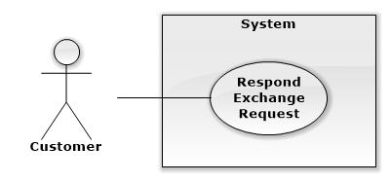

Figure 38: <Customer>Respond Exchange Request

**Use Case Specification**

|  |  |  |  |
| --- | --- | --- | --- |
| **USE CASE RESPOND EXCHANGE REQUEST** | | | |
| **Use Case No.** | UC029 | **Use Case Version** | 1.0 |
| **Use Case Name** | Respond Exchange Request | | |
| **Author** | Nguyễn Ngọc Tường Vy | | |
| **Date** | 15/09/2014 | **Priority** | High |
| **Actor:**   * Customer   **Summary:**   * This use case allows customer to respond receive exchange request   **Goal:**   * Customer can respond to receive exchange request   **Triggers:**   * Click “Yêu cầu trao đổi” submenu * Click “Yêu cầu trao đổi gửi đến tôi” tab   **Preconditions:**   * User must log in the system with Customer role. * Customer must have at least one exchange request.   **Post Conditions:**   * **Success:** Exchange’s status is changed to “confirmed”. * **Fail:** Cannot update exchange’s status.   **Main Success Scenario:**   |  |  |  | | --- | --- | --- | | Step | Actor Action | System Response | | 1 | Clicks “Chi tiết” button on the row of exchange request he want to respond | Display request’s details includes:   * Sender product information:   + Product name: label   + Product image: image   + Rent price: textview   + Rent time: textview   + New return date: text view * Receiver product information:   + Product name: label   + Product image: image   + Rent price: textview   + Rent time: textview   + Return soon: checkbox   + New return date: datepicker * Payment details:   + Product name: textview   + Deposit: textview   + Return soon fee: textview   + Return back money: textview   + Total payment: textview * “Đồng ý” button * “Từ chối” button | | 2 | Select new return date | Update payment details | | 3 | Clicks on “Đồng ý” button [Alternative 1] | Display message to confirm: “Bạn có chắc chắn muốn trao đổi không?” | | 4 | Clicks “Có” button [Alternative 2] | Update exchange’s status to “confirmed”.  Display success message “Yêu cầu trao đổi đã được xác nhận đồng ý”.  [Exception 1] |   **Alternative Scenario:**   |  |  |  | | --- | --- | --- | | No | Actor Action | System Response | | 1 | Clicks “Từ chối” button  Clicks “Có” button [Alternative 2] | Display message to confirm: “Bạn có chắc chắn muốn từ chối trao đổi không?”  Update exchange’s status to “denied”.  Display success message “Yêu cầu trao đổi đã được từ chối”.  [Exception 1] | | 2 | Clicks “Không” button | Close pop up and do nothing |   **Exceptions:**   |  |  |  | | --- | --- | --- | | No | Actor Action | System Response | | 1 | Cannot update exchange’s status. | Display error message: “Không thể phản hồi yêu cầu trao đổi. Vui lòng thử lại.” |   **Relationships:** Send Exchange Request  **Business Rules:**   * Customer can select new return date for exchange toy when confirm exchange. But customer has to pay return soon fee, which is 20% of rent price of return soon time. * Earliest return soon date is 2 days latter than resond date * Customer has 1 day to respond exchange request after request is sent. After that time, if request is confirmed, exchange’s status is changed to delivering. And staff will handle and assign shipper to process exchange. * If after 1 day, customer hasn’t respond the request, it will be canceled. * If sender of request canceled that request, receiver cannot respond to request. | | | |

Table 29: <Customer>Respond Exchange Request

##### **<Customer>View Others Exchangeable Toys List**

**Use Case Diagram**

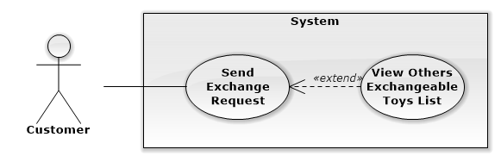

Figure 39: <Customer> View Others Exchangeable Toys List

**Use Case Specification**

|  |  |  |  |
| --- | --- | --- | --- |
| **USE CASE VIEW OTHERS EXCHANGEABLE TOYS LIST** | | | |
| **Use Case No.** | UC030 | **Use Case Version** | 1.0 |
| **Use Case Name** | View Others Exchangeable Toys List | | |
| **Author** | Nguyễn Ngọc Tường Vy | | |
| **Date** | 15/09/2014 | **Priority** | Normal |
| **Actor:**   * Customer   **Summary:**   * This use case allows customer to view exchangeable toys list of other customers.   **Goal:**   * Customer can view all exchangeable toys of other customers.   **Triggers:**   * From the top menu:   + Choose “Trao đổi sản phẩm” menu.   + Choose “Sản phẩm trao đổi của mọi người” submenu.   **Preconditions:**   * User must log in the system with Customer role. * Customer wants to view other exchangeable toys.   **Post Conditions:**   * **Success:** Exchangeable toys list is loaded and displayed to customer. * **Fail:** Cannot load and display exchangeable toys list.   **Main Success Scenario:**   |  |  |  | | --- | --- | --- | | Step | Actor Action | System Response | | 1 | Clicks on “Danh sách đồ chơi có thể trao đổi” submenu | Display all exchangeable toys list of other customer includes:   * Product information * “Trao đổi” button   [Alternative 1][Exception 1] |   **Alternative Scenario:**   |  |  |  | | --- | --- | --- | | No | Actor Action | System Response | | 1 | Clicks on “Danh sách đồ chơi có thể trao đổi” submenu | Display message: “Không có sản phẩm trao đổi nào” |   **Exceptions:**   |  |  |  | | --- | --- | --- | | No | Actor Action | System Response | | 1 | Cannot view others’ exchangeable toys list | Display error message: “Không thể tải danh sách đồ chơi. Vui lòng thử lại sau.” |   **Relationships:** Send Exchange Request  **Business Rules:**   * Toys list is sorted by “add to exchangeable” date * On each toy in list, if current customer hasn’t sent exchange request to this toy, “Trao đổi” button will be enable to send exchange request. If exchange request has been sent, this button is disble. | | | |

Table 30: <Customer>View Others Exchangeable Toys List

##### **<Customer>Edit Exchangeable Toys List**

**Use Case Diagram**

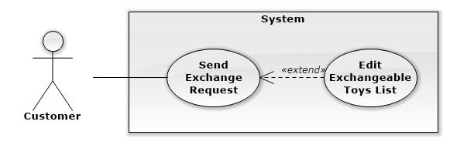

Figure 40: <Customer>Edit Exchangeable Toys List

**Use Case Specification**

|  |  |  |  |
| --- | --- | --- | --- |
| **USE CASE EDIT EXCHANGEABLE TOYS LIST** | | | |
| **Use Case No.** | UC031 | **Use Case Version** | 1.0 |
| **Use Case Name** | Edit Exchangeable Toys List | | |
| **Author** | Nguyễn Ngọc Tường Vy | | |
| **Date** | 15/09/2014 | **Priority** | Normal |
| **Actor:**   * Customer   **Summary:**   * This use case allows customer to edit his/her exchangeable toys list.   **Goal:**   * Customer can add or remove toys in his/her exchangeable toys list.   **Triggers:**   * From the top menu:   + Choose “Trao đổi sản phẩm” menu.   + Choose “Sản phẩm trao đổi của tôi” submenu   **Preconditions:**   * User must log in the system with customer role. * Customer wants to edit his/her exchangeable toys list.   **Post Conditions:**   * **Success:** Exchangeable toys list updated. * **Fail:** Cannot update exchangeable toys list.   **Main Success Scenario:**   |  |  |  | | --- | --- | --- | | Step | Actor Action | System Response | | 1 | Clicks on “Sản phẩm trao đổi của tôi” submenu | Display customer’s exchangeable page includes:   * Exchangeable toys list:   + Product information   + “Hủy bỏ” button * “Thêm sản phẩm” button | | 2 | Clicks on “Hủy bỏ” button [Alternative 1] | Display warning message to confirm:   * “Bạn có chắc muốn xóa sản phẩm này khỏi danh sách trao đổi?” message * “Có” button * “Không” button | | 3 | Clicks on “Có” button [Alternative 2] | Remove toy from list. Display updated list to customer [Exception 1] |   **Alternative Scenario:**   |  |  |  | | --- | --- | --- | | No | Actor Action | System Response | | 1 | Clicks on “Thêm sản phẩm” button  Select toys to add to list and click “Thêm vào trao đổi” button  Clicks on “Có” button [Alternative 2] | Display popup to select toys with renting toys list, includes:   * Product information * “Thêm vào trao đổi” button   Display warning message to confirm: “Bạn có chắc muốn thêm sản phẩm này vào danh sách trao đổi?”  Add toys to list. Display updated list to customer [Exception 1] | | 2 | Clicks on “Không” button | Close popup and do nothing |   **Exceptions:**   |  |  |  | | --- | --- | --- | | No | Actor Action | System Response | | 1 | Cannot update toys list due to database connection | Display error message: “Không thể cập nhật danh sách đồ chơi. Vui lòng thử lại sau.” |   **Relationships:** Send Exchange Request  **Business Rules:**   * Toys list is sorted by “add to exchangeable” date * Only renting product, which rent time is still not overdue and is not in exchange process with other customer can be added to exchangeable list * When product is returned, or rent time is overdue, or it is exchanged with other customer, this product will be removed from exchange list automatically | | | |

Table 31: <Customer>Edit Exchangeable Toys List

##### **<Customer>Send Exchange Request**

**Use Case Diagram**

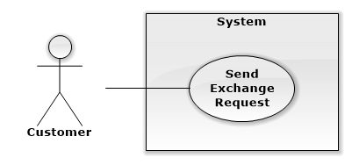

Figure 41: <Customer>Send Exchange Request

**Use Case Specification**

|  |  |  |  |
| --- | --- | --- | --- |
| **USE CASE SEND EXCHANGE REQUEST** | | | |
| **Use Case No.** | UC032 | **Use Case Version** | 1.0 |
| **Use Case Name** | Send Exchange Request | | |
| **Author** | Nguyễn Ngọc Tường Vy | | |
| **Date** | 15/09/2014 | **Priority** | High |
| **Actor:**   * Customer   **Summary:**   * This use case allows customer to send exchange request to other customer.   **Goal:**   * Customer can send request to other customer.   **Triggers:**   * Click “trao đổi” button on the row of product he want to exchange   **Preconditions:**   * User must log in the system with customer role. * Customer wants to send request to other customer. * Customer selected a product to exchange   **Post Conditions:**   * **Success:** Exchange request is saved to database * **Fail:** Cannot save exchange request.   **Main Success Scenario:**   |  |  |  | | --- | --- | --- | | Step | Actor Action | System Response | | 1 | Clicks on “Trao đổi” button on selected product’s row. | Display form to send exchange request with 3 steps.  First step includes select customer’s product to exchange with selected product | | 2 | Selects product to exchange and clicks on “Chọn” button.  [Alternative 1] | Update product’s state as selected  [Exception 1] | | 3 | Click “Kế tiếp” button  [Alternative 1] | Display second step, select new return date for receive toy. | | 4 | Select new return date [Alternative 1, 2] | Display return soon fee | | 5 | Click “Kế tiếp” button  [Alternative 1] | Display step 3, confirm exchange details | | 6 | Clicks on “Gửi yêu cầu” button  [Alternative 1] | Save exchange request to database.  Display success message: “Yêu cầu trao đổi đã được ghi nhận và gửi“  [Exception 2] |   **Alternative Scenario:**   |  |  |  | | --- | --- | --- | | No | Actor Action | System Response | | 1 | Click on close popup button | Close popup and cancel send exchange request process | | 2 | Not select new return date | Do nothing |   **Exceptions:**   |  |  |  | | --- | --- | --- | | No | Actor Action | System Response | | 1 | Select product that is used to send exchange request to 3 other products that are waiting to confirm | Display error message “Sản phẩm này đã được sử dụng để gửi tối đa số yêu cầu trao đổi. Vui lòng chờ phản hồi.” | | 2 | Cannot save and send requeset. | Display error message: “Không thể gửi yêu cầu trao đổi. Vui lòng thử lại sau.” |   **Relationships:** Exchange Toys  **Business Rules:**   * Customer can only send exchange request to product that he hasn’t sent request before. * Product to exchange with selected product is selected from customer’s exchangeable list. Customer can also add renting product to exchangeable list at step 1 by click on “Thêm sản phẩm” button. * If customer select new return date for receive product, customer has to pay return soon fee, which is 20% of rent price of return soon time. * Payment amount when exchange includes different of deposit of 2 exchange products, and return soon fee (if have), and return back money if receiver also return toy soon. * Earliest return soon date is 3 days after send request time. * After sent exchange request, customer has 1 day to cancel request if he don’t want to exchange anymore. | | | |

Table 32: <Customer>Send Exchange Request

##### **<Customer>Manager User Profile**

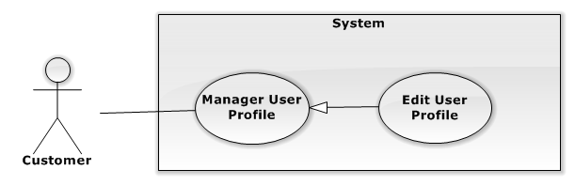

Figure 42: <Customer> Manage User Profile

###### **<Customer>Edit User Profile**

**Use Case Diagram**



Figure 43: <Customer>Edit User Profile

**Use Case Specification**

|  |  |  |  |
| --- | --- | --- | --- |
| **USE CASE EDIT USER PROFILE** | | | |
| **Use Case No.** | UC033 | **Use Case Version** | 1.0 |
| **Use Case Name** | Edit User Profile | | |
| **Author** | Nguyễn Thị Ái Trinh | | |
| **Date** | 15/09/2014 | **Priority** | Normal |
| **Actor:** Customer  **Summary:**   * This use case allow customer to edit his profile information.   **Goal:**   * Customer can change his profile information   **Triggers:**   * Click on “Thông Tin Cá Nhân” menu. * Click on “Sửa Thông Tin” tab.   **Preconditions:**   * User must be logged in the system with customer role.   **Post Conditions:**   * **Success:** Profile of account is updated successful. * **Fail:** Not changing or system redirect to error page.   **Main Success Scenario:**   |  |  |  | | --- | --- | --- | | Step | Actor Action | System Response | | 1 | Clicks on “ Sửa Thông Tin” tab | Show Edit Profile tab, contains:  Thông tin cá nhân: label   * Tên :Text box. * Ngày Sinh : date time picker * Email: Textbox (match regular expression: ^([\w\.])+@([\w])+\.(\w){2,6}(\.([\w]){2,4})*$, required) * Số điện thoại: Textbox (min length:10, max length:11, required) * Số nhà: Textbox * Phường : Textbox   [Only input number]   * Quận: drop down list * Thành phố : textbox   “Cập nhật”: button  “Hủy” : Button | | 2 | Edits information.  Clicks “ Cập nhật” button | [Exception 1, 2]  Update user’s information and reload page  [Exception 3] |   **Alternative Scenario:** N/A  **Exceptions:**   |  |  |  | | --- | --- | --- | | No | Actor Action | System Response | | 1 | “Số điện thoại” length is not in range [10,11] | Show error message “Số điện thoại phải từ 10 đến 11 chữ số” | | 2 | Not input full fill form | Show error message “Vui lòng điền đầy đủ thông tin” | | 3 | Cannot update user’s information | Display error message “Không thể cập nhật thông tin. Vui lòng thử lại sau.” |   **Relationships:** Manager User Profile.  **Business Rules:**   * Information of user’s profile will be use to contact with customer and set as default delivery information. | | | |

Table 33: <Customer>Edit User Profile

##### **<Customer>View Orders History**

**Use Case Diagram**

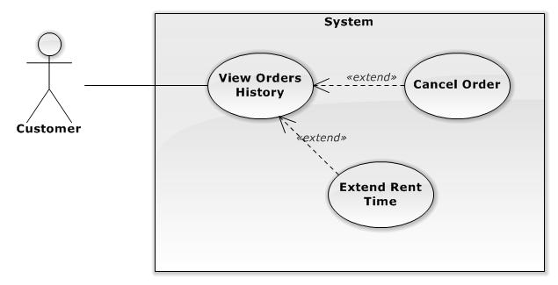

Figure 44: <Customer>View Order History

**Use Case Specification**

|  |  |  |  |
| --- | --- | --- | --- |
| **USE CASE VIEW ORDERS HISTORY** | | | |
| **Use Case No.** | UC034 | **Use Case Version** | 2.0 |
| **Use Case Name** | View Order History | | |
| **Author** | Nguyễn Thị Ái Trinh | | |
| **Date** | 15/09/2014 | **Priority** | Normal |
| **Actor:** Customer  **Summary:**   * This use case is used to view history of customer orders   **Goal:**   * Customer can view all orders he has rented.   **Triggers:**   * Customer click on “Lịch sử đơn hàng” menu.   **Preconditions:**   * User must be logged in the system with Customer role.   **Post Conditions:**   * **Success:** Customer can view all his orders. * **Fail:**  System redirect to error page.   **Main Success Scenario:**   |  |  |  | | --- | --- | --- | | Step | Actor Action | System Response | | 1 | Clicks on “Lịch Sử Đơn Hàng” menu. | Show List Order:   * Đơn hàng * Mã số * Ngày tạo đơn hàng * Trạng thái   [Exception 1] | |  | Clicks on order to view detail | A table with 4 columns:   * STT: label * Tên sản phẩm: label * Ngày thuê: label * Ngày trả: label * Giá thuê: label * Đặt cọc: label * Trạng thái   “Tổng tiền thuê”: label |   **Alternative Scenario:** N/A  **Exceptions:**   |  |  |  | | --- | --- | --- | | No | Actor Action | System Response | | 1 | Clicks on “Lịch Sử Đơn Hàng” menu. | Display message “Hiện tại không có đơn hàng nào” |   **Relationships:** N/A  **Business Rules:**   * All order of current customer will be loaded and sorted by newest order time * Customer can view detail of order and cancel order or change return date of order. * If order is not delivered, “Hủy” button will be displayed for customer to cancel order. * If product is delivered, “Trả sớm” and “Thuê thêm” button will be displayed for customer to change return date. * If product’s rent time is overdue, “Trả sớm” button will not be displayed. | | | |

Table 34: <Customer>View Order History

##### **<Customer>Extend Rent Time**

**Use Case Diagram**

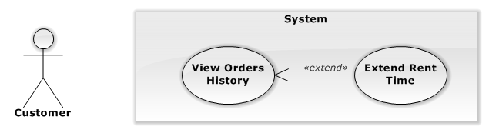

Figure 45: <Customer>Extend Rent Time

**Use Case Specification**

|  |  |  |  |
| --- | --- | --- | --- |
| **USE CASE EXTEND RENT TIME** | | | |
| **Use Case No.** | UC035 | **Use Case Version** | 1.0 |
| **Use Case Name** | Extend Rent Time | | |
| **Author** | Nguyễn Thị Ái Trinh | | |
| **Date** | 13/09/2014 | **Priority** | Normal |
| **Actor:**   * Customer   **Summary:**   * This use case is used to extend rent time for renting product   **Goal:**   * Allowed user extend time to rent product.   **Triggers:**   * Customer click to “Lịch Sử đơn hàng” menu. * Choose order that have toy want to extend rent time * Click “Thuê Thêm” button of toy that user want to extend time.   **Preconditions:**   * User must be logged in the system with customer role. * There is at least one renting product   **Post Conditions:**   * **Success:** New return date is updated for that rented product * **Fail:** Cannot update new return date.   **Main Success Scenario:**   |  |  |  | | --- | --- | --- | | Step | Actor Action | System Response | | 1 | Clicks on “ Thuê thêm” button | Show information, contains:   * Ngày thuê: label * Ngày trả : date time picker * Tiền đặt cọc: label * Giá theo ngày: label * Giá theo tuần: label * Giá theo tháng: label * Tổng tiền trả: label   “Xác nhận”: button  “Trở lại” : button | | 2 | Clicks on “Xác Nhận” button  [Alternative 1] | Update new return date to database  Show popup:   * “Thuê thêm thành công” message * “OK” button   [Exception 1] | | 3 | Clicks on “OK” button | Close current popup |   **Alternative Scenario:**   |  |  |  | | --- | --- | --- | | No | Actor Action | System Response | | 1 | Clicks on “Trở Lại” button | Close current popup |   **Exceptions:**   |  |  |  | | --- | --- | --- | | No | Actor Action | System Response | | 1 | Cannot update new return date | Display error message: “Không thể cập nhật ngày trả mới. Vui lòng thử lại sau.” |   **Relationships:** N/A  **Business Rules:**   * When product is delivered and is being rent, customer can assign new return date to extend rent time. * If customer extend rent time when rent time is still remain, surcharge is calculated by old price, as the price customer has rent as the beginning * If customer extend rent time when rent timr is overdue, surcharge is calculated by new price, as current rent price of that product in system. * Surcharge will be paid when customer return product to store. | | | |

Table 35: <Customer>Extend Rent Time

##### **<Customer>Cancel Order**

**Use Case Diagram**

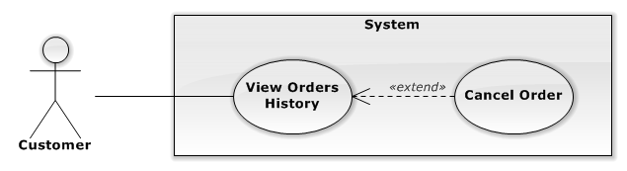

Figure 46: <Customer>Cancel Order

**Use Case Specification**

|  |  |  |  |
| --- | --- | --- | --- |
| **USE CASE CANCEL ORDER** | | | |
| **Use Case No.** | UC036 | **Use Case Version** | 1.0 |
| **Use Case Name** | Cancel Order | | |
| **Author** | Nguyễn Thị Ái Trinh | | |
| **Date** | 15/09/2014 | **Priority** | Normal |
| **Actor:**   * Customer   **Summary:**   * This use case is used to cancel order that customer don’t want to rent   **Goal:**   * Customer can cancel order that he has made.   **Triggers:**   * Customer click to “Lịch Sử đơn hàng” menu. * Click “Hủy Đơn Hàng” button   **Preconditions:**   * User must be logged in the system with customer role. * Customer has made at least 1 order   **Post Conditions:**   * **Success:** Customer cancel order successfully. * **Fail:** Cannot update status of order to cancel   **Main Success Scenario:**   |  |  |  | | --- | --- | --- | | Step | Actor Action | System Response | | 1 | Clicks on “ Hủy Đơn Hàng” button on details of order he want to cancel | Display message “Bạn có chắc muốn hủy đơn hàng này”   * “Có”: button * “Không” : button | | 2 | Clicks on “Có” button  [Alternative 1] | Update status of order to cancel  Display pop-up “Đơn hàng đã bị hủy”.  “OK” button  [Exception 1] | | 3 | Clicks on “OK” button | Close current popup |   **Alternative Scenario:**   |  |  |  | | --- | --- | --- | | No | Actor Action | System Response | | 1 | Clicks on “Không” button | Close current popup and do nothing |   **Exceptions:**   |  |  |  | | --- | --- | --- | | No | Actor Action | System Response | | 1 | Cannot update status of order | Display error message “Không thể hủy đơn hàng. Vui lòng thử lại sau.” |   **Relationships:** N/A  **Business Rules:**   * If order’s payment method is cost on delivering, customer only have 1 day from order time to cancel order. After that time, order’s status is changed to delivering, and customer has to contact with staff to cancel order if he want. * If order’s payment method is online payment, if customer hasn’t finished payment in 1 day from order time, order will be canceled automatically. If customer has finished payment, customer cannot cancel order by himseft, he has to contact to staff to cancel order if he want, so staff can process return money back to customer. | | | |

Table 36: <Customer>Cancel Order

##### **<Customer> Reserve Toy**

**Use Case Diagram**

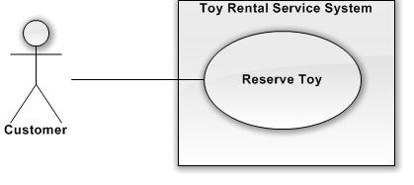

Figure 47: <Customer> Reserve Toy

**Use Case Specification**

|  |  |  |  |  |
| --- | --- | --- | --- | --- |
| **USE CASE – RESERVE TOY** | | | | |
| **Use-case No.** | UC037 | **Use-case Version** | | 2.0 |
| **Use-case Name** | Reserve Toy | | | |
| **Author** | Hồ Quang Hưng | | | |
| **Date** | 18/09/2014 | **Priority** | Normal | |
| **Actor:**   * Customer   **Summary:**   * Customer want to reserve the toy that was temporarily out of stock.   **Goal:**   * Help customer reserve toy was temporarity out of stock.   **Triggers:**   * On the [Home Page], [Category Page], [Search Page],[Detail Page] customer clicks “Đặt trước” button.   **Preconditions:**   * User must be logged in the system with customer role   **Post Conditions:**   * **Success**: Reservation is saved in database * **Fail:** Cannot save reservation   **Main Success Scenario:**   |  |  |  | | --- | --- | --- | | Step | Actor Action | System Response | | 1 | Customer clicks “Đặt trước” button on [Home Page], [Category Page], [Search Page], [Detail Page] | Display message “Bạn chắc chắn muốn đặt trước sản phẩm này?”  [Exception 1,2] | | 2 | Customer clicks “Có” button.  [Alternative 1] | Save reservation to database  Display message “Bạn đã đặt trước thành công!” |   **Alternative Scenario:**   |  |  |  | | --- | --- | --- | | No | Actor Action | System Response | | 1 | Clicks “Không” button. | Close the popup and do nothing |   **Exceptions:**   |  |  |  | | --- | --- | --- | | No | Actor Action | System Response | | 1 | User not login into the website. | Display message “Bạn phải đăng nhập để thực hiện chức năng này!” on screen. | | 2 | Customer has reserved this toy | Display message “Bạn đã đặt trước sản phẩm này!” |   **Relationships:** N/A  **Business Rules**:   * Customer can only reserve toy one time. After reserved toy and then rented toy when toy is available. Customer can reserve toy again. * When reserve toy, reserve time is saved and used as renting priority of customers who rent this toy when thoy is available | | | | |

Table 37: <Customer> Reserve Toy

##### **<System>Overview Use Case**

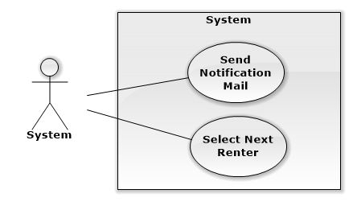

Figure 48: <System>Overview Use Case

##### **<System>Select Next Renter**

**Use Case Diagram**

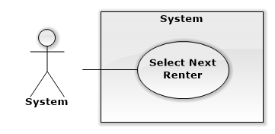

Figure 49: <System>Select Next Renter

**Use Case Specification**

|  |  |  |  |
| --- | --- | --- | --- |
| **USE CASE VIEW SUGGESTED TOYS** | | | |
| **Use Case No.** | UC038 | **Use Case Version** | 1.0 |
| **Use Case Name** | Select Next Renter | | |
| **Author** | Nguyễn Ngọc Tường Vy | | |
| **Date** | 16/09/2014 | **Priority** | Normal |
| **Actor:**   * System   **Summary:**   * When toy is available, system sent mail to notify customers in reservation list. After 24 hours for ordering, system will select next customer that can rent toy from toy-reserved customer list.   **Goal:**   * System can select the next customer who can rent toy.   **Triggers:**   * Run at 0:00 daily   **Preconditions:**   * 24 hours after sent notification mails to reserved customers.   **Post Conditions:**   * **Success:** Next renter can be selected. * **Fail:** Cannot select next renter.   **Main Success Scenario:**   |  |  |  | | --- | --- | --- | | Step | Actor Action | System Response | | 1 | Server check customers’ order and select next renter based on priority in reservation group | Send notify mail to selected customer and other customers [Exception 1] |   **Alternative Scenario:** N/A  **Exceptions:**   |  |  |  | | --- | --- | --- | | No | Actor Action | System Response | | 1 | Cannot send notify mail or notification | Log error message |   **Relationships:** N/A  **Business Rules:**   * At 0:00 daily, system will check which reservation group has been sent mail 24 hours before and process selecting next renter. * Selected customer is the one who has earliest reserve time in reservation group and has made order of this product in 24 hours after available product notification mail is sent | | | |

Table 38: <Customer>View Suggested Toys

##### **<System>Send Notification Mail**

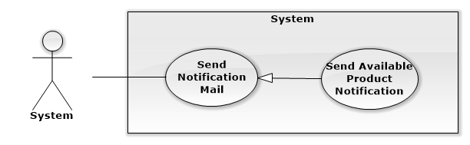

Figure 50: <System> Send Notitication Mail

###### **<System>Send Available Product Notification**

**Use Case Diagram**

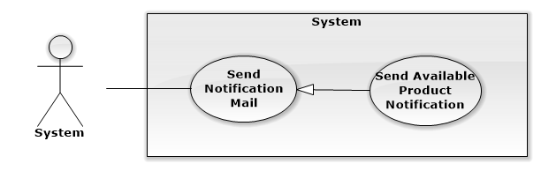

Figure 51: <System>Send Available Product Notification

**Use Case Specification**

|  |  |  |  |
| --- | --- | --- | --- |
| **USE CASE SEND AVAILABLE PRODUCT NOTIFICATION** | | | |
| **Use Case No.** | UC039 | **Use Case Version** | 1.0 |
| **Use Case Name** | Send Available Product Notification | | |
| **Author** | Nguyễn Ngọc Tường Vy | | |
| **Date** | 17/09/2014 | **Priority** | Normal |
| **Actor:**   * System   **Summary:**   * When product is available, system will auto send mail to notify customer who reserved that product.   **Goal:**   * System can send mail to all reserved customer   **Triggers:**   * Run at 0:00 daily   **Preconditions:**   * Reserved product is now available   **Post Conditions:**   * **Success:** Notification mail is sent to all reserved customer * **Fail:** Customers don’t receive notification mail.   **Main Success Scenario:**   |  |  |  | | --- | --- | --- | | Step | Actor Action | System Response | | 1 | Server select all products that just available and have reserving customer | Send mail to customers to notify product is available  [Exception 1] |   **Alternative Scenario:**  **Exceptions:**   |  |  |  | | --- | --- | --- | | No | Actor Action | System Response | | 1 | Cannot send notify mail or notification | Log error message |   **Relationships:** Send Notification Mail  **Business Rules:**   * Only send mail to customer who reserved product and hasn’t receive that product (reservation status is still waiting) | | | |

Table 39: <System>Send Expire Date Remind Mail

##### **<Admin>Overview Use Case**

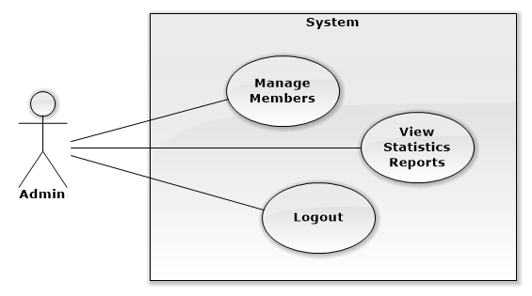

Figure 52: <Admin> Overview Use Case

##### **<Admin> View Statistics Reports**

**Use Case Diagram**

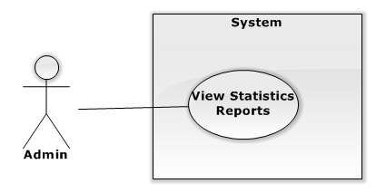

Figure 53: <Admin> View Statistics Reports

**Use Case Specification**

|  |  |  |  |
| --- | --- | --- | --- |
| **USE CASE VIEW STATISTIC REPORT** | | | |
| **Use Case No.** | UC040 | **Use Case Version** | 1.0 |
| **Use Case Name** | View Statistics Reports | | |
| **Author** | Nguyễn Ngọc Tường Vy | | |
| **Date** | 16/09/2014 | **Priority** | Normal |
| **Actor:**   * Admin   **Summary:**   * This use case allow admin to view statistic report of store   **Goal:**   * Admin can view statistic report of store   **Triggers:**   * Click to “Báo cáo thống kê” menu   **Preconditions:**   * User must be logged in the system with Admin role.   **Post Conditions:**   * **Success:** Statistics reports is displayed * **Fail:** Statistic reports is not displayed.   **Main Success Scenario:**   |  |  |  | | --- | --- | --- | | Step | Actor Action | System Response | | 1 | Clicks on “Báo cáo thống kê” link | Show Statistics Reports Page with report by days, months and compare business of 2 years [Exception 1] |   **Alternative Scenario:** N/A  **Exceptions:**   |  |  |  | | --- | --- | --- | | No | Actor Action | System Response | | 1 | Cannot load statistic report | Display error message: “Không thể tải báo cáo thống kê” |   **Relationships:** N/A  **Business Rules:**   * Statistic report can be view by date, month or compare 2 year business. | | | |

Table 40: <Admin> View Statistics Reports.

##### **<Admin> Manage Members**

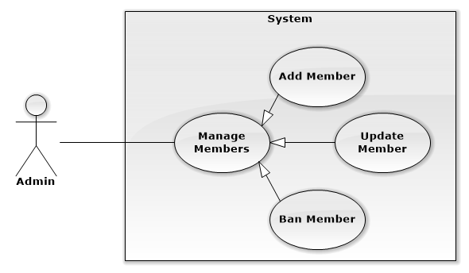

Figure 54: <Admin> Manage Members

###### **< Admin > Add Member**

**Use Case Diagram**

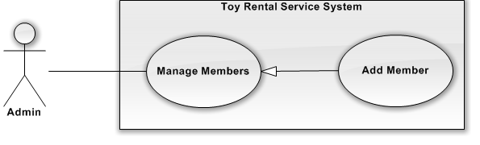

Figure 55: <Admin> Add Member

**Use Case Specification**

|  |  |  |  |  |
| --- | --- | --- | --- | --- |
| **USE CASE – ADD MEMBER** | | | | |
| **Use-case No.** | UC041 | **Use-case Version** | | 2.0 |
| **Use-case Name** | Add Member | | | |
| **Author** | Hồ Quang Hưng | | | |
| **Date** | 18/09/2014 | **Priority** | Normal | |
| **Actor:**   * Admin   **Summary:**   * This use case allows user add new staff.   **Goal:**   * Admin can create new account for staff.   **Triggers:**   * Click “Quản Lý Thành Viên” in menu. * Click “Quản Lý nhân viên” submenu. * Click “Thêm mới nhân viên” button.   **Preconditions:**   * User must log in the system with Admin role.   **Post Conditions:**   * **Success:** **:** New staff account is created * **Fail:** No staff account is created   **Main Success Scenario:**   |  |  |  | | --- | --- | --- | | Step | Actor Action | System Response | | 1 | Clicks “Thêm mới nhân viên” button | Show popup includes:   * Họ và tên: Textbox (length [6, 30]) * Địa chỉ Email: Textbox   In format: /^(\w+[\.])*\w+@@(\w+\.)+[a-zA-Z]+$/   * Mật khẩu: Password Filed (length [8, 20]) * Xác nhận mật khẩu: Password Field (length [8, 20]) * Ngày sinh: Date time picker * Quận: Dropdown list * Số nhà/ đường: Textbox * Số điện thoại: Textbox (length[10, 11])   In format: /^[0-9]*$/   * Tạo mới: button * Đóng: button | | 3 | Fill information and click on the “Tạo mới tài khoản” button.  [Alternative 1] | [Exceptions 1,2 3,4,5,6,7]  Display message “Đã tạo mới tài khoản nhân viên thành công!” |   **Alternative Scenario:**   |  |  |  | | --- | --- | --- | | No. | Actor Action | System Response | | 1 | Click “Đóng” button. | Close popup and do nothing |   **Exceptions:**   |  |  |  | | --- | --- | --- | | No. | Actor Action | System Response | | 1 | Incomplete information in multiple data fileds. Include “Họ và tên”, “Địa chỉ email”, “Mật khẩu”, “Xác nhận mật khẩu”, “Ngày sinh”, “Địa chỉ”. | Display error message:” Vui lòng nhập đầy đủ thông tin yêu cầu!” | | 2 | Email is already exists. | Display error message:”Email này đã được sử dụng để đăng ký thành viên!” | | 3 | Password is less than 8 or more than 32 characters characters. | Display error message “Yêu cầu mật khẩu từ 8-32 kí tự!” | | 4 | Password and re-password different | Display error message” Mật khẩu nhập lại chưa chính xác!” | | 5 | Cannot create new account due to database connection. | Display error message “Đã xảy ra lỗi trong quá trình đăng ký, vui lòng thử lại!” | | 6 | Phone Number is not a number or less than 10 numbers or greater than 11 numbers. | Display error message “Số điện thoại không hợp lệ!” | | 7 | Full Name is less than 6 characters or greater than 50 characters. | Display error message “Vui lòng nhập tên từ 6 đến 50 ký tự!” |   **Relationships:** Manage Member  **Business Rules:**   * Admin can only create account for staff, can’t create account for customer. * Email is unique in system. | | | | |

Table 41: <Admin> Add Member

###### **< Admin > Update Member**

**Use Case Diagram**

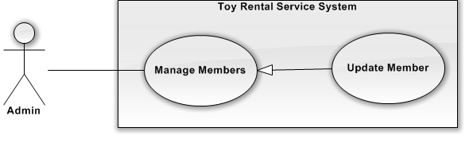

Figure 56: <Admin> Update Member

**Use Case Specification**

|  |  |  |  |  |
| --- | --- | --- | --- | --- |
| **USE CASE – UPDATE MEMBER** | | | | |
| **Use-case No.** | UC042 | **Use-case Version** | | 2.0 |
| **Use-case Name** | Update Member | | | |
| **Author** | Hồ Quang Hưng | | | |
| **Date** | 18/09/2014 | **Priority** | Normal | |
| **Actor:**   * Admin   **Summary:**   * This use case allowes user update information of staff.   **Goal:**   * Admin can update information of staff.   **Triggers:**   * Click “Quản Lý Thành Viên” in menu. * Click “Quản Lý nhân viên” submenu. * Clicks “Cập nhật” button on “Thao tác” column of staff account row.   **Preconditions:**   * User must login into system with Admin role   **Post Conditions:**   * **Success**: Information of member is updated successfully. * **Fail:** Cannot update account information.   **Main Success Scenario:**   |  |  |  | | --- | --- | --- | | Step | Actor Action | System Response | | 1 | Click “Cập nhật” button on “Thao tác” column of row of selected staff account | The pop up “Cập nhật thông tin tài khoản” is displayed on screen. Account form includes:   * Họ và tên: Textbox (min length: 6, max length: 50) * Địa chỉ Email: Textbox   In format: /^(\w+[\.])*\w+@@(\w+\.)+[a-zA-Z]+$/   * Ngày sinh: Datetimepicker * Quận: Dropdownlist * Số nhà/ đường: Textbox * Số điện thoại: Textbox (min length: 10, max length: 11)   In format: /^[0-9]*$/   * Lưu thay đổi: button * Đóng: button | | 3 | Click “Lưu thay đổi” button.  [Alternative 1] | Update new information to database.  Show message “Cập nhật thành công!”  [Exceptions 1, 2, 3, 4] |   **Alternative Scenario:**   |  |  |  | | --- | --- | --- | | No. | Actor Action | System Response | | 1 | Click “Đóng” button. | Close popup and do nothing |   **Exceptions:**   |  |  |  | | --- | --- | --- | | No. | Actor Action | System Response | | 1 | Incomplete information in multiple data fileds. Include “Họ và tên”, “Địa chỉ email”, “Mật khẩu”, “Xác nhận mật khẩu”, “Ngày sinh”, “Địa chỉ”. | Display error message:” Vui lòng nhập đầy đủ thông tin yêu cầu!” | | 2 | Cannot create new account due to database connection. | Display error message “Đã xảy ra lỗi trong quá trình đăng ký, vui lòng thử lại các bước trên!” | | 3 | Phone Number is not a number or less than 10 numbers or greater than 11 numbers. | Display error message “Số điện thoại không hợp lệ!” | | 4 | Full Name is less than 6 characters or greater than 50 characters. | Display error message “Vui lòng nhập tên từ 6 đến 50 ký tự!” |   **Relationships:** Manage Member.  **Business Rules:**   * Email and password of member cannot be updated by admin | | | | |

Table 42: <Admin> Update Member

###### **< Admin > Ban Member**

**Use Case Diagram**

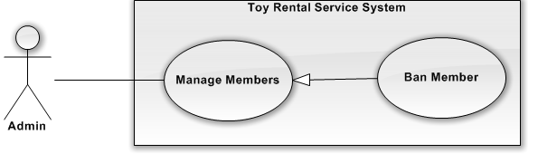

Figure 57: <Admin> Ban Member

**Use Case Specification**

|  |  |  |  |  |
| --- | --- | --- | --- | --- |
| **USE CASE – BAN MEMBER** | | | | |
| **Use-case No.** | UC043 | **Use-case Version** | | 2.0 |
| **Use-case Name** | Ban Member | | | |
| **Author** | Hồ Quang Hưng | | | |
| **Date** | 18/09/2014 | **Priority** | Normal | |
| **Actor:**   * Admin   **Summary:**   * This use case allowes admin to ban account of member   **Goal:**   * Admin can ban account of member   **Triggers:**   * Click “Quản Lý Thành Viên” in menu. * Click “Quản Lý nhân viên” or “Quản lý khách hàng” submenu. * Clicks “Khóa tài khoản” button on “Thao tác” column of row of selected account.   **Preconditions:**   * Admin can ban account of member   **Post Conditions:**   * **Success**: Account is banned successfully. * **Fail:** Cannot ban account   **Main Success Scenario:**   |  |  |  | | --- | --- | --- | | Step | Actor Action | System Response | | 1 | Click “Khóa tài khoản” button on “Thao tác” column of row of selected account | Show confirm popup with message “Bạn muốn khóa tài khoản này?” | | 2 | Click “Có” button on screen.  [Alternative 1] | Show successful message “Khóa tài khoản thành công!” on screen.  [Exception 1] |   **Alternative Scenario:**   |  |  |  | | --- | --- | --- | | No. | Actor Action | System Response | | 1 | Click “Không” button. | Close popup and do nothing |   **Exceptions:**   |  |  |  | | --- | --- | --- | | No. | Actor Action | System Response | | 1 | Cannot ban account due to database connection | Show error message: “Không thể khóa tài khoản. Vui lòng thử lại sau.” |   **Relationships:** Manage Member  **Business Rules:**   * Admin can ban account of member. After that, admin can re-active this account if he want. * Banned account cannot login into system anymore | | | | |

Table 43: <Admin> Ban Member

##### **<General user>Overview Use Case**

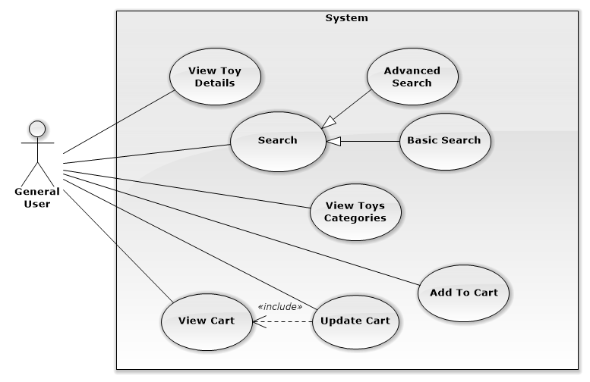

Figure 58: <General User>Overview Use Case

##### **<General User>View Toy Details**

**Use Case Diagram**

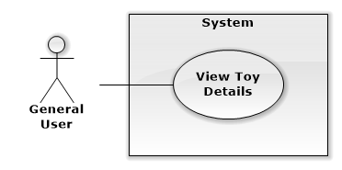

Figure 59: <General user>View Toy Details

**Use Case Specification**

|  |  |  |  |
| --- | --- | --- | --- |
| **USE CASE VIEW TOY DETAILS** | | | |
| **Use Case No.** | UC044 | **Use Case Version** | 1.0 |
| **Use Case Name** | View Toy Details | | |
| **Author** | Nguyễn Ngọc Tường Vy | | |
| **Date** | 13/09/2014 | **Priority** | Normal |
| **Actor:**   * General User   **Summary:**   * This use case allow user to view details of product.   **Goal:**   * User can view details of product.   **Triggers:**   * Click on product link   **Preconditions:**   * There is product’s information in current page   **Post Conditions:**   * **Success:** Details of product is displayed. * **Fail:** Cannot display details of product   **Main Success Scenario:**   |  |  |  | | --- | --- | --- | | Step | Actor Action | System Response | | 1 | User clicks product link (product name or product image) | Display product details includes:   * Details of product: * Product name: label * Product images: image * Deposit: textview * Rent price: textview * Other detail includes manufacturer, origin, dimensions, short description, appropriate sex, age and hobbies * RentFromDate: datepicker * RentToDate: datepicker * Amount: input * “Thuê” : button * Suggest same category products: product list * Suggest who rent this product often rent: product list   [Exception 1] |   **Alternative Scenario:** N/A  **Exceptions:**   |  |  |  | | --- | --- | --- | | No | Actor Action | System Response | | 1 | Cannot load product details | Redirect to error Page. |   **Relationships:** N/A  **Business Rules:**   * Product’s information is displayed clearly for customer to view * Suggested products list is displayed to support customer selected other similar product when they are interested in current product | | | |

Table 44: <Guest> View Toy Details

##### **<General User> Search**

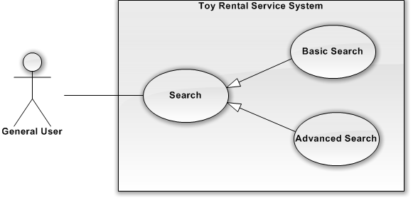

Figure 60: <General User> Search

###### **<General User> Basic Search**

**Use Case Diagram**

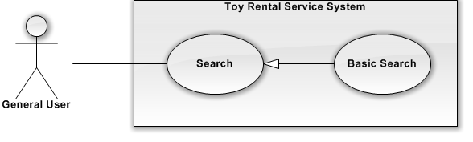

Figure 61: <General User> Basic Search

**Use Case Specification**

|  |  |  |  |  |
| --- | --- | --- | --- | --- |
| **USE CASE – BASIC SEARCH** | | | | |
| **Use-case No.** | UC045 | **Use-case Version** | | 2.0 |
| **Use-case Name** | Basic Search | | | |
| **Author** | Hồ Quang Hưng | | | |
| **Date** | 18/09/2014 | **Priority** | Normal | |
| **Actor:**   * General User   **Summary:**   * User can searches by toy name, category name, origin and manufacture of product .   **Goal:**   * User can find appropriate product quickly by toy name, category name, origin and manufacture.   **Triggers:**   * Input keyword (Toy name, Category Name, Origin or Manufacture) * Click “Tìm kiếm” button.   **Preconditions:**   * User has keyword to search   **Post Conditions:**   * **Success** : Show list of search result. * **Fail:** Cannot search toys   **Main Success Scenario:**   |  |  |  | | --- | --- | --- | | Step | Actor Action | System Response | | 1 | Input keyword(Toy Name, Category Name, Origin, Manufacture) into search textbox  Click “Tìm kiếm” button. | Show suitable products list [Alternative 1] |   **Alternative Scenario:**   |  |  |  | | --- | --- | --- | | No. | Actor Action | System Response | | 1 | No search result was found | Display message “Không tìm thấy sản phẩm phù hợp” |   **Exceptions:**   |  |  |  | | --- | --- | --- | | No. | Actor Action | System Response | | 1 | User don’t input keyword into search textbox.  Click “Tìm kiếm” button | The system do not search and do not show results for user. |   **Relationships:** Search  **Business Rules:**   * System only search when user has inputted keyword. * System will serach free text by product name, category name, origin and manufacture. | | | | |

Table 45: <General User>Basic Search

###### **<General User> Advanced Search**

**Use Case Diagram**

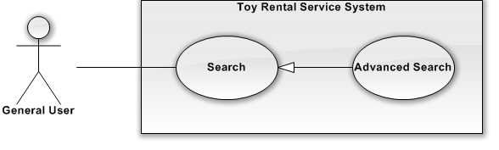

Figure 62: <General User> Advanced Search

**Use Case Specification**

|  |  |  |  |  |
| --- | --- | --- | --- | --- |
| **USE CASE – ADVANSED SEARCH** | | | | |
| **Use-case No.** | UC046 | **Use-case Version** | | 2.0 |
| **Use-case Name** | Advanced Search | | | |
| **Author** | Hồ Quang Hưng | | | |
| **Date** | 18/09/2014 | **Priority** | Normal | |
| **Actor:**   * General User   **Summary:**   * This usecase allows user search toys more correctly by keyword, category name, rental price folow day, gender, age, hobby name, origin, manufacture of toy.   **Goal:**   * Help user can find appropriate toy a way quickly, more accurate.   **Triggers:**   * Enter in keyword in search textbox * Click “Tìm Kiếm” button.   **Preconditions:**   * The Search Page loaded is successfully. * The user need to provide search information in the search fileds, depending on search purpose of user.   **Post Conditions:**   * **Success** : The system will show list of appropriate toys. * **Fail:** Cannot search and display   **Main Success Scenario:**   |  |  |  | | --- | --- | --- | | Step | Actor Action | System Response | | 1 | Click “Tìm Kiếm” button | Show search page, include:  Search Form:   * Từ khóa: Textbox (Keyword of advanced saerch, optional) * Danh mục: Checkbox (Name of category, optional) * Giá thuê/1 ngày: Slider range(Rents for one day, required) * Giới tính: Checkbox (Gender of child, optional) * Độ tuổi: Slider range (Age of child, required) * Sở thích: Checkbox (Hobby of child, optional) * Xuất sứ: Droplist (Origin of toy, optional) * Nhà sản xuất: Droplist (Manufacture of toy, optional)   Search result: list of toys | | 1 | Input search fields  Click “Tìm kiếm” button on Search Page | Show results of toy that suitable with search critia.  [Alternative 1][Exceptions 1] |   **Alternative Scenario:**   |  |  |  | | --- | --- | --- | | No. | Actor Action | System Response | | 1 | No appropriate toys for search critia | Display message “Không có sản phẩm phù hợp” |   **Exceptions:**   |  |  |  | | --- | --- | --- | | No. | Actor Action | System Response | | 1 | Cannot do advanced search due to database connection | Display error message “Không thể tìm kiếm sản phẩm” |   **Relationships:** Search  **Business Rules:**   * System will do search with all field that user selected, suiable products wil be showed in list. | | | | |

Table 46: <General User> Advanced Search

##### **<General User> View Toy Categories**

**Use Case Diagram**

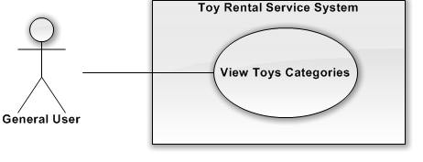

Figure 63: <General User>View Toys Categories

**Use Case Specification**

|  |  |  |  |  |
| --- | --- | --- | --- | --- |
| **USE CASE – VIEW TOY CATEGORIES** | | | | |
| **Use-case No.** | UC047 | **Use-case Version** | | 2.0 |
| **Use-case Name** | View Toy Categories | | | |
| **Author** | Hồ Quang Hưng | | | |
| **Date** | 18/09/2014 | **Priority** | High | |
| **Actor:**   * General User   **Summary:**   * The use case allowes user can view all toy that in the same category.   **Goal:**   * User can view toys in same category that they want to focus.   **Triggers:**   * Click on “Sản phẩm cho thuê” and choose category name.   **Preconditions:**   * N/A   **Post Conditions:**   * **Success**: The system redirect to Category Page and show list of toys in that category. * **Fail:** Cannot load list of toys   **Main Success Scenario:**   |  |  |  | | --- | --- | --- | | Step | Actor Action | System Response | | 1 | Click on category name link at top menu  [Alternative 1] | Redirect to Category Page and show list of toys in that category.  [Alternative 2][Exceptions 1] |   **Alternative Scenario:**   |  |  |  | | --- | --- | --- | | No | Actor Action | System Response | | 1 | Clicks on link of category name on left categories menu | Redirect to Category Page and show list of toys in that category.  [Alternative 2][Exceptions 1] | | 2 | No product to display | Redirect to Category Page and display message “Không có sản phẩm nào thuộc chủng loại này” |   **Exceptions:**   |  |  |  | | --- | --- | --- | | No | Actor Action | System Response | | 1 | Cannot load products list | Display error message: “Không thể tải danh sách sản phẩm” |   **Relationships:** N/A  **Business Rules:**   * All toy in selected category will be displayed in list. * List of toy will be sorted in order of added time. | | | | |

Table 47: <General User>View Toys Categories

##### **<Customer, Staff, Admin> Logout**

**Use Case Diagram**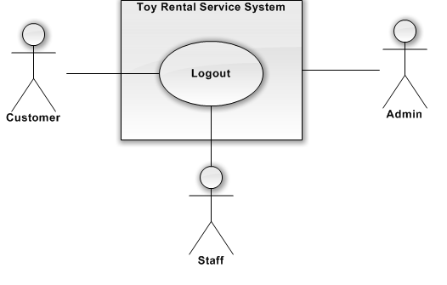

Figure 64: <Customer, Admin, Staff>Logout

**Use Case Specification**

|  |  |  |  |  |
| --- | --- | --- | --- | --- |
| **USE CASE – LOGOUT** | | | | |
| **Use-case No.** | UC048 | **Use-case Version** | | 2.0 |
| **Use-case Name** | Logout | | | |
| **Author** | Hồ Quang Hưng | | | |
| **Date** | 18/09/2014 | **Priority** | Normal | |
| **Actor:**  Customer, Staff, Admin.  **Summary:**   * This use case allowes user to log out of current account.   **Goal:**   * User can log out of current account   **Triggers:**   * On the Curent Page, click “Đăng xuất” button .   **Preconditions:**   * User logged into the system.   **Post Conditions:**   * **Success**: Log out successfully and redirect to [Home Page]**.** * **Fail**: Cannot logout   **Main Success Scenario:**   |  |  |  | | --- | --- | --- | |  | Actor Action | System Response | | 1 | Click on “Đăng xuất” button.  [Alternative 1] | Redirect to Home Page.  [Exception 1] |   **Alternative Scenario:**   |  |  |  | | --- | --- | --- | |  | Actor Action | System Response | | 1 | Don’t use the website 30 minutes. | The account will be automatically log out. |   **Exceptions:**   |  |  |  | | --- | --- | --- | | No | Actor Action | System Response | | 1 | Cannot logout | Redirect to Home Page |   **Relationships:** N/A  **Business Rules:**   * If user don’t’ use the website in 30 minutes, session will be expired and user will be auto logout | | | | |

Table 48: <Customer, Admin, Staff>Logout

##### **<Guest>Overview Use Case**

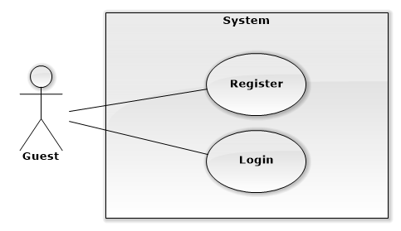

Figure 65: <Guest>Overview Use Case

##### **<Guest> Register**

**Use Case Diagram**

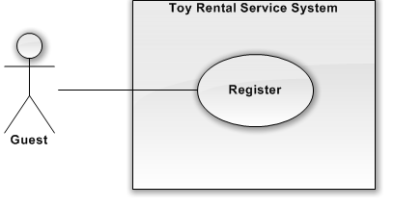

Figure 66: <Guest>Register

**Use Case Specification**

|  |  |  |  |  |
| --- | --- | --- | --- | --- |
| **USE CASE – REGISTER** | | | | |
| **Use-case No.** | UC049 | **Use-case Version** | | 2.0 |
| **Use-case Name** | Register | | | |
| **Author** | Hồ Quang Hưng | | | |
| **Date** | 18/09/2014 | **Priority** | Normal | |
| **Actor:**   * Guest   **Summary:**   * This use case allows guest create account to use advanced functions of CTS system.   **Goal:**   * Help guest to create new account.   **Trigger:**   * Click “Đăng ký” button.   **Pre-conditions:**   * User want to create new account   **Post conditions:**   * **Success**: The new account will be added into database. * **Failure**: Cannot create account. System displays error message on register page.   **Main Success Scenario:**   |  |  |  | | --- | --- | --- | | Step | Actor Action | System Response | | 1 | Click “Đăng ký” button | System redirect to [Register Page], contain a register form :   * Họ và tên: Textbox (min length: 6, max length: 50) * Địa chỉ Email: Textbox   In format: /^(\w+[\.])*\w+@@(\w+\.)+[a-zA-Z]+$/   * Mật khẩu: Password Filed (min length: 8, max length: 20) * Xác nhận mật khẩu: Password Field (min length: 8, max length: 20) * Ngày sinh: Date time picker * Quận: Dropdownlist * Phường: Textbox * Số nhà/ đường: Textbox * Số điện thoại: Textbox (min length: 10, max length: 11)   In format: /^[0-9]*$/   * Đăng ký[ Register :button] * Xóa[Clear: button] | | 2 | Input information.  Clicks “Đăng ký” button. | [Exceptions 1,2 3,4,5,6]  Redirect to [Home Page] and displays popup:”Bạn đã đăng ký tài khoản thành công!”. |   **Alternative Scenario:**   |  |  |  | | --- | --- | --- | |  | Actor Action | System Response | | 1 | Click on the “Xóa trắng” button. | All information in register form is cleared. |   **Exceptions:**   |  |  |  | | --- | --- | --- | | No. | Actor Action | System Response | | 1 | “Họ và tên”, “Địa chỉ email”, “Mật khẩu”, “Xác nhận mật khẩu”, “Ngày sinh”, “Địa chỉ” are blank. | Display error message:” Vui lòng nhập đầy đủ thông tin yêu cầu!” | | 2 | Email is already exists. | Display error message:”Email này đã được sử dụng để đăng ký thành viên!” | | 3 | Password is less than 8 or more than 32 characters characters. | Display error message “Yêu cầu mật khẩu từ 8-32 kí tự!” | | 4 | Guest fills password and re-password different | Display error message” Mật khẩu nhập lại chưa chính xác !” | | 5 | Phone Number is not a number or less than 10 numbers or greater than 11 numbers. | Display error message “Số điện thoại không hợp lệ!” | | 6 | Full Name is less than 6 characters or greater than 50 characters. | Display error message “Vui lòng nhập tên từ 6 đến 50 ký tự!” |   **Relationships:** N/A  **Business Rules**:   * Register email must be different from email of existed account of system. * Other information will be use as contact information and default deliver information for rent toys. | | | | |

Table 49: <Guest> Register

##### **<Guest> Login**

**Use Case Diagram**

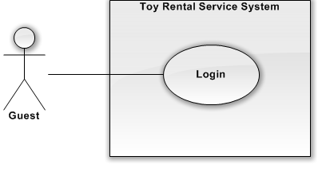

Figure 67: <Guest>Login

**Use Case Specification**

|  |  |  |  |  |
| --- | --- | --- | --- | --- |
| **USE CASE – LOGIN** | | | | |
| **Use-case No.** | UC050 | **Use-case Version** | | 2.0 |
| **Use-case Name** | Login | | | |
| **Author** | Hồ Quang Hưng | | | |
| **Date** | 18/09/2014 | **Priority** | Normal | |
| **Actor:**   * Members   **Summary:**   * This use case allowes user to login to system   **Goal:**   * User can login into system   **Triggers:**   * Click “Đăng nhập” button.   **Preconditions:**   * The member has already had an account of this system.   **Post Conditions:**   * **Success:** User successfully login into the system * **Failure:** User cannot login, error message is display   **Main Success Scenario:**   |  |  |  | | --- | --- | --- | | Step | Actor Action | System Response | | 1 | Click “Đăng nhập” button | Show [Login Page] with the login form:   * Email: Textbox   In format: /^(\w+[\.])*\w+@@(\w+\.)+[a-zA-Z]+$/   * Password: Password Filed (min length: 8, max length: 32) * Đăng Nhập: Button * Tạo tài khoản: Link * Quên mật khẩu: Link | | 2 | Input email and password.  Click on “Đăng Nhập” button.  [Alternative 1,2] | [Exceptions 1,2 3]  Save login session  Redirect to [Curent Page]. |   **Alternative Scenario:**   |  |  |  | | --- | --- | --- | |  | Actor Action | System Response | | 1 | Click on “Tạo tài khoản” link. | Redirect to Register page. | | 2 | Click on “Quên mật khẩu” link. | Redirect to ResetPassword page. |   **Exceptions:**   |  |  |  | | --- | --- | --- | | No. | Actor Action | System Response | | 1 | Email or Password textbox is empty. | Display error message “Vui lòng nhập đầy đủ thông tin địa chỉ email và mật khẩu!”. | | 2 | Email or Passowrd not correct. | Display error message “Email hoặc mật khẩu không chính xác, vui lòng thử lại!” | | 3 | Cannot login due to database connection | Display error message “Không thể đăng nhập. Vui lòng thử lại” |   **Relationships:** N/A  **Business Rules:**   * Customer can only login in [customer login] page * Staff and admin can only login in [staff login] page | | | | |

Table 50: <Guest>Login

### **Non-Functional Requirements**

#### **Reliability**

* Mean Time Between Failures is more than 6 months.
* Accuracy: 100%.
* Critical bugs: not any

#### **Availability**

* N/A

#### **Security**

* All input data should be validated before saving to database
* All privacy information, such as password, should be encrypted to ensure security.
* Roles permission should be specify clearly and user should be authenticated and authorized when accessing to the system.

#### **Maintainability**

* All program files shall include comments concerning authorship and date of last change.
* The system should be divided into modules and code should be easy to maintain and extend.

#### **Portability**

* N/A

#### **Performance**

* All requests should be response in no more than 1 minute.

## Entity Relationship Diagram or Data Structures

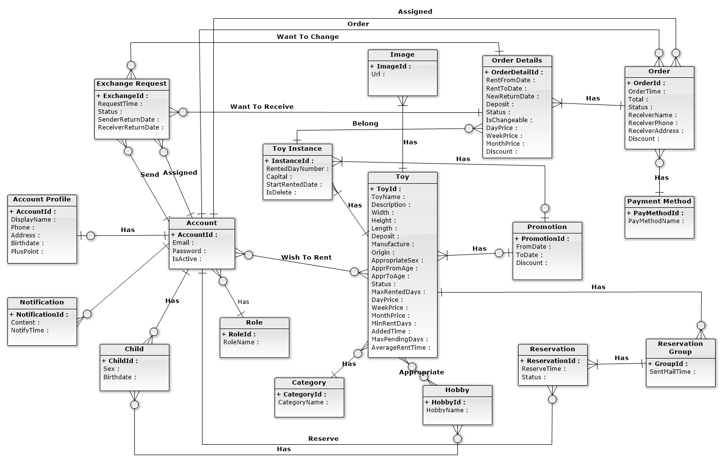

Figure 68: Entity Relationship Diagram

|  |  |
| --- | --- |
| **Entity Data dictionary: describe content of all entities** | |
| **Entity Name** | **Description** |
| Account | Describe account of user of system. |
| Role | Describe role of user. One user has one role. |
| Child | Describe child of customers in system. |
| Hobby | Describe all normal hobbies of real child. |
| AccountProfile | Describe information of account in system. |
| Notification | Describe all of user’s notification of the system. |
| Toy | Describe all information of toys in system. |
| Image | Describe all image of toys in system. |
| ToyInstance | Describe all instances of a toy in system. |
| Category | Describe all kind of toys in system. |
| Promotion | Describe all information of promotion in system. |
| OrderDetails | Describe all details of an order in system. |
| Order | Describe all orders of the renter in system. |
| PaymentMethod | Describe all payment method of customer in system. |
| Reservation | Describe all toys booking of customer in system. |
| ReservationGroup | Describe all booking group of each toy in system. |
| ExchangeRequest | Describe toys exchanges of customer in system. |

Table 51: Entity Data Dictionary

## Other material (if any)

N/A

# Software Design Description (SDD)

## Design Overview

This document describes the technical and user interface design of the Children's Toy Rental Service Website. Document includes the system architectural design, component diagram, detailed description of the components, user interface, and database design.

The system architectural design describes the overall architecture of the system, general description of the model used, including detailed information for each component, the function of each component in the system, description how the system works and the way that sub-components communicate together.

The component diagram show the physical structure of the command line in accordance with the concept of part code. Contains information about the class or classes that logic execution, component diagram also shows the dependencies between the components together.

The detailed design describes includes class diagrams, class diagram explanations, and sequence diagrams of all use cases. Class diagram describes the static view of system with class concepts and the relationships between them. Sequence diagram describes in detail the interactions between objects.

All diagram using UML 2.0

The user interface design describes the layout of the system.

The database design describes detail entities and relationships between them.

Document overview:

* Section 2: gives an overall description of the system architecture design.
* Section 3: gives component diagrams that describe the connection and integration of the system.
* Section 4: gives the detail design description include class diagram, class explanation
* Section 5: sequence diagram to details the application functions.
* Section 6: overview some main user interface of system.
* Section 7: describe database design and details of database with data dictionary.
* Section 8: describe in details all algorithms used in the system.

## System Architectural Design

### **Choice of System Architecture**

The system is developed using MVC combine with 3-tiers architechture.

For the view of MVC Architecture:

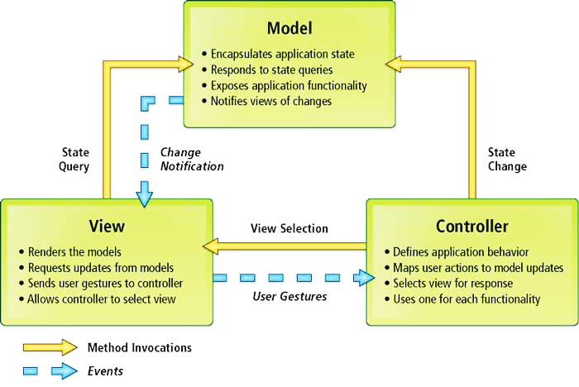

Figure 69: MVC Architecture

* **Model.** The model manages the behavior and data of the application domain, responds to requests for information about its state (usually from the view), and responds to instructions to change state (usually from the controller).
* **View.** The view manages the display of information.
* **Controller**. The controller interprets the mouse and keyboard inputs from the user, informing the model and/or the view to change as appropriate.

[<http://msdn.microsoft.com/en-us/library/ff649643.aspx> ]

 3-tier application typically consists of the following levels:

**MODEL**

3-Tier Architecture

MVC Architecture

Figure 70: 3-tiers Architecture

* **Data Access** - used for actually interacting with your database and accessing data.
* **Business Logic** - used for adding in your specific business rules, processing and manipulating data and other calculations.
* **Presentation** - used for presenting the actual data to the user.

In the view of 3-tiers, model of MVC includes business layer and data access layer.

### **Discussion of Alternative Designs**

N/A

### **Description of System Interface**

N/A

## Component Diagram

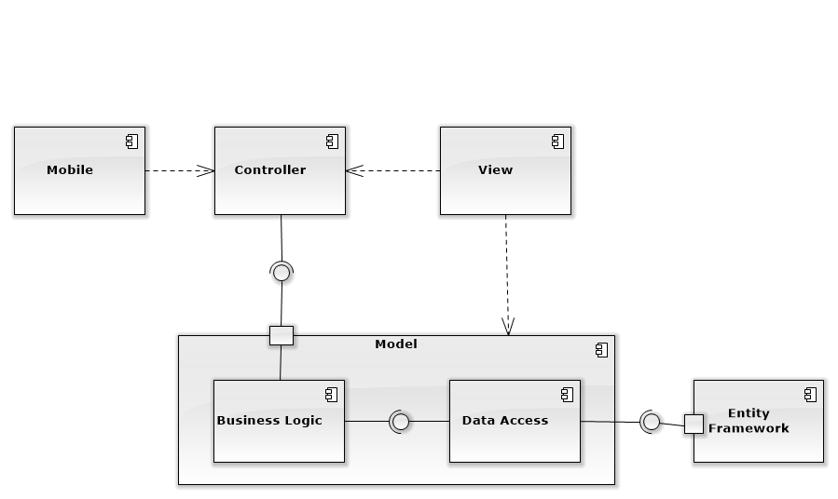

Figure 71: Component Diagram

## Detailed Description of Components

### **Class Diagram**

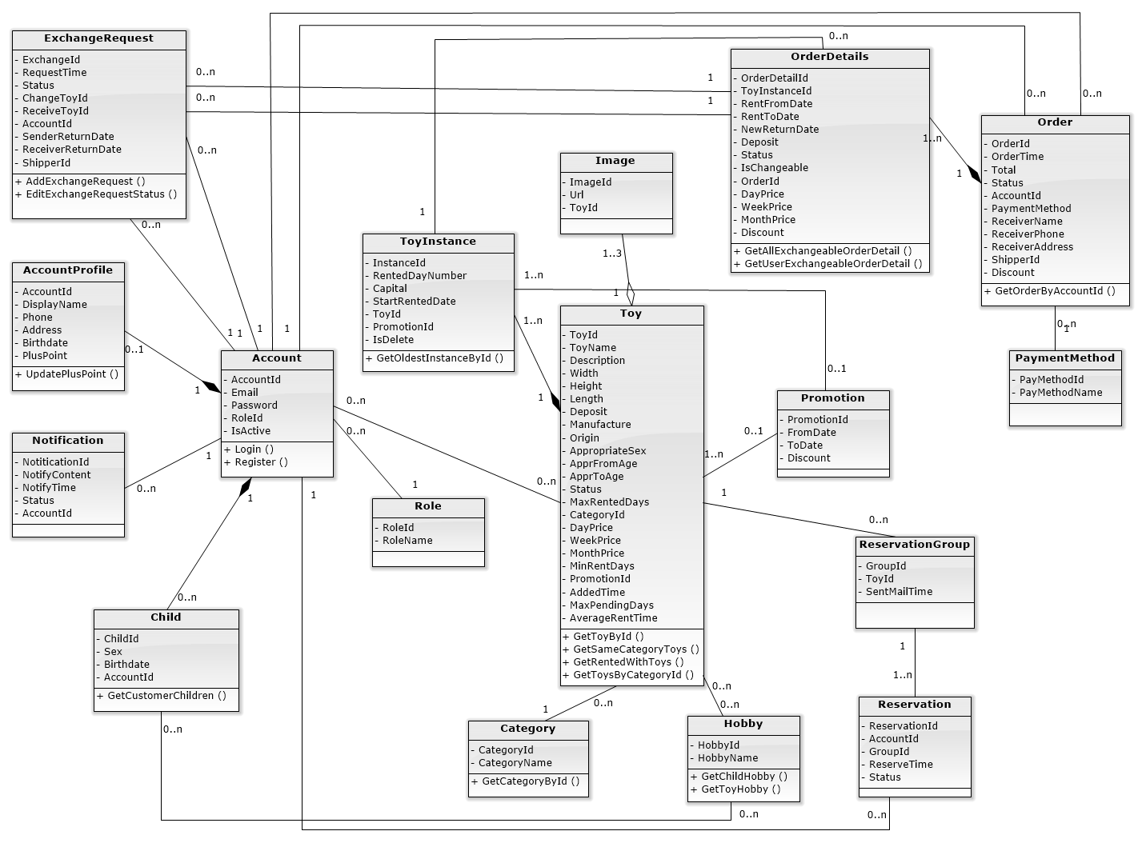

Figure 72: Class Diagram

### **Class Diagram Explanation**

#### **OrderDetails**

Attribute

|  |  |  |  |
| --- | --- | --- | --- |
| **Attribute** | **Type** | **Visibility** | **Description** |
| OrderDetailId | Int | Public | Unique ID of each order detail |
| ToyInstanceId | Int | Public | ID of rented toy instance |
| RentFromDate | DateTime | Public | Start renting date of this order detail |
| RentToDate | DateTime | Public | Return rented toy date of this order detail |
| NewReturnDate | DateTime | Public | New return rented toy date of this order detail |
| Deposit | Long | Public | Deposit money of rented toy |
| Status | String | Public | Renting status of this order detail |
| IsChangeable | Boolean | Public | State that rented toy is exchangeable or not |
| OrderId | Int | Public | ID of order that order detail belongs to |
| DayPrice | Long | Public | Price for renting toy 1 day |
| WeekPrice | Long | Public | Price for renting toy 1 week |
| MonthPrice | Long | Public | Price for renting toy 1 month |
| Discount | Int | Public | Discount percent of this order detail |

Method

|  |  |  |  |
| --- | --- | --- | --- |
| **Method** | **Return Type** | **Visibility** | **Description** |
| GetAllExchangeableOrderDetail | List<OrderDetail> | Public | Get all order details that can be exchanged |
| GetUserExchangeableOrderDetail | List<OrderDetail> | Public | Get all order detail of current user that can be exchanged |

#### **Order**

Attribute

|  |  |  |  |
| --- | --- | --- | --- |
| **Attribute** | **Type** | **Visibility** | **Description** |
| OrderId | Int | Public | Unique ID of each order |
| OrderTime | DateTime | Public | Order time of this order |
| Total | Long | Public | Total price of this order |
| Status | String | Public | Renting status of this order |
| AccountId | Int | Public | Account ID of customer |
| PaymentMethod | Int | Public | ID of this order payment method |
| ReceiverName | String | Public | Name of order receiver |
| ReceiverPhone | String | Public | Phone number of order receiver |
| ReceiverAddress | String | Public | Address to deliver order |
| ShipperId | Int | Public | ShipperId of order |
| Discount | Int | Public | Discount of order |

Method

|  |  |  |  |
| --- | --- | --- | --- |
| **Method** | **Return Type** | **Visibility** | **Description** |
| GetOrderByAccountId | List<Order> | Public | Get all order of current customer |

#### **ExchangeRequest**

Attribute

|  |  |  |  |
| --- | --- | --- | --- |
| **Attribute** | **Type** | **Visibility** | **Description** |
| ExchangeId | Int | Public | Unique ID of each exchange request |
| ChangeToyId | Int | Public | ID of exchange order detail of request sender |
| ReceiveToyId | Int | Public | ID of exchange order detail of request receiver |
| Status | String | Public | Renting status of exchange request |
| RequestTime | DateTime | Public | Time when sender send exchange request |
| AccountId | Int | Public | ID of exchange request sender |
| SenderReturnDate | DateTime | Public | Sender selected return date of exchange toy |
| ReceiverReturnDate | DateTime | Public | Receiver selected return date of exchange toy |
| ShipperId | Int | Public | ShipperId of order |

Method

|  |  |  |  |
| --- | --- | --- | --- |
| **Method** | **Return Type** | **Visibility** | **Description** |
| AddExchangeRequest | Boolean | Public | Create new exchange request |
| EditExchangeRequestStatus | Boolean | Public | Edit exchange request status when customer confirm/ deny request or staff complete delivering |

#### **Reservation**

Attribute

|  |  |  |  |
| --- | --- | --- | --- |
| **Attribute** | **Type** | **Visibility** | **Description** |
| ReservationId | Int | Public | Unique ID of each reservation |
| AccountId | Int | Public | ID of customer who make this reservation |
| GroupId | Int | Public | ID of group that reservation belong to |
| ReserveTime | DateTime | Public | Time when customer make this reservation |
| Status | Boolean | Public | Describe this reservation is done or not |

#### **ReservationGroup**

Attribute

|  |  |  |  |
| --- | --- | --- | --- |
| **Attribute** | **Type** | **Visibility** | **Description** |
| GroupId | Int | Public | Unique ID of each reservation group |
| ToyId | String | Public | ID of toy that reservation group reserved |
| SentMailTime | DateTime | Public | Time when system send mail to customer group to notify reserved toy availability |

#### **PaymentMethod**

Attribute

|  |  |  |  |
| --- | --- | --- | --- |
| **Attribute** | **Type** | **Visibility** | **Description** |
| PayMethodId | Int | Public | Unique ID of each payment method |
| PayMethodName | String | Public | Name of payment method |

#### **Toy**

Attribute

|  |  |  |  |
| --- | --- | --- | --- |
| **Attribute** | **Type** | **Visibility** | **Description** |
| ToyId | String | Public | Unique identifier of a toy |
| ToyName | String | Public | Name of a toy |
| Description | String | Public | Information about a toy |
| Width | Float | Public | Width of a toy |
| Height | Float | Public | Height of a toy |
| Length | Float | Public | Length of a toy |
| Deposit | Long | Public | Price to deposit a toy |
| Manufacture | String | Public | Manufacture of a toy |
| Origin | String | Public | Origin of a toy |
| AppropriateSex | Int | Public | Sex suitable with a toy |
| AppropFromAge | Int | Public | Suitable age for start to play a toy |
| AppropToAge | Int | Public | Suitable age for end to play a toy |
| Status | String | Public | Status shows state of a toy |
| MaxRentedDays | Int | Public | Sum of days for rent a toy |
| CategoryId | Int | Public | Id of kind of toy. |
| DayPrice | Long | Public | Price of toy in a day |
| WeekPrice | Long | Public | Price of toy in week |
| MonthPrice | Long | Public | Price of toy in a month |
| MinRentDays | Int | Public | Limit day for rent a toy |
| AddedTime | DateTime | Public | Time starts add to order |
| MaxPendingDays | Int | Public | Time limit to start rent a toy |
| PromotionId | Int | Public | ID of promotion for each toy |
| AverageRentTime | Float | Public | Average rent time of toy |

Method

|  |  |  |  |
| --- | --- | --- | --- |
| **Method** | **Return Type** | **Visibility** | **Description** |
| GetNewestToys | List<Toy> | Public | Get the toy newest. |
| GetToyById | Toy | Public | Get the toy follow id |
| GetSameCategoryToys | List<Toy> | Public | Get all toys that same category |
| GetRentedWithToy | List<Toy> | Public |  |
| GetToyByCategoryId | List<Toy> | Public | Get all toys follow categoryId |
| GetQuantityInstancesById | Int | Public | Get amount instance exist in storage. |
| GetSuggestToyForChild | List<Toy> | Public | Get all toy suitable for child |
| UpdateStatusOfToy | Boolean | Public | Edit status of toy |

#### **ToyInstance**

Attribute

|  |  |  |  |
| --- | --- | --- | --- |
| **Attribute** | **Type** | **Visibility** | **Description** |
| InstanceId | Int | Public | Unique Id of each instance. |
| RentedDayNumber | Int | Public | Amount of days instance is rented |
| Capital | Long | Public | Funds of a toy. |
| StartRentedDate | DateTime | Public | The date a toys start to rent |
| ToyId | String | Public | ID of main toy |
| PromotionId | Int | Public | ID of promotion |
| IsDelete | Boolean | Public | Describe this toy instance is deleted or not |

Method

|  |  |  |  |
| --- | --- | --- | --- |
| **Method** | **Return Type** | **Visibility** | **Description** |
| GetOldestInstanceById | ToyInstance | Public | Get instance that is the oldest in all instances same id |

#### **Account**

Attribute

|  |  |  |  |
| --- | --- | --- | --- |
| **Attribute** | **Type** | **Visibility** | **Description** |
| AccountId | Int | Public | Unique identifier of an account |
| Email | String | Public | Email using to login into system |
| Password | String | Public | Password to login into system |
| RoleId | Int | Public | Role ID of each account |
| isActive | Boolean | Public | Describe this account is active or not |

Method

|  |  |  |  |
| --- | --- | --- | --- |
| **Method** | **Return Type** | **Visibility** | **Description** |
| GetAccountById | Account | Public | Get all information of current account by id |
| CheckLogin | Account | Public | Check username, password and login in system |
| GetAccountRegisterByEmail | Account | Public | Get account by email |
| CheckExistEmail | Account | Public | Check email input exist or not |
| CreateNewAccount | Boolean | Public | Create new account |
| CreateNewAccountProfile | Boolean | Public | Create new account profile |

#### **AccountProfile**

Attribute

|  |  |  |  |
| --- | --- | --- | --- |
| **Attribute** | **Type** | **Visibility** | **Description** |
| AccountId | Int | Public | Unique identifier of an account |
| DisplayName | String | Public | Name of customer |
| Phone | String | Public | Phone number of customer |
| Address | String | Public | Address of customer |
| Birthdate | DateTime | Public | Birthdate of customer |
| PlusPoint | Int | Public | Plus point having when customer rented toy |

Method

|  |  |  |  |
| --- | --- | --- | --- |
| **Method** | **Return Type** | **Visibility** | **Description** |
| UpdatePlusPoint | Boolean | Public | Update plus point of a customer |
| GetCusProfileById | CustomerProfile | Public | Get profile of a customer. |
| UpdateCusProfile | Boolean | Public | Edit profile of a customer |

#### **Image**

Attribute

|  |  |  |  |
| --- | --- | --- | --- |
| **Attribute** | **Type** | **Visibility** | **Description** |
| ImageId | Int | Public | Unique identifier of an image |
| Url | String | Public | This is link of a image in system. |
| ToyId | String | Public | Id of toy |

#### **Promotion**

Attribute

|  |  |  |  |
| --- | --- | --- | --- |
| **Attribute** | **Type** | **Visibility** | **Description** |
| PromotionId | Int | Public | Unique identifier of a promotion |
| FromDate | DateTime | Public | The date start a promotion. |
| ToDate | DateTime | Public | The date end of a promotion |
| Discount | Int | Public | Percent discount toys. |

#### **Category**

Attribute

|  |  |  |  |
| --- | --- | --- | --- |
| **Attribute** | **Type** | **Visibility** | **Description** |
| CategoryId | Int | Public | Unique identifier of a category |
| CategoryName | String | Public | Name of a category |

#### **Notification**

Attribute

|  |  |  |  |
| --- | --- | --- | --- |
| **Attribute** | **Type** | **Visibility** | **Description** |
| NotificationId | Int | Public | Unique ID of each notify. |
| NotifyContent | String | Public | Include content of notify. |
| NotifyTime | DateTime | Public | Time that notification is sent |
| Status | String | Public | Reading status of this notification |
| AccountId | int | Public | Id of account receive notification |

#### **Role**

Attribute

|  |  |  |  |
| --- | --- | --- | --- |
| **Attribute** | **Type** | **Visibility** | **Description** |
| RoleId | Int | Public | Unique ID of each role |
| RoleName | String | Public | Name of each role |

#### **Child**

Attribute

|  |  |  |  |
| --- | --- | --- | --- |
| **Attribute** | **Type** | **Visibility** | **Description** |
| ChildId | Int | Public | Unique ID of each child |
| Sex | Boolean | Public | Gender of child |
| Birthdate | DateTime | Public | Birthdate of child |
| AccountId | Int | Public | ID of customer who this child belongs to |

Method

|  |  |  |  |
| --- | --- | --- | --- |
| **Method** | **Return Type** | **Visibility** | **Description** |
| GetChildById | Child | Public | Get child by child id |
| GetCustomerChildren | List <Child> | Public | Get all customer children by account id |

#### **Hobby**

Attribute

|  |  |  |  |
| --- | --- | --- | --- |
| **Attribute** | **Type** | **Visibility** | **Description** |
| HobbyId | Int | Public | Unique ID of each hobby |
| HobbyName | String | Public | Name of each hobby |

Method

|  |  |  |  |
| --- | --- | --- | --- |
| **Method** | **Return Type** | **Visibility** | **Description** |
| GetChildHobby | List <Hobby> | Public | Get all hobby of child |
| GetToyHobby | List <Hobby> | Public | Get all hobby of toy |

## Sequence Diagram

### **Add Exchangeable Toy**

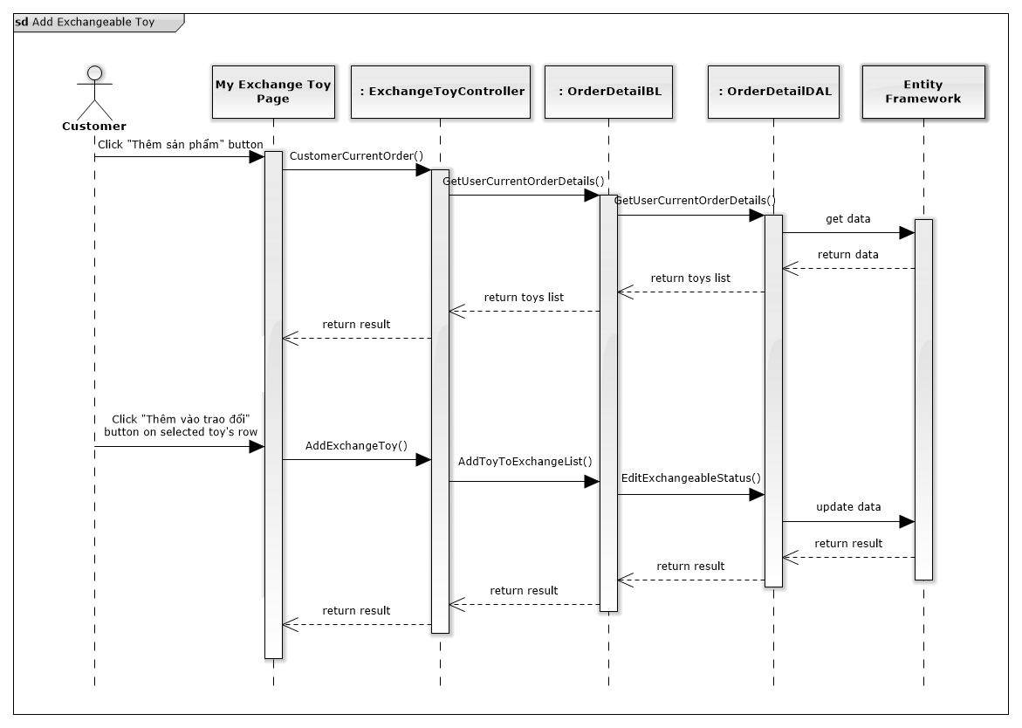

Figure 73: Add Exchangeable Toy Sequence Diagram

### **Remove Exchangeable Toy**

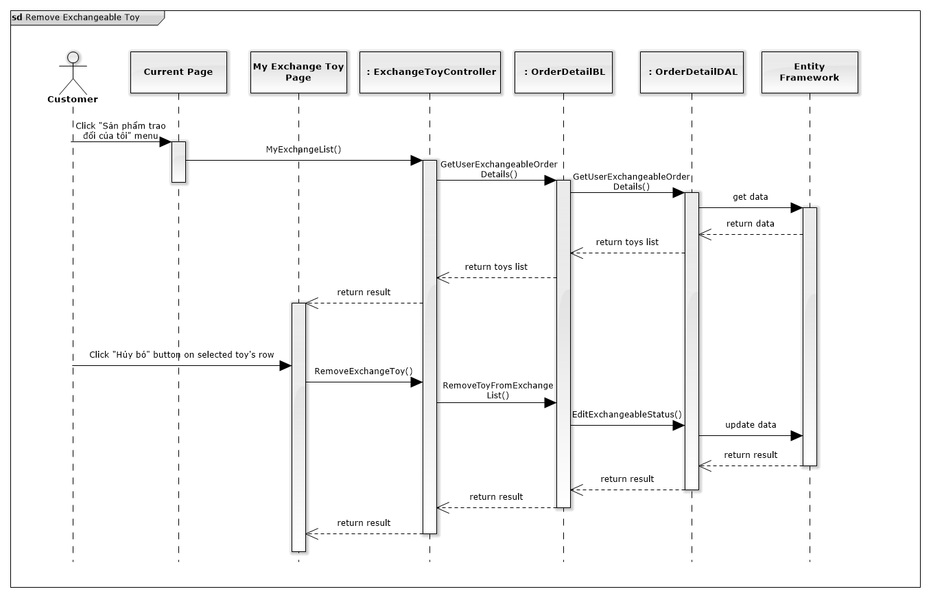

Figure 74: Remove Exchangeable Toy Sequence Diagram

### **View All Exchangeable Toys**

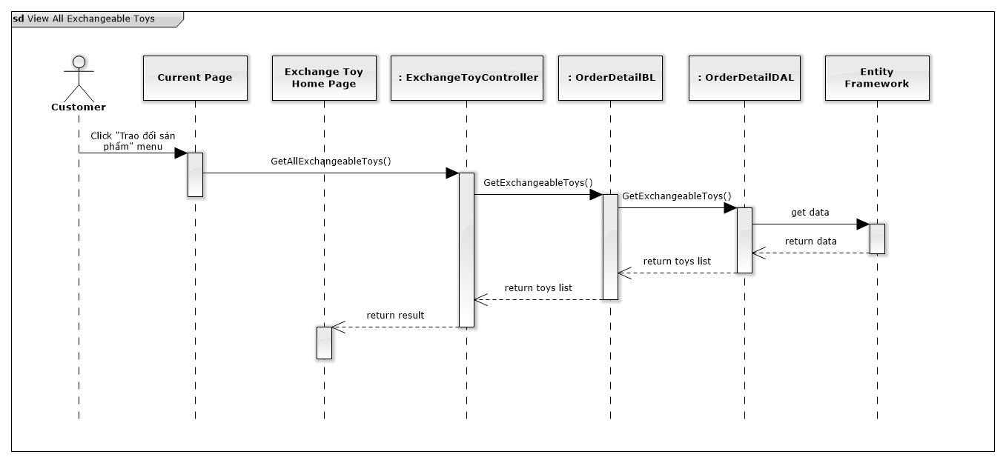

Figure 75: View All Exchangeable Toys

### **Send Exchange Request**

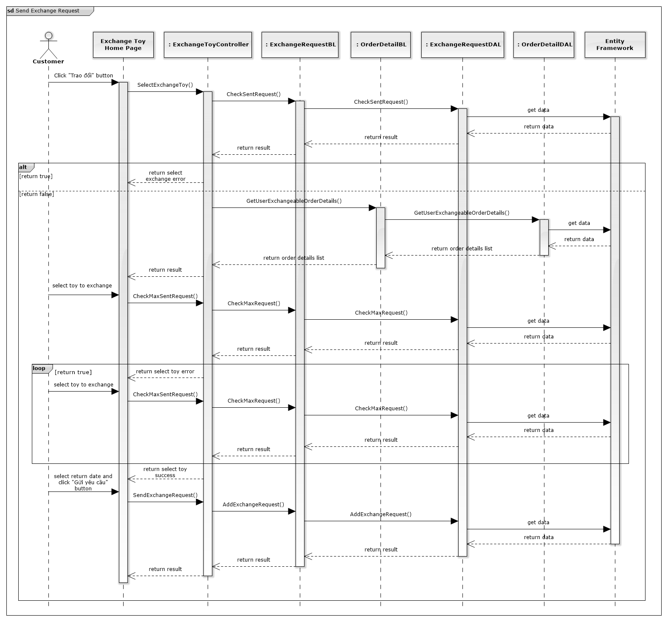

Figure 76: Send Exchange Request Sequence Diagram

### **View Exchange Request**

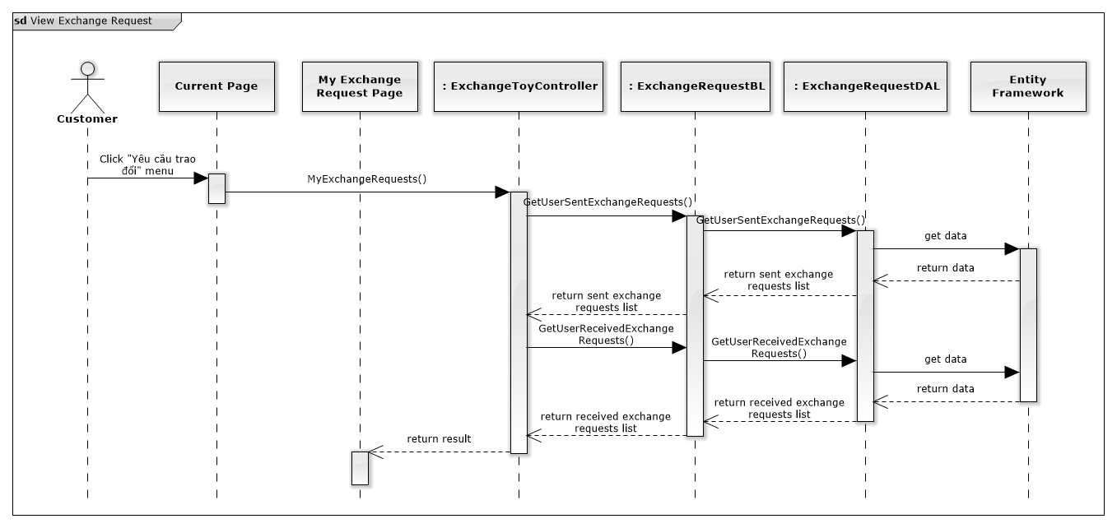

Figure 77: View Exchange Request

### **Respond Exchange Request**

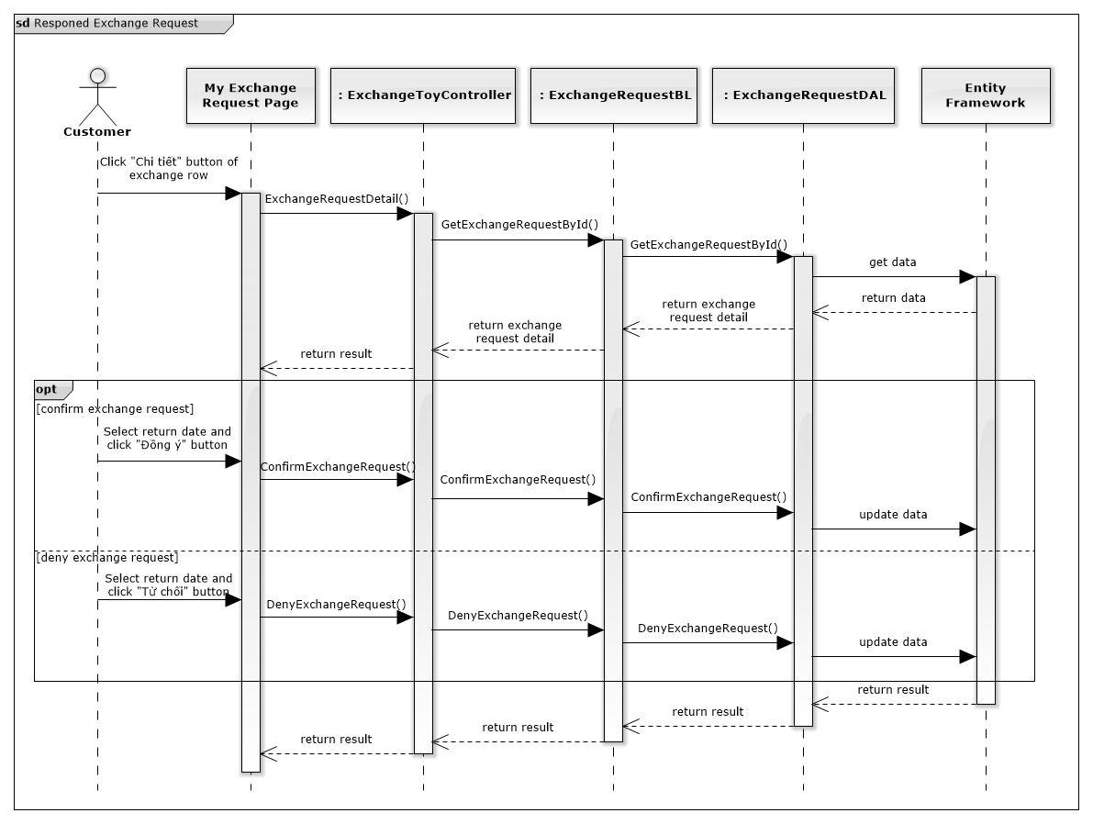

Figure 78: Respond Exchange Request Sequence Diagram

### **Finish Exchange**

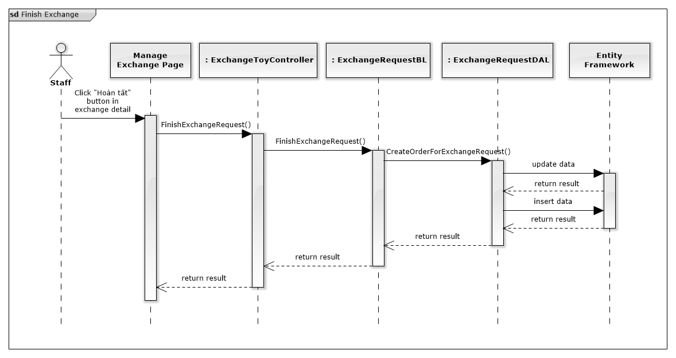

Figure 79: Finish Exchange Sequence Diagram

### **Cancel Exchange**

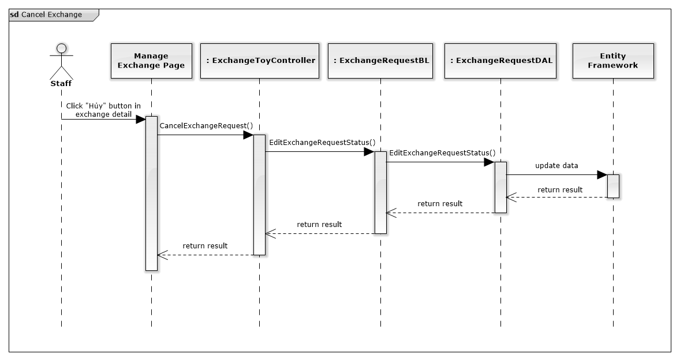

Figure 80: Cancel Exchange Sequence Diagram

### **Assign Shipper For Exchange**

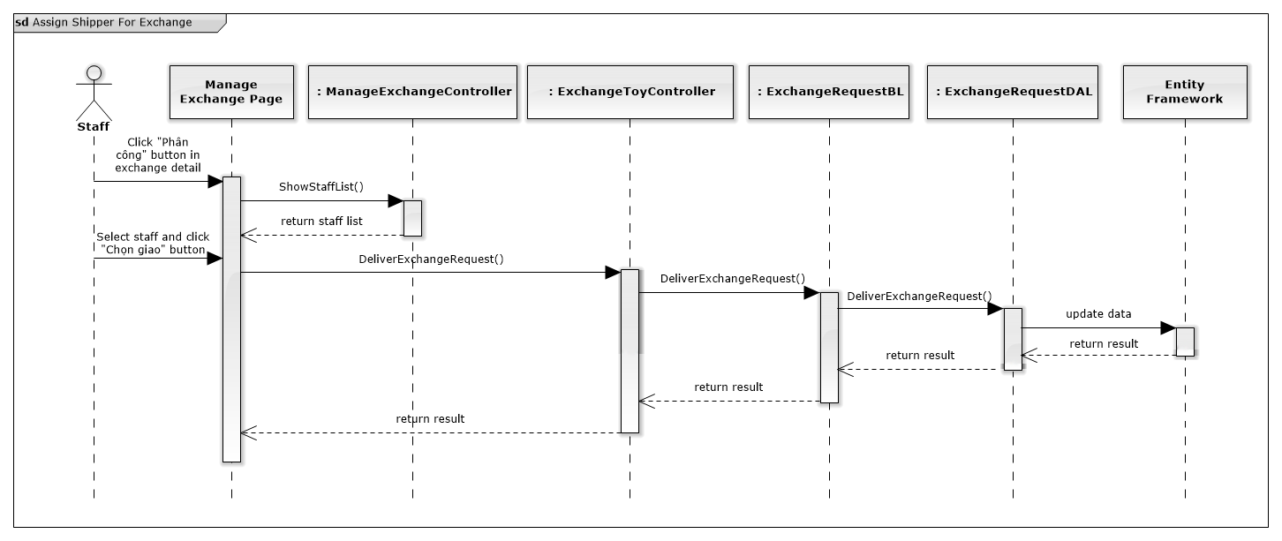

Figure 81: Assign Shipper For Sequence Diagram

### **Add To Cart**

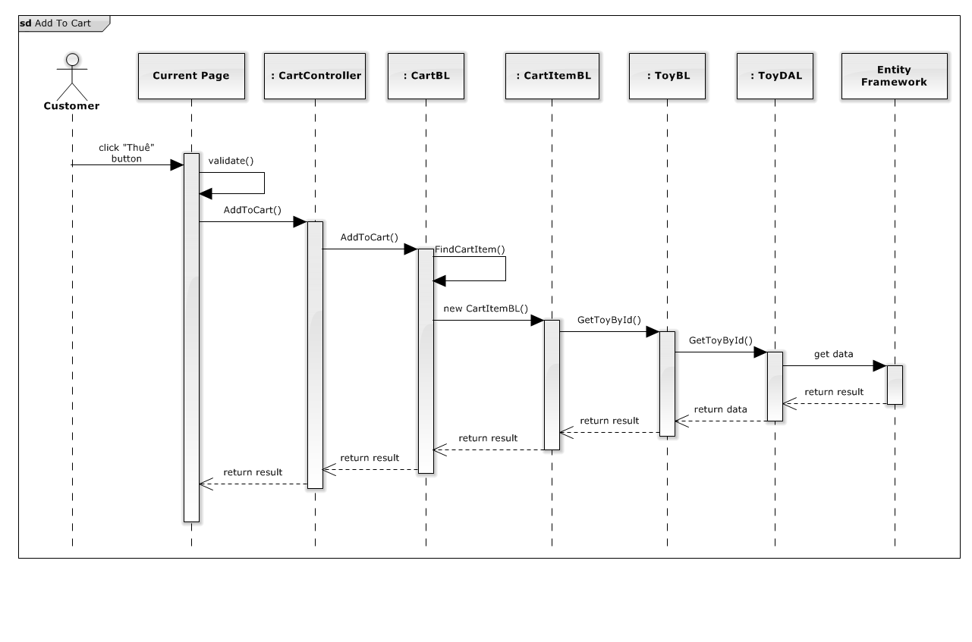

Figure 82: Add To Cart Sequence Diagram

### **Update Cart**

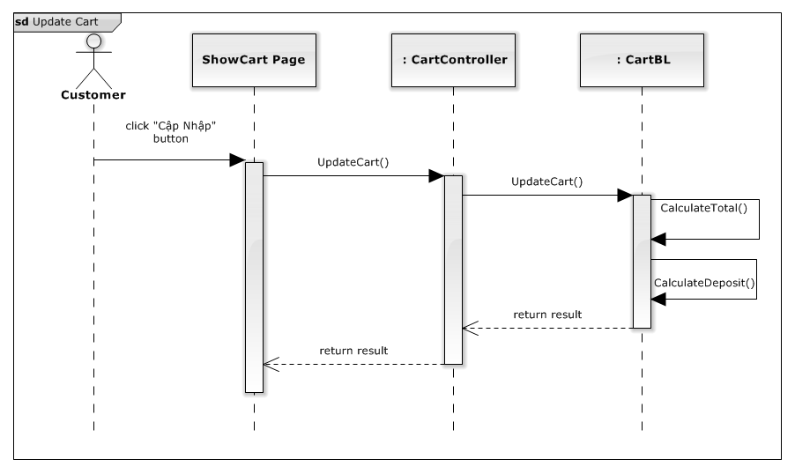

Figure 83: Update Cart Sequence Diagram

### **Remove Cart**

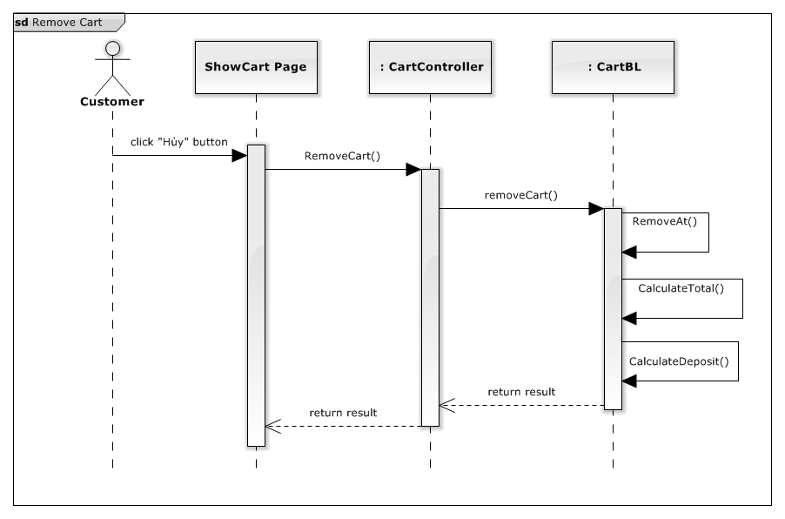

Figure 84: Remove Cart Sequence Diagram

### **View Cart**

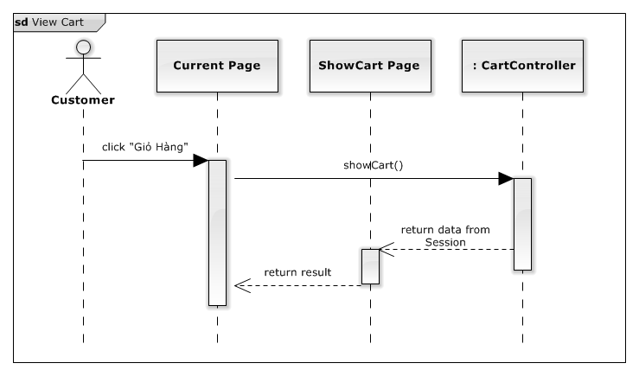

Figure 85: View Cart Sequence Diagram

### **View Order History**

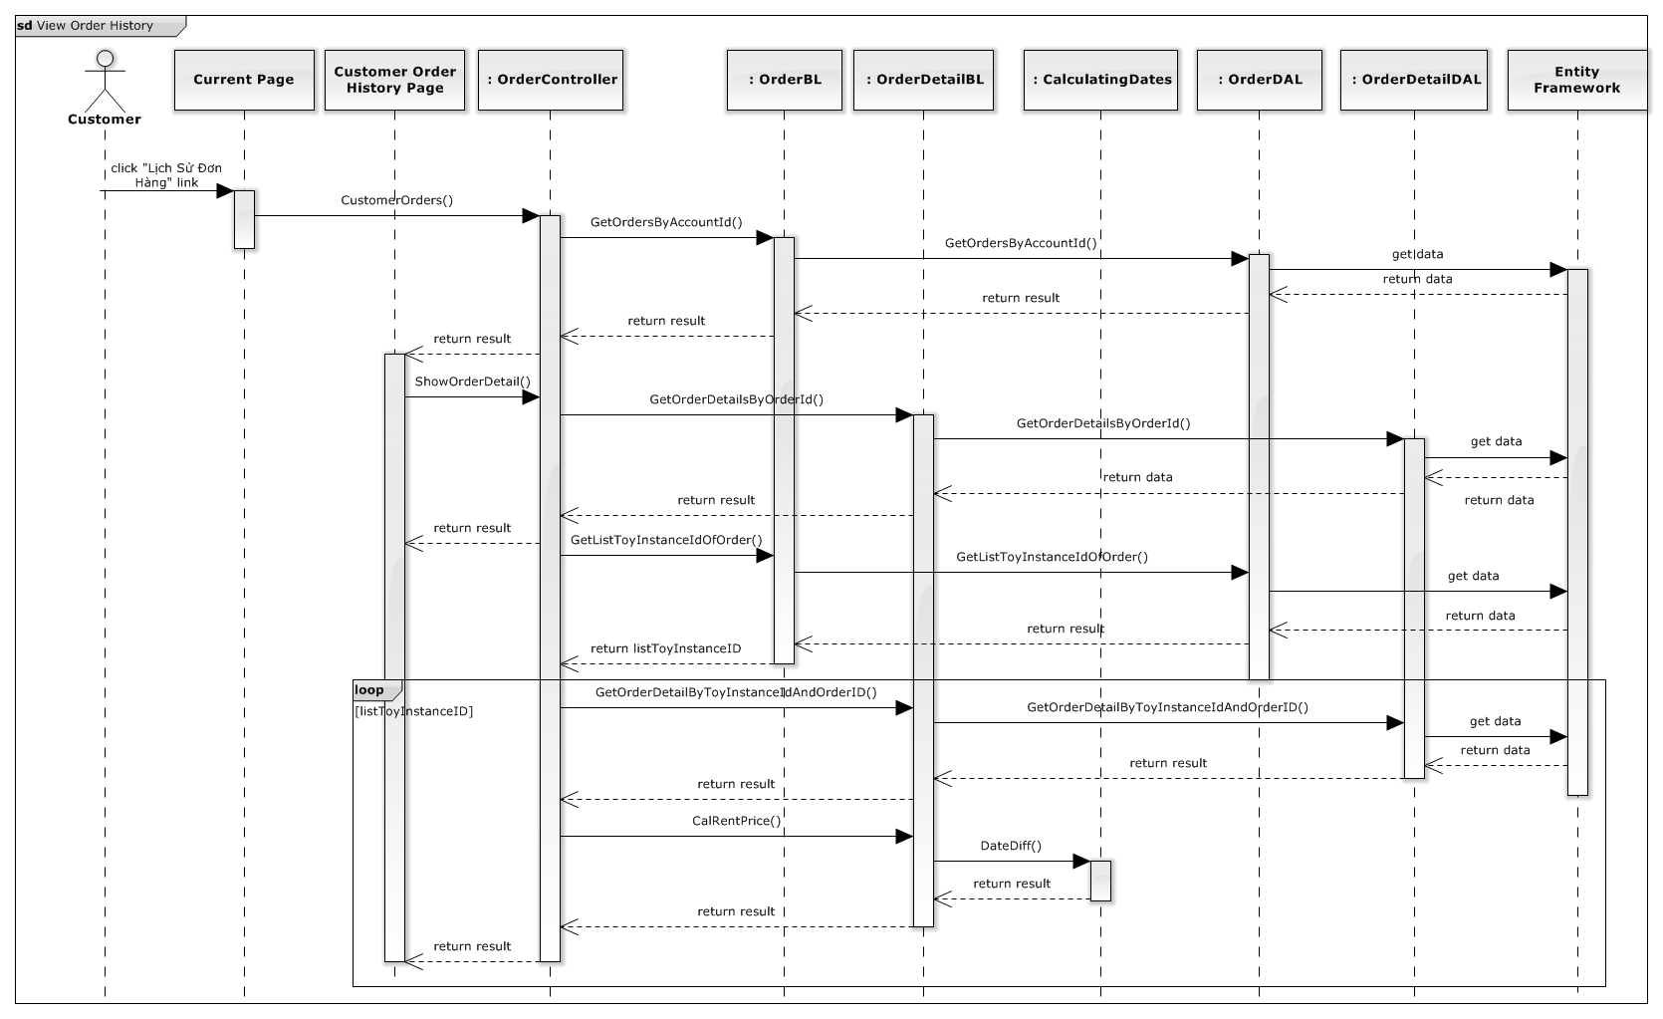

Figure 86: View Order History Sequence Diagram

### **Cancel Order**

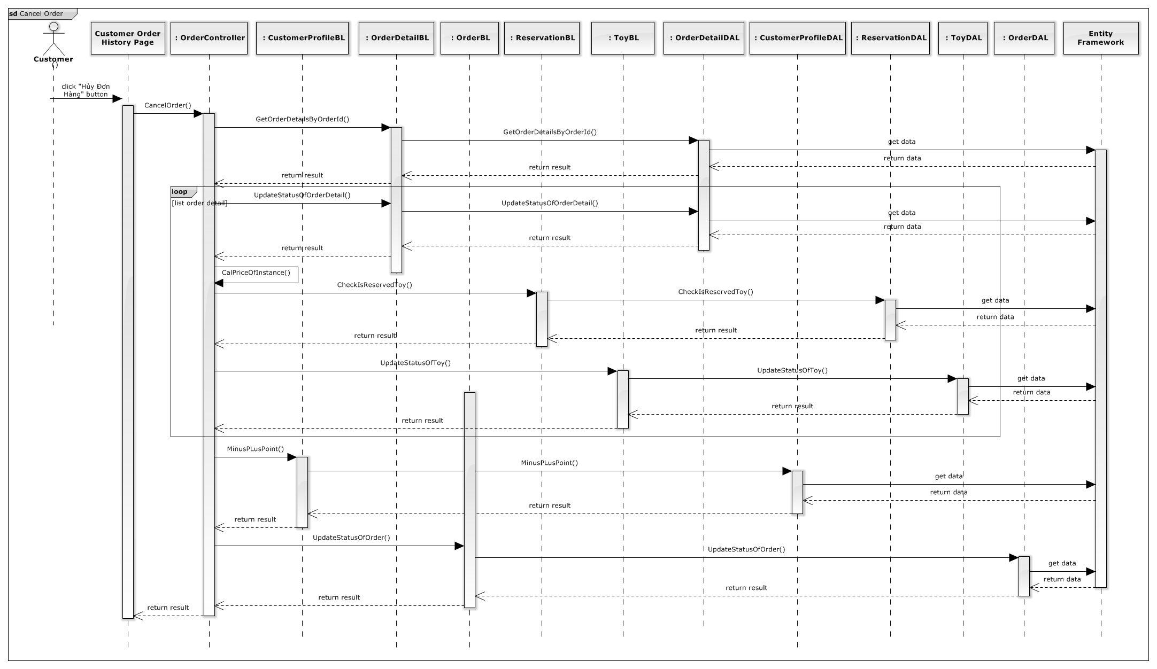

Figure 87: Cancel Order Sequence Diagram

### **Cancel Rented Toy**

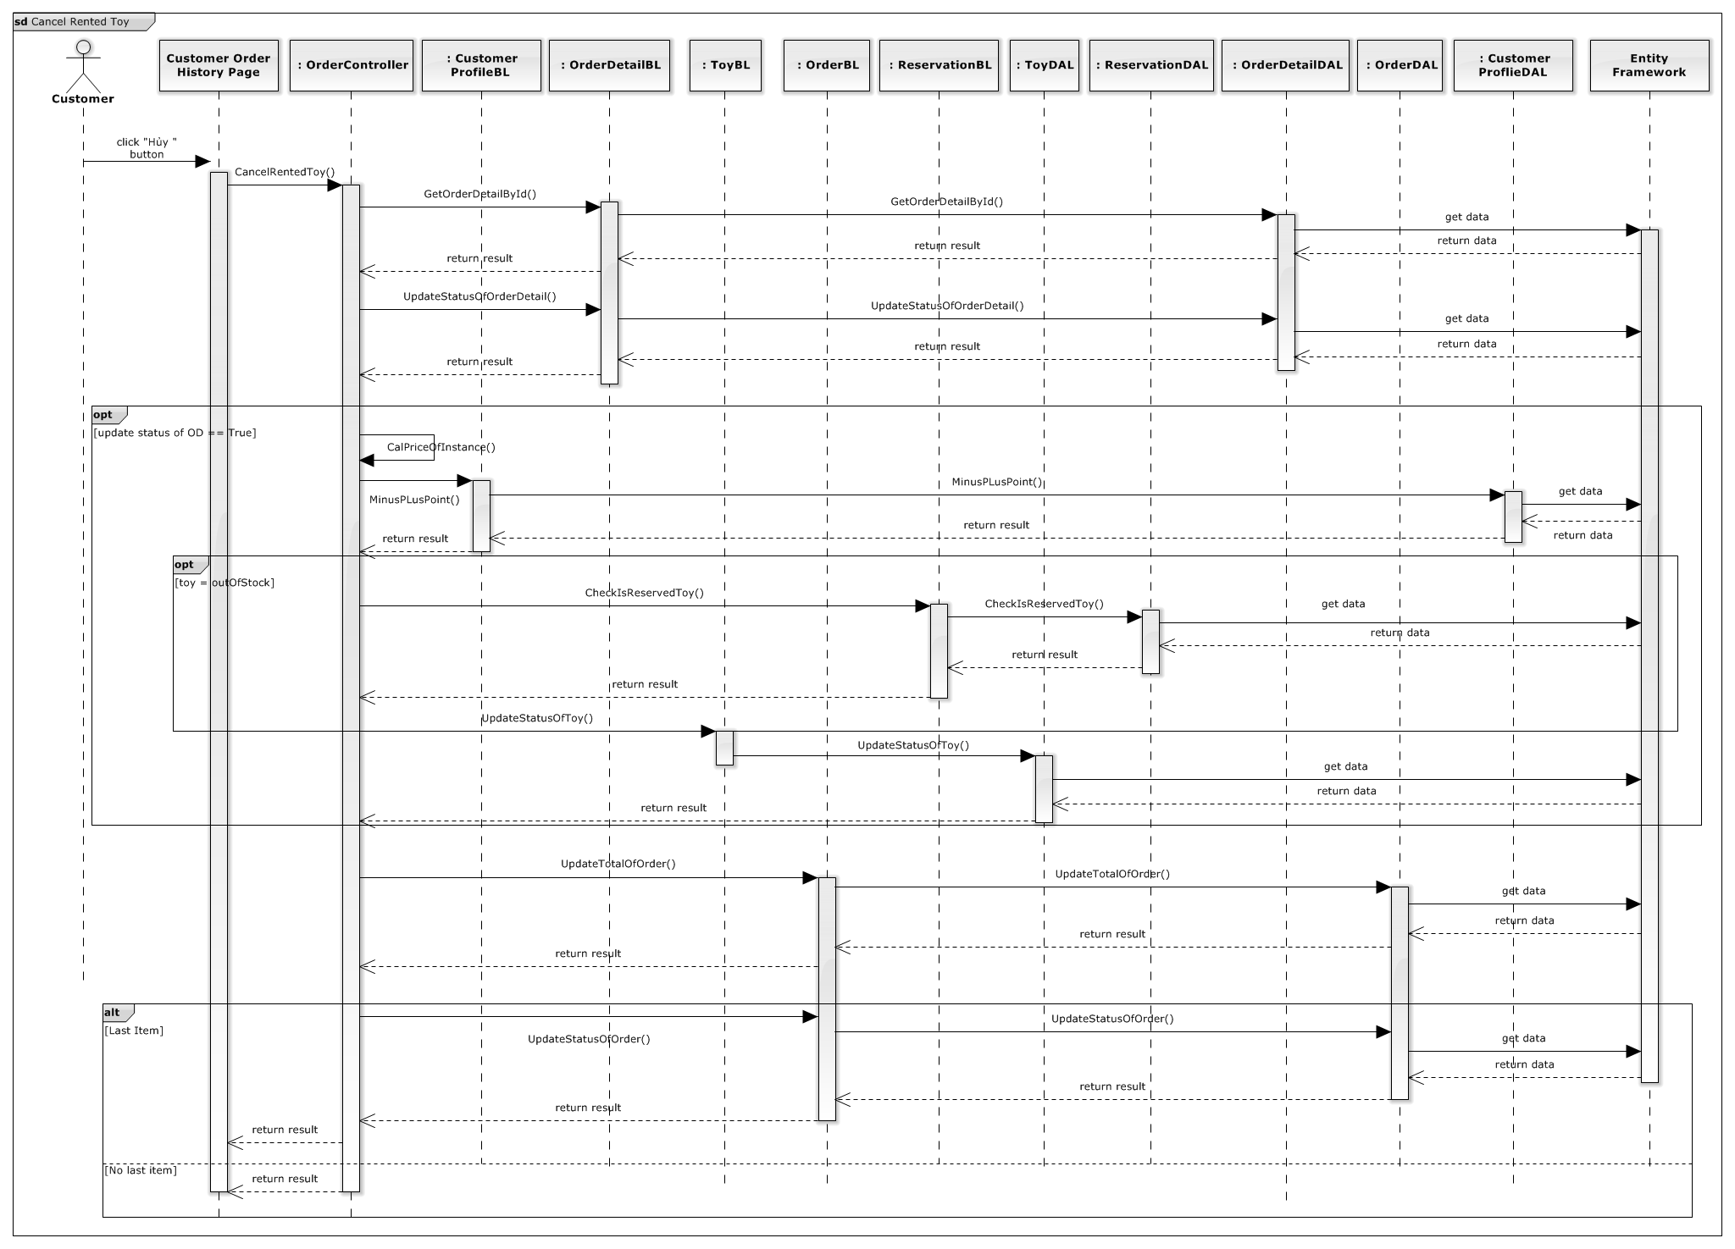

Figure 88: Cancel Rented Toy Sequence Diagram

### **Return Toy Soon**

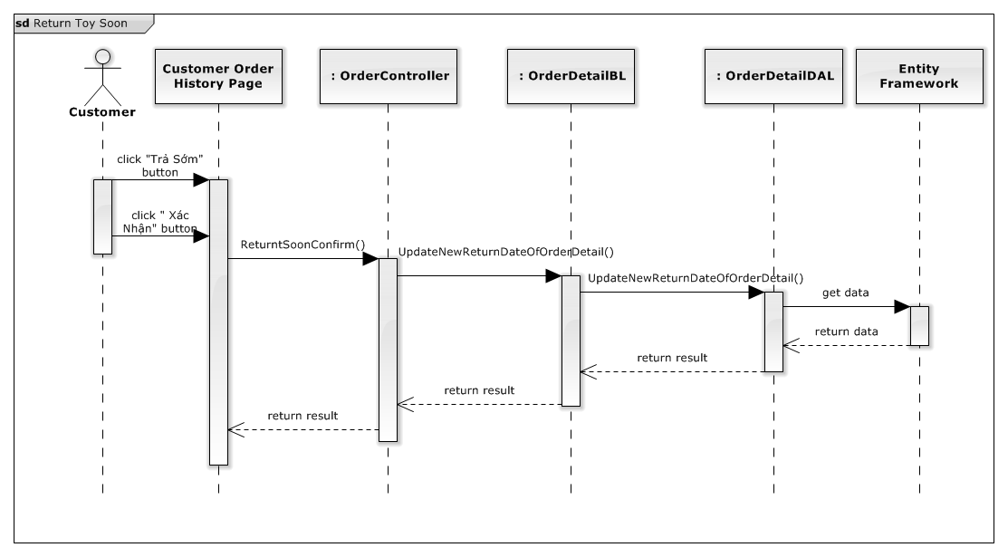

Figure 89: Return Toy Soon Sequence Diagram

### **Login**

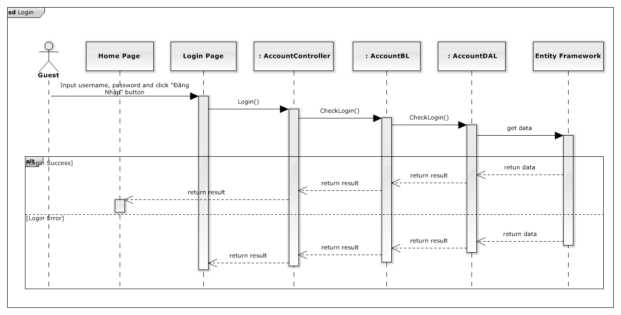

Figure 90: Login Sequence Diagram

### **Logout**

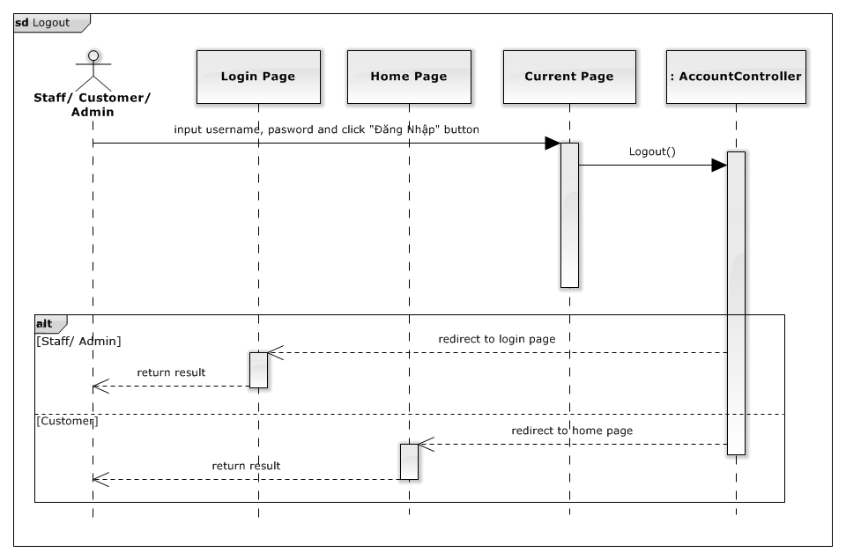

Figure 91: Logout Sequence Diagram

### **View Toy Details**

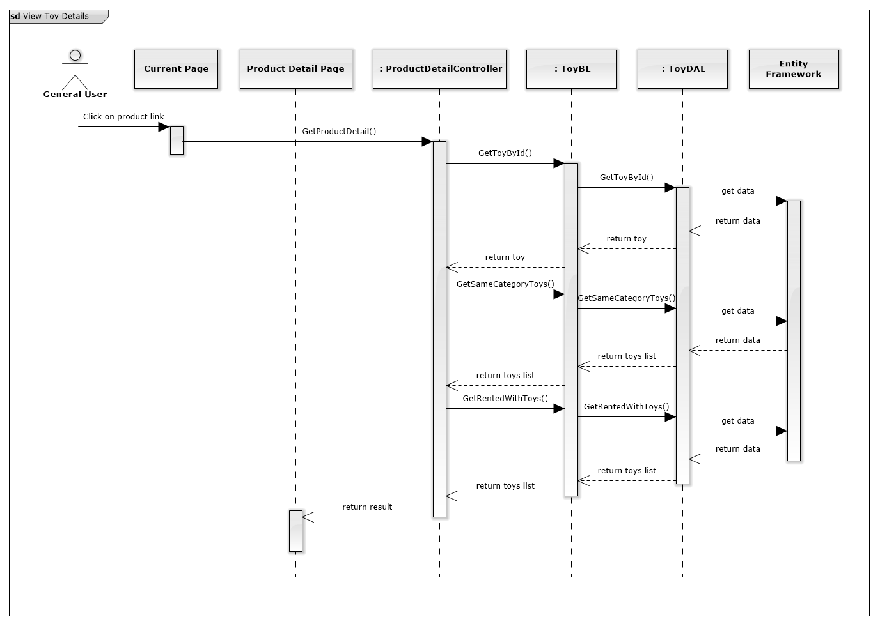

Figure 92: View Toy Detail Sequence Diagram

### **View Toy Categories**

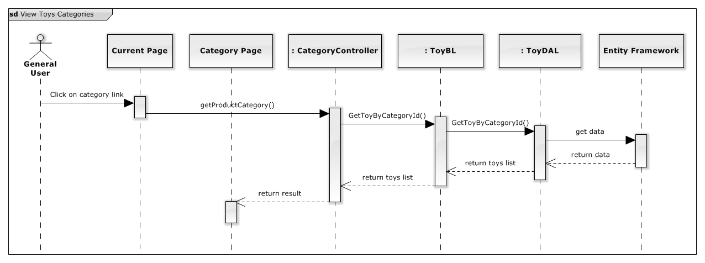

Figure 93: View Toy Categories Sequence Diagram

### **Checkout Payment Cash On Delivery**

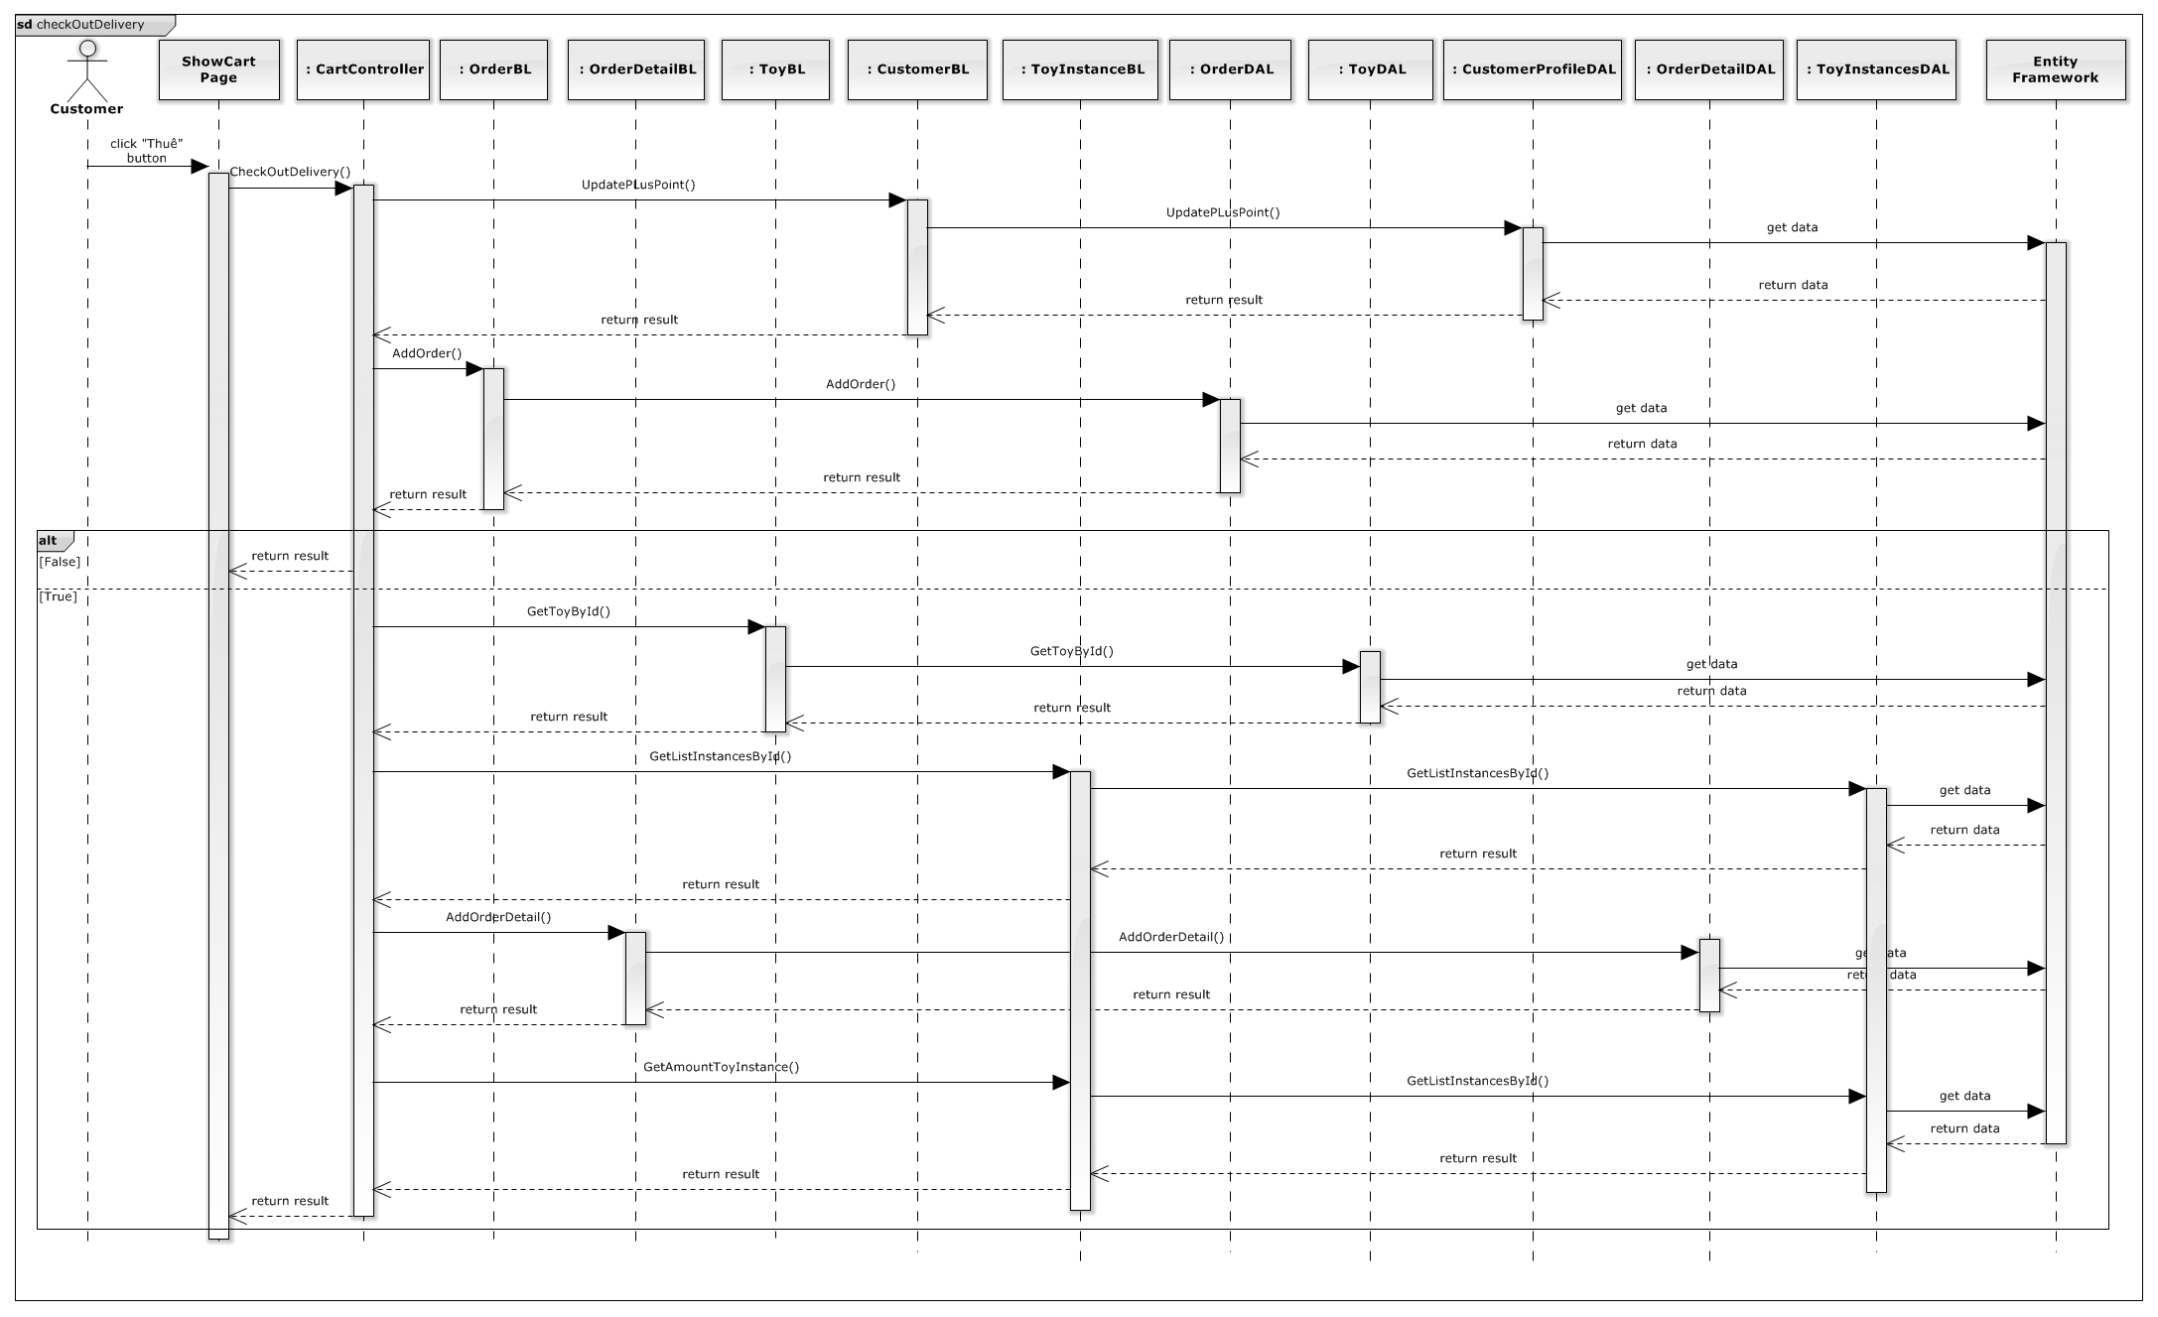

Figure 94: Checkout Payment Cash On Delivery Sequence Diagram

### **Checkout Payment Online**

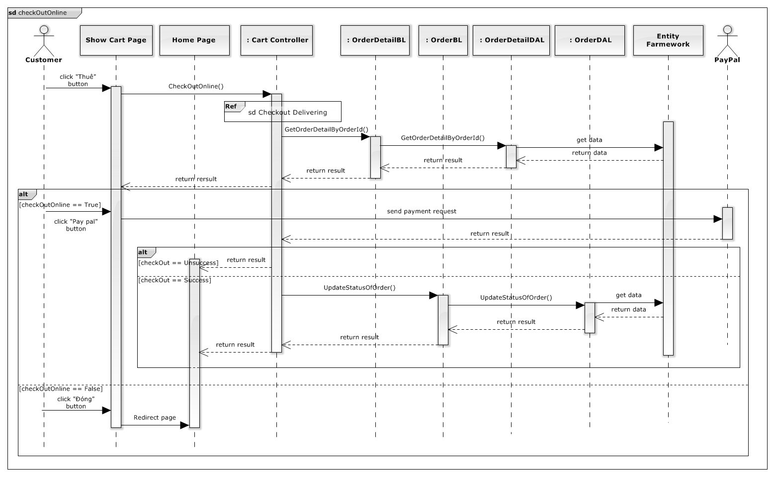

Figure 95: Checkout Payment Online Sequence Diagram

### **Return Toy**

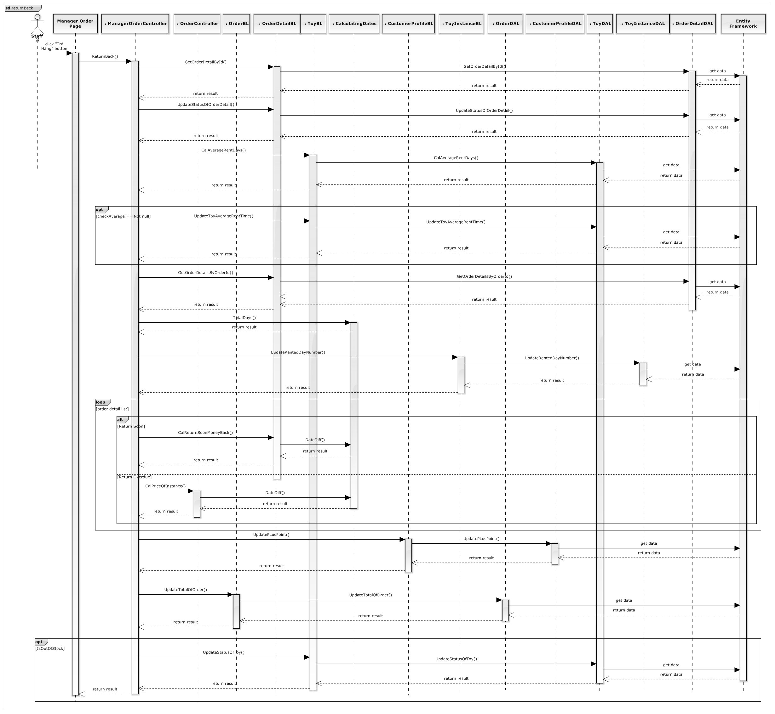

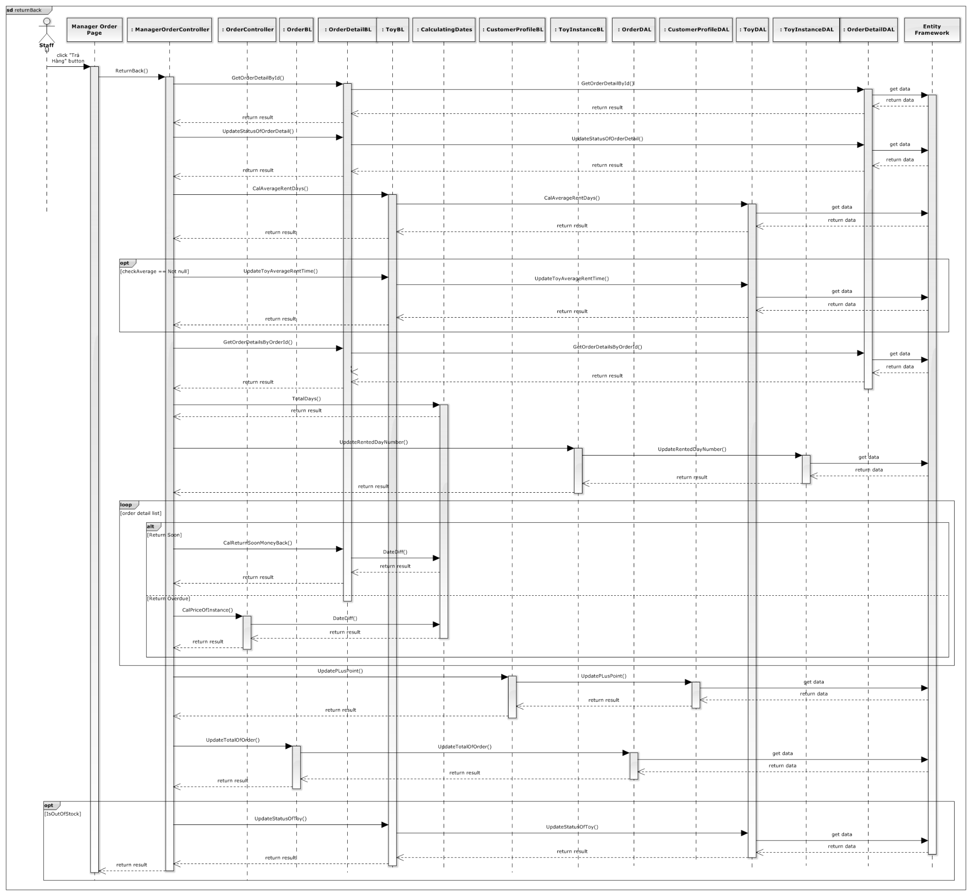

Figure 96: Return Toy Sequence Diagram

### **Advanced Search**

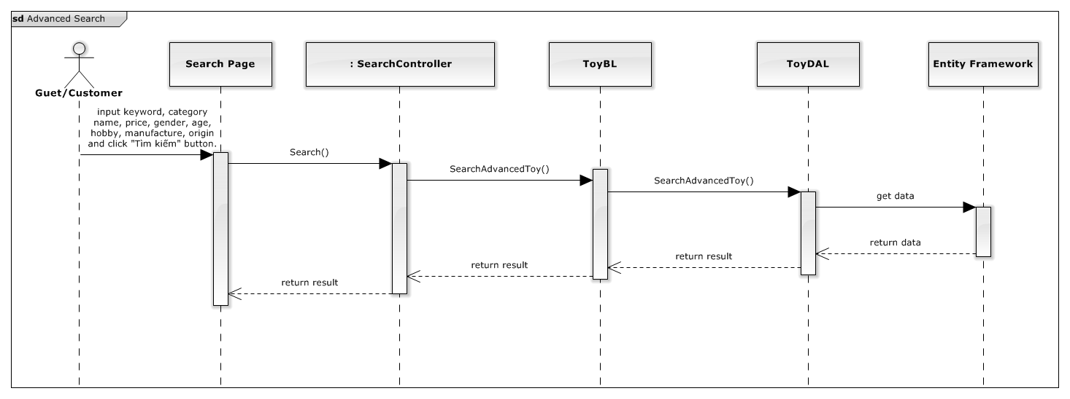

Figure 97: Advanced Search Sequence Diagram

### **Basic Search**

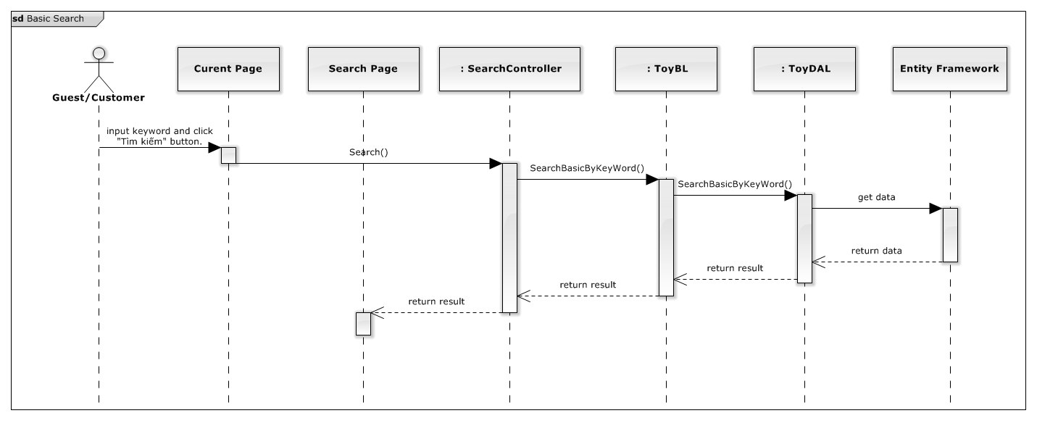

Figure 98: Basic Search Sequence Diagram

### **Reserve Toy**

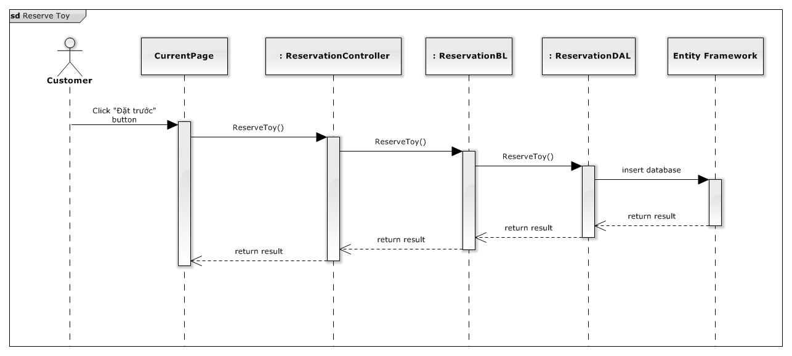

Figure 99: Reserve Toy Sequence Diagram

### **View Suggested Toys**

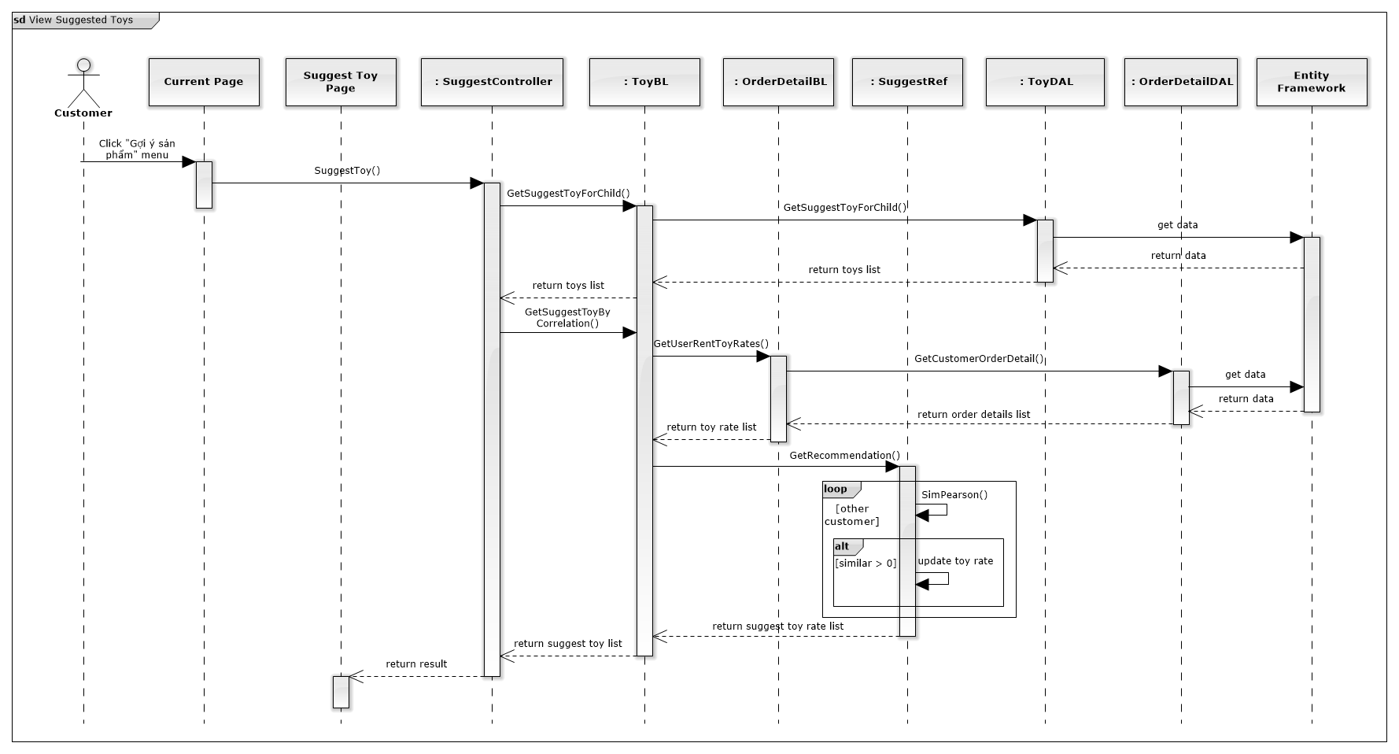

Figure 100: View Suggested Toy Sequence Diagram

### **Extend Rent Time**

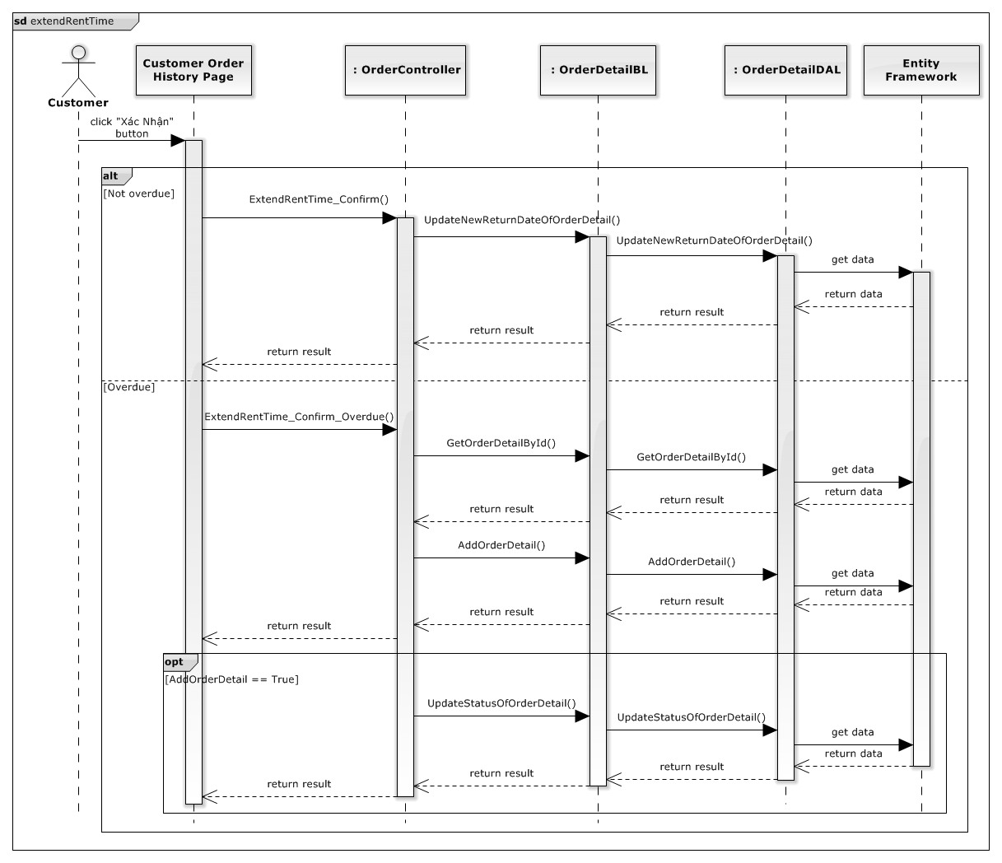



Figure 101: Extend Rent Time Sequence Diagram

### **Edit Customer Profile**

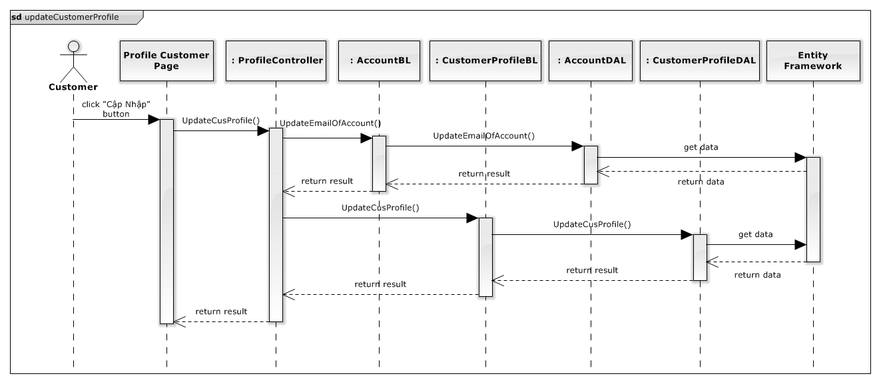

Figure 102: Extend Rent Time Sequence Diagram

### **Mobile Finish Deliver Order**

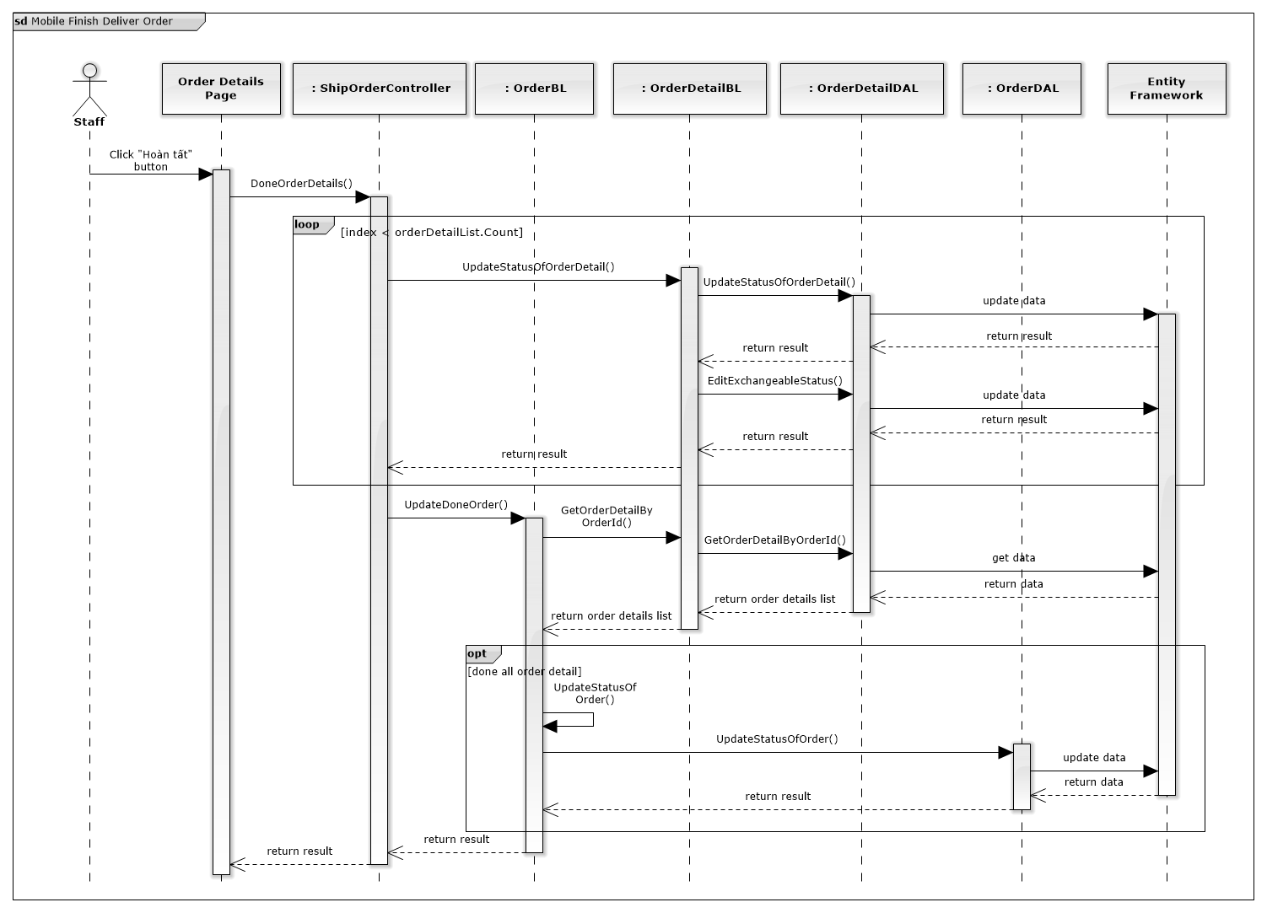

Figure 103: Mobile Finish Deliver Order

### **Mobile Return Toy**

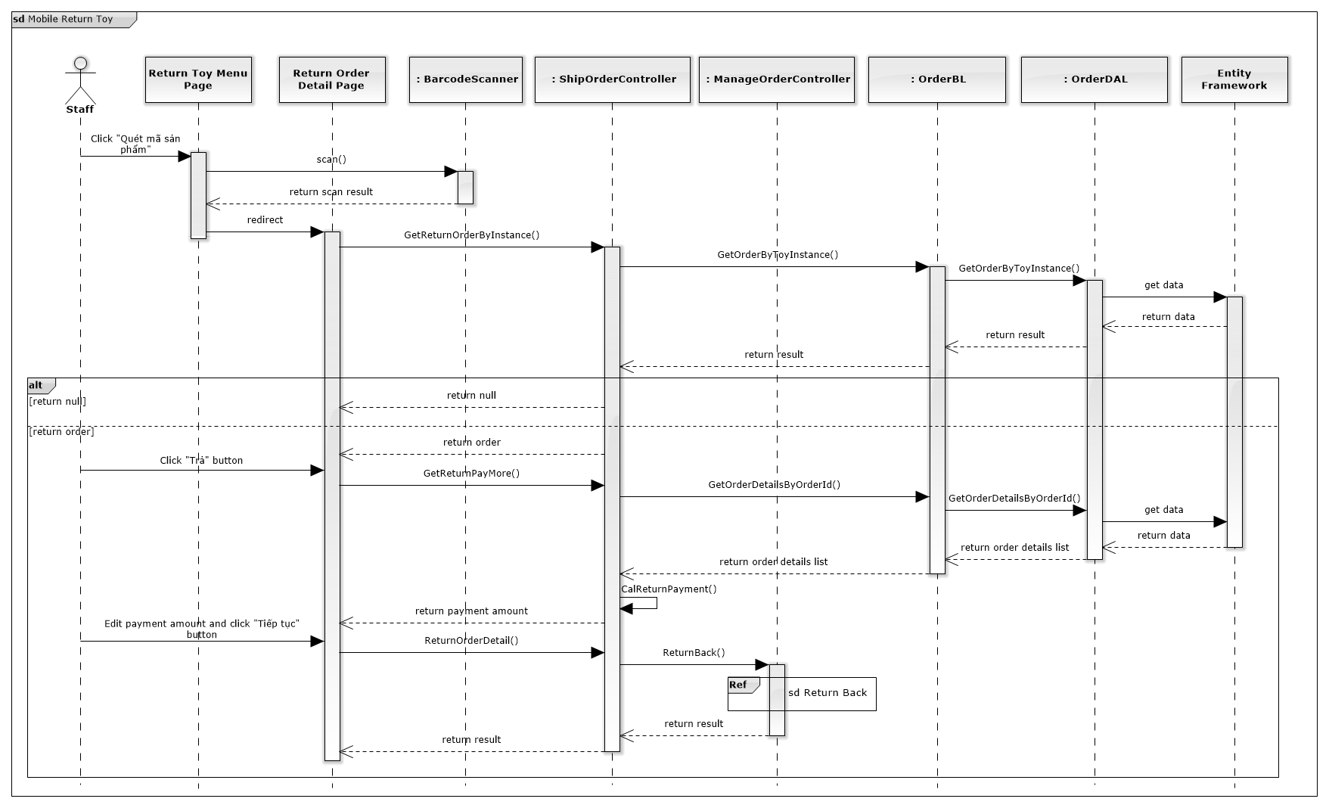

Figure 104: Mobile Return Toy

### **Mobile Finish Exchange**

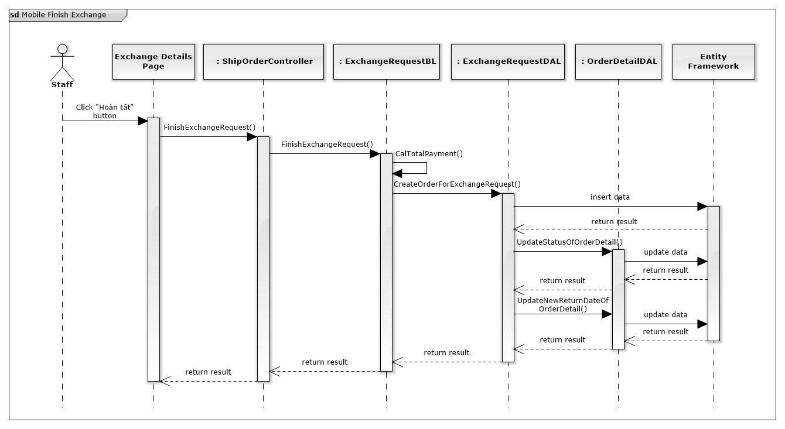

Figure 105: Mobile Finish Exchange

## User Interface Design

### **Login**

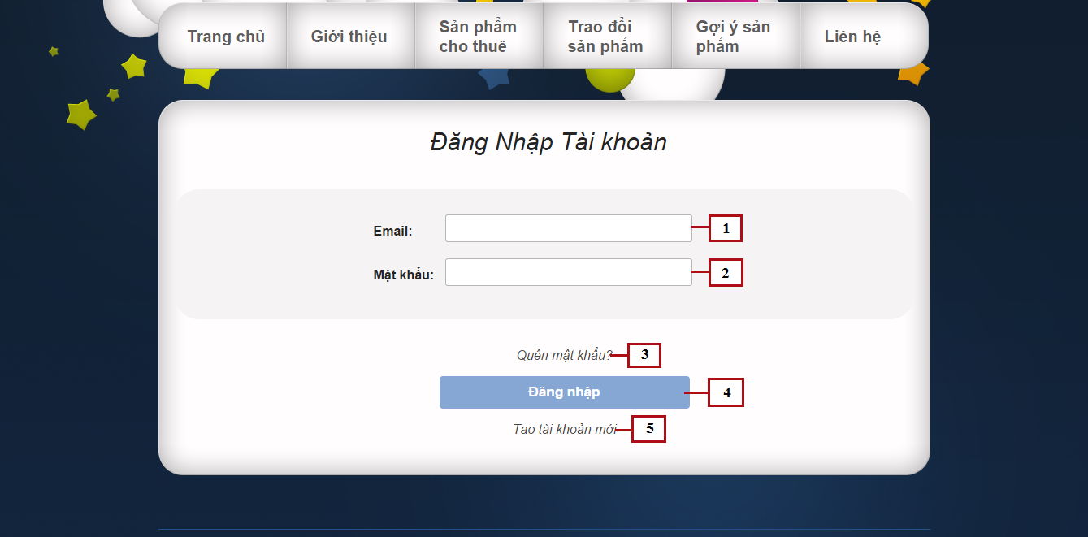

Figure 106: Login

**Fields**

|  |  |  |  |  |  |  |  |
| --- | --- | --- | --- | --- | --- | --- | --- |
| **No** | **Field Name** | **Description** | **Read only** | **Mandatory** | **Control Type** | **Data Type** | **Length** |
| 1 | Email | Fill user email | No | Yes | Textbox | String | N/A |
| 2 | Password | Fill password | No | Yes | Password | String | [8-32] |

**Buttons/Hyperlinks**

|  |  |  |  |  |
| --- | --- | --- | --- | --- |
| **No** | **Function** | **Description** | **Validation** | **Outcome** |
| 3 | Forget password | Click when forget password, to request new password | N/A | N/A |
| 3 | Login | Click to login into the system | Yes | Transfer to home page |
| 5 | Register | Click to register a new account | N/A | Transfer to register page |

### **View suggest toys**

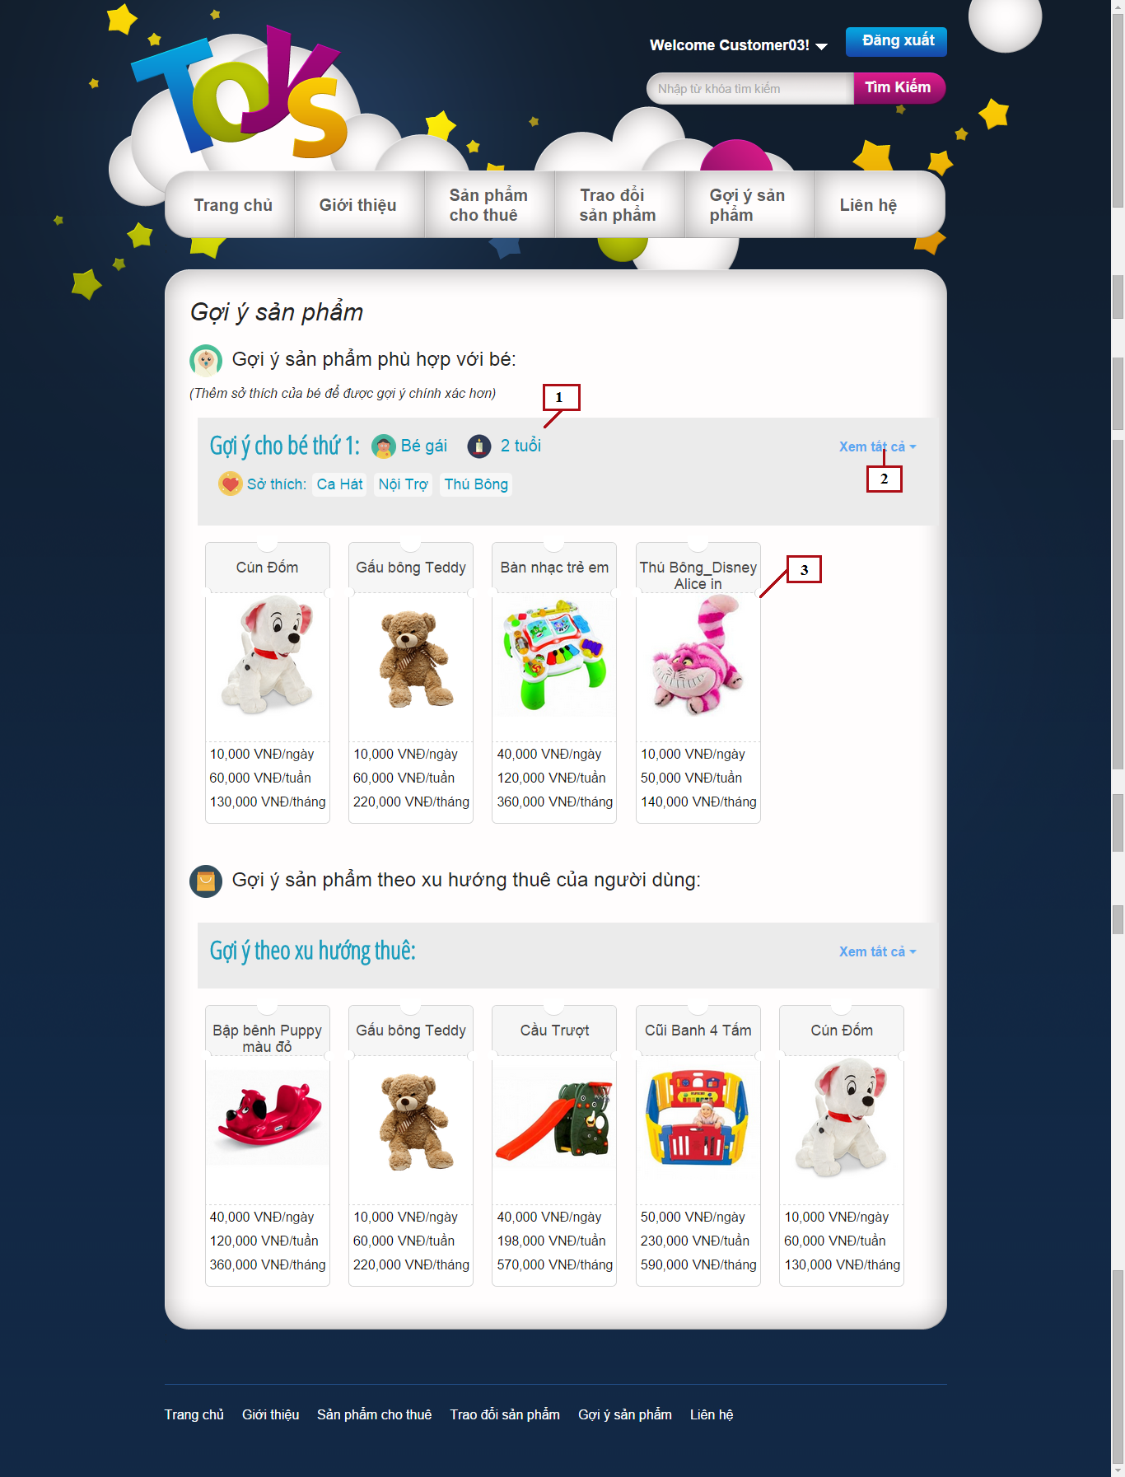

Figure 107: View Suggest Toys

**Fields**

|  |  |  |  |  |  |  |  |
| --- | --- | --- | --- | --- | --- | --- | --- |
| **No** | **Field Name** | **Description** | **Read only** | **Mandatory** | **Control Type** | **Data Type** | **Length** |
| 3 | Suggest Product List | List of suggested products | No | Yes | Grid list view | N/A | N/A |

**Buttons/Hyperlinks**

|  |  |  |  |  |
| --- | --- | --- | --- | --- |
| **No** | **Function** | **Description** | **Validation** | **Outcome** |
| 2 | Show/hide all | Click to show all suggested toys or to hide and display only 5 top toys | No | Show/hide products |

**Child’s information includes**

|  |  |  |  |  |  |
| --- | --- | --- | --- | --- | --- |
| **Field Name** | **Description** | **Read only** | **Control Type** | **Data Type** | **Length** |
| Child gender | Gender of child | Yes | Textview | String | N/A |
| Child age | Age of child | Yes | Textview | Integer | N/A |
| Child hobbies | Hobbies list of child | Yes | Textview | String | N/A |

**Suggest Product List includes**

|  |  |  |  |  |  |
| --- | --- | --- | --- | --- | --- |
| **Field Name** | **Description** | **Read only** | **Control Type** | **Data Type** | **Length** |
| Product name | Name of product | Yes | Textview | String | N/A |
| Product image | Image of product | Yes | Image | Bitmap | N/A |
| Product price | Day price, week price and month price of product | Yes | Textview | Integer | N/A |

### **My Exchangeable List**

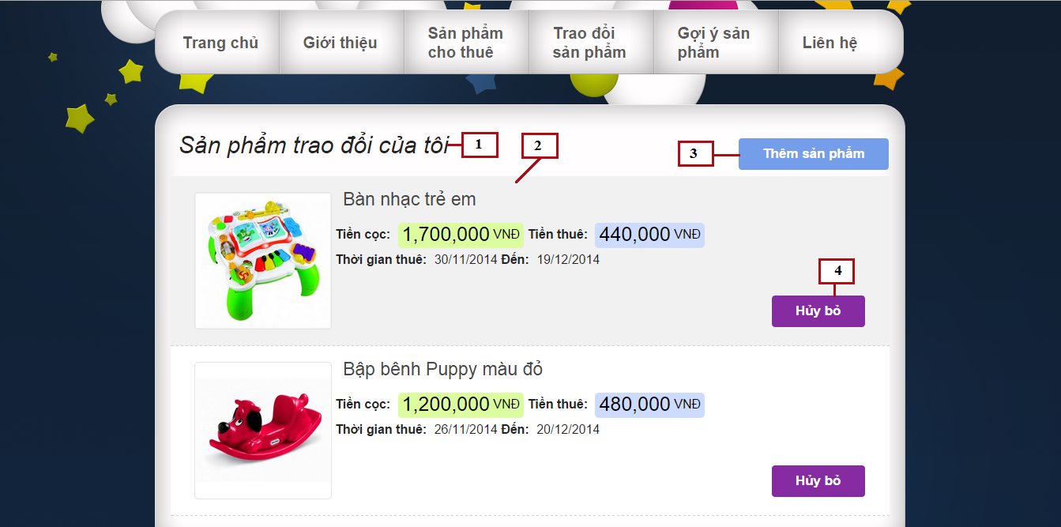

Figure 108: My Exchangeable List

**Fields**

|  |  |  |  |  |  |  |  |
| --- | --- | --- | --- | --- | --- | --- | --- |
| **No** | **Field Name** | **Description** | **Read only** | **Mandatory** | **Control Type** | **Data Type** | **Length** |
| 1 | Page title | Title of my exchange page | Yes | Yes | Label | N/A | N/A |
| 2 | Exchangeable Product List | List of suggested products | Yes | Yes | List view | N/A | N/A |

**Buttons/Hyperlinks**

|  |  |  |  |  |
| --- | --- | --- | --- | --- |
| **No** | **Function** | **Description** | **Validation** | **Outcome** |
| 3 | Add product | Add renting toy to exchangeable list | No | Display popup to select renting toys |
| 4 | Remove product | Remove renting toy from exchangeable list | No | Display popup to confirm removing |

**Exchangeable Product List includes**

|  |  |  |  |  |  |
| --- | --- | --- | --- | --- | --- |
| **Field Name** | **Description** | **Read only** | **Control Type** | **Data Type** | **Length** |
| Product name | Name of product | Yes | Textview | String | N/A |
| Product image | Image of product | Yes | Image | Bitmap | N/A |
| Product rent price | Rent price of product | Yes | Textview | Integer | N/A |
| Product deposit price | Deposit price of product | Yes | Textview | Integer | N/A |
| Rent time | Rent time of product | Yes | Textview | Datetime | N/A |

### **Add exchangeable products**

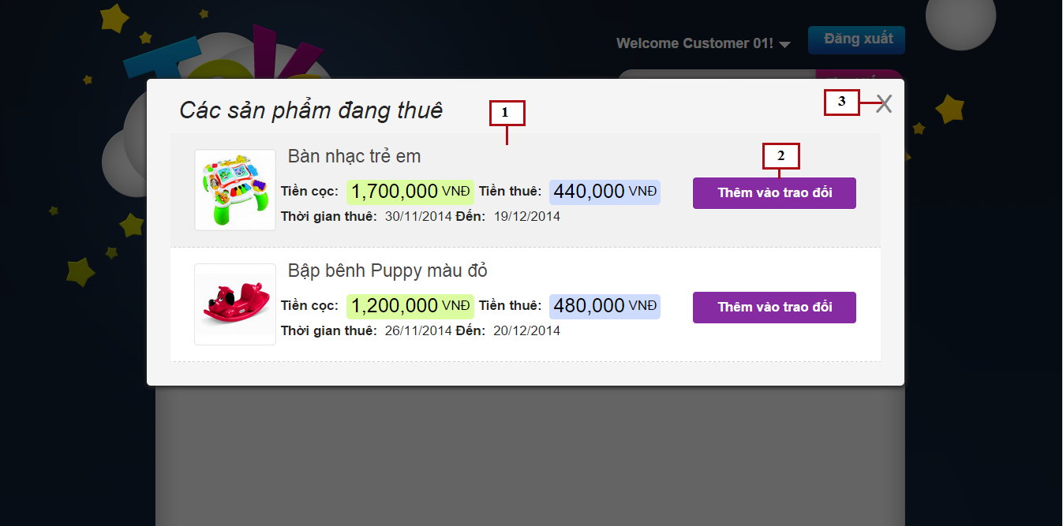

Figure 109: Add Exchangeable Products

**Fields**

|  |  |  |  |  |  |  |  |
| --- | --- | --- | --- | --- | --- | --- | --- |
| **No** | **Field Name** | **Description** | **Read only** | **Mandatory** | **Control Type** | **Data Type** | **Length** |
| 1 | Renting Product List | List of renting products | Yes | Yes | List view | N/A | N/A |

**Buttons/Hyperlinks**

|  |  |  |  |  |
| --- | --- | --- | --- | --- |
| **No** | **Function** | **Description** | **Validation** | **Outcome** |
| 2 | Add product | Click to add renting product to exchange list | No | Display popup to confirm adding product |
| 3 | Close | Click to close popup | No | Close popup |

**Renting Product List includes**

|  |  |  |  |  |  |
| --- | --- | --- | --- | --- | --- |
| **Field Name** | **Description** | **Read only** | **Control Type** | **Data Type** | **Length** |
| Product name | Name of product | Yes | Textview | String | N/A |
| Product image | Image of product | Yes | Image | Bitmap | N/A |
| Product rent price | Rent price of product | Yes | Textview | Integer | N/A |
| Product deposit price | Deposit price of product | Yes | Textview | Integer | N/A |
| Rent time | Rent time of product | Yes | Textview | Datetime | N/A |

### **Other Customer Exchangeable List**

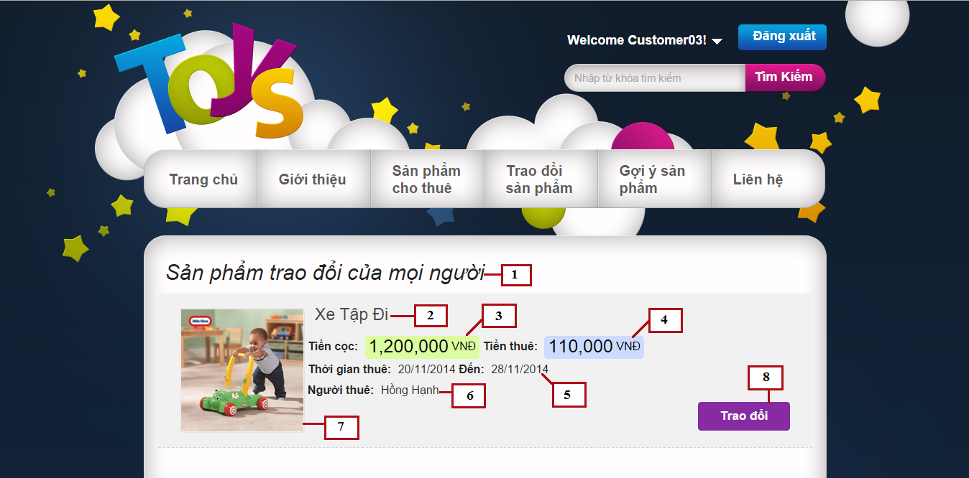

Figure 110: Other Customer Exchangeable List

**Fields**

|  |  |  |  |  |  |  |  |
| --- | --- | --- | --- | --- | --- | --- | --- |
| **No** | **Field Name** | **Description** | **Read only** | **Mandatory** | **Control Type** | **Data Type** | **Length** |
| 1 | Page title | Title of other customer exchange page | Yes | Yes | Label | N/A | N/A |
| 2 | Product name | Name of product | Yes | Yes | Textview | String | N/A |
| 3 | Product deposit price | Deposit price of product | Yes | Yes | Textview | Integer | N/A |
| 4 | Product rent price | Rent price of product | Yes | Yes | Textview | Integer | N/A |
| 5 | Rent time | Rent time of product | Yes | Yes | Textview | Datetime | N/A |
| 6 | Customer name | Name of customer renting this toy | Yes | Yes | Textview | String | N/A |
| 7 | Product image | Image of product | Yes | Yes | Image | Bitmap | N/A |

**Buttons/Hyperlinks**

|  |  |  |  |  |
| --- | --- | --- | --- | --- |
| **No** | **Function** | **Description** | **Validation** | **Outcome** |
| 8 | Exchage | Click to send exchange request | No | Display popup to send exchange request |

### **Send Exchange Request – Select product**

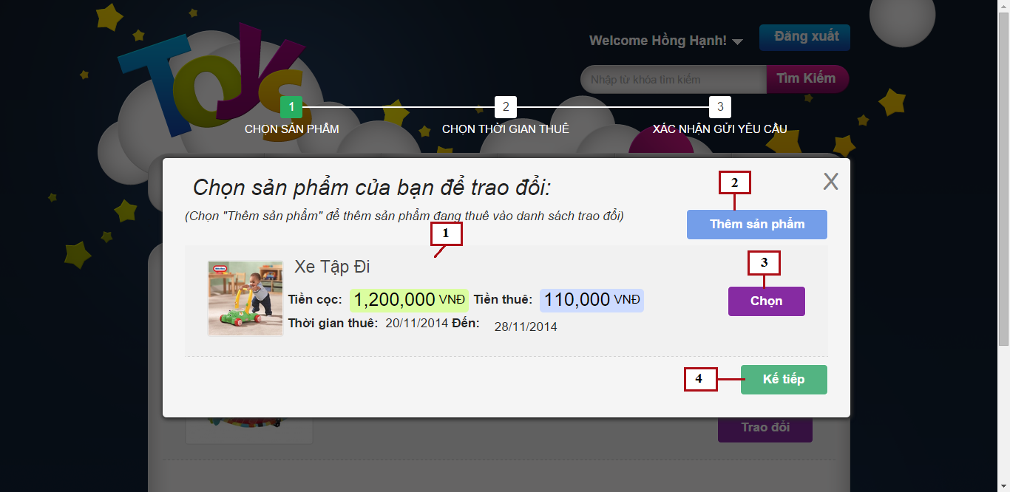

Figure 111: Send Exchange Request – Select Product

**Fields**

|  |  |  |  |  |  |  |  |
| --- | --- | --- | --- | --- | --- | --- | --- |
| **No** | **Field Name** | **Description** | **Read only** | **Mandatory** | **Control Type** | **Data Type** | **Length** |
| 1 | Exchangeable Product List | List of suggested products | Yes | Yes | List view | N/A | N/A |

**Buttons/Hyperlinks**

|  |  |  |  |  |
| --- | --- | --- | --- | --- |
| **No** | **Function** | **Description** | **Validation** | **Outcome** |
| 2 | Add product | Add renting toy to exchangeable list | No | Display popup to select renting toys |
| 3 | Select product | Click to select product to exchange | Yes | Mark product ad selected |
| 4 | Next step | Click to go to next step | Yes | Transfer to next step |

**Exchangeable Product List includes**

|  |  |  |  |  |  |
| --- | --- | --- | --- | --- | --- |
| **Field Name** | **Description** | **Read only** | **Control Type** | **Data Type** | **Length** |
| Product name | Name of product | Yes | Textview | String | N/A |
| Product image | Image of product | Yes | Image | Bitmap | N/A |
| Product rent price | Rent price of product | Yes | Textview | Integer | N/A |
| Product deposit price | Deposit price of product | Yes | Textview | Integer | N/A |
| Rent time | Rent time of product | Yes | Textview | Datetime | N/A |

### **Send Exchange Request – Select new return date**

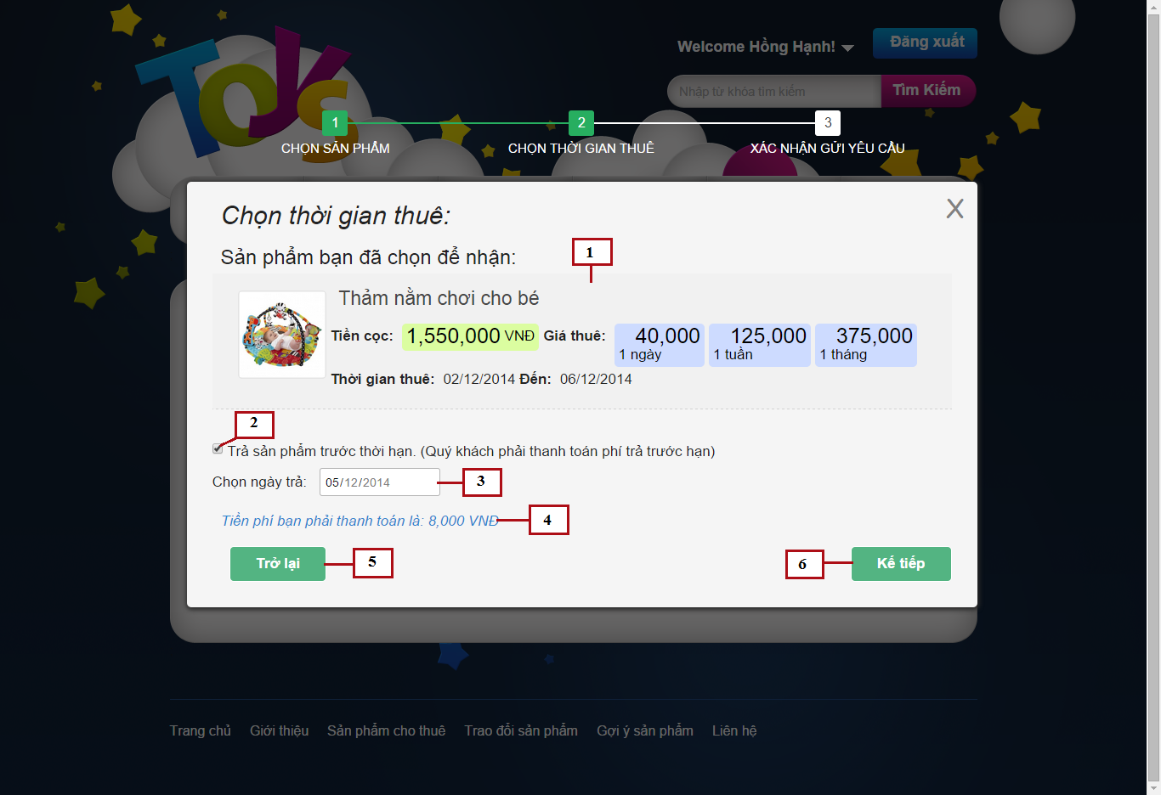

Figure 112: Send Exchange Request – Select new return date

**Fields**

|  |  |  |  |  |  |  |  |
| --- | --- | --- | --- | --- | --- | --- | --- |
| **No** | **Field Name** | **Description** | **Read only** | **Mandatory** | **Control Type** | **Data Type** | **Length** |
| 1 | Receive Product Detail | Short detail of receive product | Yes | Yes | List view | N/A | N/A |
| 2 | Return soon checkbox | Enable/disable return soon date | No | No | Checkbox | Bool | N/A |
| 3 | Return soon date | Select date to return soon | No | No | Date picker | Datetime | N/A |
| 4 | Return soon fee | Fee customer has to pay when return product soon | Yes | No | Textview | Integer | N/A |

**Buttons/Hyperlinks**

|  |  |  |  |  |
| --- | --- | --- | --- | --- |
| **No** | **Function** | **Description** | **Validation** | **Outcome** |
| 5 | Previous step | Click to go to previous step | No | Transfer to previous step |
| 6 | Next step | Click to go to next step | No | Transfer to next step |

**Receive Product Detail includes**

|  |  |  |  |  |  |
| --- | --- | --- | --- | --- | --- |
| **Field Name** | **Description** | **Read only** | **Control Type** | **Data Type** | **Length** |
| Product name | Name of product | Yes | Textview | String | N/A |
| Product image | Image of product | Yes | Image | Bitmap | N/A |
| Product rent price | Rent price of product for 1 day, 1 week or 1 month | Yes | Textview | Integer | N/A |
| Product deposit price | Deposit price of product | Yes | Textview | Integer | N/A |
| Rent time | Rent time of product | Yes | Textview | Datetime | N/A |

### **Send Exchange Request – Confirm and send request**

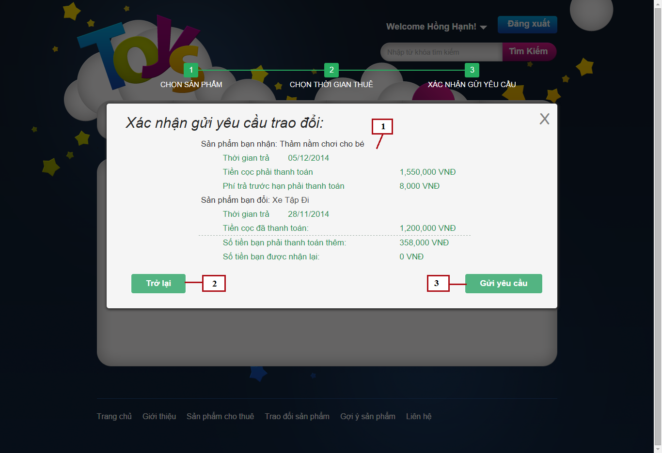

Figure 113: Send Exchange Request – Confirm and send request

**Fields**

|  |  |  |  |  |  |  |  |
| --- | --- | --- | --- | --- | --- | --- | --- |
| **No** | **Field Name** | **Description** | **Read only** | **Mandatory** | **Control Type** | **Data Type** | **Length** |
| 1 | Exchange details | Exchange fee details of exchange | Yes | Yes | Textview | N/A | N/A |

**Buttons/Hyperlinks**

|  |  |  |  |  |
| --- | --- | --- | --- | --- |
| **No** | **Function** | **Description** | **Validation** | **Outcome** |
| 2 | Previous step | Click to go to previous step | No | Transfer to previous step |
| 3 | Send request | Click to send exchange request | Yes | Save exchange request to system and close popup |

**Exchange details includes**

|  |  |  |  |  |  |
| --- | --- | --- | --- | --- | --- |
| **Field Name** | **Description** | **Read only** | **Control Type** | **Data Type** | **Length** |
| Product name | Name of each product | Yes | Textview | String | N/A |
| Return time | Return time of each product | Yes | Textview | Datetime | N/A |
| Receive product deposit | Deposit of receive product | Yes | Textview | Integer | N/A |
| Return soon fee | Fee for return product soon | Yes | Textview | Integer | N/A |
| Exchange product deposit | Deposit of exchange product | Yes | Textview | Integer | N/A |
| Total payment | Total price customer has to pay | Yes | Textview | Integer | N/A |
| Total return back | Total money customer receive when exchange | Yes | Textview | Integer | N/A |

### **My sent exchange request**

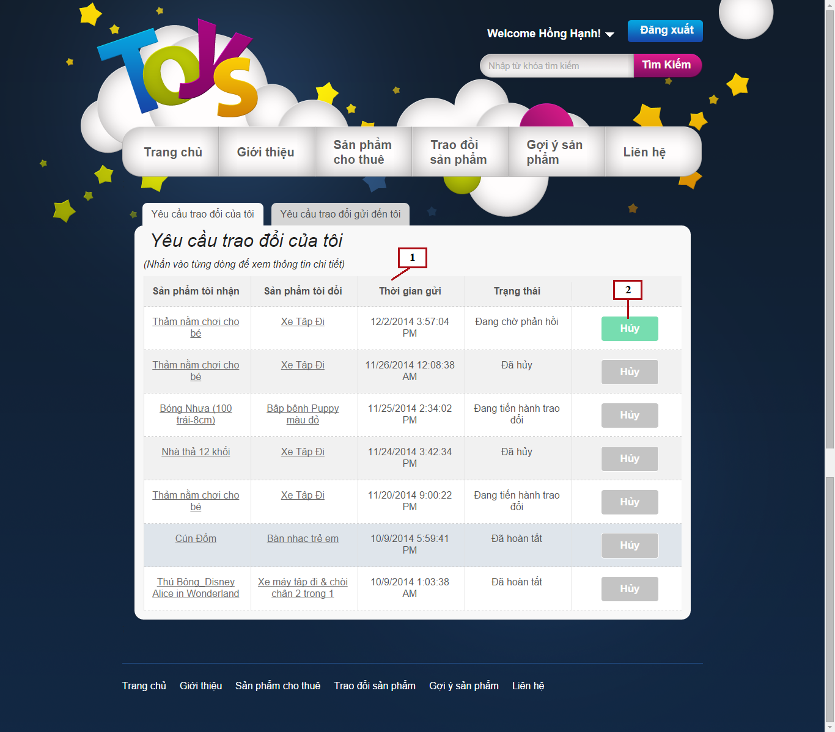

Figure 114: My Sent Exchange Request

**Fields**

|  |  |  |  |  |  |  |  |
| --- | --- | --- | --- | --- | --- | --- | --- |
| **No** | **Field Name** | **Description** | **Read only** | **Mandatory** | **Control Type** | **Data Type** | **Length** |
| 1 | Exchange Request List | List of exchange request current customer has sent | Yes | Yes | Listview | N/A | N/A |

**Buttons/Hyperlinks**

|  |  |  |  |  |
| --- | --- | --- | --- | --- |
| **No** | **Function** | **Description** | **Validation** | **Outcome** |
| 2 | Cancel | Click to cancel exchange request | Yes | Change exchange request status to cancel |

**Exchange Request List includes**

|  |  |  |  |  |  |
| --- | --- | --- | --- | --- | --- |
| **Field Name** | **Description** | **Read only** | **Control Type** | **Data Type** | **Length** |
| Receive product name | Name of receive product | Yes | Textview | String | N/A |
| Exchange product name | Name of exchange product | Yes | Textview | String | N/A |
| Send request time | Time that request has been sent | Yes | Textview | Datetime | N/A |
| Status | Status of exchange request | Yes | Textview | String | N/A |

### **My receive exchange request**

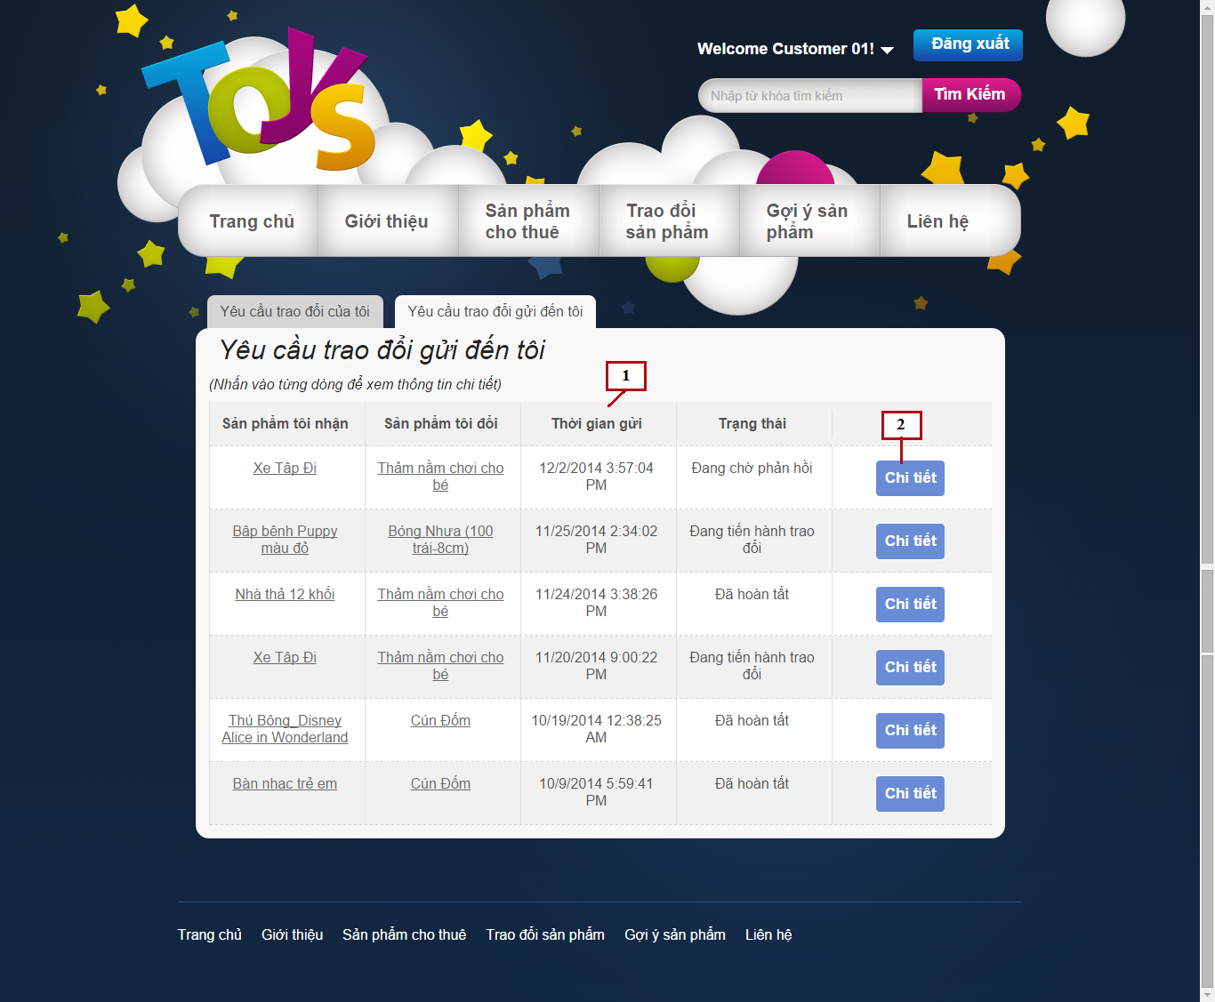

Figure 115: My Receive Exchange Request

**Fields**

|  |  |  |  |  |  |  |  |
| --- | --- | --- | --- | --- | --- | --- | --- |
| **No** | **Field Name** | **Description** | **Read only** | **Mandatory** | **Control Type** | **Data Type** | **Length** |
| 1 | Exchange Request List | List of exchange request current customer has sent | Yes | Yes | Listview | N/A | N/A |

**Buttons/Hyperlinks**

|  |  |  |  |  |
| --- | --- | --- | --- | --- |
| **No** | **Function** | **Description** | **Validation** | **Outcome** |
| 2 | View Detail | Click to view exchange request detail | No | Display exchange request detail |

**Exchange Request List includes**

|  |  |  |  |  |  |
| --- | --- | --- | --- | --- | --- |
| **Field Name** | **Description** | **Read only** | **Control Type** | **Data Type** | **Length** |
| Receive product name | Name of receive product | Yes | Textview | String | N/A |
| Exchange product name | Name of exchange product | Yes | Textview | String | N/A |
| Send request time | Time that request has been sent | Yes | Textview | Datetime | N/A |
| Status | Status of exchange request | Yes | Textview | String | N/A |

### **Exchange Request Details**

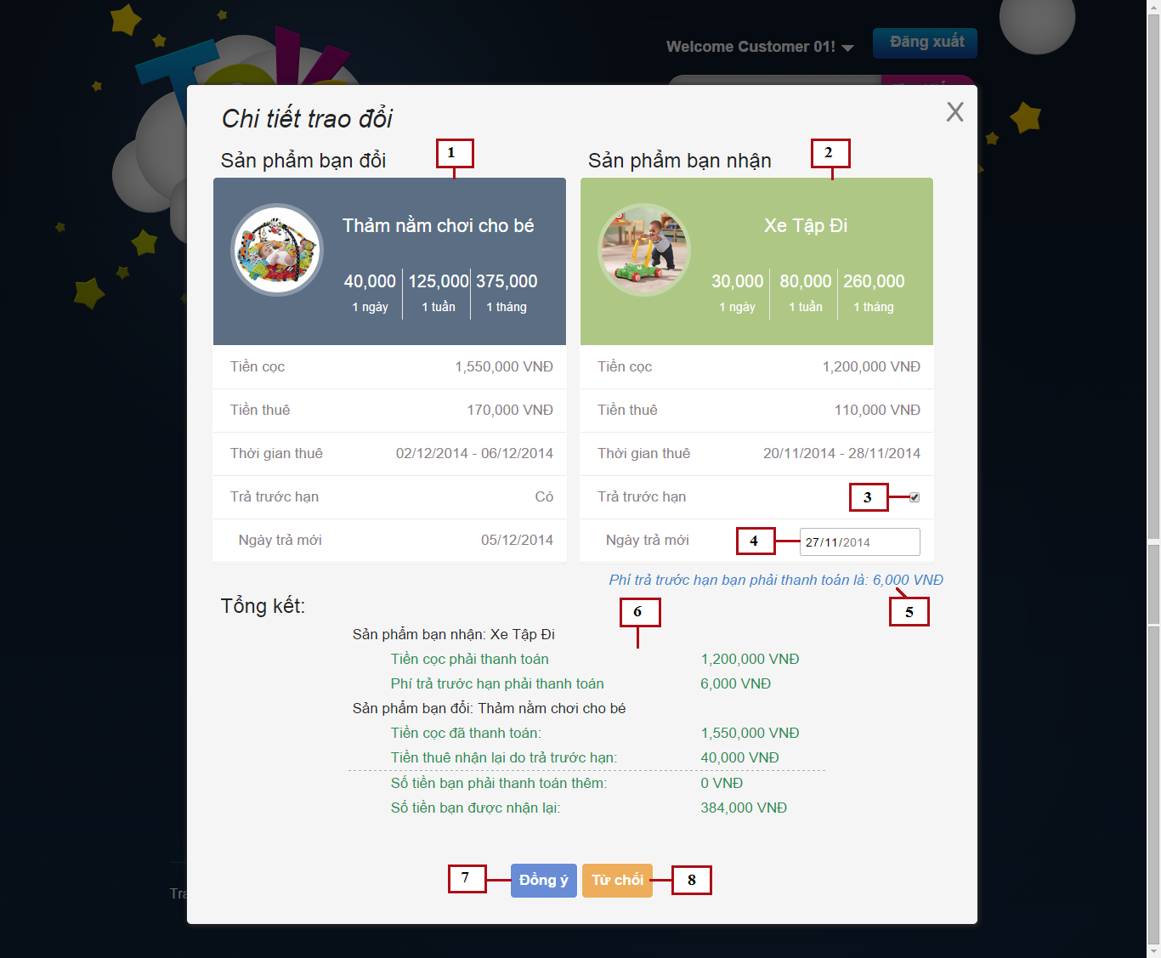

Figure 116: Exchange Request Details

**Fields**

|  |  |  |  |  |  |  |  |
| --- | --- | --- | --- | --- | --- | --- | --- |
| **No** | **Field Name** | **Description** | **Read only** | **Mandatory** | **Control Type** | **Data Type** | **Length** |
| 1 | Receive product detail | Detail of receive product | Yes | Yes | N/A | N/A | N/A |
| 2 | Exchange product detail | Detail of exchange product | Yes | Yes | N/A | N/A | N/A |
| 3 | Return soon checkbox | Enable/disable return soon date | No | No | Checkbox | Bool | N/A |
| 4 | Return soon date | Select date to return soon | No | No | Date picker | Datetime | N/A |
| 5 | Return soon fee | Fee customer has to pay when return product soon | Yes | No | Textview | Integer | N/A |
| 6 | Exchange details | Exchange fee details of exchange | Yes | Yes | Textview | N/A | N/A |

**Buttons/Hyperlinks**

|  |  |  |  |  |
| --- | --- | --- | --- | --- |
| **No** | **Function** | **Description** | **Validation** | **Outcome** |
| 7 | Confirm exchange | Click to confirm exchange | Yes | Change exchange request status to confirmed and close popup |
| 8 | Deny exchange | Click to deny exchange | Yes | Change exchange request status to denied and close popup |

**Receive product detail includes**

|  |  |  |  |  |  |
| --- | --- | --- | --- | --- | --- |
| **Field Name** | **Description** | **Read only** | **Control Type** | **Data Type** | **Length** |
| Product name | Name of product | Yes | Textview | String | N/A |
| Product image | Image of product | Yes | Image | Bitmap | N/A |
| Product rent price | Rent price of product | Yes | Textview | Integer | N/A |
| Product deposit price | Deposit price of product | Yes | Textview | Integer | N/A |
| Total rent price | Total rent price of product | Yes | Textview | Integer | N/A |
| Rent time | Rent time of product | Yes | Textview | Datetime | N/A |
| Return soon date | Return soon date of sender | Yes | Textview | Datetime | N/A |

**Exchange product detail includes**

|  |  |  |  |  |  |
| --- | --- | --- | --- | --- | --- |
| **Field Name** | **Description** | **Read only** | **Control Type** | **Data Type** | **Length** |
| Product name | Name of product | Yes | Textview | String | N/A |
| Product image | Image of product | Yes | Image | Bitmap | N/A |
| Product rent price | Rent price of product | Yes | Textview | Integer | N/A |
| Product deposit price | Deposit price of product | Yes | Textview | Integer | N/A |
| Total rent price | Total rent price of product | Yes | Textview | Integer | N/A |
| Rent time | Rent time of product | Yes | Textview | Datetime | N/A |

**Exchange details includes**

|  |  |  |  |  |  |
| --- | --- | --- | --- | --- | --- |
| **Field Name** | **Description** | **Read only** | **Control Type** | **Data Type** | **Length** |
| Product name | Name of each product | Yes | Textview | String | N/A |
| Receive product deposit | Deposit of receive product | Yes | Textview | Integer | N/A |
| Return soon fee | Fee for return product soon | Yes | Textview | Integer | N/A |
| Exchange product deposit | Deposit of exchange product | Yes | Textview | Integer | N/A |
| Return soon money back | Money return back when sender return soon | Yes | Textview | Integer | N/A |
| Total payment | Total price customer has to pay | Yes | Textview | Integer | N/A |
| Total return back | Total money customer receive when exchange | Yes | Textview | Integer | N/A |

### **Manage Exchange**

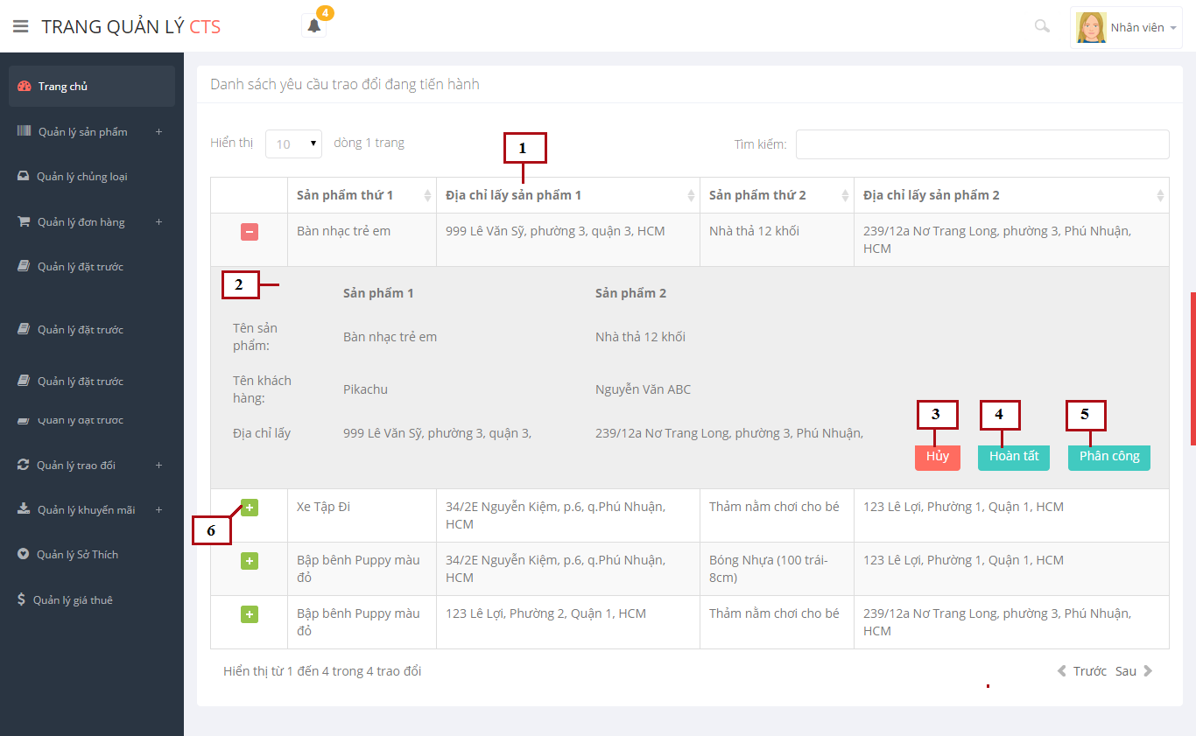

Figure 117: Manage Exchange

**Fields**

|  |  |  |  |  |  |  |  |
| --- | --- | --- | --- | --- | --- | --- | --- |
| **No** | **Field Name** | **Description** | **Read only** | **Mandatory** | **Control Type** | **Data Type** | **Length** |
| 1 | Exchange request list | List of exchange request | Yes | Yes | Table | N/A | N/A |
| 2 | Exchange detail | More detail of exchange request | Yes | Yes | Listview | N/A | N/A |

**Buttons/Hyperlinks**

|  |  |  |  |  |
| --- | --- | --- | --- | --- |
| **No** | **Function** | **Description** | **Validation** | **Outcome** |
| 3 | Cancel exchange | Click to cancel exchange request | Yes | Change exchange request status to cancel |
| 4 | Done exchange | Click to done exchange process | Yes | Change exchange request status to done |
| 5 | Assign shipper | Assign staff to manage this exchange | No | Display popup to select staff |
| 6 | View detail | Click to display more details of exchange | No | Display more detail of exchange |

**Exchange request list includes**

|  |  |  |  |  |  |
| --- | --- | --- | --- | --- | --- |
| **Field Name** | **Description** | **Read only** | **Control Type** | **Data Type** | **Length** |
| First product name | Name of first product | Yes | Textview | String | N/A |
| First address | Address to take first product | Yes | Textview | String | N/A |
| Second product name | Name of second product | Yes | Textview | String | N/A |
| Second address | Address to take second product | Yes | Textview | String | N/A |

**Exchange detail includes**

|  |  |  |  |  |  |
| --- | --- | --- | --- | --- | --- |
| **Field Name** | **Description** | **Read only** | **Control Type** | **Data Type** | **Length** |
| Product name | Name of product | Yes | Textview | String | N/A |
| Customer name | Name of customer renting these product | Yes | Textview | String | N/A |
| Address | Address to take these product | Yes | Textview | String | N/A |

### **Product Details**

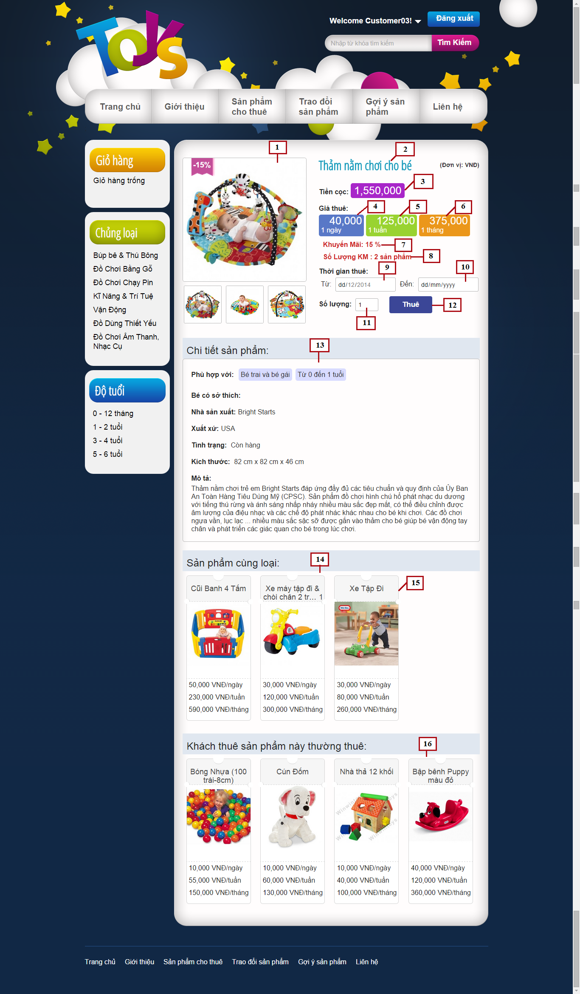

Figure 118: Product Details

**Fields**

|  |  |  |  |  |  |  |  |
| --- | --- | --- | --- | --- | --- | --- | --- |
| **No** | **Field Name** | **Description** | **Read only** | **Mandatory** | **Control Type** | **Data Type** | **Length** |
| 1 | Product images | Images of current product | Yes | Yes | Image | Bitmap | N/A |
| 2 | Product name | Name of current product | Yes | Yes | Textview | String | N/A |
| 3 | Deposit | Deposit price to rent this product | Yes | Yes | Textview | Integer | N/A |
| 4 | Day price | Rent price for 1 day | Yes | Yes | Textview | Integer | N/A |
| 5 | Week price | Rent price for 1 week | Yes | Yes | Textview | Integer | N/A |
| 6 | Month price | Rent price for 1 month | Yes | Yes | Textview | Integer | N/A |
| 7 | Discount percent | Discount percent of this product | Yes | Yes | Textview | Integer | N/A |
| 8 | Discount remain amount | Remaining amount of discount items in stock | Yes | Yes | Textview | Integer | N/A |
| 9 | Rent from date | Select date to start renting | No | Yes | Datepicker | Datetime | N/A |
| 10 | Rent to date | Select date to return product | No | Yes | Datepicker | Datetime | N/A |
| 11 | Amount | Select amount to rent | No | Yes | Input | Integer | N/A |
| 13 | Product details | Details of current product | Yes | Yes | Textview | N/A | N/A |
| 14 | Same category list | List of products in same category with current product | Yes | Yes | Grid list view | N/A | N/A |
| 15 | Suggest product | Suggest product for current product | No | Yes | Grid view | N/A | N/A |
| 16 | Customer often rent | List of products that customer rented this product often rent | No | Yes | Grid list view | N/A | N/A |

**Buttons/Hyperlinks**

|  |  |  |  |  |
| --- | --- | --- | --- | --- |
| **No** | **Function** | **Description** | **Validation** | **Outcome** |
| 12 | Rent product | Click to add current product to cart | Yes | Add current product to cart and display success message |

**Product Details includes**

|  |  |  |  |  |  |
| --- | --- | --- | --- | --- | --- |
| **Field Name** | **Description** | **Read only** | **Control Type** | **Data Type** | **Length** |
| Appropriate age | Appropriate age to use this product | Yes | Textview | Integer | N/A |
| Appropriate gender | Appropriate gender to use this product | Yes | Textview | String | N/A |
| Appropriate hobbies | Appropriate hobbies to use this product | Yes | Textview | String | N/A |
| Manufacturer | Manufacturer of this product | Yes | Textview | String | N/A |
| Origin | Origin of this product | Yes | Textview | String | N/A |
| Status | Status of this product | Yes | Textview | String | N/A |
| Dimensions | Dimensions of this product | Yes | Textview | Double | N/A |
| Short description | Short description of this product | Yes | Textview | String | N/A |

**Suggest Product includes**

|  |  |  |  |  |  |
| --- | --- | --- | --- | --- | --- |
| **Field Name** | **Description** | **Read only** | **Control Type** | **Data Type** | **Length** |
| Product name | Name of product | Yes | Textview | String | N/A |
| Product image | Image of product | Yes | Image | Bitmap | N/A |
| Product price | Day price, week price and month price of product | Yes | Textview | Integer | N/A |

### **View statistic report by year**

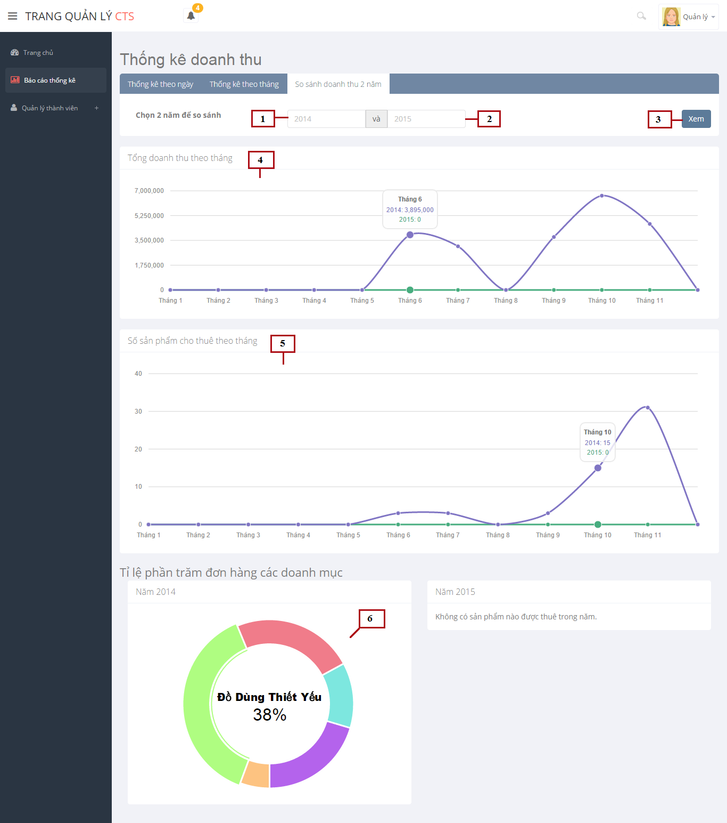

Figure 119: View Statistic Report

**Fields**

|  |  |  |  |  |  |  |  |
| --- | --- | --- | --- | --- | --- | --- | --- |
| **No** | **Field Name** | **Description** | **Read only** | **Mandatory** | **Control Type** | **Data Type** | **Length** |
| 1 | First | Input first year to compare | No | Yes | Input | Integer | N/A |
| 2 | Second year | Input second year to compare | No | Yes | Input | Integer | N/A |
| 4 | Incomes line chart | Line chart compares incomes of 2 years | Yes | Yes | Line Chart | N/A | N/A |
| 5 | Rent amount line chart | Line chart compares rented amount of products of 2 years | Yes | Yes | Line Chart | N/A | N/A |
| 6 | Category portion pie chart | Pie charts show rented percent of product categories | Yes | Yes | Pie Chart | N/A | N/A |

**Buttons/Hyperlinks**

|  |  |  |  |  |
| --- | --- | --- | --- | --- |
| **No** | **Function** | **Description** | **Validation** | **Outcome** |
| 3 | Compare | Click to start compare 2 years | Yes | Compare and display charts as result |

### **Mobile app menu**

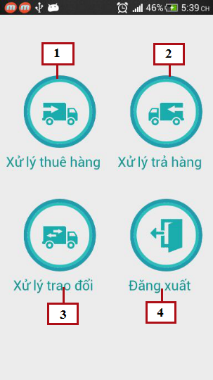

Figure 120: Mobile App Menu

**Buttons/Hyperlinks**

|  |  |  |  |  |
| --- | --- | --- | --- | --- |
| **No** | **Function** | **Description** | **Validation** | **Outcome** |
| 1 | Process rent toys | Click to go to process rent toys page | No | Transfer to Process Rent Toys page |
| 2 | Process return toys | Click to go to process return toys page | No | Transfer to Process Return Toys page |
| 3 | Process exchange toys | Click to go to process exchange toys page | No | Transfer to Process Exchange Toys page |
| 4 | Logout | Click to logout of mobile app | No | Transfer to Login page |

### **Mobile Assigned Orders**

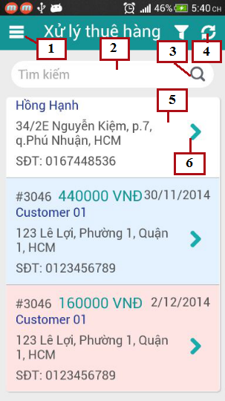

Figure 121: Mobile Assigned Orders

**Fields**

|  |  |  |  |  |  |  |  |
| --- | --- | --- | --- | --- | --- | --- | --- |
| **No** | **Field Name** | **Description** | **Read only** | **Mandatory** | **Control Type** | **Data Type** | **Length** |
| 2 | Search field | Input keyword to search order | No | Yes | Input | String | N/A |
| 5 | Order list | List of assigned orders | Yes | Yes | List view | N/A | N/A |

**Buttons/Hyperlinks**

|  |  |  |  |  |
| --- | --- | --- | --- | --- |
| **No** | **Function** | **Description** | **Validation** | **Outcome** |
| 1 | Menu | Click to open menu | No | Show application menu |
| 3 | Search | Click to search order by keyword | No | Search and show results |
| 4 | Refresh | Refresh orders list, get new orders | No | Refresh orders list |
| 6 | View detail | Click to view order details | No | Transfer to order details page |

**Order List includes**

|  |  |  |  |  |  |
| --- | --- | --- | --- | --- | --- |
| **Field Name** | **Description** | **Read only** | **Control Type** | **Data Type** | **Length** |
| Order Id | ID of order | Yes | Textview | Integer | N/A |
| Total | Total price of order | Yes | Textview | Integer | N/A |
| Deliver date | Date to deliver order | Yes | Textview | Datetime | N/A |
| Customer name | Name of customer | Yes | Textview | String | N/A |
| Address | Address of customer | Yes | Textview | String | N/A |
| Phone | Phone of customer | Yes | Textview | String | [10-11] |

### **Mobile order details**

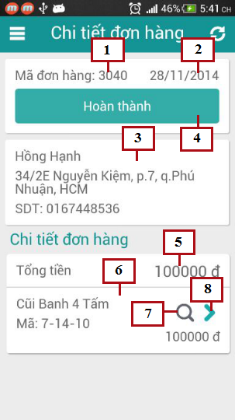

Figure 122: Mobile Order Details

**Fields**

|  |  |  |  |  |  |  |  |
| --- | --- | --- | --- | --- | --- | --- | --- |
| **No** | **Field Name** | **Description** | **Read only** | **Mandatory** | **Control Type** | **Data Type** | **Length** |
| 1 | Order Id | Id of order | Yes | Yes | Textview | Integer | N/A |
| 2 | Deliver date | Date to deliver order | Yes | Yes | Textview | Datetime | N/A |
| 3 | Customer information | Information of receive customer | Yes | Yes | Textview | N/A | N/A |
| 5 | Total | Total price of order | Yes | Yes | Textview | Integer | N/A |
| 6 | Order details | Details of order | Yes | Yes | List view | N/A | N/A |

**Buttons/Hyperlinks**

|  |  |  |  |  |
| --- | --- | --- | --- | --- |
| **No** | **Function** | **Description** | **Validation** | **Outcome** |
| 4 | Done | Click to done deliver process | No | Change order status to done |
| 7 | Scan | Click to scan QR code of product | No | Open camera to start scan QR code |
| 8 | View Detail | Click to view detail of product | No | Transfer to product details page |

**Customer Information includes**

|  |  |  |  |  |  |
| --- | --- | --- | --- | --- | --- |
| **Field Name** | **Description** | **Read only** | **Control Type** | **Data Type** | **Length** |
| Customer name | Name of customer | Yes | Textview | String | N/A |
| Customer address | Address of customer | Yes | Textview | String | N/A |
| Customer phone | Phone of customer | Yes | Textview | String | [10-11] |

**Order Detail includes**

|  |  |  |  |  |  |
| --- | --- | --- | --- | --- | --- |
| **Field Name** | **Description** | **Read only** | **Control Type** | **Data Type** | **Length** |
| Product name | Name of product | Yes | Textview | String | N/A |
| Product code | QR code of product | Yes | Textview | String | N/A |

### **Mobile product details**

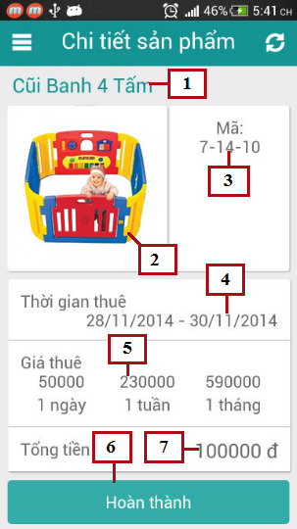

Figure 123: Mobile Product Details

**Fields**

|  |  |  |  |  |  |  |  |
| --- | --- | --- | --- | --- | --- | --- | --- |
| **No** | **Field Name** | **Description** | **Read only** | **Mandatory** | **Control Type** | **Data Type** | **Length** |
| 1 | Product name | Name of product | Yes | Yes | Textview | String | N/A |
| 2 | Product image | Image of product | Yes | Yes | Image | Bitmap | N/A |
| 3 | Product code | QR code of product | Yes | Yes | Textview | String | N/A |
| 4 | Rent time | Product’s rent time | Yes | Yes | Textview | Datetime | N/A |
| 5 | Rent price | Rent price of product for 1 day, 1 week or 1 month | Yes | Yes | Textview | Integer | N/A |
| 7 | Total | Total rent price of product | Yes | Yes | Textview | Integer | N/A |

**Buttons/Hyperlinks**

|  |  |  |  |  |
| --- | --- | --- | --- | --- |
| **No** | **Function** | **Description** | **Validation** | **Outcome** |
| 6 | Done | Click to done deliver product | No | Change order detail status to done |

### **Mobile Assigned Exchange List**

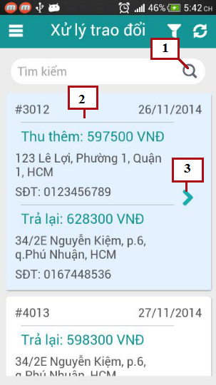

Figure 124: Mobile Assigned Exchange List

**Fields**

|  |  |  |  |  |  |  |  |
| --- | --- | --- | --- | --- | --- | --- | --- |
| **No** | **Field Name** | **Description** | **Read only** | **Mandatory** | **Control Type** | **Data Type** | **Length** |
| 2 | Exchange List | List of assigned exchange | Yes | Yes | List view | N/A | N/A |

**Buttons/Hyperlinks**

|  |  |  |  |  |
| --- | --- | --- | --- | --- |
| **No** | **Function** | **Description** | **Validation** | **Outcome** |
| 1 | Search | Search exchange by Id | No | Search exchange by Id |
| 3 | View detail | View details of exchange | No | Transfer to Exchange detail page |

**Exchange List includes**

|  |  |  |  |  |  |
| --- | --- | --- | --- | --- | --- |
| **Field Name** | **Description** | **Read only** | **Control Type** | **Data Type** | **Length** |
| Exchange Id | ID of exchange | Yes | Textview | Integer | N/A |
| Exchange date | Date to exchange | Yes | Textview | Datetime | N/A |
| First product fee | Money first customer has to pay or receive | Yes | Textview | Integer | N/A |
| First Address | Address of first customer | Yes | Textview | String | N/A |
| First Phone | Phone of first customer | Yes | Textview | String | [10-11] |
| Second product fee | Money second customer has to pay or receive | Yes | Textview | Integer | N/A |
| Second Address | Address of second customer | Yes | Textview | String | N/A |
| Second Phone | Phone of second customer | Yes | Textview | String | [10-11] |

### **Mobile Exchange Details**

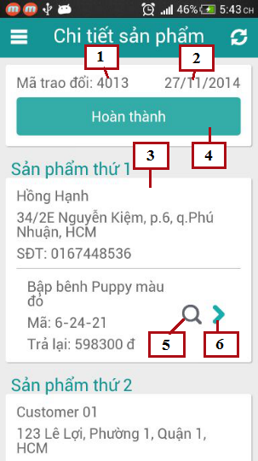

Figure 125: Mobile Exchange Details

**Fields**

|  |  |  |  |  |  |  |  |
| --- | --- | --- | --- | --- | --- | --- | --- |
| **No** | **Field Name** | **Description** | **Read only** | **Mandatory** | **Control Type** | **Data Type** | **Length** |
| 1 | Exchange Id | Id of exchange | Yes | Yes | Textview | Integer | N/A |
| 2 | Exchange date | Date to exchange | Yes | Yes | Textview | Datetime | N/A |
| 3 | Exchange detail | Information of exchange | Yes | Yes | Textview | N/A | N/A |

**Buttons/Hyperlinks**

|  |  |  |  |  |
| --- | --- | --- | --- | --- |
| **No** | **Function** | **Description** | **Validation** | **Outcome** |
| 4 | Done | Click to done exchange process | No | Change exchange status to done |
| 5 | Scan | Click to scan QR code of product | No | Open camera to start scan QR code |
| 6 | View Detail | Click to view detail of product | No | Transfer to product details page |

**Exchange Details includes**

|  |  |  |  |  |  |
| --- | --- | --- | --- | --- | --- |
| **Field Name** | **Description** | **Read only** | **Control Type** | **Data Type** | **Length** |
| Customer name | Name of customer | Yes | Textview | String | N/A |
| Customer address | Address of customer | Yes | Textview | String | N/A |
| Customer phone | Phone of customer | Yes | Textview | String | [10-11] |
| Product name | Name of product | Yes | Textview | String | N/A |
| Product code | QR code of product | Yes | Textview | String | N/A |
| Total | Total pay or return back to customer | Yes | Textview | Integer | N/A |

### **Mobile Search Return Product Options**

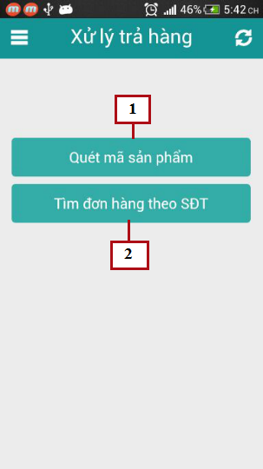

Figure 126: Mobile Search Return Product Options

**Buttons/Hyperlinks**

|  |  |  |  |  |
| --- | --- | --- | --- | --- |
| **No** | **Function** | **Description** | **Validation** | **Outcome** |
| 1 | Scan | Click to scan QR code of product | No | Open camera to start scan QR code |
| 2 | Search order by phone | Click to search order by phone | No | Transfer to search order page |

### **Rent Toy**

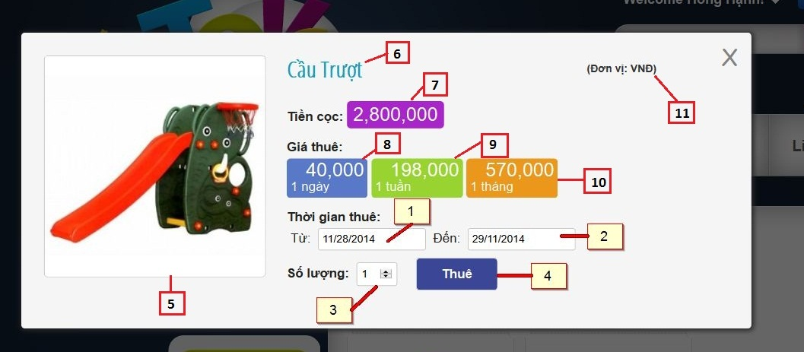

Figure 127: Rent Toy

**Fields**

|  |  |  |  |  |  |  |  |
| --- | --- | --- | --- | --- | --- | --- | --- |
| **No** | **Field Name** | **Description** | **Read only** | **Mandatory** | **Control Type** | **Data Type** | **Length** |
| 1 | FromDate | Fill rent from date | No | Yes | Date time picker | String | N/A |
| 2 | ToDate | Fill rent to date | No | Yes | Date time picker | String | N/A |
| 3 | Amount | Fill quantity toy want to rent | No | Yes | Textbox | String | N/A |
| 5 | Image | Description image of toy | Yes | Yes | Image | N/A | N/A |
| 6 | Name | Name of toy | Yes | Yes | Label | String | N/A |
| 7 | Deposit | Deposit of toy | Yes | Yes | Label | String | N/A |
| 8 | Day price | Price of toy in a day | Yes | Yes | Label | String | N/A |
| 9 | Week price | Price of toy in a week | Yes | Yes | Label | String | N/A |
| 10 | Month price | Price of toy in a month | Yes | Yes | Label | String | N/A |
| 11 | Unit | Unit of price | Yes | Yes | Label | String | N/A |

**Buttons/Hyperlinks**

|  |  |  |  |  |
| --- | --- | --- | --- | --- |
| **No** | **Function** | **Description** | **Validation** | **Outcome** |
| 4 | Rent | Click to rent current toy | Yes | N/A |

### **View Order History**

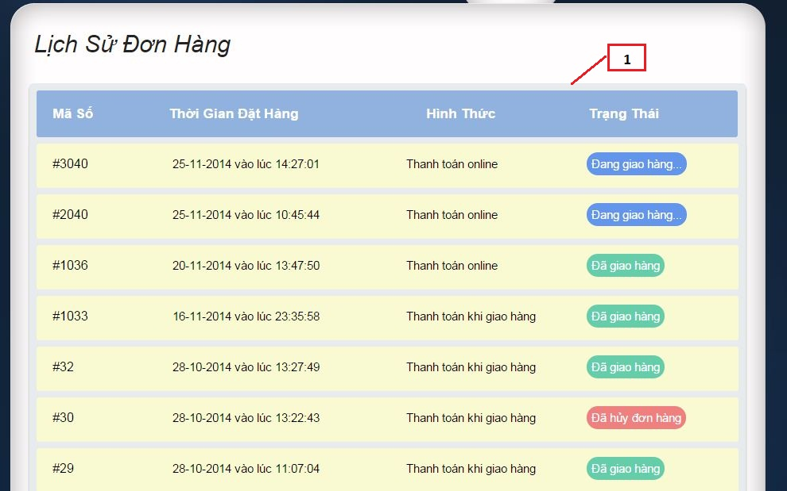

Figure 128: View Order History

**Fields**

|  |  |  |  |  |  |  |  |
| --- | --- | --- | --- | --- | --- | --- | --- |
| **No** | **Field Name** | **Description** | **Read only** | **Mandatory** | **Control Type** | **Data Type** | **Length** |
| 1 | Order list | List of all orders of current user | Yes | Yes | Table | N/A | N/A |

**Order List Include**

|  |  |  |  |  |  |  |  |
| --- | --- | --- | --- | --- | --- | --- | --- |
| **No** | **Field Name** | **Description** | **Read only** | **Mandatory** | **Control Type** | **Data Type** | **Length** |
| 1 | Code | List of all orders of current user | Yes | Yes | Label | String | N/A |
| 2 | Rent time | Time that start to rent order | Yes | Yes | Label | String | N/A |
| 3 | Form | Way to payment of order | Yes | Yes | Label | String | N/A |
| 4 | Status | Status of order in difference time | Yes | Yes | Label | String | N/A |

### **Extend Rent Time**

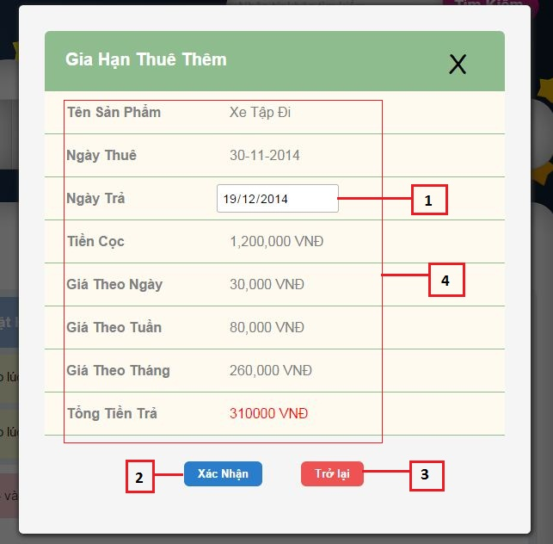

Figure 129: Extend Rent Time

**Fields**

|  |  |  |  |  |  |  |  |
| --- | --- | --- | --- | --- | --- | --- | --- |
| **No** | **Field Name** | **Description** | **Read only** | **Mandatory** | **Control Type** | **Data Type** | **Length** |
| 1 | ToDate | Fill new return date that customer ant to extend rent time | No | Yes | Date time picker | String | N/A |
| 4 | Information of order detail | All core information of renting a toy | Yes | Yes | Label | N/A | N/A |

**Information of order detail include**

|  |  |  |  |  |  |  |  |
| --- | --- | --- | --- | --- | --- | --- | --- |
| **No** | **Field Name** | **Description** | **Read only** | **Mandatory** | **Control Type** | **Data Type** | **Length** |
| 1 | Name | Name of toy | Yes | Yes | Label | String | N/A |
| 2 | Rent from date | The date start to rent toy | Yes | Yes | Label | String | N/A |
| 3 | Deposit | Deposit of toy | Yes | Yes | Label | String | N/A |
| 4 | Day price | Price of toy in a day | Yes | Yes | Label | String | N/A |
| 5 | Week price | Price of toy in a week | Yes | Yes | Label | String | N/A |
| 6 | Month price | Price of toy in a month | Yes | Yes | Label | String | N/A |

**Buttons/Hyperlinks**

|  |  |  |  |  |
| --- | --- | --- | --- | --- |
| **No** | **Function** | **Description** | **Validation** | **Outcome** |
| 2 | Confirm | Click to confirm extend rent time | Yes | Transfer to view order history page |
| 3 | Return back | Click to cancel process and return back current page | No | Transfer to view order history page |

### **View Cart**

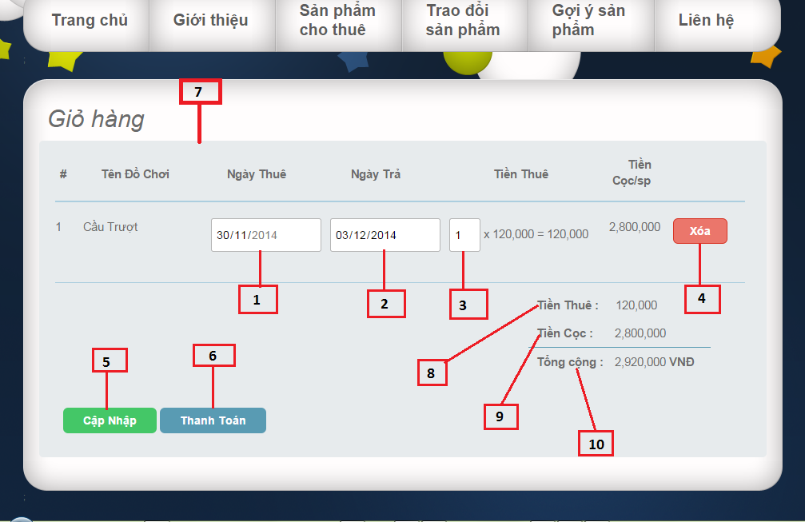

Figure 130: View Cart

**Fields**

|  |  |  |  |  |  |  |  |
| --- | --- | --- | --- | --- | --- | --- | --- |
| **No** | **Field Name** | **Description** | **Read only** | **Mandatory** | **Control Type** | **Data Type** | **Length** |
| 1 | FromDate | Fill rent from date | No | Yes | Date time picker | String | N/A |
| 2 | ToDate | Fill rent to date | No | Yes | Date time picker | String | N/A |
| 3 | Amount | Fill quantity toy want to rent | No | Yes | Textbox | String | N/A |
| 7 | Product list | List all products that user add to cart | Yes | Yes | Table | N/A | N/A |
| 8 | Total rent price | Total rent price of all products in cart | Yes | Yes | Label | String | N/A |
| 9 | Total deposit | Total deposit of all products in cart | Yes | Yes | Label | String | N/A |
| 10 | Total price | Total price include total rent price and total deposit | Yes | Yes | Label | String | N/A |

**Product list include:**

|  |  |  |  |  |  |  |  |
| --- | --- | --- | --- | --- | --- | --- | --- |
| **No** | **Field Name** | **Description** | **Read only** | **Mandatory** | **Control Type** | **Data Type** | **Length** |
| 1 | Ordinal | Ordinal number of product list | Yes | Yes | Label | Integer | N/A |
| 2 | Name | Name of toy | Yes | Yes | Label | String | N/A |
| 3 | Rent Price | Amount of toy | Yes | Yes | Label | String | N/A |
| 4 | Deposit | Deposit of toy | Yes | Yes | Label | Long | N/A |

**Buttons/Hyperlinks**

|  |  |  |  |  |
| --- | --- | --- | --- | --- |
| **No** | **Function** | **Description** | **Validation** | **Outcome** |
| 4 | Remove toy out of cart | Click to remove current toy out of cart | No | N/A |
| 5 | Update cart | Click to update new information of cart | Yes | N/A |
| 6 | Check out cart | Click to show popup check out cart | Yes | N/A |

### **Check Out _ Choose payment way**

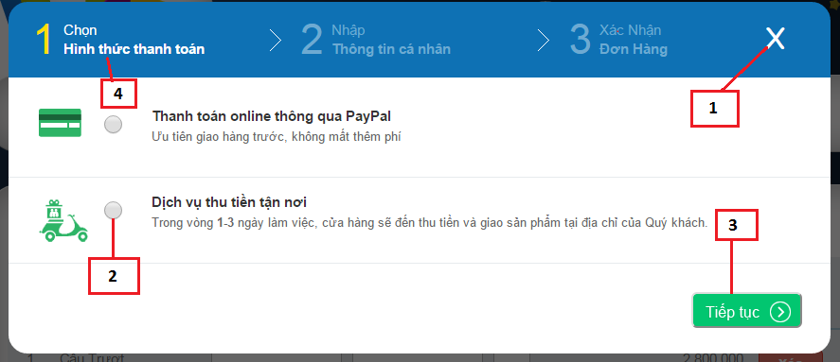

Figure 131: Check out_ Choose payment way

**Fields**

|  |  |  |  |  |  |  |  |
| --- | --- | --- | --- | --- | --- | --- | --- |
| **No** | **Field Name** | **Description** | **Read only** | **Mandatory** | **Control Type** | **Data Type** | **Length** |
| 2 | Way to payment | Click to choose way to payment | No | Yes | Radio button | Boolean | N/A |
| 4 | Step 1 | Step choose way to payment | Yes | Yes | Label | String | N/A |

**Buttons/Hyperlinks**

|  |  |  |  |  |
| --- | --- | --- | --- | --- |
| **No** | **Function** | **Description** | **Validation** | **Outcome** |
| 1 | Close popup | Click to close current popup | No | Transfer to view cart page |
| 3 | Continue next step | Click to continue next step of check out | Yes | Transfer to confirm information delivering popup |

### **Check Out _ Confirm information delivering**

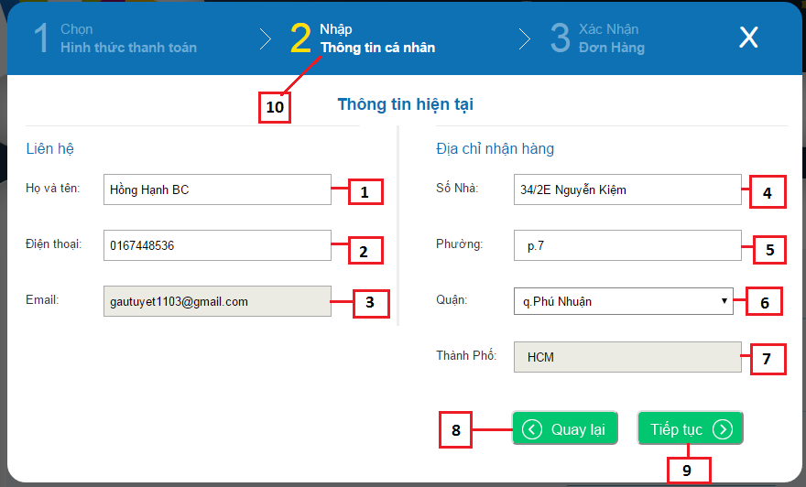

Figure 132: Check out _ Confirm information delivering

**Fields**

|  |  |  |  |  |  |  |  |
| --- | --- | --- | --- | --- | --- | --- | --- |
| **No** | **Field Name** | **Description** | **Read only** | **Mandatory** | **Control Type** | **Data Type** | **Length** |
| 1 | Name | Fill name of receiver | No | Yes | Textbox | String | N/A |
| 2 | Phone | Fill phone of receiver | No | Yes | Textbox | String | [10,11] |
| 3 | Email | Fill email of current user | Yes | Yes | Textbox | String | N/A |
| 4 | Address | Fill address delivering | No | Yes | Textbox | String | N/A |
| 5 | Precinct | Fill precinct of address | No | Yes | Textbox | String | N/A |
| 6 | District | Fill district of address | No | Yes | Drop down list | String | N/A |
| 7 | City | Fill name of city to delivering | Yes | Yes | Textbox | String | N/A |
| 10 | Step 2 | Step confirm profile | Yes | Yes | Label | String | N/A |

**Buttons/Hyperlinks**

|  |  |  |  |  |
| --- | --- | --- | --- | --- |
| **No** | **Function** | **Description** | **Validation** | **Outcome** |
| 8 | Return back | Click to return back previous step that choose payment way | Yes | Transfer to popup choose payment way |
| 9 | Continue | Click to continue next step that confirm all information | Yes | Transfer to popup confirm all information of cart |

### **Check Out_ Confirm al information**

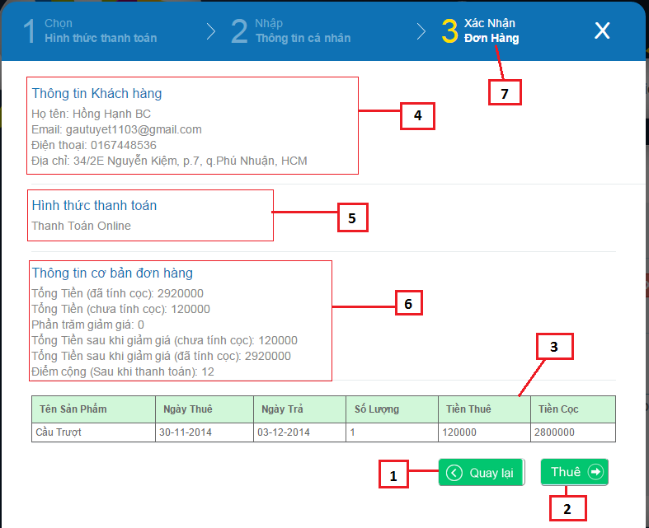

Figure 133: Check Out_ Confirm all information

**Fields**

|  |  |  |  |  |  |  |  |
| --- | --- | --- | --- | --- | --- | --- | --- |
| **No** | **Field Name** | **Description** | **Read only** | **Mandatory** | **Control Type** | **Data Type** | **Length** |
| 3 | Product list | List product user added to cart | Yes | Yes | Table | N/A | N/A |
| 4 | Information of user | Summary information that help to delivering | Yes | Yes | Label | String | N/A |
| 5 | Way to payment | Confirm way to payment | Yes | Yes | Label | String | N/A |
| 6 | Information payment | Summary information use need to know about price, promotion | Yes | Yes | Label | String | N/A |
| 7 | Step 3 | Step confirm all information before check out | Yes | Yes | Label | String | N/A |

**Product include**

|  |  |  |  |  |  |  |  |
| --- | --- | --- | --- | --- | --- | --- | --- |
| **No** | **Field Name** | **Description** | **Read only** | **Mandatory** | **Control Type** | **Data Type** | **Length** |
| 1 | Name | Name of toy | Yes | Yes | Label | String | N/A |
| 2 | Rent from date | The date start to rent toy | Yes | Yes | Label | String | N/A |
| 3 | Rent to date | The date end of time to rent toy | Yes | Yes | Label | String | N/A |
| 4 | Quantity | Quantity toy current user rent | Yes | Yes | Label | String | N/A |
| 5 | Amount | Total rent price | Yes | Yes | Label | String | N/A |
| 6 | Deposit | Deposit of toy | Yes | Yes | Label | String | N/A |

**Buttons/Hyperlinks**

|  |  |  |  |  |
| --- | --- | --- | --- | --- |
| **No** | **Function** | **Description** | **Validation** | **Outcome** |
| 1 | Return back | Click to return back previous step that confirm information delivering | Yes | Transfer to popup confirm information delivering |
| 2 | Check out | Click to confirm check out | Yes | Transfer to Home page |

### **View User Profile**

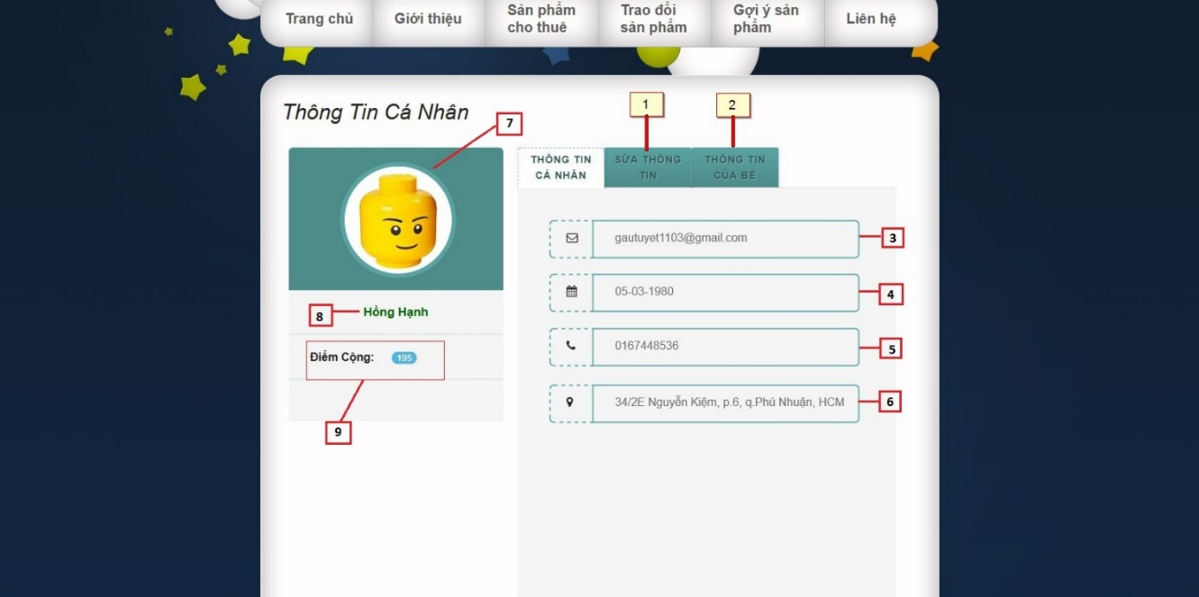

Figure 134: View User Profile

**Fields**

|  |  |  |  |  |  |  |  |
| --- | --- | --- | --- | --- | --- | --- | --- |
| **No** | **Field Name** | **Description** | **Read only** | **Mandatory** | **Control Type** | **Data Type** | **Length** |
| 3 | Email | Email of current user | Yes | Yes | Textbox | String | N/A |
| 4 | Birthdate | Birthdate of current user | Yes | Yes | Textbox | String | N/A |
| 5 | Phone | Phone of current user | Yes | Yes | Textbox | String | [10,11] |
| 6 | Address | Address of current user | Yes | Yes | Textbox | String | N/A |
| 7 | Image | Image default of user | Yes | Yes | Image | N/A | N/A |
| 8 | Name | Name of current user | Yes | Yes | Label | String | N/A |
| 9 | Plus point | Plus point of current user | Yes | Yes | Label | String | N/A |

**Buttons/Hyperlinks**

|  |  |  |  |  |
| --- | --- | --- | --- | --- |
| **No** | **Function** | **Description** | **Validation** | **Outcome** |
| 1 | Update information | Fill update information of current user profile | No | N/A |
| 2 | View child | Fill view information of children | No | N/A |

### **Update User Profile**

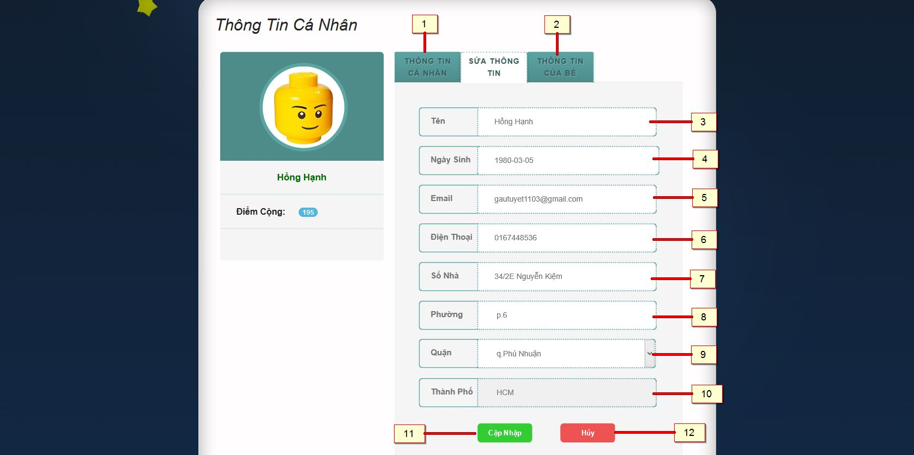

Figure 135: Update User Profile

**Fields**

|  |  |  |  |  |  |  |  |
| --- | --- | --- | --- | --- | --- | --- | --- |
| **No** | **Field Name** | **Description** | **Read only** | **Mandatory** | **Control Type** | **Data Type** | **Length** |
| 3 | Name | Fill name of current user | No | Yes | Textbox | String | N/A |
| 4 | Birthdate | Fill birthdate of current user | No | Yes | Date time picker | String | N/A |
| 5 | Phone | Fill phone of current user | No | Yes | Textbox | String | [10,11] |
| 6 | Email | Fill email of current user | No | Yes | Textbox | String | N/A |
| 7 | Address | Fill address delivering | No | Yes | Textbox | String | N/A |
| 8 | Precinct | Fill precinct of address | No | Yes | Textbox | String | N/A |
| 9 | District | Fill district of address | No | Yes | Drop down list | String | N/A |
| 10 | City | Fill name of city to delivering | Yes | Yes | Textbox | String | N/A |

**Buttons/Hyperlinks**

|  |  |  |  |  |
| --- | --- | --- | --- | --- |
| **No** | **Function** | **Description** | **Validation** | **Outcome** |
| 1 | User Profile | Click to view user profile | No | Transfer to user profile page |
| 2 | View child | Fill view information of children | No | N/A |
| 11 | Update | Update information of current user profile | No | Transfer to view user profile |
| 12 | Cancel | Cancel update information of profile | No | Transfer to view user profile |

### **Information of Child**

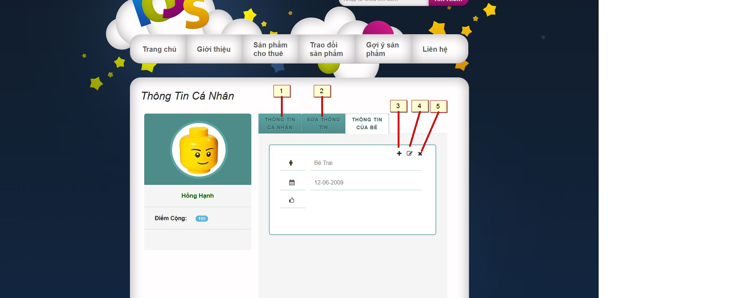

Figure 136: Information of child

**Buttons/Hyperlinks**

|  |  |  |  |  |
| --- | --- | --- | --- | --- |
| **No** | **Function** | **Description** | **Validation** | **Outcome** |
| 1 | User Profile | Click to view user profile | No | Transfer to user profile page |
| 2 | Update information | Fill update information of current user profile | No | N/A |
| 3 | Add new | Add new child | No | Transfer to popup add child |
| 4 | Update | Update current child | No | Transfer to popup update child |
| 5 | Delete | Remove child of user | No | Transfer to view user profile |

### **Add Child**

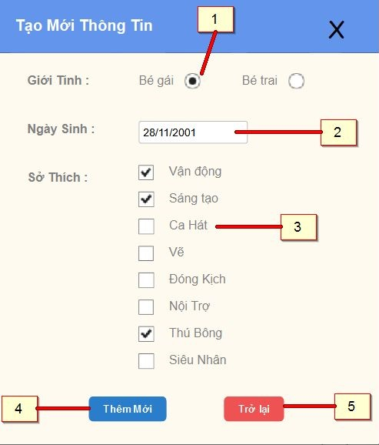

Figure 137: Add Child

**Fields**

|  |  |  |  |  |  |  |  |
| --- | --- | --- | --- | --- | --- | --- | --- |
| **No** | **Field Name** | **Description** | **Read only** | **Mandatory** | **Control Type** | **Data Type** | **Length** |
| 1 | Gender | Sex of child | No | Yes | Radio button | N/A | N/A |
| 2 | Birthdate | Birthdate of child | No | Yes | Date time picker | String | N/A |
| 3 | Hobby | Hobbies of child | No | Yes | Checkbox | String | N/A |

**Buttons/Hyperlinks**

|  |  |  |  |  |
| --- | --- | --- | --- | --- |
| **No** | **Function** | **Description** | **Validation** | **Outcome** |
| 1 | Add child | Click to confirm add child | Yes | Transfer to View Use Profile |
| 2 | Return Back | Click to return back information of child | No | Transfer to current page |

### **Update Child**

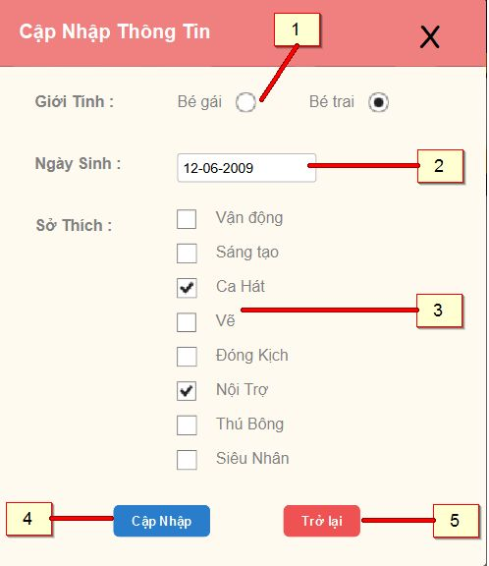

Figure 138: Update Child

**Fields**

|  |  |  |  |  |  |  |  |
| --- | --- | --- | --- | --- | --- | --- | --- |
| **No** | **Field Name** | **Description** | **Read only** | **Mandatory** | **Control Type** | **Data Type** | **Length** |
| 1 | Gender | Sex of child | No | Yes | Radio button | N/A | N/A |
| 2 | Birthdate | Birthdate of child | No | Yes | Date time picker | String | N/A |
| 3 | Hobby | Hobbies of child | No | Yes | Checkbox | String | N/A |

**Buttons/Hyperlinks**

|  |  |  |  |  |
| --- | --- | --- | --- | --- |
| **No** | **Function** | **Description** | **Validation** | **Outcome** |
| 1 | Update child | Click to confirm update child | Yes | Transfer to View Use Profile |
| 2 | Return Back | Click to return back information of child | No | Transfer to current page |

### **Manage Order**

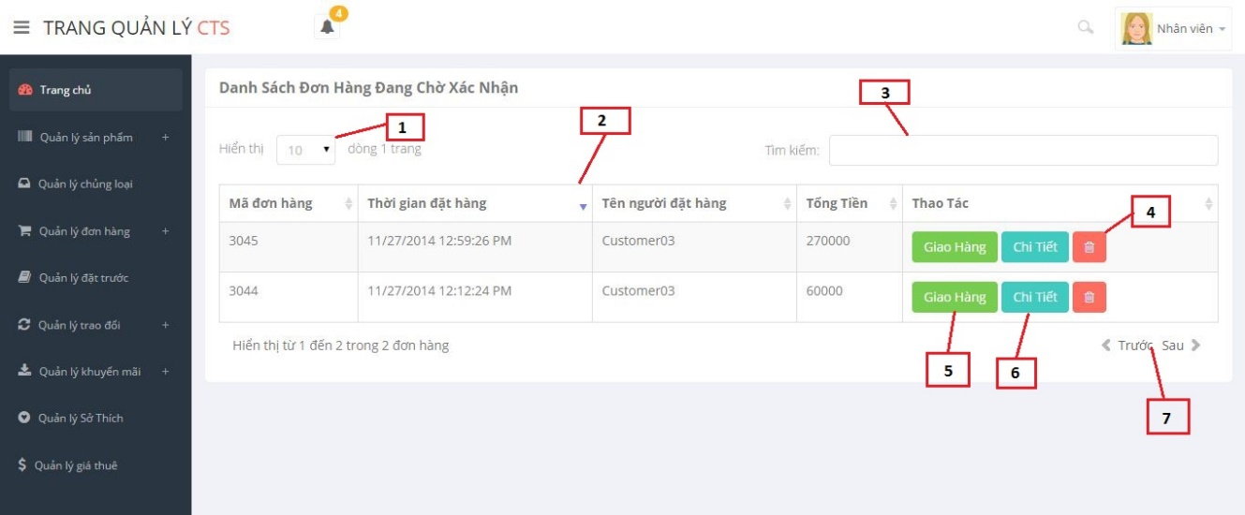

Figure 139: Manage Order

**Fields**

|  |  |  |  |  |  |  |  |
| --- | --- | --- | --- | --- | --- | --- | --- |
| **No** | **Field Name** | **Description** | **Read only** | **Mandatory** | **Control Type** | **Data Type** | **Length** |
| 1 | Row display | Number of rows display in current page | No | Yes | Drop down list | Integer | N/A |
| 2 | Order list | List all orders of store | Yes | Yes | Table | N/A | N/A |
| 3 | Search | Fill search order | No | Yes | Textbox | String | N/A |

**Order List include:**

|  |  |  |  |  |  |  |  |
| --- | --- | --- | --- | --- | --- | --- | --- |
| **No** | **Field Name** | **Description** | **Read only** | **Mandatory** | **Control Type** | **Data Type** | **Length** |
| 1 | Order code | Code of order | Yes | Yes | Label | Integer | N/A |
| 2 | Time to rent order | The date start to order | Yes | Yes | Label | String | N/A |
| 3 | Name of renter | Name pf customer | Yes | Yes | Label | String | N/A |
| 4 | Total price | Total price of order | Yes | Yes | Label | Long | N/A |

**Buttons/Hyperlinks**

|  |  |  |  |  |
| --- | --- | --- | --- | --- |
| **No** | **Function** | **Description** | **Validation** | **Outcome** |
| 4 | Delete order | Click to cancel order | No | N/A |
| 5 | Assign shipper | Click to assign shipper for that order | No | Transfer to popup assign |
| 6 | View order detail | Click to view order detail | No | Transfer to popup view order detail |
| 7 | Paging | Divide page previous and next | No | N/A |

### **View Order Detail (staff)**

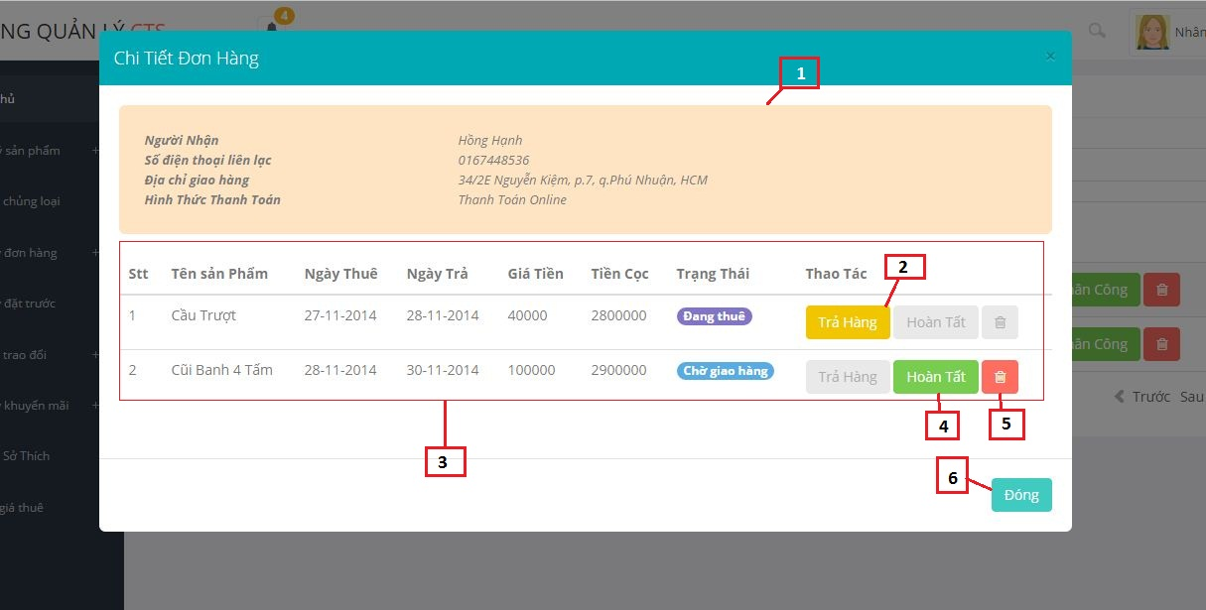

Figure 140: View Order Detail (staff)

**Fields**

|  |  |  |  |  |  |  |  |
| --- | --- | --- | --- | --- | --- | --- | --- |
| **No** | **Field Name** | **Description** | **Read only** | **Mandatory** | **Control Type** | **Data Type** | **Length** |
| 1 | Field information of order’s user | Description all information of order’s user and way to payment | Yes | Yes | Label | String | N/A |
| 3 | Order detail list | All product in order | Yes | Yes | Table | N/A | N/A |

**Order Detail List include**

|  |  |  |  |  |  |  |  |
| --- | --- | --- | --- | --- | --- | --- | --- |
| **No** | **Field Name** | **Description** | **Read only** | **Mandatory** | **Control Type** | **Data Type** | **Length** |
| 1 | Ordinal | Ordinal number of order detail list | Yes | Yes | Label | Integer | N/A |
| 2 | Name | Name of toy | Yes | Yes | Label | String | N/A |
| 3 | Rent from date | The date start to rent toy | Yes | Yes | Label | String | N/A |
| 4 | Rent to date | The date end of time to rent toy | Yes | Yes | Label | String | N/A |
| 5 | Amount | Total rent price | Yes | Yes | Label | String | N/A |
| 6 | Status | Status of order detail in difference time | Yes | Yes | Label | String | N/A |

**Buttons/Hyperlinks**

|  |  |  |  |  |
| --- | --- | --- | --- | --- |
| **No** | **Function** | **Description** | **Validation** | **Outcome** |
| 2 | Return back | Click to return back toy | Yes | Transfer to Manager Order Page |
| 4 | Done delivering | Click to confirm done delivering order | Yes | Transfer to Manager Order Page |
| 5 | Delete | Cancel order detail | Yes | Transfer to Manager Order Page |
| 6 | Close | Close current popup | No | Transfer to current page |

### **View Order Detail (customer)**

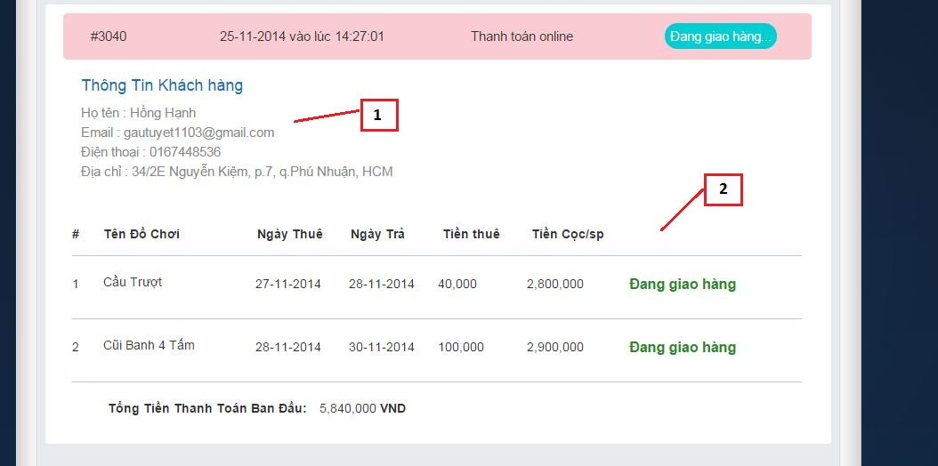

Figure 141: View Order Detail

**Fields**

|  |  |  |  |  |  |  |  |
| --- | --- | --- | --- | --- | --- | --- | --- |
| **No** | **Field Name** | **Description** | **Read only** | **Mandatory** | **Control Type** | **Data Type** | **Length** |
| 1 | Information profile | Description information about order’s user | Yes | Yes | Label | String | N/A |
| 2 | List order detail | All product were rented of current order. | Yes | Yes | Table | N/A | N/A |

**Order Detail List include**

|  |  |  |  |  |  |  |  |
| --- | --- | --- | --- | --- | --- | --- | --- |
| **No** | **Field Name** | **Description** | **Read only** | **Mandatory** | **Control Type** | **Data Type** | **Length** |
| 1 | Ordinal | Ordinal number of order detail list | Yes | Yes | Label | Integer | N/A |
| 2 | Name | Name of toy | Yes | Yes | Label | String | N/A |
| 3 | Rent from date | The date start to rent toy | Yes | Yes | Label | String | N/A |
| 4 | Rent to date | The date end of time to rent toy | Yes | Yes | Label | String | N/A |
| 5 | Amount | Total rent price | Yes | Yes | Label | String | N/A |
| 6 | Status | Status of order detail in difference time | Yes | Yes | Label | String | N/A |

### **Return Back**

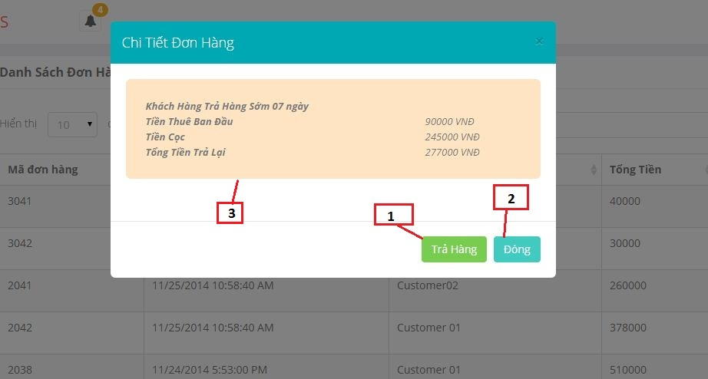

Figure 142: Return Back

**Fields**

|  |  |  |  |  |  |  |  |
| --- | --- | --- | --- | --- | --- | --- | --- |
| **No** | **Field Name** | **Description** | **Read only** | **Mandatory** | **Control Type** | **Data Type** | **Length** |
| 3 | Information confirm when customer return back product | Information confirm when customer return back product: rent price, deposit, total price return for customer | Yes | Yes | Label | String | N/A |

**Buttons/Hyperlinks**

|  |  |  |  |  |
| --- | --- | --- | --- | --- |
| **No** | **Function** | **Description** | **Validation** | **Outcome** |
| 1 | Return back | Click to confirm return back | Yes | Transfer to current page |
| 2 | Close | Click to close current popup | No | Transfer to current page |

### **Assign Shipper**

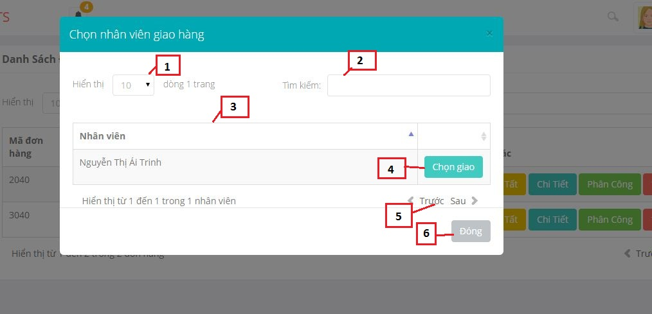

Figure 143: Assign shipper

**Fields**

|  |  |  |  |  |  |  |  |
| --- | --- | --- | --- | --- | --- | --- | --- |
| **No** | **Field Name** | **Description** | **Read only** | **Mandatory** | **Control Type** | **Data Type** | **Length** |
| 1 | Row display | Number of rows display in current page | No | Yes | Drop down list | Integer | N/A |
| 2 | Staff list | List all staffs of store | Yes | Yes | Table | N/A | N/A |
| 3 | Search | Fill search staff | No | Yes | Textbox | String | N/A |

**Buttons/Hyperlinks**

|  |  |  |  |  |
| --- | --- | --- | --- | --- |
| **No** | **Function** | **Description** | **Validation** | **Outcome** |
| 1 | Assign | Click to assign shipper for current order | No | Transfer to current page |
| 7 | Paging | Divide page previous and next | No |  |

### **Manage Promotion**

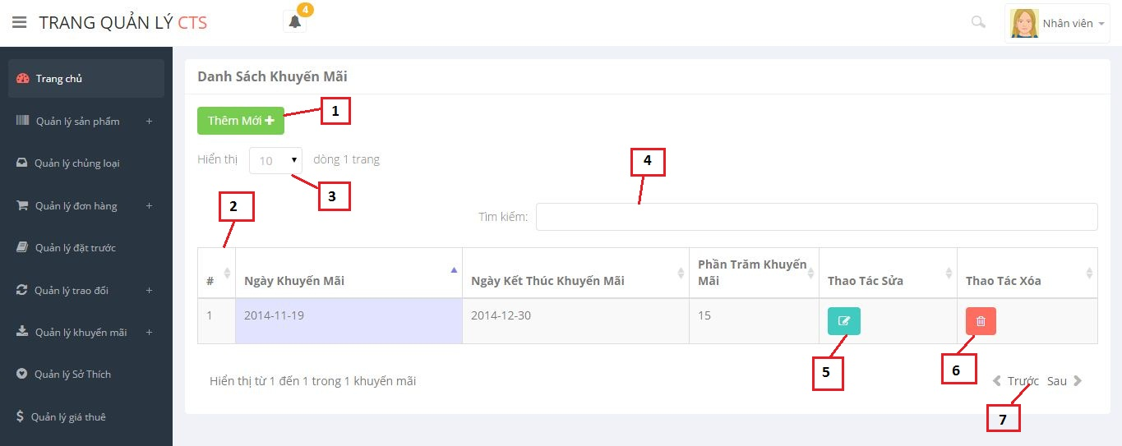

Figure 144: Manage Promotion

**Fields**

|  |  |  |  |  |  |  |  |
| --- | --- | --- | --- | --- | --- | --- | --- |
| **No** | **Field Name** | **Description** | **Read only** | **Mandatory** | **Control Type** | **Data Type** | **Length** |
| 3 | Row display | Number of rows display in current page | No | No | Drop down list | Integer | N/A |
| 2 | List promotion | List promotion of store | Yes | No | Table | N/A | N/A |
| 4 | Search | Fill search promotion | No | No | Textbox | String | N/A |

**Promotion list include**

|  |  |  |  |  |  |  |  |
| --- | --- | --- | --- | --- | --- | --- | --- |
| **No** | **Field Name** | **Description** | **Read only** | **Mandatory** | **Control Type** | **Data Type** | **Length** |
| 1 | Ordinal | Ordinal number of promotion list | Yes | Yes | Label | Integer | N/A |
| 2 | Start date | The date start promotion | Yes | Yes | Label | String | N/A |
| 3 | End date | The date end promotion | Yes | Yes | Label | String | N/A |
| 4 | Percent | Percent promotion | Yes | Yes | Label | String | N/A |

**Buttons/Hyperlinks**

|  |  |  |  |  |
| --- | --- | --- | --- | --- |
| **No** | **Function** | **Description** | **Validation** | **Outcome** |
| 1 | Add new | Click to add new promotion | No | Transfer to current page |
| 5 | Update | Click to update information of a promotion | Yes | Transfer to current page |
| 6 | Delete | Click to delete a promotion | No | Transfer to current page |
| 7 | Paging | Divide page previous and next | No | N/A |

### **Register**

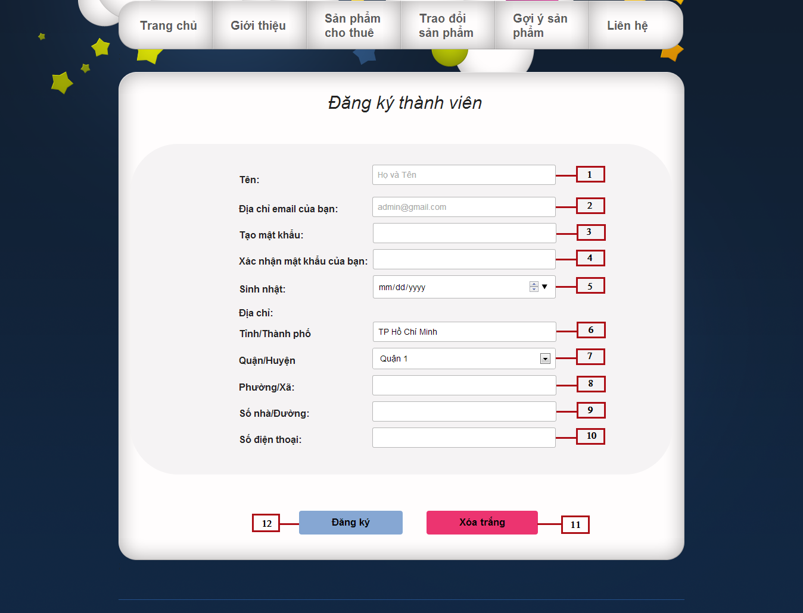

Figure 145: Register

**Fields**

|  |  |  |  |  |  |  |  |
| --- | --- | --- | --- | --- | --- | --- | --- |
| **No** | **Field Name** | **Description** | **Read only** | **Mandatory** | **Control Type** | **Data Type** | **Length** |
| 1 | Full Name | Fill user fullname | No | Yes | Textbox | String | N/A |
| 2 | Email | Fill user email | No | Yes | Email | String | N/A |
| 3 | Password | Fill password | No | Yes | Password | String | [8-32] |
| 4 | Re-Password | Fill re-password | No | Yes | Password | String | [8-32] |
| 5 | Birthday | Fill user birthday | No | Yes | Date time picker | String | N/A |
| 6 | City | Show city’s name | Yes | Yes | Textbox | String | N/A |
| 7 | District | Select user district | No | Yes | Drop down list | String | N/A |
| 8 | Ward | Fill user ward | No | Yes | Textbox | String | N/A |
| 9 | Adress | Fill user address | No | Yes | Textbox | String | N/A |
| 10 | Phone Number | Fill user phone number | No | Yes | Textbox | String | [10-11] |

**Buttons/Hyperlinks**

|  |  |  |  |  |
| --- | --- | --- | --- | --- |
| **No** | **Function** | **Description** | **Validation** | **Outcome** |
| 11 | Clear Text | Click to delete information in all field | N/A | All information in the data filed will be clear(Except : birthday, city, district fileds) |
| 12 | Register | Click to register a new account | N/A | Transfer to register page |

### **View Category**

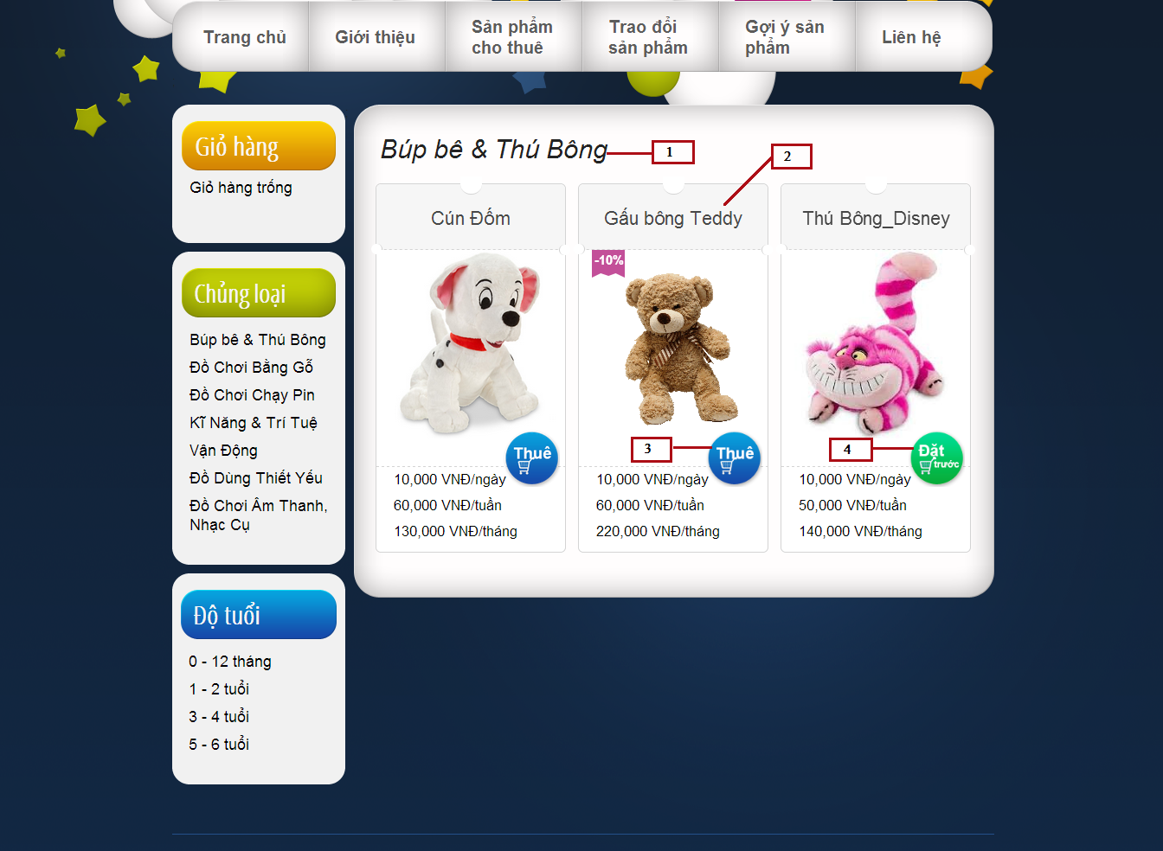

Figure 146: View Category

**Fields**

|  |  |  |  |  |  |  |  |
| --- | --- | --- | --- | --- | --- | --- | --- |
| **No** | **Field Name** | **Description** | **Read only** | **Mandatory** | **Control Type** | **Data Type** | **Length** |
| 1 | Category name lable | Show name of category | Yes | Yes | Label | String | N/A |
| 2 | Toy list | Show list toy | No | Yes | Gird list view | N/A | N/A |

**Buttons/Hyperlinks**

|  |  |  |  |  |
| --- | --- | --- | --- | --- |
| **No** | **Function** | **Description** | **Validation** | **Outcome** |
| 3 | Rent | Click to rent a toy | N/A | Show popup to choose the time and quantity to rent |
| 4 | Reserve | Click to reserve a toy | N/A | Show popup to confirm reserve toy |

**Toy List Includes**

|  |  |  |  |  |  |
| --- | --- | --- | --- | --- | --- |
| **Field Name** | **Description** | **Read only** | **Control Type** | **Data Type** | **Length** |
| Toy name | Show toy name | No | Textview | String | N/A |
| Promotion | Show percent promotion of toy | No | Textview | Integer | N/A |
| Toy image | Show toy image | No | Image | String | N/A |
| Price | Show toy price | Yes | Textview | Double | N/A |
| Action | Action of toy | No | Button | N/A | N/A |

### **Advanced search**

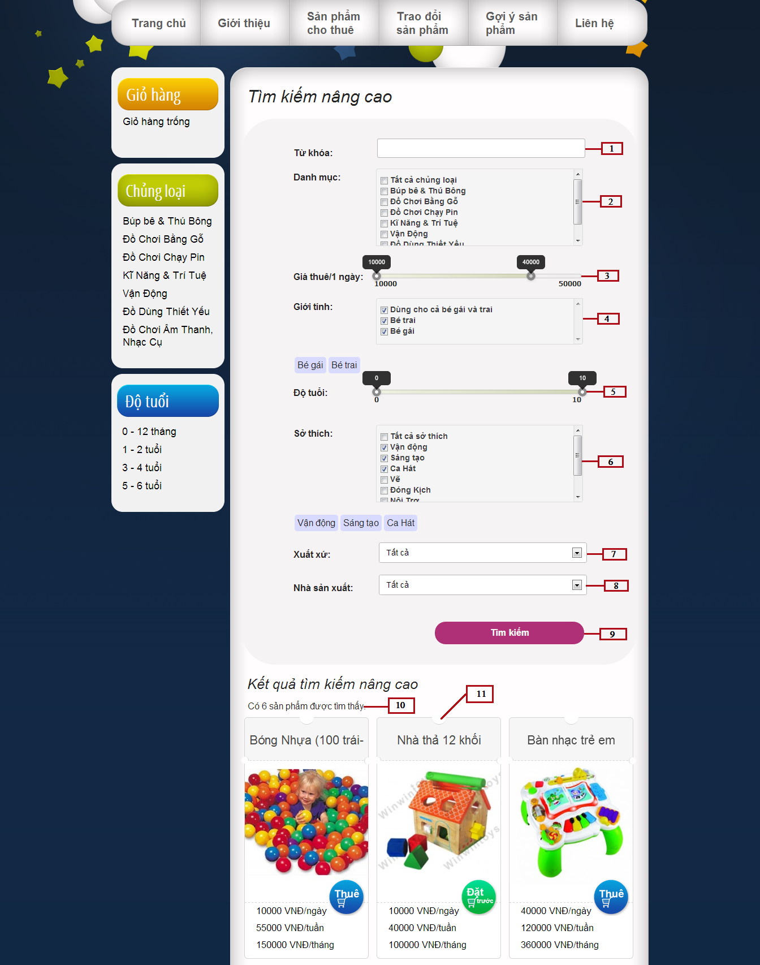

Figure 147: Advanced Search

**Fields**

|  |  |  |  |  |  |  |  |
| --- | --- | --- | --- | --- | --- | --- | --- |
| **No** | **Field Name** | **Description** | **Read only** | **Mandatory** | **Control Type** | **Data Type** | **Length** |
| 1 | Keyword | Fill keyword | No | Yes | Textbox | String | N/A |
| 2 | Category | Select category name | No | N/A | Checkbox | N/A | N/A |
| 3 | Price | Select price | No | N/A | Slider | N/A | N/A |
| 4 | Gender | Select gender | No | N/A | Checkbox | N/A | N/A |
| 5 | Age | Select age | No | N/A | Slider | N/A | N/A |
| 6 | Hobby | Select hobby | No | N/A | Checkbox | N/A | N/A |
| 7 | Origin | Select origin | No | N/A | Drop-down-list | N/A | N/A |
| 8 | Manufacture | Select manufacture | No | N/A | Drop-down-list | N/A | N/A |
| 10 | Result number | Show result number | Yes | N/A | Textview | N/A | N/A |
| 11 | Toy list | Show list toy result | No | N/A | Gird list view | N/A | N/A |

**Buttons/Hyperlinks**

|  |  |  |  |  |
| --- | --- | --- | --- | --- |
| **No** | **Function** | **Description** | **Validation** | **Outcome** |
| 9 | Search | Click to search toys | N/A | Show toys result below |

### **Manage Members**

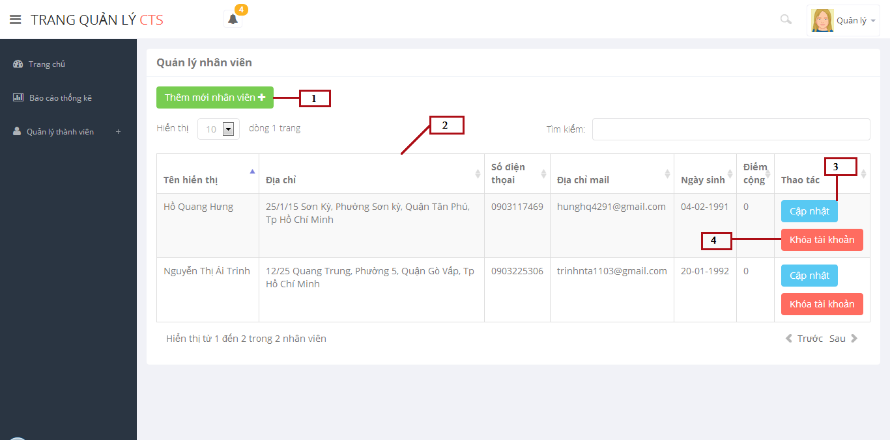

Figure 148: Manage Members

**Fields**

|  |  |  |  |  |  |  |  |
| --- | --- | --- | --- | --- | --- | --- | --- |
| **No** | **Field Name** | **Description** | **Read only** | **Mandatory** | **Control Type** | **Data Type** | **Length** |
| 2 | Members list | Show members list | Yes | N/A | Table list | N/A | N/A |

**Buttons/Hyperlinks**

|  |  |  |  |  |
| --- | --- | --- | --- | --- |
| **No** | **Function** | **Description** | **Validation** | **Outcome** |
| 1 | Create new member | Click to go to create new member page | No | Transfer to create new member page |
| 3 | Edit member | Click to edit information of member | No | Transfer to edit member page |
| 4 | Enable/Disable account | Click to enable/disable account | No | Message completed |

**Table Members List Includes**

|  |  |  |  |  |  |
| --- | --- | --- | --- | --- | --- |
| **Field Name** | **Description** | **Read only** | **Control Type** | **Data Type** | **Length** |
| Full name | Show full name | Yes | Textview | String | N/A |
| Address | Show address | Yes | Textview | String | N/A |
| Phone number | Show phone number | Yes | Textview | String | N/A |
| Email | Show email | Yes | Textview | String | N/A |
| Birthday | Show birthday | Yes | Textview | Datetime | N/A |
| Plus points | Show plus points | Yes | Textview | Integer | N/A |

### **Add New Member**

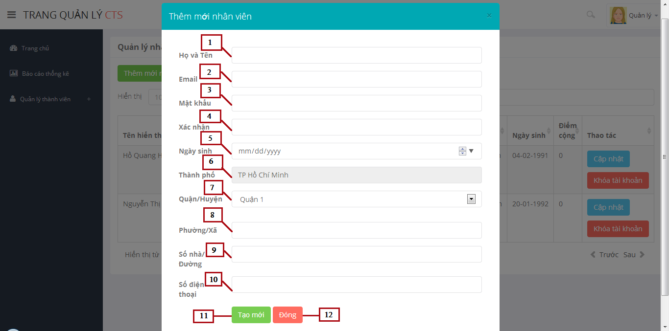

Figure 149: Add New Member

**Fields**

|  |  |  |  |  |  |  |  |
| --- | --- | --- | --- | --- | --- | --- | --- |
| **No** | **Field Name** | **Description** | **Read only** | **Mandatory** | **Control Type** | **Data Type** | **Length** |
| 1 | Full Name | Fill user fullname | No | Yes | Textbox | String | N/A |
| 2 | Email | Fill user email | No | Yes | Email | String | N/A |
| 3 | Password | Fill password | No | Yes | Password | String | [8-32] |
| 4 | Re-Password | Fill re-password | No | Yes | Password | String | [8-32] |
| 5 | Birthday | Fill user birthday | No | Yes | Date | String | N/A |
| 6 | City | Display city of user | Yes | Yes | Textbox | String | N/A |
| 7 | District | Click to choose district of user | No | Yes | Drop-down-list | String | N/A |
| 8 | Ward | Fill ward of user | No | Yes | Textbox | String | N/A |
| 9 | Adress | Fill address of user | No | Yes | Textbox | String | N/A |
| 10 | Phone Number | Fill phone number of user | No | Yes | Textbox | String | [10-11] |

**Buttons/Hyperlinks**

|  |  |  |  |  |
| --- | --- | --- | --- | --- |
| **No** | **Function** | **Description** | **Validation** | **Outcome** |
| 11 | Create new member | Create new member | Yes | Message completed |
| 12 | Close popup | Click to close popup | N/A | Popup add new member closed |

### **Update Member**

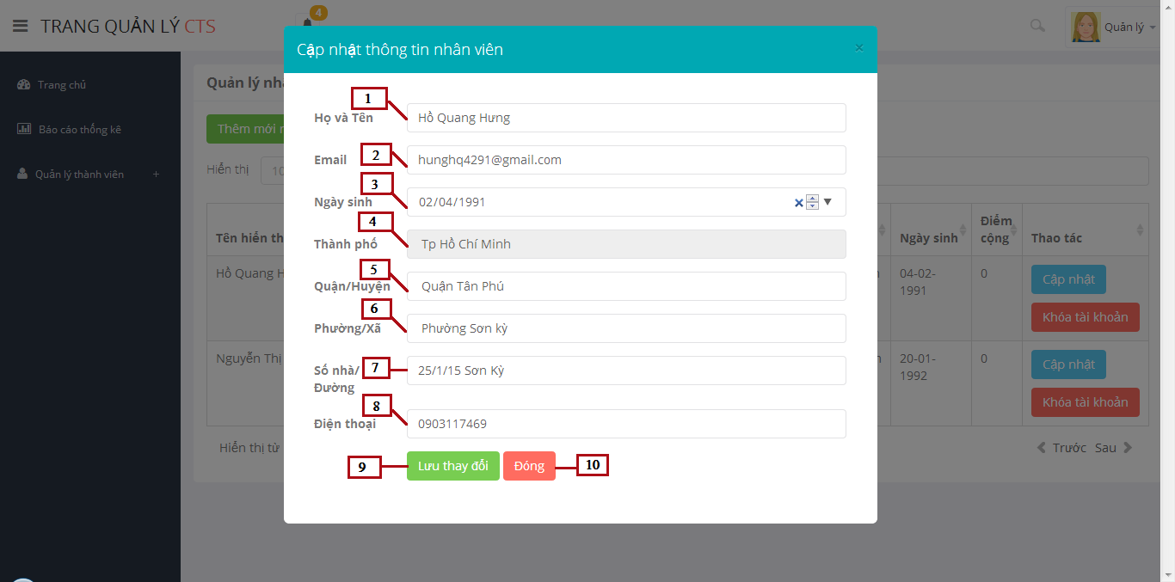

Figure 150: Update Member

**Fields**

|  |  |  |  |  |  |  |  |
| --- | --- | --- | --- | --- | --- | --- | --- |
| **No** | **Field Name** | **Description** | **Read only** | **Mandatory** | **Control Type** | **Data Type** | **Length** |
| 1 | Full Name | Fill user fullname | No | Yes | Textbox | String | N/A |
| 2 | Email | Fill user email | No | Yes | Email | String | N/A |
| 3 | Birthday | Fill user birthday | No | Yes | Date time picker | String | N/A |
| 4 | City | Display city of user | Yes | Yes | Textbox | String | N/A |
| 5 | District | Click to choose district of user | No | Yes | Drop down list | String | N/A |
| 6 | Ward | Fill ward of user | No | Yes | Textbox | String | N/A |
| 7 | Adress | Fill address of user | No | Yes | Textbox | String | N/A |
| 8 | Phone Number | Fill phone number of user | No | Yes | Textbox | String | [10-11] |

**Buttons/Hyperlinks**

|  |  |  |  |  |
| --- | --- | --- | --- | --- |
| **No** | **Function** | **Description** | **Validation** | **Outcome** |
| 9 | Create new member | Create new member | Yes | Message completed |
| 10 | Close popup | Click to close popup | N/A | Popup add new member closed |

### **Manage Toys**

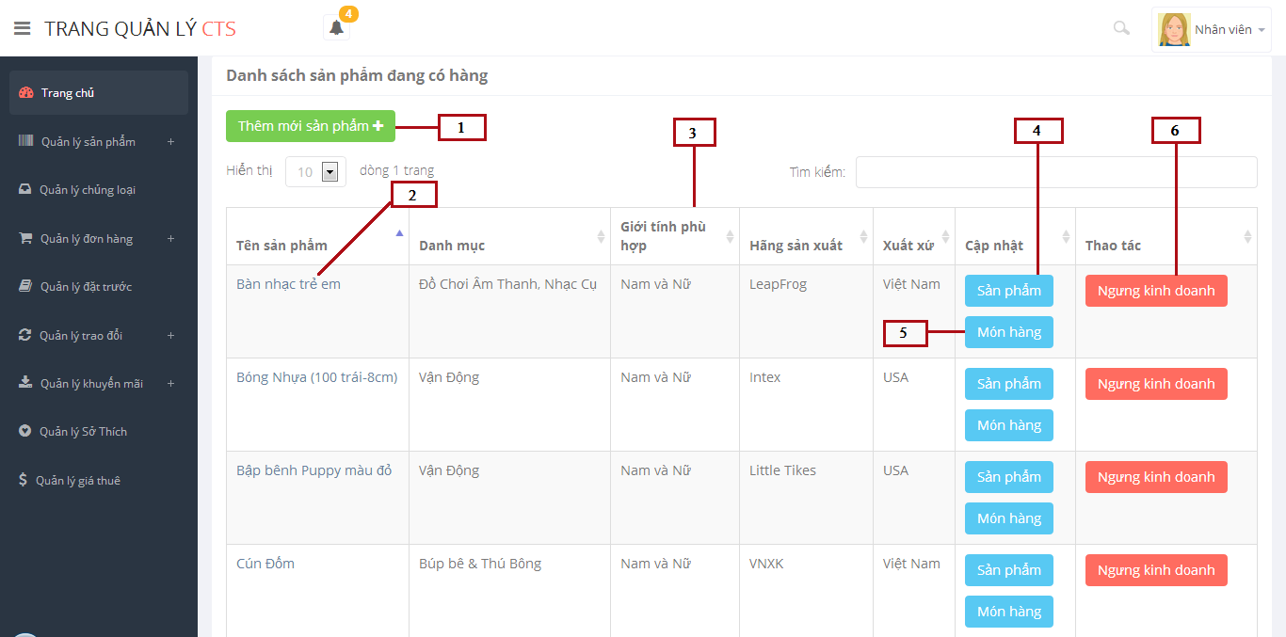

Figure 151: Manage Toys

**Fields**

|  |  |  |  |  |  |  |  |
| --- | --- | --- | --- | --- | --- | --- | --- |
| **No** | **Field Name** | **Description** | **Read only** | **Mandatory** | **Control Type** | **Data Type** | **Length** |
| 3 | Toys List | Show toy list | No | N/A | Table list | N/A | N/A |

**Buttons/Hyperlinks**

|  |  |  |  |  |
| --- | --- | --- | --- | --- |
| **No** | **Function** | **Description** | **Validation** | **Outcome** |
| 1 | Create new toy | Click to go to create new toy page | No | Transfer to create new toy page |
| 2 | Toy name | Click to view detail inforation of toy | No | Transfer to detail toy page |
| 4 | Edit toy | Click to edit information of toy | No | Transfer to edit toy page |
| 5 | Edit toy instance | Click to edit information of toy instance | No | Tranfer to edit toy instance page |
| 6 | Discontinue/Available toy | Click to discontinue/available toy | No | Message completed |

**Table Toys List Includes**

|  |  |  |  |  |  |
| --- | --- | --- | --- | --- | --- |
| **Field Name** | **Description** | **Read only** | **Control Type** | **Data Type** | **Length** |
| Toy name | Display name of toy | No | Link | String | N/A |
| Category name | Display category name of toy | Yes | Textview | String | N/A |
| Gender | Display suitable gender with toy | Yes | Textview | Integer | N/A |
| Manufacture | Display manufature of toy | Yes | Textview | String | N/A |
| Origin | Display origin of toy | Yes | Textview | String | N/A |
| Action | Edit toy, toy instance.  Discontinue/available toy | No | Button | N/A | N/A |

### **Toy Instance List**

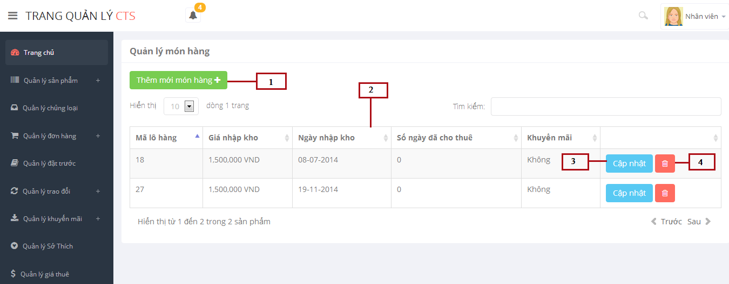

Figure 152: Toy Instance List

**Fields**

|  |  |  |  |  |  |  |  |
| --- | --- | --- | --- | --- | --- | --- | --- |
| **No** | **Field Name** | **Description** | **Read only** | **Mandatory** | **Control Type** | **Data Type** | **Length** |
| 2 | Toy Instance List | Show toy instance list | No | N/A | Table list | N/A | N/A |

**Buttons/Hyperlinks**

|  |  |  |  |  |
| --- | --- | --- | --- | --- |
| **No** | **Function** | **Description** | **Validation** | **Outcome** |
| 1 | Create new toy instance | Click to go to create new toy instance popup | No | Transfer to create new toy instance popup |
| 3 | Edit | Click to edit information of a toy instance | No | Transfer to edit toy instance popup |
| 4 | Delete toy instance | Click to delete a toy instance | N/A | Message completed |

**Table Toy Instance List Includes**

|  |  |  |  |  |  |
| --- | --- | --- | --- | --- | --- |
| **Field Name** | **Description** | **Read only** | **Control Type** | **Data Type** | **Length** |
| Code | Display code of toy instance | Yes | Textview | Integer | N/A |
| Capital Price | Display capital price | Yes | Textview | Double | N/A |
| Start rented day | Display start rented day | Yes | Textview | Datetime | N/A |
| Rented day number | Display rented day number | Yes | Textview | Integer | N/A |
| Promotion | Display promotion of toy instance | Yes | Textview | Integer | N/A |
| Action | Edit/delete toy instance | No | Button | N/A | N/A |

### **Add New Toy Instance**

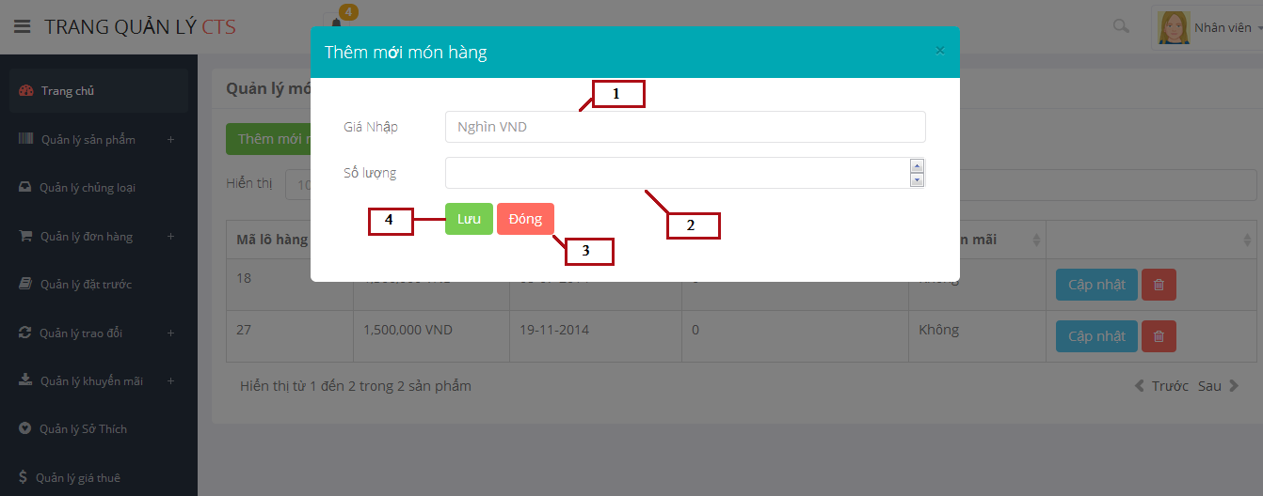

Figure 153: Add New Toy Instance

**Fields**

|  |  |  |  |  |  |  |  |
| --- | --- | --- | --- | --- | --- | --- | --- |
| **No** | **Field Name** | **Description** | **Read only** | **Mandatory** | **Control Type** | **Data Type** | **Length** |
| 1 | Capital Price | Fill capital price of toy instane | No | Yes | Textbox | Double | N/A |
| 2 | Quantity | Fill quantity of toy instance | No | Yes | Textbox | Integer | N/A |

**Buttons/Hyperlinks**

|  |  |  |  |  |
| --- | --- | --- | --- | --- |
| **No** | **Function** | **Description** | **Validation** | **Outcome** |
| 3 | Close | Click to close popup | No | Popup add new toy instance closed |
| 4 | Save | Click to save information of toy instance into database. | N/A | Message completed |

### **Update Toy Instance**

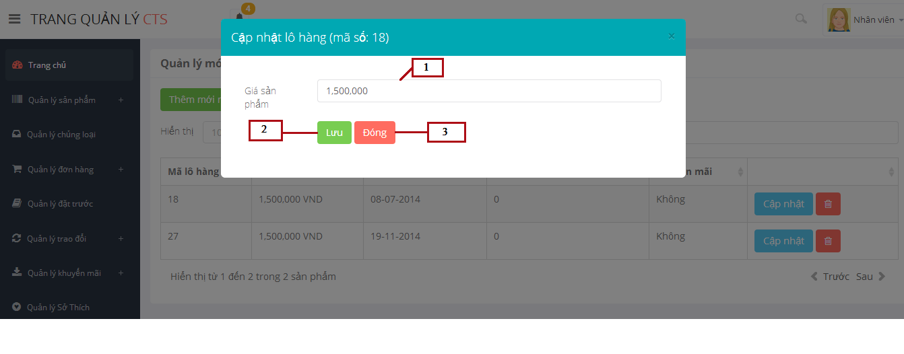

Figure 154: Update Toy Instance

**Fields**

|  |  |  |  |  |  |  |  |
| --- | --- | --- | --- | --- | --- | --- | --- |
| **No** | **Field Name** | **Description** | **Read only** | **Mandatory** | **Control Type** | **Data Type** | **Length** |
| 1 | Capital Price | Fill capital price of toy instane | No | Yes | Textbox | Double | N/A |

**Buttons/Hyperlinks**

|  |  |  |  |  |
| --- | --- | --- | --- | --- |
| **No** | **Function** | **Description** | **Validation** | **Outcome** |
| 2 | Close | Click to close popup | No | Popup add new toy instance closed |
| 3 | Save | Click to save information of toy instance into database. | N/A | Message completed |

### **Add New Toy**

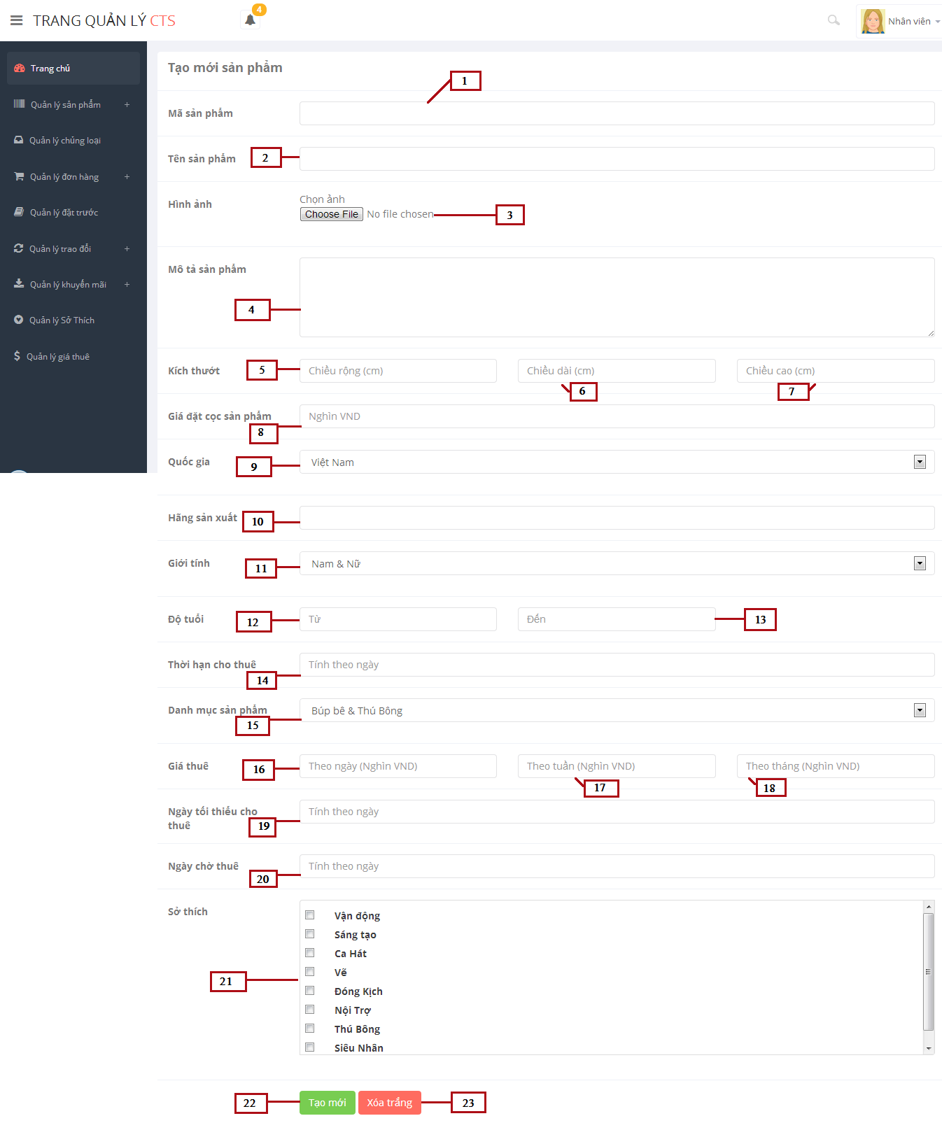

Figure 155: Add New Toy

**Fields**

|  |  |  |  |  |  |  |  |
| --- | --- | --- | --- | --- | --- | --- | --- |
| **No** | **Field Name** | **Description** | **Read only** | **Mandatory** | **Control Type** | **Data Type** | **Length** |
| 1 | Code | Fill code of toy | No | Yes | Textbox | String | [1-5] |
| 2 | Toy Name | Fill toy name | No | Yes | Textbox | String | N/A |
| 4 | Description | Fill description of toy | No | Yes | Textarea | String | N/A |
| 5 | Width | Fill width of toy | No | Yes | Textbox | Float | N/A |
| 6 | Length | Fill length of toy | No | Yes | Textbox | Float | N/A |
| 7 | Height | Fill height of toy | No | Yes | Textbox | Float | N/A |
| 8 | Deposit price | Fill deposit price of toy | No | Yes | Textbox | Double | N/A |
| 9 | Origin | Select origin of toy | No | Yes | Drop down list | N/A | N/A |
| 10 | Manufacture | Fill manufacture of toy | No | Yes | Textbox | String | N/A |
| 11 | Gender | Select suitable gender of toy | No | Yes | Drop down list | N/A | N/A |
| 12 | Age from | Fill age from | No | Yes | Textbox | Integer | N/A |
| 13 | Age to | Fill age to | No | Yes | Textbox | Integer | N/A |
| 14 | Max rented day | Fill max rented day | No | Yes | Textbox | Integer | N/A |
| 15 | Category name | Select category name | No | Yes | Drop down list | String | N/A |
| 16 | Day price | Fill day price | No | Yes | Textbox | Double | N/A |
| 17 | Week price | Fill week price | No | Yes | Textbox | Double | N/A |
| 18 | Month price | Fill month price | No | Yes | Textbox | Double | N/A |
| 19 | Min rent day | Fill min rent day | No | Yes | Textbox | Integer | N/A |
| 20 | Max pending day | Fill max pending day | No | Yes | Textbox | Integer | N/A |
| 21 | Hobby | Select hobby | No | Yes | Checkbox | N/A | N/A |

**Buttons/Hyperlinks**

|  |  |  |  |  |
| --- | --- | --- | --- | --- |
| **No** | **Function** | **Description** | **Validation** | **Outcome** |
| 3 | Upload image | Click to browse image | No | Upload image |
| 22 | Clear Text | Click to delete all information in the data field | N/A | All information in the data filed will be clear(Except : gender, category, hobby fileds) |
| 23 | Create new | Click to create new toy | Yes | Message completed |

### **Update Toy**

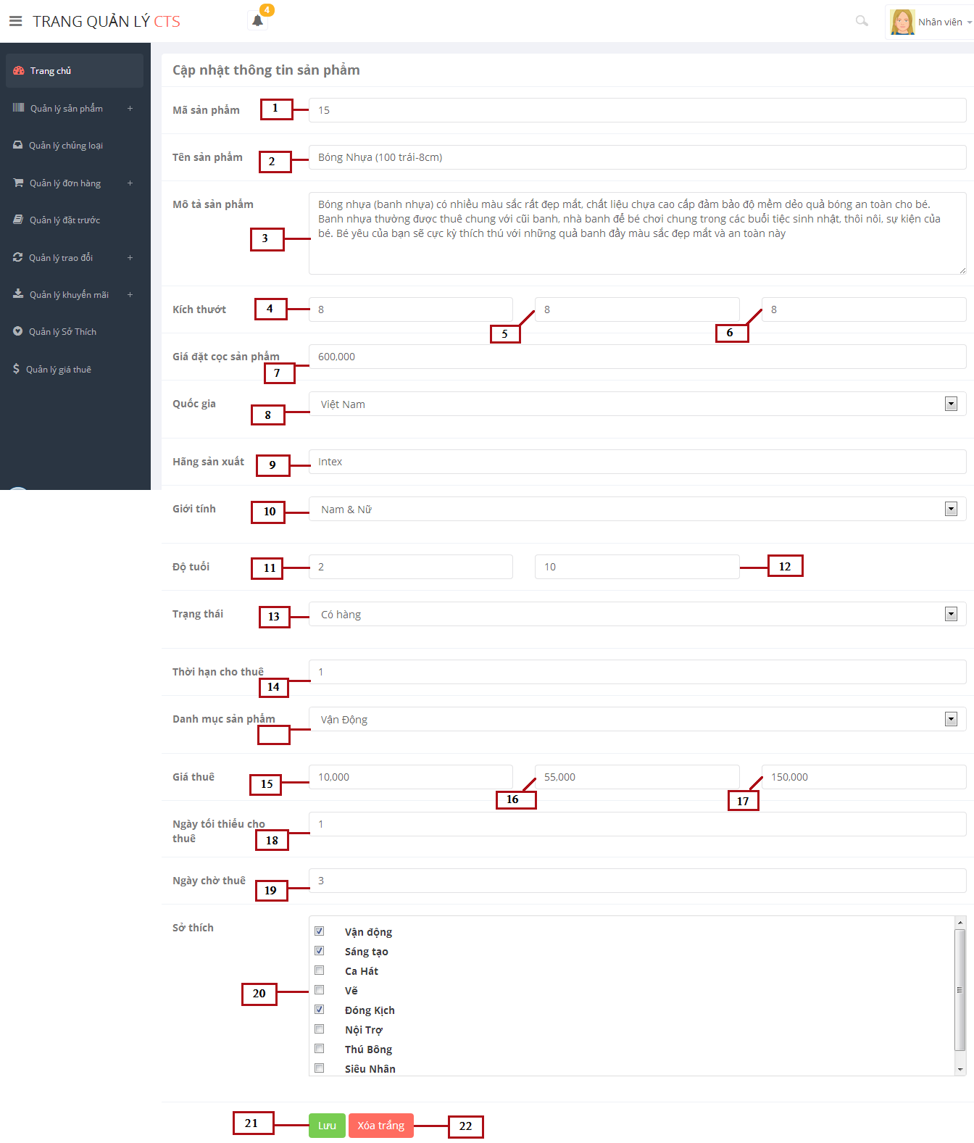

Figure 156: Update Toy

**Fields**

|  |  |  |  |  |  |  |  |
| --- | --- | --- | --- | --- | --- | --- | --- |
| **No** | **Field Name** | **Description** | **Read only** | **Mandatory** | **Control Type** | **Data Type** | **Length** |
| 1 | Code | Fill code of toy | No | Yes | Textbox | String | [1-5] |
| 2 | Toy Name | Fill toy name | No | Yes | Textbox | String | N/A |
| 4 | Description | Fill description of toy | No | Yes | Textarea | String | N/A |
| 5 | Width | Fill width of toy | No | Yes | Textbox | Float | N/A |
| 6 | Length | Fill length of toy | No | Yes | Textbox | Float | N/A |
| 7 | Height | Fill height of toy | No | Yes | Textbox | Float | N/A |
| 8 | Deposit price | Fill deposit price of toy | No | Yes | Textbox | Double | N/A |
| 9 | Origin | Select origin of toy | No | Yes | Drop down list | N/A | N/A |
| 10 | Manufacture | Fill manufacture of toy | No | Yes | Textbox | String | N/A |
| 11 | Gender | Select suitable gender of toy | No | Yes | Drop down list | N/A | N/A |
| 12 | Age from | Fill age from | No | Yes | Textbox | Integer | N/A |
| 13 | Age to | Fill age to | No | Yes | Textbox | Integer | N/A |
| 14 | Max rented day | Fill max rented day | No | Yes | Textbox | Integer | N/A |
| 15 | Category name | Select category name | No | Yes | Drop down list | String | N/A |
| 16 | Day price | Fill day price | No | Yes | Textbox | Double | N/A |
| 17 | Week price | Fill week price | No | Yes | Textbox | Double | N/A |
| 18 | Month price | Fill month price | No | Yes | Textbox | Double | N/A |
| 19 | Min rent day | Fill min rent day | No | Yes | Textbox | Integer | N/A |
| 20 | Max pending day | Fill max pending day | No | Yes | Textbox | Integer | N/A |
| 21 | Hobby | Select hobby | No | Yes | Checkbox | N/A | N/A |

**Buttons/Hyperlinks**

|  |  |  |  |  |
| --- | --- | --- | --- | --- |
| **No** | **Function** | **Description** | **Validation** | **Outcome** |
| 3 | Upload image | Click to browse image | No | Upload image |
| 22 | Clear Text | Click to delete all information in the data field | N/A | All information in the data filed will be clear(Except : gender, category, hobby fileds) |
| 23 | Create new | Click to create new toy | Yes | Message completed |

## Database Design

### **Physical Database Diagram**

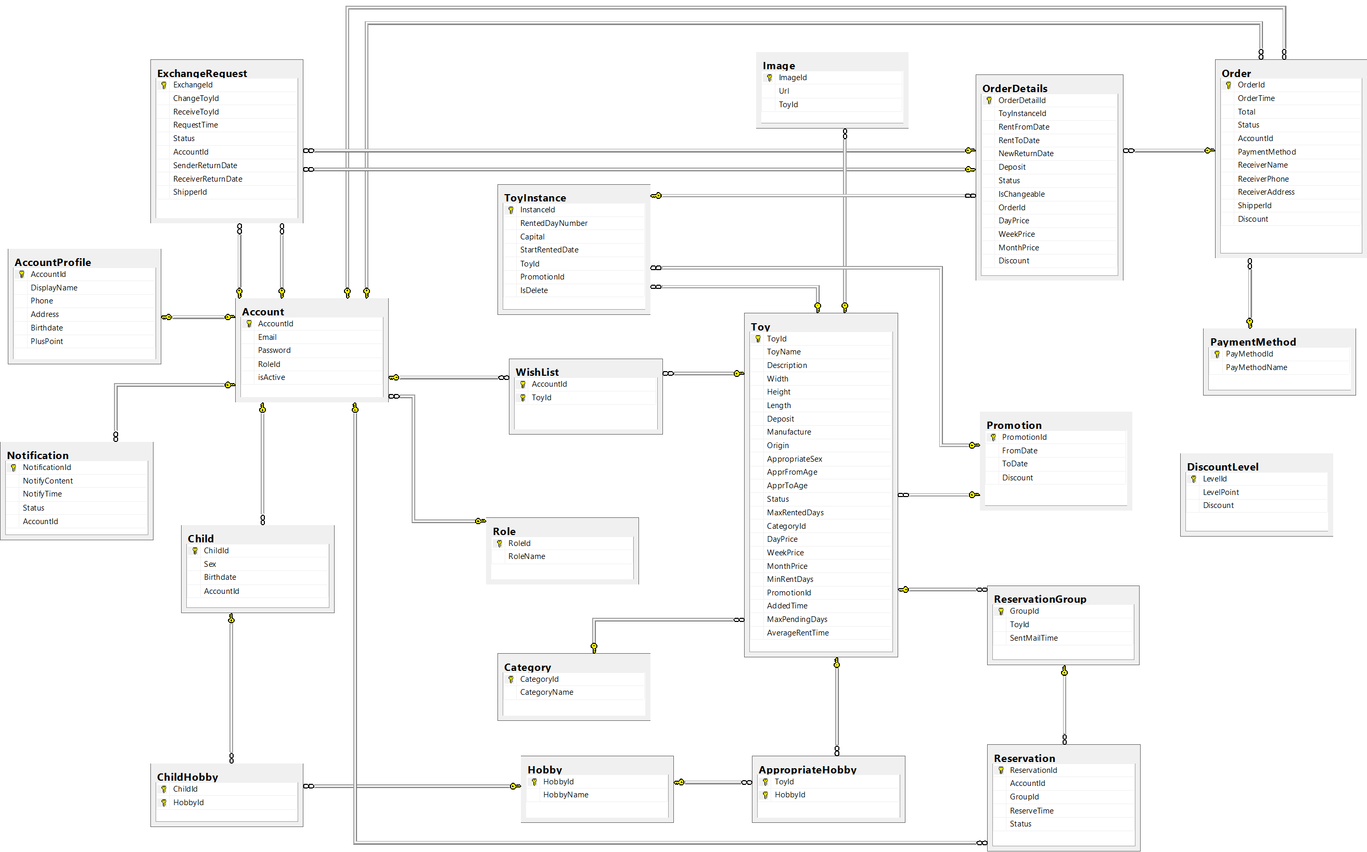

**Figure 157: Physical Database Diagram**

### **Data Dictionary**

|  |  |
| --- | --- |
| **Entity Data dictionary: describe content of all entities** | |
| **Entity Name** | **Description** |
| Account | Describe account of user of system. |
| Role | Describe role of user. One user has one role. |
| Child | Describe child of customers in system. |
| ChildHobby | Describe all hobbies of each child. |
| Hobby | Describe all normal hobbies of real child. |
| AccountProfile | Describe information of account in system. |
| Notification | Describe all of user’s notification of the system. |
| Toy | Describe all information of toys in system. |
| Image | Describe all image of toys in system. |
| ToyInstance | Describe all instances of a toy in system. |
| Category | Describe all kind of toys in system. |
| AppropriateHobby | Describe suitable hobbies of toys in system. |
| WishList | Describe favorite toys list of customer in system. |
| Promotion | Describe all information of promotion in system. |
| OrderDetails | Describe all details of an order in system. |
| Order | Describe all order of the renter in system. |
| PaymentMethod | Describe all payment of customer in system. |
| Reservation | Describe all toys booking of customer in system. |
| ReservationGroup | Describe all booking group of each toy in system. |
| DiscountLevel | Describe percent of discount based on plus point of customer |
| ExchangeRequest | Describe all toys exchange of customer in system. |

Table 52: Entity Data Dictionary

#### **Table Role**

|  |  |  |  |  |
| --- | --- | --- | --- | --- |
| **Entity name** | **Attributes** | **Description** | **Type** | **Null** |
| Role | RoleID {PK} | Unique identifier of a role, auto increment. | Integer | No |
| RoleName | Role name of each role | Varchar(10) | No |
| Unique Key: RoleName | | | | |

Table 53: Data Dictionary of Role

#### **Table Account**

|  |  |  |  |  |
| --- | --- | --- | --- | --- |
| **Entity name** | **Attributes** | **Description** | **Type** | **Null** |
| Account | AccountId{PK} | Unique identifier of an account, auto increment. | Integer | No |
| Email | Email to login system of customer | Nvarchar(50) | No |
| Password | Password to login system of customer | Nvarchar(32) | No |
| RoleId{FK} | Role of this account. Foreign key references to table Role (RoleId). | Integer | No |
| isActive | This description account isactive or active | Bit | No |
| Unique Key: Email | | | | |

Table 54: Data Dictionary of Account

#### **Table Child**

|  |  |  |  |  |
| --- | --- | --- | --- | --- |
| **Entity name** | **Attributes** | **Description** | **Type** | **Null** |
| Child | ChildId{PK} | Unique identifier of a child, auto increment. | Integer | No |
| Sex | Sex of child | Bit | No |
| Birthdate | Birthdate of child | Date | No |
| AccountId{FK} | ID of account that child belong to. Foreign key references to table Account (AccountId) | Integer | No |

Table 55: Data Dictionary of Child

#### **Table ChildHobby**

|  |  |  |  |  |
| --- | --- | --- | --- | --- |
| **Entity name** | **Attributes** | **Description** | **Type** | **Null** |
| ChildHobby | ChildId{PK, FK} | ID of child that has this hobby. Foreign key references to table Child (ChildId). | Integer | No |
| HobbyId{PK, FK} | ID of hobby of child. Foreign key references to table Hobby (HobbyId). | Integer | No |

Table 56: Data Dictionary of ChildHobby

#### **Table Hobby**

|  |  |  |  |  |
| --- | --- | --- | --- | --- |
| **Entity name** | **Attributes** | **Description** | **Type** | **Null** |
| Hobby | HobbyId{PK} | Unique identifier of a hobby, auto increment. | Integer | No |
| HobbyName | Name of hobby | Nvarchar(50) | No |
| Unique Key: HobbyName | | | | |

Table 57: Data Dictionary of Hobby

#### **Table AccountProfile**

|  |  |  |  |  |
| --- | --- | --- | --- | --- |
| **Entity name** | **Attributes** | **Description** | **Type** | **Null** |
| AccountProfile | AccountId{PK,FK} | Unique identifier of an account, auto increment. Foreign key references to table Account (AccountId). | Integer | No |
| DisplayName | Name of customer | Nvarchar(50) | No |
| Phone | Phone of a customer | Varchar(11) | No |
| Address | Address of a customer | Nvarchar(100) | No |
| Birthdate | Birthdate of a customer | Date | No |
| PlusPoint | Sum of point is plused | Integer | No |
| Unique Key: Phone | | | | |

Table 58: Data Dictionary of AccountProfile

#### **Table Notification**

|  |  |  |  |  |
| --- | --- | --- | --- | --- |
| **Entity name** | **Attributes** | **Description** | **Type** | **Null** |
| Notification | NotificationId{PK} | Unique identifier of a notification, auto increment. | Integer | No |
| NotifyContent | Content of a notification | Nvarchar(200) | No |
| NotifyTime | Time notification has been sent | DateTime | No |
| Status | Status shows state of a notification. | Varchar(6) | No |
| AccountId{FK} | ID of account receive this notification. Foreign key references to table Account (AccountId). | Integer | No |

Table 59: Data Dictionary of Notification

#### **Table Toy**

|  |  |  |  |  |
| --- | --- | --- | --- | --- |
| **Entity name** | **Attributes** | **Description** | **Type** | **Null** |
| Toy | ToyId{PK} | Unique identifier of each toy. | Varchar(5) | No |
| ToyName | Name of a toy | Nvarchar(100) | No |
| Description | Information about a toy | Nvarchar(500) | No |
| Width | Width of a toy | Float | No |
| Height | Height of a toy | Float | No |
| Length | Length of a toy | Float | No |
| Deposit | Deposit price customer has to pay when renting a toy | Bigint | No |
| Manufacture | Manufacture of a toy | Nvarchar(100) | No |
| Origin | Origin of a toy | Nvarchar(50) | No |
| AppropriateSex | Sex suitable with a toy | Integer | No |
| ApprFromAge | Suitable age for start to play a toy | Integer | No |
| ApprToAge | Suitable age for end to play a toy | Integer | No |
| Status | Status shows state of a toy | Varchar(15) | No |
| MaxRentedDays | Sum of days for rent a toy | Integer | No |
| CategoryId{FK} | ID of category that toy belong to. Foreign key references to table Category (CategoryID). | Integer | No |
| DayPrice | Rent price of toy for a day | BigInt | No |
| WeekPrice | Rent price of toy for a week | BigInt | No |
| MonthPrice | Rent price of toy for a month | BigInteger | No |
| MinRentDays | Minimum number of days customer has to rent this toy | Integer | No |
| AddedTime | Time that toy has been added to system | DateTime | No |
| MaxPendingDays | Maximum duration between order time and receive toy date | Integer | No |
| AverageRentTime | Average rent time of a toy | Float | Yes |
| PromotionId{FK} | ID of promotion that is applied for this toy. Foreign key references to table Promotion (PromotionId). | Integer | Yes |

Table 60: Data Dictionary of Toy

#### **Table Image**

|  |  |  |  |  |
| --- | --- | --- | --- | --- |
| **Entity name** | **Attributes** | **Description** | **Type** | **Null** |
| Image | ImageId{PK} | Unique identifier of an image, auto increment. | Integer | No |
| Url | Url to get image | Nvarchar(200) | No |
| ToyId{FK} | ID of toy that image belong to. Foreign key references to table Toy (ToyId). | Varchar(5) | No |
| Unique Key: Url | | | | |

Table 61: Data Dictionary of Image

#### **Table ToyInstance**

|  |  |  |  |  |
| --- | --- | --- | --- | --- |
| **Entity name** | **Attributes** | **Description** | **Type** | **Null** |
| ToyInstance | InstanceId{PK} | Code of each instance. | Integer | No |
| RentedDayNumber | Number of days that toy instance has been rented | Integer | No |
| Capital | Capital of that toy instance | BigInt | No |
| StartRentedDate | The date that toy intance is in stock | Date | No |
| ToyId{FK} | ID of toy that toy instance belong to. Foreign key references to table Toy (ToyId). | Varchar(5) | No |
| isDelete | Show instance is deleted or not | Bit | No |
| PromotionId{FK} | ID of promotion that toy instance is applied. Foreign key references to table Promotion (PromotionId). | Integer | Yes |

Table 62: Data Dictionary of ToyInstance

#### **Table Category**

|  |  |  |  |  |
| --- | --- | --- | --- | --- |
| **Entity name** | **Attributes** | **Description** | **Type** | **Null** |
| Category | CategoryId{PK} | Unique identifier of a category, auto increment. | Integer | No |
| CategoryName | Name of a category | Nvarchar(50) | No |
| Unique Key: CategoryName | | | | |

Table 63: Data Dictionary of Category

#### **Table AppropriateHobby**

|  |  |  |  |  |
| --- | --- | --- | --- | --- |
| **Entity name** | **Attributes** | **Description** | **Type** | **Null** |
| ApproriateHobby | ToyId{PK, FK} | ID of toy that have this hobby. Foreign key references to table Toy (ToyId). | Varchar(5) | No |
| HobbyId{PK, FK} | ID of hobby of toy. Foreign key references to table Hobby (HobbyId). | Integer | No |

Table 64: Data Dictionary of AppropriateHobby

#### **Table WishList**

|  |  |  |  |  |
| --- | --- | --- | --- | --- |
| **Entity name** | **Attributes** | **Description** | **Type** | **Null** |
| WishList | AccountId{PK, FK} | ID of customer that has saved this toy to wishlist. Foreign key references to table Account (AccountId). | Integer | No |
| ToyId{PK, FK} | ID of toy that has been saved to wishlist. Foreign key references to table Toy (ToyId). | Varchar(5) | No |

Table 65: Data Dictionary of WishList

#### **Table Promotion**

|  |  |  |  |  |
| --- | --- | --- | --- | --- |
| **Entity name** | **Attributes** | **Description** | **Type** | **Null** |
| Promotion | PromotionId{PK} | Unique identifier of a promotion, auto increment. | Integer | No |
| FromDate | Start date a promotion. | Date | No |
| ToDate | End date of a promotion | Date | No |
| Discount | Discount percent of this promotion | Integer | No |

Table 66: Data Dictionary of Promotion

#### **Table DiscountLevel**

|  |  |  |  |  |
| --- | --- | --- | --- | --- |
| **Entity name** | **Attributes** | **Description** | **Type** | **Null** |
| DiscountLevel | LevelId{PK} | Unique identifier of a discount level, auto increment. | Integer | No |
| LevelPoint | Plus point of customer that start apply discount in this level | Integer | No |
| Discount | Discount percent | Integer | No |
| Unique Key : LevelPoint | | | | |

Table 67: Data Dictionary of DiscountLevel

#### **Table OrderDetail**

|  |  |  |  |  |
| --- | --- | --- | --- | --- |
| **Entity name** | **Attributes** | **Description** | **Type** | **Null** |
| OrderDetails | OrderDetailId{PK} | Unique identifier of an order details, auto increment. | Integer | No |
| ToyInstanceId{FK} | ID of toy instance that has been rented. Foreign key references to table ToyInstance (ToyInstanceId). | Integer | No |
| RentFromDate | Start renting date | Date | No |
| RentToDate | Date to return toy | Date | No |
| NewReturnDate | Updated new date to return toy | Date | Yes |
| Status | Status shows renting state of order details. | Varchar(15) | No |
| OrderId{PK} | ID of order that order detail belong to. Foreign key references to table Order (OrderId). | Integer | No |
| IsChangeable | Show that rented product is exchangeable or not | Bit | No |
| Deposit | Deposit price of rented toy | BigInt | No |
| DayPrice | Rent price of toy for a day | BigInt | No |
| WeekPrice | Rent price of toy for a week | BigInt | No |
| MonthPrice | Rent pprice of toy for a month | BigInt | No |
| Discount | Discount percent of this order detail | Integer | No |

Table 68: Data Dictionary of OrderDetail

#### **Table Order**

|  |  |  |  |  |
| --- | --- | --- | --- | --- |
| **Entity name** | **Attributes** | **Description** | **Type** | **Null** |
| Order | OrderId{PK} | Unique identifier of an order, auto increment. | Integer | No |
| OrderTime | Time when order is made | DateTime | No |
| Total | Total payment amount af an order. | Bigint | No |
| Status | Status shows renting state of an order | Varchar(10) | No |
| AccountId{FK} | ID of account that rented this order. Foreign key references to table Account (AccountId). | Integer | No |
| PaymentMethod{FK} | ID of payment method customer has selected for this order. Foreign key references to table PaymentMethod (PayMethodId). | Integer | No |
| ReceiveName | Name of receiver | Nvarchar(50) | No |
| ReceivePhone | Phone of receiver | Varchar(11) | No |
| ReceiveAddress | Address of receiver | Nvarchar(200) | No |
| ShipperId | ID of staff who process this order. Foreign key references to table Account (AccountId) | Integer | Yes |
| Discount | Discount percent of entire order based on customer’s plus point | Integer | No |
| Unique Key: {AccountId, OrderTime} | | | | |

Table 69: Data Dictionary of Order

#### **Table PaymentMethod**

|  |  |  |  |  |
| --- | --- | --- | --- | --- |
| **Entity name** | **Attributes** | **Description** | **Type** | **Null** |
| PaymentMethod | PayMethodId{PK} | Unique identifier of a payment, auto increment. | Integer | No |
| PayMethodName | Name of payment method | Nvarchar(50) | No |
| Unique Key: {PayMethodName} | | | | |

Table 70: Data Dictionary of PaymetMethod

#### **Table Reservation**

|  |  |  |  |  |
| --- | --- | --- | --- | --- |
| **Entity name** | **Attributes** | **Description** | **Type** | **Null** |
| Reservation | ReservationId{PK} | Unique identifier of a reservation, auto increment. | Integer | No |
| AccountId{FK} | ID of customer who made reservation. Foreign key references to table Account (AccountId). | Integer | No |
| Status | Show that customer has received toy or not | Bit | No |
| GroupId{FK} | ID of reservation group of this toy. Foreign key references to table ReservationGroup (GroupId). | Integer | No |
| ReserveTime | Time when customer made reservation | Datetime | No |
| Unique Key: {AccountId, GroupId} | | | | |

Table 71: Data Dictionary of Reservation

#### **Table ReservationGroup**

|  |  |  |  |  |
| --- | --- | --- | --- | --- |
| **Entity name** | **Attributes** | **Description** | **Type** | **Null** |
| ReservationGroup | GroupId{PK} | Unique identifier of a reservation group, auto increment. | Integer | No |
| SentMailTime | Last time that system sent mail to customer in group to notify toy is available | Date | Yes |
| ToyId{FK} | ID of toy that is reserved by this group. Foreign key references to table Toy (ToyId). | Varchar(5) | No |
| Unique Key: {ToyId} | | | | |

Table 72: Data Dictionary of ReservationGroup

#### **Table ExchangeRequest**

|  |  |  |  |  |
| --- | --- | --- | --- | --- |
| **Entity name** | **Attributes** | **Description** | **Type** | **Null** |
| ExchangeRequest | ExchangeId{PK} | Unique identifier of an exchange request, auto increment. | Integer | No |
| ChangeToyId{FK} | ID of rented toy of request sender. Foreign key references to table OrderDetail (OrderDetailId). | Integer | No |
| ReceiveToyId{FK} | ID of rented toy of request receiver. Foreign key references to table OrderDetail (OrderDetailId). | Integer | No |
| RequestTime | Time when customer sent exchange request | DateTime | No |
| Status | Status of exchange | Varchar(15) | No |
| SenderReturnDate | Date sender want to return exchange toy | Date | No |
| ReceiverReturnDate | Date receiver want to return exchange toy | Date | No |
| ShipperId | ID of staff who process this exchange. Foreign key references to table Account (AccountId) | Integer | No |
| AccountId{FK} | ID of customer who sent this request. Foreign key references to table Account (AccountId). | Integer | No |

Table 73: Data Dictionary of ExchangeRequest

## Algorithms

### **Suggest products which rented by customers who rented current product**

#### **Requirement:**

Suggest related product for current viewed product by getting products most rent by customers who rented current product.

#### **Solution:**

1. Get all customers who rented current product
2. Get all products rented by these customers which is different from current product
3. Sort product list in order of most rented
4. Get top 5 products to suggest for customer

#### **Example:**

Current product: Gấu bông teddy

1. Customer who rented this product: Customer 1, Customer 2, Customer 3
2. Product these customers had rented:

|  |  |  |  |
| --- | --- | --- | --- |
|  | Customer 1 | Customer 2 | Customer 3 |
| Gấu bông teddy | X | X | X |
| Cún đốm | X | X |  |
| Nhà thả 12 khối | X |  |  |
| Bàn nhạc trẻ em |  | X | X |
| Bập bênh puppy | X | X | X |
| Xe tập đi |  | X |  |

1. Sorted list of most rented: Bập bênh puppy, Cún đốm, Bàn nhạc trẻ em, Nhà thả 12 khối, Xe tập đi
2. Top 5 products: Bập bênh puppy, Cún đốm, Bàn nhạc trẻ em, Nhà thả 12 khối, Xe tập đi

### **Suggest products appropriate for child**

#### **Requirement:**

Suggest products that appropriate for each child of customer.

#### **Solution:**

1. Get all children of customer
2. Get all products that appropriate to child’s age, gender and hobbies
3. Sort products list in order of most matched number of hobbies
4. Get top 20 products in products list

#### **Example:**

1. Child’s information:

* Age: 2 years
* Gender: female
* Hobbies: đóng kịch, thú bông, vận động

1. Product’s information:

|  |  |  |  |
| --- | --- | --- | --- |
|  | Age | Gender | Hobbies |
| Gấu bông teddy | 1 – 5 years | Both | Đóng kịch, thú bông |
| Cún đốm | 1 – 5 years | Both | Đóng kịch, thú bông |
| Nhà thả 12 khối | 1 – 3 years | Both | Sáng tạo |
| Bàn nhạc trẻ em | 3 – 6 years | Both | Ca hát |
| Bập bênh puppy | 3 – 5 years | Both | Vận động |
| Xe tập đi | 0 – 2 years | Both | Vận động |

Suggest products must be appropriate to age, gender and matched with hobbies.

* “Bàn nhạc trẻ em” and “Bập bênh puppy” are not appropriate for 2 age child
* “Nhà thả 12 khối” is not matched with child hobbies
  + Matched products: Gấu bông Teddy, Cún đốm, Xe tập đi

1. Sorted list of product by number of matched hobbies: Gấu bông Teddy, Cún đốm, Xe tập đi
2. Get top 20 products: Gấu bông Teddy, Cún đốm, Xe tập đi

### **Suggest products by customer orders**

#### **Requirement:**

Suggest products based on customer’s order. Compare orders history of all customers to find customers who have same renting trend of current customer.

#### **Solution:**

Using Pearson Correlation Coefficient Formula to calculate similarity between customers. And then select products most rented by these similar customer to suggest for current customer.

Pearson Correlation Coefficient is a way to determine the similarity between people’s interests. The correlation coefficient is a measure of how well two sets of data fit on a straight line.

To find the Pearson correlation score, first we have to find the items rented by both customers.

It then calculates the sums and the sum of the squares of the ratings for the two customer, and calculates the sum of the products of their ratings. Finally, it uses these results to calculate the Pearson correlation coefficient

##### **Create input dataset:**

* **Purpose**: Create customer’s point for each rented product as input dataset to compare renting trend of customers
* **Step**:
  + Get all products rented by each customer
  + Calculate customer’s point for each product by comparing with average rent time. Customer’s point will between 1 and 5, due to customer’s rent time.
* **Formula**: (let average rent time = average point = 2.5)

$$customer^{'}s point= \frac{customer^{'}s rent time*2.5}{average rent time}$$

If customer’s point > 5 🡪 set customer’s point = 5

##### **Calculate customer’s similarity:**

* **Purpose**: Calculate similarity of each other customer with current customer
* **Step**:
  + Get list of other customer
  + For each other customer, get all customer’s point for rented product of this customer and current customer
  + Calculate similarity point using **Pearson Correlation Coefficient Formula**.
* **Formula**:

***r = $\frac{N\sum{xy} -(\sum{x})(\sum{y})}{\sqrt{\left[N\sum{x^{2}} -{\left(\sum{x}\right)}^{2}\right][N\sum{y^{2}} -{\left(\sum{y}\right)}^{2}]}}$***

Where:

N: number of products rented by both customer

$\sum{xy}$: sum of the product of paired scores from 2 customer for each product

$\sum{x}$: sum of scores from current suggesting customer

$\sum{y}$: sum of scores from other customer

$\sum{x^{2}}$: sum of squared of scores from current suggesting customer

$\sum{y^{2}}$: sum of squared of scores from other customer

The formula will return result from -1 to 1.

r = -1 : 2 customers are opposite

r = 0 : 2 customers are not correlated

r = 1 : 2 customers are totally similar

##### **Suggest products for customer**

* **Purpose**: Suggest appropriate products for current customer
* **Step**:
  + Get all customer who has similarity point > 0 (who have same renting trend with current customer)
  + Get all rented products of each other customer in list
  + Exclude products that rented by current customer from products list
  + Calculate predict customer’s point of current customer for each product in list.
  + Sort products list in order of highest predict customer’s point
  + Get top products and suggest to current customer.
* **Formula**:

***Predict customer’s product point = $\sum{(similarity*customer's point)}/\sum{similarity}$***

Where:

similarity: similarity point of current customer and other customer

customer’s point: other customer’s point for each product

$\sum{similarity}$: sum of similarity point of current customer and other customers who rented this product

#### **Example:**

##### **Create input dataset:**

Customer 9 rented 3 product: product 1, product 2, product 3 with rent time showed in table.

* 1. Customer9’s point for each product is calculate in table

|  |  |  |  |
| --- | --- | --- | --- |
|  | Product 1 | Product 2 | Product 3 |
| Customer’s rent time | 7 days | 15 days | 26 days |
| Product’s average rent time | 5 days | 20 days | 12 days |
| Customer’s point | (7*2.5)/5 = 3.5 | (15*2.5)/20 = 1.875 | (26*2.5)/12 = 5.42 ~ 5 |

##### **Calculate customer’s similarity:**

Customer 1 rented 4 product: product 1, product 2, product 4, and product 5

Customer 2 rented 4 product: product 1, product 2, product 3, and product 5

Customer’s point for each rented product is shown in table

|  |  |  |  |  |  |
| --- | --- | --- | --- | --- | --- |
|  | **Product 1** | **Product 2** | **Product 3** | **Product 4** | **Product 5** |
| **Customer1’s point (x)** | 2.5 | 2 | - | 3 | 4 |
| **Customer2’s point (y)** | 2 | 3 | 3.5 | - | 4.5 |
| **xy** | 5 | 6 | - | - | 18 |
| $$x^{2}$$ | 6.25 | 4 | - | - | 16 |
| $$y^{2}$$ | 4 | 9 | - | - | 20.25 |

The Pearson Correlation Coefficient is only applied for products that is rented by both customer. So we exclude product 3 and product 4 from list when calculating.

We have:

; ;

;

;

*N* = 3

* 1. Apply Pearson formula:

r = $\frac{N\sum{xy} -(\sum{x})(\sum{y})}{\sqrt{\left[N\sum{x^{2}} -{\left(\sum{x}\right)}^{2}\right][N\sum{y^{2}} -{\left(\sum{y}\right)}^{2}]}}$ = $\frac{3*29 -8.5*9.5 }{\sqrt{\left[3*26.25 - 72.25\right][3*33.25 -90.25]}}$ = 0.7954

🡪 r > 0 🡪 customer 1 and customer 2 have same renting trend

##### **Suggest products for customer**

Pretend that system have 4 customers.

Current customer is Customer 1

Customer 2, Customer 3, Customer 4 have similarity point with Customer 1 as shown in below table.

Each customer has rented some products that Customer 1 hasn’t rented before. Customer’s point of each customer for each rented product is shown in below table.

|  |  |  |  |  |  |  |  |
| --- | --- | --- | --- | --- | --- | --- | --- |
|  | **Similarity** | **P3** | **Sim*P3** | **P6** | **Sim*P6** | **P7** | **Sim*P7** |
| **Customer 2** | 0.8 | 3.5 | 2.8 | 3 | 2.4 | 4 | 3.2 |
| **Customer 3** | 0.92 | - | - | 2.5 | 2.3 | 4.5 | 4.14 |
| **Customer 4** | 0.65 | 2.5 | 1.625 | - | - | 3 | 1.95 |
| **Total sim*point** |  |  | 2.8 + 1.625 = 4.425 |  | 2.4 + 2.3 = 4.7 |  | 3.2 + 4.14 = 9.29 |
| **Sim. Sum** |  |  | 0.8 + 0.65 = 1.45 |  | 0.8 + 0.92 = 1.72 |  | 0.8 + 0.92 + 0.65 = 2.37 |
| **Total/Sim. Sum (predict point)** |  |  | 4.424/1.45 = 3.05 |  | 4.7/1.72 = 2.73 |  | 9.29/2.37 = 3.92 |

* Recommend product for Customer 1 in order: Product 7, Product 3, Product 6

# System Implementation & Test (SIT)

## Introduction

### **System Overview**

This section provides in detail all necessary information about test plans, test cases, test result, test environments, pass/fail criteria and risks estimations as well as a checklist to cover all possible cases of CTS system.

### **Test Approach**

Goal: Check all the features in CTS system and record remain bug to fix.

Type: White box testing, Black-box Testing.

Size: System Component.

Technique: Check list.

## Test Plan

### **Features to be tested**

We will carry out test based on core workflow of system. All main functions will be tested carefully and clearly following phases.

* Guest: add to cart, view cart, update cart, view product detail, basic search, and advance search, register
* Admin: view statistic report
* Customer: check out online, check out delivering, view other exchange list, edit exchange list, send exchange request, respond exchange request, return toy soon, extend rent time, reserve toy, cancel order, cancel order detail
* System: auto send mail, auto select next renter, update status of order and exchange.
* Staff: confirm return toy, cancel order, cancel order detail, assign order’s shipper, done delivering order, cancel exchange, done exchange, assign exchange’s shipper, mobile process order, mobile process exchange, mobile process return toy

### **Features not to be tested**

* Login, Logout.
* Register
* Change password.
* Manage members.
* Manage toys.
* Manager promotions.
* Manage hobbies.
* Manage categories.
* View reservation list.
* View customer profile, edit profile, add/edit child
* View order history
* Edit discount level

## Test Cases

### **Basic Search**

|  |  |  |  |  |  |  |
| --- | --- | --- | --- | --- | --- | --- |
| **ID** | **Test Case Description** | **Pre-Condition** | **Test Case Procedure** | **Expected output** | **Result** | **Test Date** |
| BS01 | Basic Search with valid inputted key word | N/A | 1 – Input “bup be” into search fields.  2 – Press enter key | - After step 2, System redirected to search page and display 3 results:   1. Thú Bông_Disney Alice in Wonderland. 2. Cún đốm (Búp bê & Thú bông category). 3. Gấu bông teddy (Búp bê & Thú bông category) | Passed | 30/11/2014 |
| BS02 | Basic Search with wrong key word | N/A | 1 – Input “abc” into search fields.  2 – Press enter key | - After step 2, System redirected to search page and display message “Hiện tại không có sản phẩm mà bạn muốn tìm” | Passed | 30/11/2014 |
| BS03 | Default Search with empty search field | N/A | 1 – Click on search input field  2 – Press enter key | - After step 2, System do nothing. | Passed | 30/11/2014 |

Table 74: Basic Search Test_Case

### **Advanced Search**

|  |  |  |  |  |  |  |
| --- | --- | --- | --- | --- | --- | --- |
| **ID** | **Test Case Description** | **Pre-Condition** | **Test Case Procedure** | **Expected output** | **Result** | **Test Date** |
| AS01 | Advanced Search with valid inputted fields | Search page is displayed | 1 – Input “bup be” into search fields.  2 – Select categories “Búp bê & Thú bông” and “Vận động”  3 – Select rent price 10,000 – 30,000 VNĐ  4 – Select gender “female”  5 – Select age 0 to 7  6 – Select hobbies “Vận động”, “Sáng tạo”, “Đóng kịch”, “Thú bông”  7 – Select origin “USA”  8 – Select manufacturer “Tất cả”  9 – Click “Tìm kiếm” button | - After step 9, System display 2 results:   1. Thú Bông_Disney Alice in Wonderland. 2. Gấu bông teddy | Passed | 30/11/2014 |
| AS02 | Advanced Search with some field leave blank | Search page is displayed | 1 – Select rent price 10,000 – 30,000 VNĐ  2 – Select gender “female”  3 – Select age 0 to 7  4 – Select hobbies “Vận động”, “Sáng tạo”, “Đóng kịch”, “Thú bông”  5 – Select origin “Tất cả”  6 – Select manufacturer “Tất cả”  7 – Click “Tìm kiếm” button | - After step 7, System display 5 results:   1. Thú Bông_Disney Alice in Wonderland. 2. Bóng nhựa (100 trái – 8cm) 3. Gấu bông teddy 4. Cún đốm 5. Nhà thả 12 khối | Passed | 30/11/2014 |
| AS03 | Advanced Search with empty search field and min to min in price and age | Search page is displayed | 1 – Select rent price 10,000 – 10,000  2 – Select age 0 to 0  3 – Click “Tìm kiếm” button | - After step 3, System displays message “Hiện không có sản phẩm mà bạn muốn tìm” | Passed | 30/11/2014 |
| AS04 | Advanced Search with empty search field and min to max in price and age | Search page is displayed | 1 – Select rent price 10,000 to 50, 000  2 – Select age 0 to 10  3 – Click “Tìm kiếm” button | - After step 3, System displays all products. | Passed | 30/11/2014 |

Table 75: Advanced Search Test_Case

### **View product details**

|  |  |  |  |  |  |  |
| --- | --- | --- | --- | --- | --- | --- |
| **ID** | **Test Case Description** | **Pre-Condition** | **Test Case Procedure** | **Expected output** | **Result** | **Test Date** |
| PD01 | View product details of available product | N/A | 1 – Click on product title in products list | - After step 1, System redirected to product details page and display:   1. Product name. 2. Product images 3. Deposit price 4. Rent price each day, week and month 5. Date picker to select rent time 6. Input field to select rent amount 7. Rent button 8. Product details 9. Suggest product with same category 10. Suggest products often rented by customer rented this product | Passed | 30/11/2014 |

Table 76: View Product Details Test_Case

### **View My Exchange List**

|  |  |  |  |  |  |  |
| --- | --- | --- | --- | --- | --- | --- |
| **ID** | **Test Case Description** | **Pre-Condition** | **Test Case Procedure** | **Expected output** | **Result** | **Test Date** |
| VE01 | View list toy exchange of mine | - Log in successful with role customer | 1 – Choose “Trao đổi sản phẩm” in menu bar.  2 – Click “Sản phẩm trao đổi của tôi ” | - After step 2: show list of renting toys that current user added to list exchange. | Passed | 29/11/2014 |

Table 77: View My Exchange List Test_Case

### **Add Toy to Exchange List**

|  |  |  |  |  |  |  |
| --- | --- | --- | --- | --- | --- | --- |
| **ID** | **Test Case Description** | **Pre-Condition** | **Test Case Procedure** | **Expected output** | **Result** | **Test Date** |
| AT01 | Add toys that is renting to exchange list | - Log in successful with role customer | 1 – Choose “Trao đổi sản phẩm” in menu bar.  2 – Click “Sản phẩm trao đổi của tôi ”  3 - Click “Thêm sản phẩm” button  4 – Click to “Thêm sản phẩm trao đổi” button of toys wanting to exchange  5- Click “Có” button | -After step 4: show a popup have message “Bạn có chắc chắn muốn thêm sản phẩm vào danh sách trao đổi?” .Button “Có” và “Không”  -After step 5:  Show popup have message “Sản phẩm đã được thêm vào danh sách trao đổi”. Button “Đóng”. This toys is moved to exchange list | Passed | 30/11/2014 |
| AT02 | Add toy but then cancel | - Log in successful with role customer. | 1 – Choose “Trao đổi sản phẩm” in menu bar.  2 – Click “Sản phẩm trao đổi của tôi ”  3 - Click “Thêm sản phẩm” button  4 – Click to “Thêm sản phẩm trao đổi” button of toys that want to exchange  5- Click “Không” button | -After step 4: show a popup have message “Bạn có chắc chắn muốn thêm sản phẩm vào danh sách trao đổi?” .Button “Có” và “Không”  -After step 5: No toy is added to exchange list | Passed | 30/11/2014 |

Table 78: Add Toy To Exchange List Test_Case

### **Remove Toy out of Exchange List**

|  |  |  |  |  |  |  |
| --- | --- | --- | --- | --- | --- | --- |
| **ID** | **Test Case Description** | **Pre-Condition** | **Test Case Procedure** | **Expected output** | **Result** | **Test Date** |
| RT01 | Remove a toy out of exchange list | - Log in successful with role customer.  -Exchange list have at least one toy | 1 – Choose “Trao đổi sản phẩm” in menu bar.  2 – Click “Sản phẩm trao đổi của tôi ”.  3- Click “Hủy bỏ” button of toy that want to remove out of exchange list  4- Click “Có” button | - After step 3: show a popup have message “Bạn có chắc muốn xóa sản phẩm này khỏi danh sách trao đổi”. Button “Có”, “Không”.  - After step 4: show popup have message “Sản Phẩm đã được xóa khỏi danh sách trao đổi”. That toy is removed out of exchange list. If that toy is the last toy in exchange list, after remove that toy, show messgae “Không còn sản phẩm nào” | Passed | 30/11/2014 |
| RT02 | Remove a toy out of exchange list but then cancel | - Log in successful with role customer.  -Exchange list have at least one toy | 1 – Choose “Trao đổi sản phẩm” in menu bar.  2 – Click “Sản phẩm trao đổi của tôi ”  3- Click “Hủy bỏ” button of toy that want to remove out of exchange list  4- Click “Không” button | - After step 3: show a popup have message “Bạn có chắc muốn xóa sản phẩm này khỏi danh sách trao đổi”. Button “Có”, “Không”.  - After step 4: No toy is removed out of exchange list. | Passed | 30/11/2014 |

Table 79: Remove Toy From Exchange List Test_Case

### **View Exchange List of Other Customer**

|  |  |  |  |  |  |  |
| --- | --- | --- | --- | --- | --- | --- |
| **ID** | **Test Case Description** | **Pre-Condition** | **Test Case Procedure** | **Expected output** | **Result** | **Test Date** |
| VO01 | View exchange list of other customer | - Log in successful with role customer. | 1 – Choose “Trao đổi sản phẩm” in menu bar.  2 – Click “Sản phẩm trao đổi của mọi người ” | - After step 2: show list toys exhcnage of other customer | Passed | 30/11/2014 |

Table 80: View Exchange List Of Other Customer Test_Case

### **Send Exchange Request**

|  |  |  |  |  |  |  |
| --- | --- | --- | --- | --- | --- | --- |
| **ID** | **Test Case Description** | **Pre-Condition** | **Test Case Procedure** | **Expected output** | **Result** | **Test Date** |
| SR01 | Show process confirm exchange | - Log in successful with role customer | 1 – Choose “Trao đổi sản phẩm” in menu bar.  2 – Click “Sản phẩm trao đổi của mọi người ”  3- Click “Trao Đổi” button | -After step 3 : show popup include 3 step to confirm exchange | Passed | 30/11/2014 |
| SR02 | Send exchange but not add toy to exchange | - Log in successful with role customer | 1 – Choose “Trao đổi sản phẩm” in menu bar.  2 – Click “Sản phẩm trao đổi của mọi người ”  3- Click “Trao Đổi” button  4- Click “Kế Tiếp” | -After step 4: A error message show “Vui lòng chọn sản phẩm trao đổi để tiếp tục” | Passed | 30/11/2014 |
| SR03 | Check show list toys that are renting | - Log in successful with role customer | 1 – Choose “Trao đổi sản phẩm” in menu bar.  2 – Click “Sản phẩm trao đổi của mọi người ”  3- Click “Trao Đổi” button  4 – Click “Thêm sản phẩm” button | -After step 4: show list all toys that are renting | Passed | 30/11/2014 |
| SR04 | Add toy to list exchange | - Log in successful with role customer  - Staying ta “Sản phẩm trao đổi của mọi người” Page | 1- Click “Trao Đổi” button  2 – Click “Thêm sản phẩm” button  3-Click “Thêm vào trao đổi”  4-Click “Có” button | -After step 3: show popup have messgae “bạn có chắc chắn muốn thêm sản phẩm này vào danh sách trao đổi”. Button “Có”, “Không”  - After step 4 : show popup have message “Sản phẩm đã được thêm vào danh sách trao đổi”. That toy added to exchange list. | Passed | 30/11/2014 |
| SR05 | Choose toy to exchange | - Log in successful with role customer  - Staying ta “Sản phẩm trao đổi của mọi người” Page | 1- Click “Chọn” | -After step 1: toy that is choosed show status “đã chọn”. | Passed | 30/11/2014 |
| SR06 | Choose toy to exchange and choose toy to add to exchange list | - Log in successful with role customer  - Staying ta “Sản phẩm trao đổi của mọi người” Page | 1- Click “Chọn”  2- Click “Trao Đổi” button  3 – Click “Thêm sản phẩm” button  4-Click “Thêm vào trao đổi”  5-Click “Có” button | -After step 5: show exchange list with tos was chose and toys choose not yet | No Pass | 30/11/2014 |
| SR07 | View page choose time rent toy | - Log in successful with role customer  - Staying ta “Sản phẩm trao đổi của mọi người” Page | 1- Click “Chọn”  2-Click “Kế Tiếp” | -After step 2: show popup “Chọn thời gian thuê” with toy was chose. Checkbox choose return back before end date | Passed | 30/11/2014 |
| SR08 | System choose time rent toy | - Log in successful with role customer  - Staying ta “Sản phẩm trao đổi của mọi người” Page | 1- Click “Chọn”  2-Click “Kế Tiếp”  3- Click “Kế Tiếp” | -After step 3: show popup confirm exchange request with time is set default | Passed | 30/11/2014 |
| SR09 | Choose time rent toy | - Log in successful with role customer  - Staying ta “Sản phẩm trao đổi của mọi người” Page | 1- Click “Chọn”  2-Click “Kế Tiếp”  3- Click to check box choose return back before end date  4- Choose other date | -After step 3:  Date time picker choose date return back is open for choose. And show fee customer have to pay.  -After step 4: fee change follow date | Passed | 30/11/2014 |
| SR10 | Send exchange request | - Log in successful with role customer  - Staying ta “Sản phẩm trao đổi của mọi người” Page | 1- Click “Chọn”  2-Click “Kế Tiếp”  3- Click “Kế Tiếp”  4-Click “Kế Tiếp” | -After step 3: show popup confirm exchange request with default time or time is chose. And show information nessesary about exchange  -After step 4: show popup have messgae “Yêu cần trao đổi đã được gửi” | Passed | 30/11/2014 |

Table 81: Send Exchange Request Test_Case

### **View Detail of Exchange Request**

|  |  |  |  |  |  |  |
| --- | --- | --- | --- | --- | --- | --- |
| **ID** | **Test Case Description** | **Pre-Condition** | **Test Case Procedure** | **Expected output** | **Result** | **Test Date** |
| HR01 | View exchange request | - Log in successful with role customer | 1 – Choose “Trao đổi sản phẩm” in menu bar.  2 – Click “Yêu cầu trao đổi ” | -After step 2: show page with 2 tabs: “Yêu cầu trao đổi của tôi” and “Yêu cầu trao đổi gửi đến tôi” | Passed | 01/12/2014 |
| HR02 | View exchange request | - Log in successful with role customer | 1 – Choose “Trao đổi sản phẩm” in menu bar.  2 – Click “Yêu cầu trao đổi ”  3-Click tab “Yêu cầu trao đổi gửi đến tôi” | -After step 3: show list exchange request of other customer sent for current user | Passed | 01/12/2014 |
| HR03 | View detail exchange request | - Log in successful with role customer | 1 – Choose “Trao đổi sản phẩm” in menu bar.  2 – Click “Yêu cầu trao đổi ”  3-Click tab “Yêu cầu trao đổi gửi đến tôi”  4-Click “Chi Tiết” button of request | -After step 4: show popup detail of exchange request have all information of two toys exchange. Button “Đồng ý”, “Từ Chối” | Passed | 01/12/2014 |

Table 82: View Details Of Exchange Request Test_Case

### **Respond Exchange Request**

|  |  |  |  |  |  |  |
| --- | --- | --- | --- | --- | --- | --- |
| **ID** | **Test Case Description** | **Pre-Condition** | **Test Case Procedure** | **Expected output** | **Result** | **Test Date** |
| CE01 | Accept exchange request | - Log in successful with role customer  - Current page is popup detail of exchange request  - Show full detail of exchange request | 1- Click “Đồng ý” button.  2-Click “Có” button | -After step 1: show popup have message “Bạn có chắc chắn muốn xác nhận yêu cầu trao đổ này”. Button “Có”, “Không”  -After step 2: show popup confirm have message “Đã xác nhận đồng ý trao đổi”. Status of exchange request change to accepted | Passed | 01/12/2014 |
| CE02 | Decline exchange request | - Log in successful with role customer  - Current page is popup detail of exchange request  - Show full detail of exchange request | 1- Click “Từ Chối” button.  2-Click “Có” button | -After step 1: show popup have message “Bạn có chắc chắn muốn từ chối yêu cầu trao đổ này”. Button “Có”, “Không”  -After step 2: show popup confirm have message “Đã từ chối trao đổi”. Status of exchange request change to declined | Passed | 01/12/2014 |

Table 83: Respond Exchange Request Test_Case

### **Cancel Exchange Request (customer)**

|  |  |  |  |  |  |  |
| --- | --- | --- | --- | --- | --- | --- |
| **ID** | **Test Case Description** | **Pre-Condition** | **Test Case Procedure** | **Expected output** | **Result** | **Test Date** |
| CR01 | View list exchange request of current user | - Log in successful with role customer | 1 – Choose “Trao đổi sản phẩm” in menu bar.  2 – Click “Yêu cầu trao đổi ”  3-Click tab “Yêu cầu trao đổi của tôi” | -After step 2: show list exchange request of current user. Each request have difference status. | Passed | 01/12/2014 |
| CR02 | Cancel exchange request | - Log in successful with role customer | 1 – Choose “Trao đổi sản phẩm” in menu bar.  2 – Click “Yêu cầu trao đổi ”  3-Click tab “Yêu cầu trao đổi của tôi”  4-Click “Hủy” button  5-Click “Có” button | --After step 4: show popup have message “Bạn có chắc chắn muốn hủy yêu cầu trao đổ này”. Button “Có”, “Không”  -After step 5: show popup confirm have message “Yêu cầu trao đổi đã được hủy”. Status of exchange request change to canceled. Disable “Hủy” button | Passed | 01/12/2014 |

Table 84: Cancel Exchange Request (Customer) Test_Case

### **Staff Assign Shipper For Exchange**

|  |  |  |  |  |  |  |
| --- | --- | --- | --- | --- | --- | --- |
| **ID** | **Test Case Description** | **Pre-Condition** | **Test Case Procedure** | **Expected output** | **Result** | **Test Date** |
| AE01 | View Exchange confirmed | - Log in successful with role staff | 1 – Choose “Quản lý trao đổi” in menu bar.  2 – Click “Trao đổi đã xác nhận ”  3-Click icon plus beside request | -After step 2: show all exchange request confirmed  -After step 3: show all information detail of request | Passed | 01/12/2014 |
| AE01 | Staff assign Exchange confirmed | - Log in successful with role staff | 1 – Choose “Quản lý trao đổi” in menu bar.  2 – Click “Trao đổi đã xác nhận ”  3-Click icon plus beside request  4-Click “Giao hàng” button  5-Click “Chọn giao” button | -After step 4: show popup assign shipper.  -After step 5: show popup have message “Yêu cầu trao đổi đã được bàn giao vận chuyển”. Request is assigned shipper | Passed | 01/12/2014 |
| AE03 | View Exchange in process | - Log in successful with role staff | 1 – Choose “Quản lý trao đổi” in menu bar.  2 – Click “Trao đổi đang tiến hành”  3-Click icon plus beside request | -After step 2: show all exchange request in process  -After step 3: show all information detail of request | Passed | 01/12/2014 |
| AE01 | Staff assign Exchange in process | - Log in successful with role staff | 1 – Choose “Quản lý trao đổi” in menu bar.  2 – Click “Trao đổi đang tiến hành”  3-Click icon plus beside request  4-Click “Phân công” button  5-Click “Chọn giao” button | -After step 4: show popup assign shipper.  -After step 5: show popup have message “Yêu cầu trao đổi đã được bàn giao vận chuyển”. Request is assigned shipper | Passed | 01/12/2014 |

Table 85: Staff Assign Shipper For Exchange Test_Case

### **Cancel Exchange Request (staff)**

|  |  |  |  |  |  |  |
| --- | --- | --- | --- | --- | --- | --- |
| **ID** | **Test Case Description** | **Pre-Condition** | **Test Case Procedure** | **Expected output** | **Result** | **Test Date** |
| CR01 | Staff cancel exchange request in exchange confirmed | - Log in successful with role staff | 1 – Choose “Quản lý trao đổi” in menu bar.  2 – Click “Trao đổi đã xác nhận ”  3-Click icon plus beside request  4-Click “Hủy” button  5-Click “Chọn giao” button | -After step 4: show popup have message “Yêu cầu trao đổi đã bị hủy”. That exchange request is canceled | Passed | 01/12/2014 |
| CR02 | Staff cancel exchange request in exchange in process | - Log in successful with role staff | 1 – Choose “Quản lý trao đổi” in menu bar.  2 – Click “Trao đổi đang tiến hành ”  3-Click icon plus beside request  4-Click “Hủy” button  5-Click “Chọn giao” button | -After step 4: show popup have message “Yêu cầu trao đổi đã bị hủy”. That exchange request is canceled | Passed | 01/12/2014 |

Table 86: Cancel Exchange Request (Staff) Test_Case

### **Finish Exchange**

|  |  |  |  |  |  |  |
| --- | --- | --- | --- | --- | --- | --- |
| **ID** | **Test Case Description** | **Pre-Condition** | **Test Case Procedure** | **Expected output** | **Result** | **Test Date** |
| DR01 | Finish exchange | - Log in successful with role customer | 1 – Choose “Quản lý trao đổi” in menu bar.  2 – Click “Trao đổi đang tiến hành ”  3-Click icon plus beside request  4-Click “Hoàn Tất” button  5-Click “Có” button | -After step 4: show popup have message “Bạn có chắc chắn muốn hoàn tất yêu cầu trao đổi này không”. “Không”, “Có” button  -After step 5:  Show popup have message “Yêu cầu trao đổi đã được hoàn tất” | Passed | 01/12/2014 |

Table 87: Finish Exchange Test_Case

### **View Statistic Report**

|  |  |  |  |  |  |  |
| --- | --- | --- | --- | --- | --- | --- |
| **ID** | **Test Case Description** | **Pre-Condition** | **Test Case Procedure** | **Expected output** | **Result** | **Test Date** |
| SR01 | View statistic report | - Log in successful with role admin | 1 – Choose “Báo cáo thống kê” in menu bar. | -After step 1: show page with 3 tab “Thống kê theo ngày”, “Thống kê theo tháng”, “Thống kê theo 2 năm”. | Passed | 01/12/2014 |
| SR02 | View statistic report follow day.  Test from 19/11/2014 to 30/11/2014 | - Log in successful with role admin | 1 – Choose “Báo cáo thống kê” in menu bar.  2- Choose from date and to date  3-Click “Xem” button | -After step 3: show error message “Khoảng thời gian bạn chọn quá dài để hiển thị. Vui lòng chọn xem tối đa 10 ngày” | Passed | 01/12/2014 |
| SR03 | View statistic report follow day.  Test from 19/11/2014 to 28/11/2014 | - Log in successful with role admin | 1 – Choose “Báo cáo thống kê” in menu bar.  2- Choose from date and to date  3- Click “Xem” button | -After step 3: show chart display statistic report from 19/11/2014 to 28/11/2014 | Passed | 01/12/2014 |
| SR04 | View statistic report follow month.  Test from 5/2014 to 12/2014 | - Log in successful with role admin | 1 – Choose “Báo cáo thống kê” in menu bar.  2- Choose from month, to month  3- Click “Xem” button | -After step 3: show chart display statistic report from 5/2014 to 12/2014 | Passed | 02/12/2014 |
| SR05 | View statistic report follow month.  Test from 12/2014 to 12/2014 | - Log in successful with role admin | 1 – Choose “Báo cáo thống kê” in menu bar.  2- Choose from month, to month  3- Click “Xem” button | -After step 3: show chart display statistic report in December | Passed | 02/12/2014 |
| SR06 | View statistic report follow month.  Test from 10/2015 to 12/2014 | - Log in successful with role admin | 1 – Choose “Báo cáo thống kê” in menu bar.  2- Choose from month, to month  3- Click “Xem” button | -After step 3: show error message | Passed | 02/12/2014 |
| SR05 | View statistic report follow year.  Test from 2013 to 2014 | - Log in successful with role admin | 1 – Choose “Báo cáo thống kê” in menu bar.  2- Choose from year to year  3- Click “Xem” button | -After step 3: show chart compare statistic between 2013 and 2014 | Passed | 02/12/2014 |

Table 88: View Statistic Report Test_Case

### **Add To Cart**

|  |  |  |  |  |  |  |
| --- | --- | --- | --- | --- | --- | --- |
| **ID** | **Test Case Description** | **Pre-Condition** | **Test Case Procedure** | **Expected output** | **Result** | **Test Date** |
| AT01 | Guest adds toy to cart | Home page loaded successful | 1 - On current page click “Thuê” button  2 - Choose from rent day, to rent day and quantity for rent toy | After step 2: Show popup successful “Thêm vào giỏ hàng thành công”. Added toy to card | Passed | 29/11/2014 |
| AT02 | Guest adds toy to cart when toy has existed in cart | Home page loaded successful | 1 - On cuurent page guest clicks “Giỏ hàng” tab.  2 - On “ShowCart” page, guest change from rent day, to rent day and quantity for rent toy | After step 2: updated from rent day, to rent day and quantity of toy in cart. | Passed | 29/11/2014 |
| AT03 | Customer add toy to cart. | Login successful with role customer. | 1 - On current page customer clicks “Thuê” button  2 - Choose from rent day, to rent day and quantity for rent | After step 2: Show popup successful “Thêm vào giỏ hàng thành công”. Added toy to card | Passed | 01/12/2014 |
| AT04 | Customer adds toy to cart when toy has existed in cart | Login successful with role customer. | 1 - On cuurent page customer clicks “Giỏ hàng” tab.  2 - On “ShowCart” page, guest edit from rent day, to rent day and quantity for rent | After step 2: updated from rent day, to rent day and quantity of toy in cart. | Passed | 01/12/2014 |

Table 89: Add To Cart Test_Case

### **Edit Cart**

|  |  |  |  |  |  |  |
| --- | --- | --- | --- | --- | --- | --- |
| **ID** | **Test Case Description** | **Pre-Condition** | **Test Case Procedure** | **Expected output** | **Result** | **Test Date** |
| ED01 | Guest update order when toy has existed in cart | Toy has existed in cart | 1 - On cuurent page guest clicks “Giỏ hàng” tab.  2 - On “ShowCart” page, guest edit from rent day, to rent day and quantity to rent  3 - Guest clicks “Cập nhật” button on “ShowCart” page. | After step 3: Rental was updated and display dialog message “Cập nhật thành công” | Passed | 01/12/2014 |
| ED02 | Customer update order when toy has existed in cart | Toy has existed in cart | 1 - On cuurent page guest clicks “Giỏ hàng” tab.  2 - On “ShowCart” page, guest edit from rent day, to rent day and quantity to rent  3 - Guest clicks “Cập nhật” button on “ShowCart” page. | After step 3: Rental was updated and display dialog message “Cập nhật thành công” | Passed | 01/12/2014 |
| ED03 | Guest/Customer edit order when toy out of stock | Toy has existed in cart | 1 - On cuurent page guest clicks “Giỏ hàng” tab.  2 - On “ShowCart” page, guest/customer increase quantity for rent | After step 2: Display dialog message “Sản phẩm này đã hết hàng để đặt thêm” | Passed | 01/12/2014 |

Table 90: Edit Cart Test_Case

### **Remove Cart**

|  |  |  |  |  |  |  |
| --- | --- | --- | --- | --- | --- | --- |
| **ID** | **Test Case Description** | **Pre-Condition** | **Test Case Procedure** | **Expected output** | **Result** | **Test Date** |
| RM01 | User want to remove order when toy has existed in cart | Home page loaded successful | 1 - On current page guest clicks “Giỏ hàng” tab.  2 - On “ShowCart” page, guest choose from rent day, to rent day and quantity to rent | After step 2: toy removed from cart | Passed | 01/12/2014 |

Table 91: Remove Cart Test_Case

### **Add Promotion Item**

|  |  |  |  |  |  |  |
| --- | --- | --- | --- | --- | --- | --- |
| **ID** | **Test Case Description** | **Pre-Condition** | **Test Case Procedure** | **Expected output** | **Result** | **Test Date** |
| AP01 | Guest adds promotion toy in cart | Home page loaded successful | 1 - Guest clicks “Thuê” button with promotion toy  Step 2 : Choose from rent day, to rent day and quantity for rent toy  3 - Clicks “Thuê” button on “ToyDetail” popup | - After step 3:  Show popup successful “Thêm vào giỏ hàng thành công”. Added toy to card and show rental deducted promotion | Passed | 01/12/2014 |

Table 92: Add Promotion Item Test_Case

### **Checkout And Online Payment**

|  |  |  |  |  |  |  |
| --- | --- | --- | --- | --- | --- | --- |
| **ID** | **Test Case Description** | **Pre-Condition** | **Test Case Procedure** | **Expected output** | **Result** | **Test Date** |
| PO01 | Customer check out order after add to cart and payment online | Toy has existed in cart  - Log in successful with role customer | 1 - On “ShowCart” page clicks “Thanh toán” button.  2 - Choose payment onlinemethods  3 - Clicks “Tiếp tục” to edit personal information  4 - Clicks “Tiếp tục” to view information of order  5 - Clicks “Check Out With PayPal” on dialog confirm to show.  6 - Customer login into  “PayPal” page and clicks “Pay” button. | -After step 6 : Display dialog message “Đã thanh toán online thành công” | Passed | 01/12/2014 |
| PO02 | Customer check out order after add to cart and payment for staff | - Toy has existed in cart  - Log in successful with role customer | 1 - On “ShowCart” page clicks “Thanh toán” button.  2 - Choose payment onlinemethods  3 - Clicks “Tiếp tục” to edit personal information  4 - Clicks “Tiếp tục” to view information of order  5 - Clicks “Thuê” on “order confirm” popup | -After step 5: Display dialog message “Đã xác nhận đơn hàng” | Passed | 01/12/2014 |

Table 93: Checkout And Online Payment Test_Case

### **View Oder History**

|  |  |  |  |  |  |  |
| --- | --- | --- | --- | --- | --- | --- |
| **ID** | **Test Case Description** | **Pre-Condition** | **Test Case Procedure** | **Expected output** | **Result** | **Test Date** |
| VO01 | View order history | Log in successful with role customer | 1 - On current page clicks “Lịch sử đơn hàng”  2 - On “CustomerOrder” page, customer clicks order to choosed | After step 2: Show detail information of order | Passed | 01/12/2014 |

Table 94: View Order History Test_Case

### **Cancel Order/Order Detail**

|  |  |  |  |  |  |  |
| --- | --- | --- | --- | --- | --- | --- |
| **ID** | **Test Case Description** | **Pre-Condition** | **Test Case Procedure** | **Expected output** | **Result** | **Test Date** |
| CO01 | Cancel order when toy has existed in cart | - Toy has existed in cart  - Log in successful with role customer | 1 - On “Customer Order” page, customer clicks detail order choosed.  2 - Customer clicks “Hủy đơn hàng” button. | After step 2: Display dialog message “Đơn hàng đã được hủy” | Passed | 01/12/2014 |
| CO02 | Cancel order detail when toy has existed in cart | - Toy has existed in cart  - Log in successful with role customer | 1 - On “Customer Order” page, customer clicks detail order choosed.  2 - Customer clicks “Hủy” button. | After step 2: Display dialog message “Đơn hàng đã được hủy” | Passed | 01/12/2014 |

Table 95: Cancel Order Test_Case

### **Extend Rent Time**

|  |  |  |  |  |  |  |
| --- | --- | --- | --- | --- | --- | --- |
| **ID** | **Test Case Description** | **Pre-Condition** | **Test Case Procedure** | **Expected output** | **Result** | **Test Date** |
| ER01 | Extend rent time of toy | - Toy has existed in cart  - Log in successful with role customer  - Toy shipped | 1 - On “Customer Order” page, customer clicks detail order want to extend rent time  2- Customer clicks “Thuê thêm” button on detail order.  3 - Customer choose new time to rent and clicks “Xác nhận” button on popup | -After step 3: Display dialog message “Đã gia hạn thành công” | Passed | 01/12/2014 |

Table 96: Extend Rent Time Test_Case

## Checklists

### **Checklist of Validation**

N/A

### **Submission Checklist**

N/A

## Other material

N/A

# System User’s Manual

## Installation Guide

### **Setting up environment at server side**

The following software must be installed into the server machine:

#### **Hardware requirements**

Server computer for deploying with the minimum configuration:

* CPU Intel® Core 2 Duo
* 2GB RAM.
* 30GB of hard disk.
* Internet

#### **Software requirements**

* Web Server: Internet Information System – IIS 7.
* Operating system: Windows Server 2008, or above
* SQL Server 2012 Express, or above: used to create and manage database of web application.

### **Deployment at server side**

#### **Prepare deployment package**

* Extract the deployment package to a folder on the server.
* For example: D:\ChildrenToyService

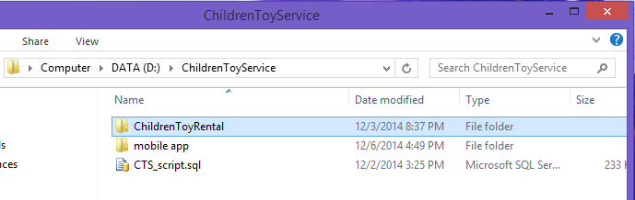

**Figure 158: Extract Deployment Package**

#### **Database Deployment**

* Open Microsoft SQL Server Management Studio 2012 and login with administration account.

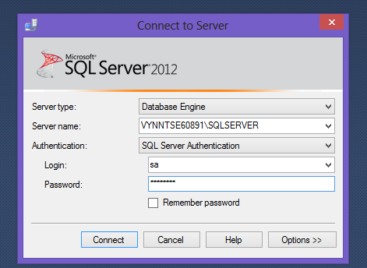

**Figure 159: Connect to server**

* Open “CTS_script.sql” in Microsoft SQL Server Management
* Change FILENAME in line 7 and 9 to the directory of SQL Server Instance in your server.

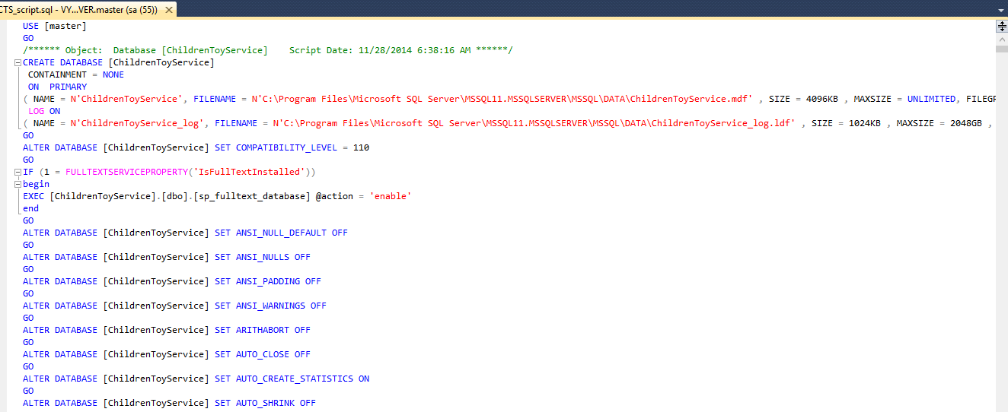

**Figure 160: Open database script**

* Execute the script

#### **Server configuration**

* Open the Internet Information System Manager
* Change the .NET Framework version to 4.0

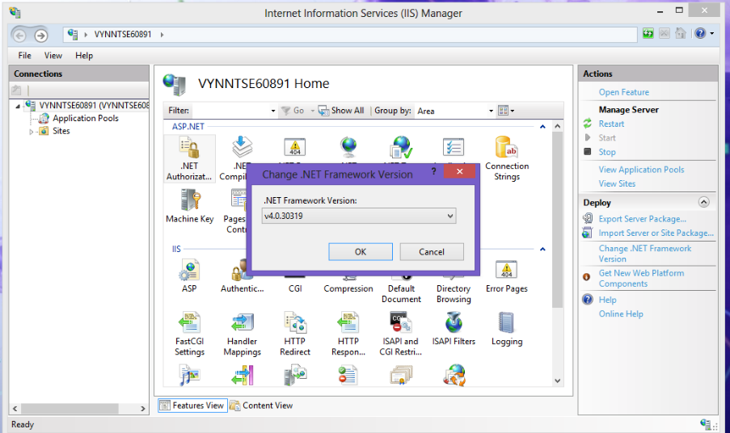

**Figure 161: Configure Server**

#### **Deploy**

* Change the user ID, password and data source parts of connection string in Web.config (in ChildrenToyRental folder) with your data
* Change the user ID, password and data source parts of connection string in App.config (in ChildrenToyRentalDAL folder) with your data

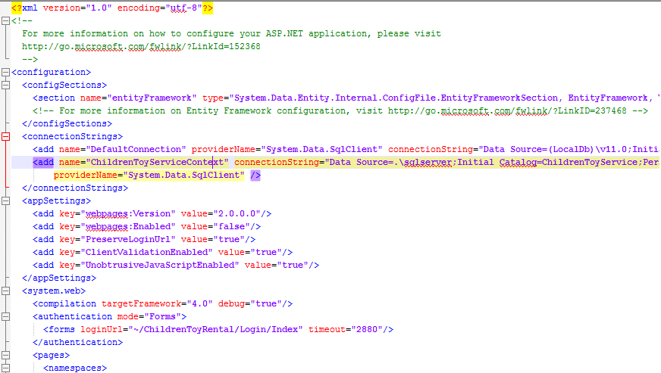

**Figure 162: Change Web.config connection string**

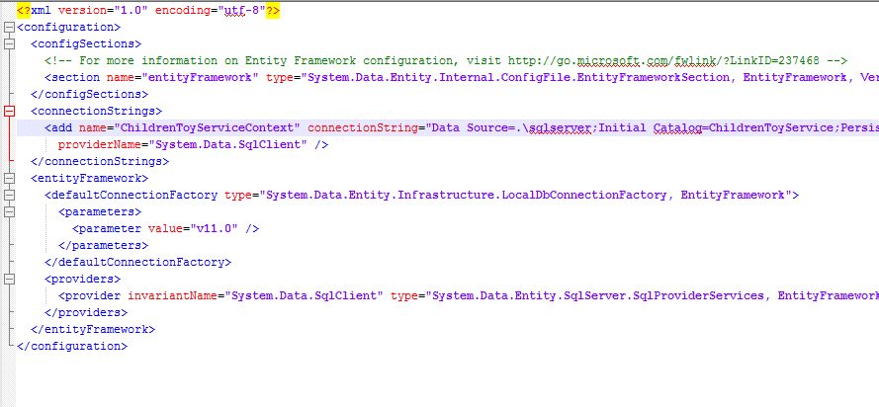

**Figure 163: Change App.config connection string**

* On IIS Manager, right click as Sites. Choose “Add Web Site”.

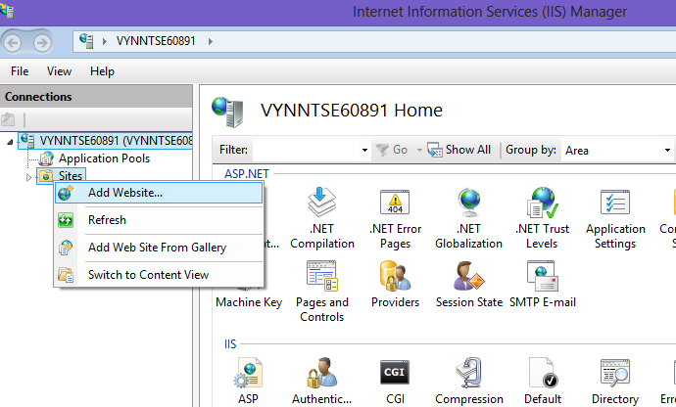

**Figure 164: Deploy web application on server**

* Enter site name. Choose ASP.NET 4.0 as Application Pool
* Select the path to the folder in step 1. Enter random port which different from port 80.

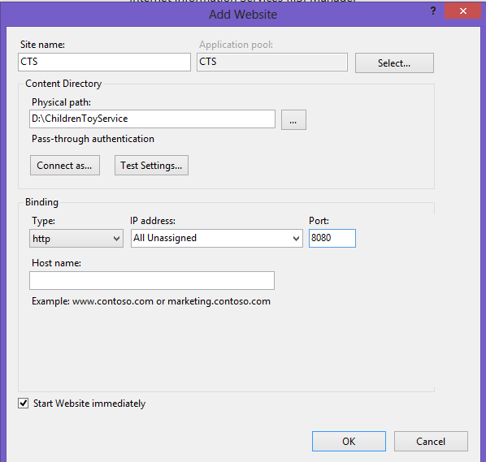

**Figure 165: Deploy web application on server**

* Press ok to finish the process

### **Client side environment setting**

Client side should have one of these following browser:

* Google Chrome
* Firefox
* Internet Explorer

## User’s Guide

This user guide describes how to use the application based on the process of children toy rental service website

### **Admin –Staff Login**

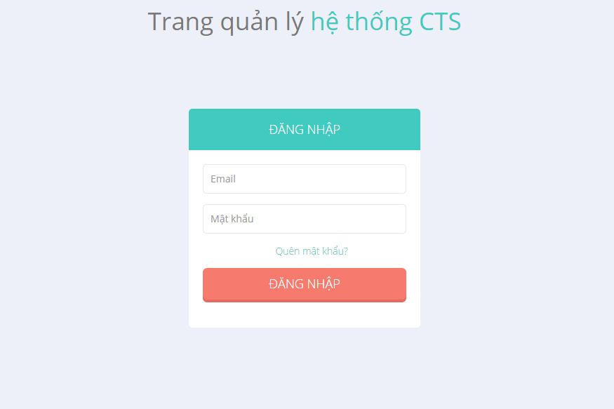

**Figure 166: Admin - Staff Login Page**

|  |  |
| --- | --- |
| **Step** | **Description** |
| 1 | Enter “Email” và “Mật khẩu”  (E.g: Email: admin@gmail.com. Mật khẩu: 12345678) |
| 2 | Click “Đăng nhập” |

**Table 97: Login Step**

### **Staff**

#### **View List Of Orders**

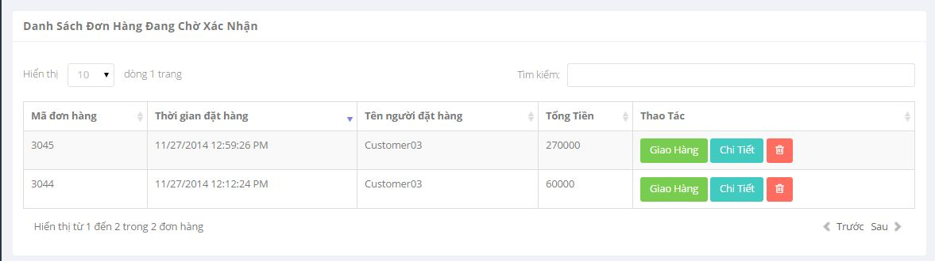

**Figure 167 : View List Of Orders**

|  |  |
| --- | --- |
| **Step** | **Description** |
| 1 | Click “Quản Lý dơn hàng” on menu => Click “Đang chờ xác nhận” |
| 2 | Show list order |

**Table 98: View List Of Orders**

#### **View Order Detail (Staff)**

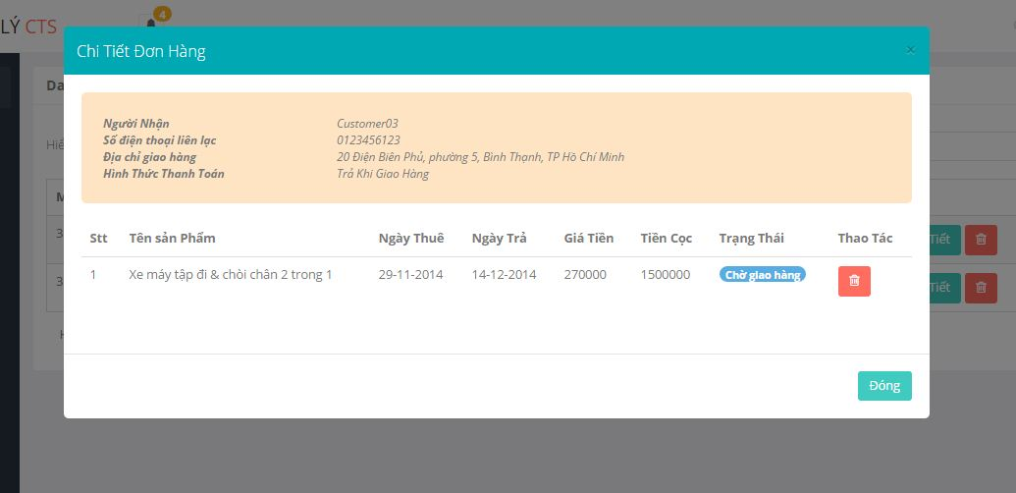

**Figure 168 : View Order Detail (Staff)**

|  |  |
| --- | --- |
| **Step** | **Description** |
| 1 | Click “Quản Lý đơn hàng” on menu => Click “Đang chờ xác nhận” |
| 2 | Click “Chi Tiết” button |

**Table 99: View Order Detail (Staff)**

#### **Assign Shipper**

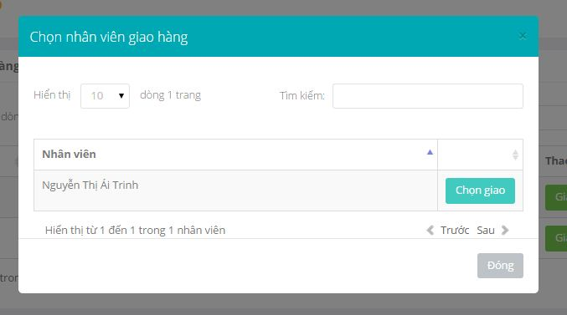

**Figure 169 : Assign Shipper**

|  |  |
| --- | --- |
| **Step** | **Description** |
| 1 | Click “Quản Lý Đơn hàng” on menu => Click “Đang chờ xác nhận” |
| 2 | Click “Giao Hàng” button |
| 3 | Click “Chọn giao” button |

**Table 100: Assign Shipper**

#### **View Exchange Request List**

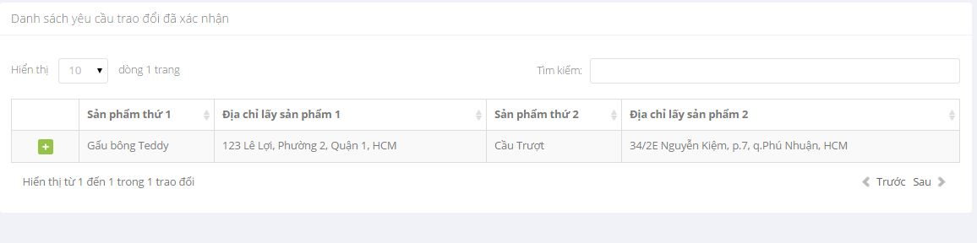

**Figure 170 : View Exchange Request List**

|  |  |
| --- | --- |
| **Step** | **Description** |
| 1 | Click “Quản Lý trao đổi” on menu => Click “Trao Đổi Đã Xác Nhận” |

**Table 101: View Exchange Request List**

#### **View Detail Of Exchange Request**

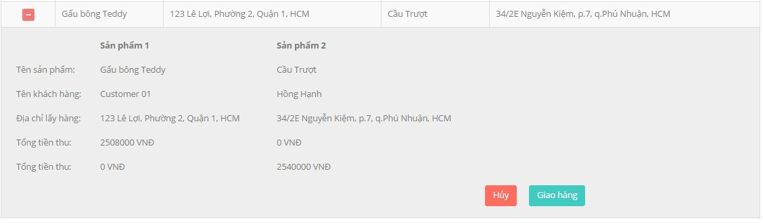

**Figure 171 : View Detail Of Exchange Request**

|  |  |
| --- | --- |
| **Step** | **Description** |
| 1 | Click “Quản Lý Trao đổi” on menu => Click “Trao đổi đã xác nhận” |
| 2 | Click icon plus |

**Table 102: View Detail Of Exchange Request**

#### **Cancel Exchange Request**



**Figure 172 : Cancel Exchange Request**

|  |  |
| --- | --- |
| **Step** | **Description** |
| 1 | Click “Quản Lý Trao đổi” on menu => Click “Trao đổi đã xác nhận” |
| 2 | Click icon plus |
| 3 | Click “Hủy” button |

**Table 103: Cancel Exchange Request**

### **Customer**

#### **Add To Cart**

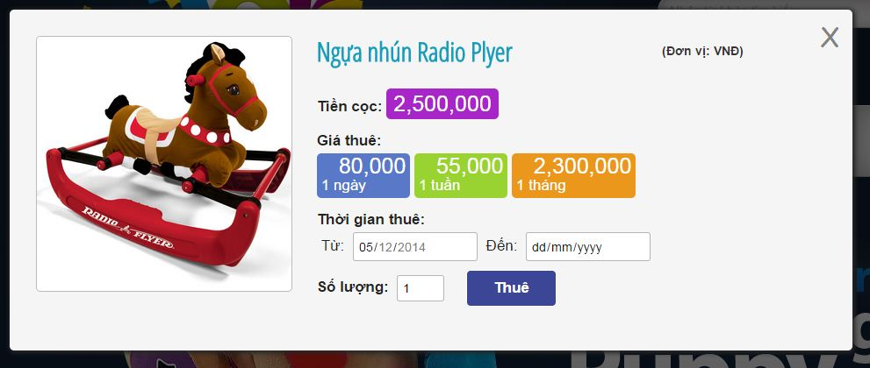

**Figure 173 : Add To Cart**

|  |  |
| --- | --- |
| **Step** | **Description** |
| 1 | Click “Thuê” of each toy |
| 2 | Full fill rent time and amount |
| 3 | Click “Thuê” button |

**Table 104: Add To Cart**

#### **View Cart**

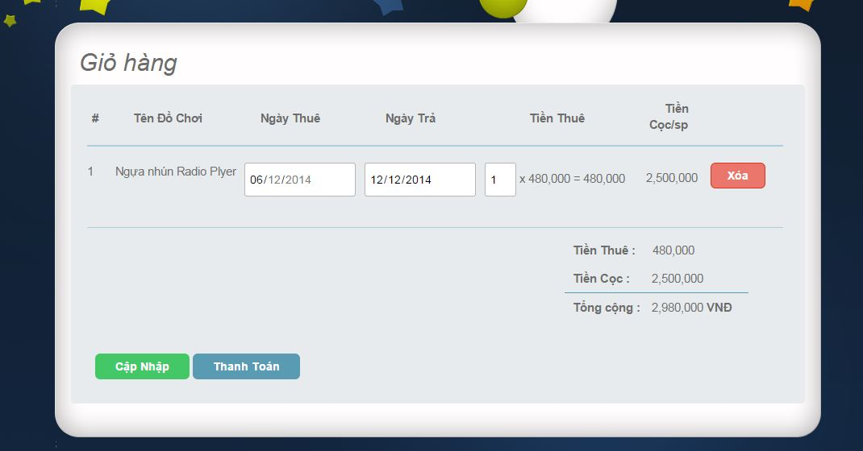

**Figure 174 : View Cart**

|  |  |
| --- | --- |
| **Step** | **Description** |
| 1 | Click “Giỏ hàng” in Home Page |

**Table 105: View Cart**

#### **Edit Cart**

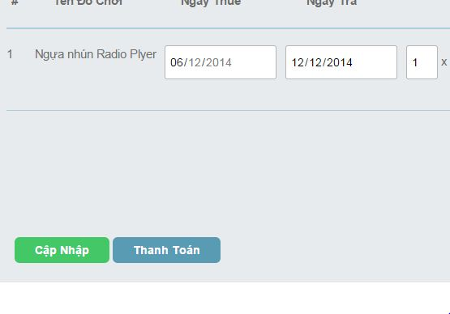

**Figure 175 : Edit Cart**

|  |  |
| --- | --- |
| **Step** | **Description** |
| 1 | Update information about rent time , amount |
| 2 | Click “Cập Nhập” button |

**Table 106: Edit Cart**

#### **CheckOut_step 1**

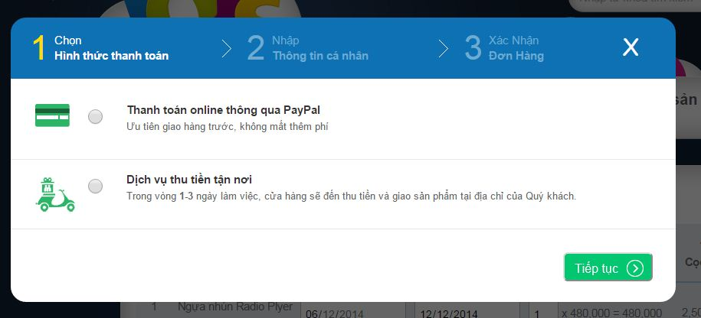

**Figure 176 : Check out_ step 1**

|  |  |
| --- | --- |
| **Step** | **Description** |
| 1 | Click “Thanh Toán” in cart |
| 2 | Click to choose way to payment |

**Table 107: Check out_ step 1**

#### **CheckOut_step 2**

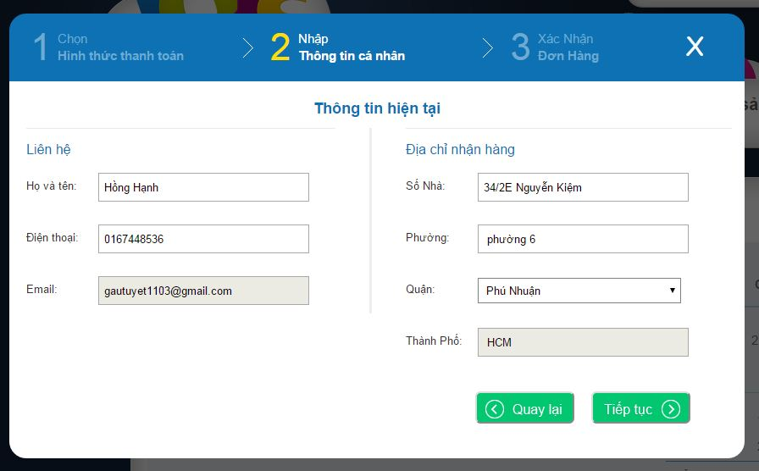

**Figure 177 : CheckOut_step 2**

|  |  |
| --- | --- |
| **Step** | **Description** |
| 1 | Click “Thanh Toán” in cart |
| 2 | Click to choose way to payment |
| 3 | Click “Tiếp Tục” button |
| 4 | Edit information profile |

**Table 108: CheckOut_step 2**

#### **CheckOut_step 3**

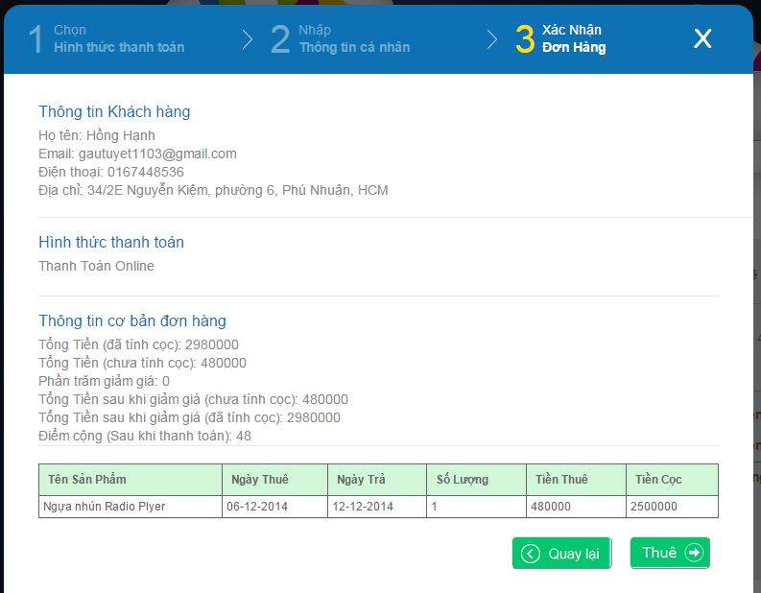

**Figure 178 : CheckOut_step 3**

|  |  |
| --- | --- |
| **Step** | **Description** |
| 1 | Click “Thanh Toán” in cart |
| 2 | Click to choose way to payment |
| 3 | Click “Tiếp Tục” button |
| 4 | Edit information profile |
| 5 | Click “Tiếp Tục” button |

**Table 109: CheckOut_step 3**

#### **View Order History**

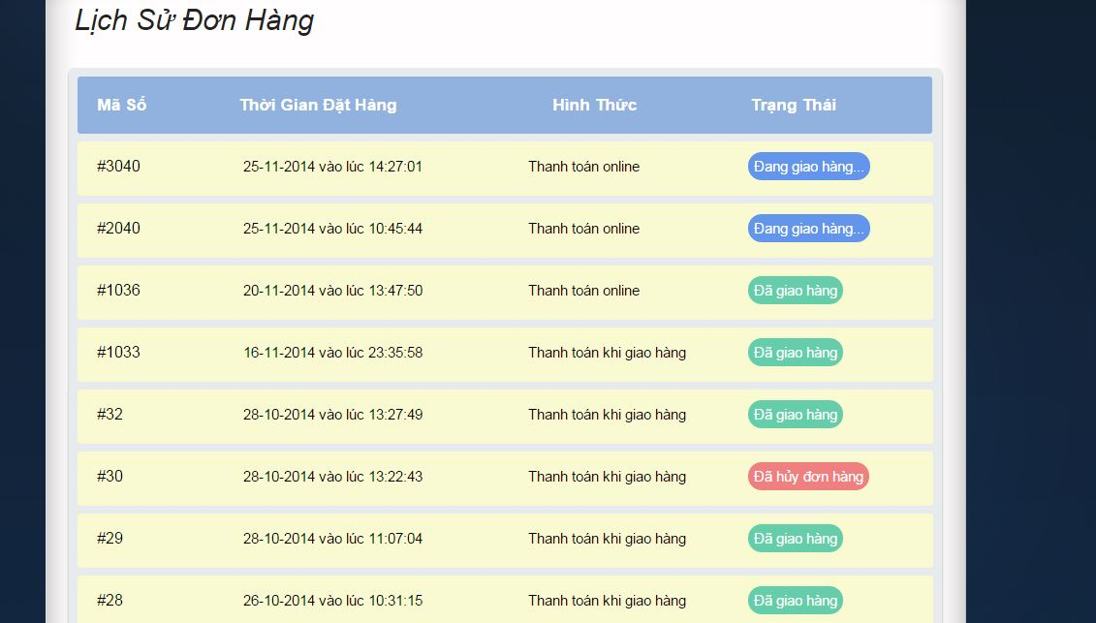

**Figure 179 : View Order History**

|  |  |
| --- | --- |
| **Step** | **Description** |
| 1 | Click “Lịch Sử Đơn Hàng” |

**Table 110: View Order History**

#### **View Order Detail (Customer)**

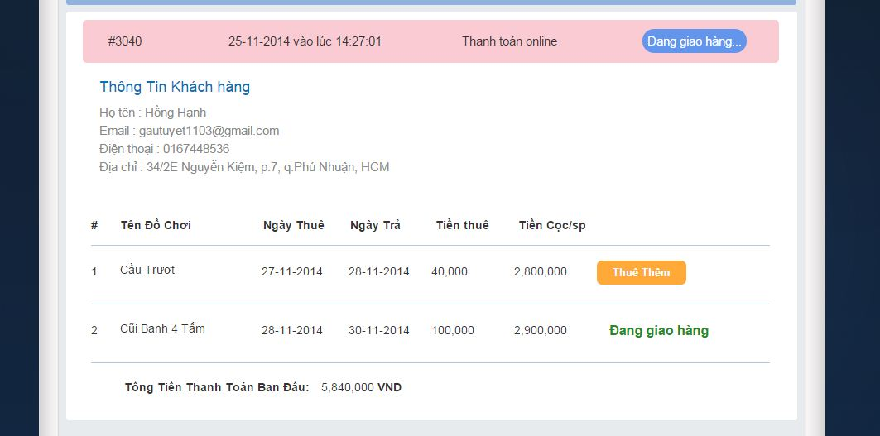

**Figure 180 : View Order Detail (Customer)**

|  |  |
| --- | --- |
| **Step** | **Description** |
| 1 | Click “Lịch Sử Đơn Hàng” |
| 2 | Click order that want to view detail |

**Table 111: View Order Detail (Customer)**

#### **Extend Rent Time**

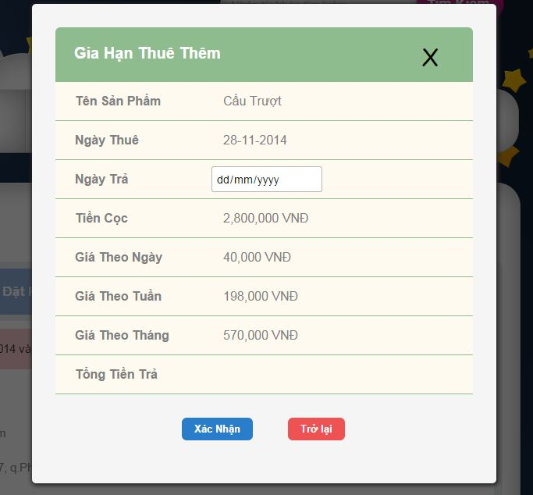

**Figure 181 : Extend Rent Time**

|  |  |
| --- | --- |
| **Step** | **Description** |
| 1 | Click “Lịch Sử Đơn Hàng” |
| 2 | Click order |
| 3 | Click “Thuê Thêm” button |

**Table 112: Extend Rent Time**

#### **Product Detail**

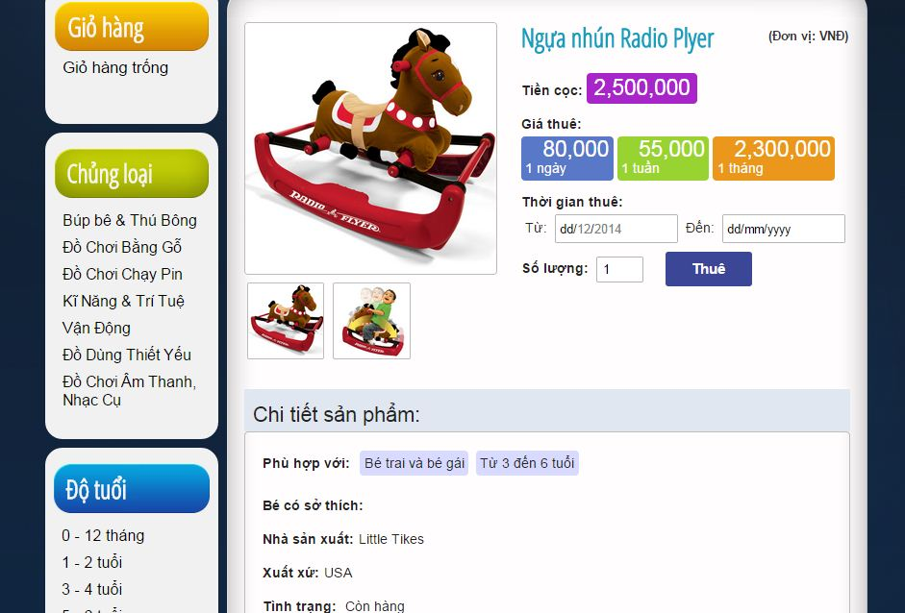

**Figure 182 : Product Detail**

|  |  |
| --- | --- |
| **Step** | **Description** |
| 1 | Click product to view detail |

**Table 113: Product Detail**

#### **View Suggest Toy**

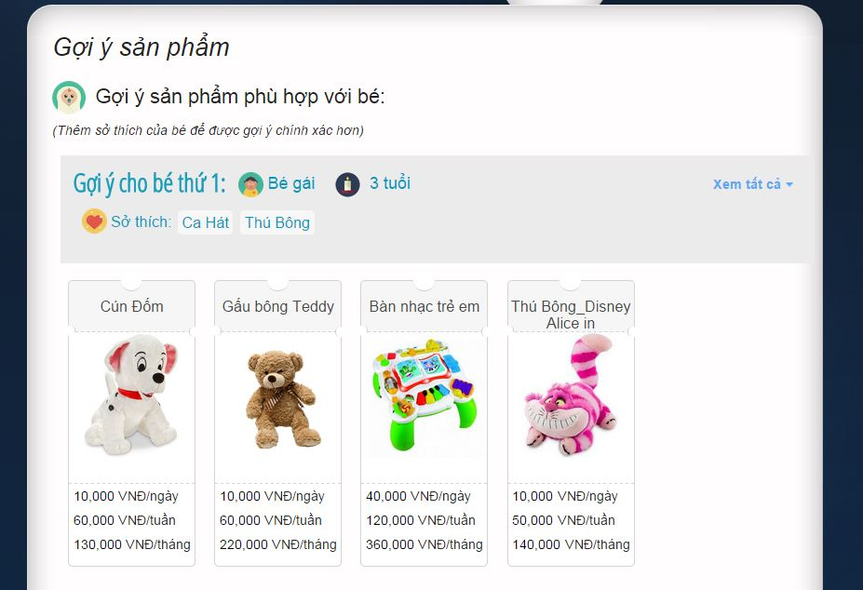

**Figure 183 : View Suggest Toy**

|  |  |
| --- | --- |
| **Step** | **Description** |
| 1 | Click “Gợi ý sản phẩm” in menu bar |

**Table 114: View Suggest Toy**

#### **View Other Exchangeable Toys List**

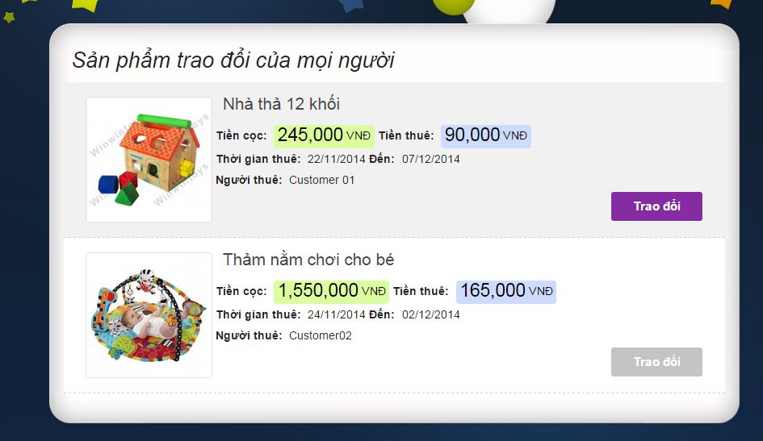

**Figure 184 : View Other Exchangeable Toy List**

|  |  |
| --- | --- |
| **Step** | **Description** |
| 1 | Click “Trao Đổi Sản Phẩm” in menu bar |
| 2 | Click “Sản Phẩm Trao Đổi Của mọi người” |

**Table 115: View Other Exchangeable Toy List**

#### **Exchange Request _step 1**

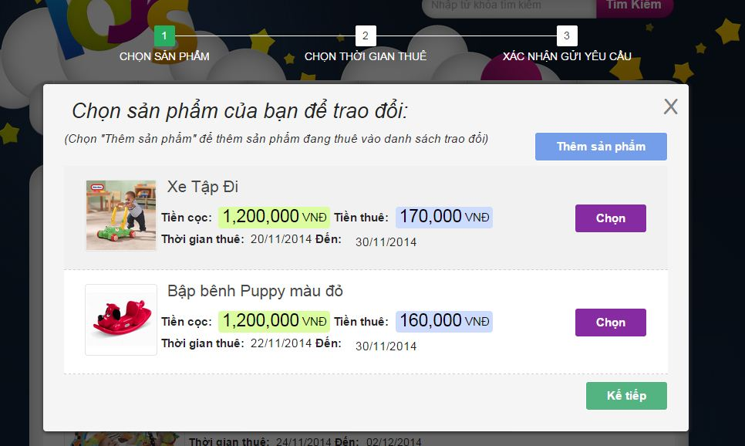

**Figure 185 : Exchange Request _ Step 1**

|  |  |
| --- | --- |
| **Step** | **Description** |
| 1 | Click “Trao Đổi Sản Phẩm” in menu bar |
| 2 | Click “Sản Phẩm Trao Đổi Của mọi người” |
| 3 | Click “Trao đổi” button |

**Table 116: Exchange Request _ Step 1**

#### **Exchange Request _ step 2**

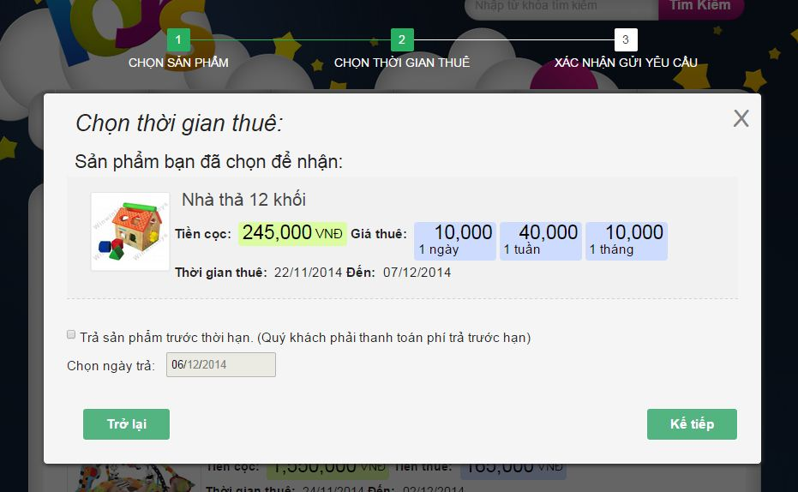

**Figure 186 : Exchange Request_ step 2**

|  |  |
| --- | --- |
| **Step** | **Description** |
| 1 | Click “Trao Đổi Sản Phẩm” in menu bar |
| 2 | Click “Sản Phẩm Trao Đổi Của mọi người” |
| 3 | Click “Trao đổi” button |
| 4 | Click “Kế tiếp” button |

**Table 117: Exchange request _ step 2**

#### **Exchange Request – step 3**

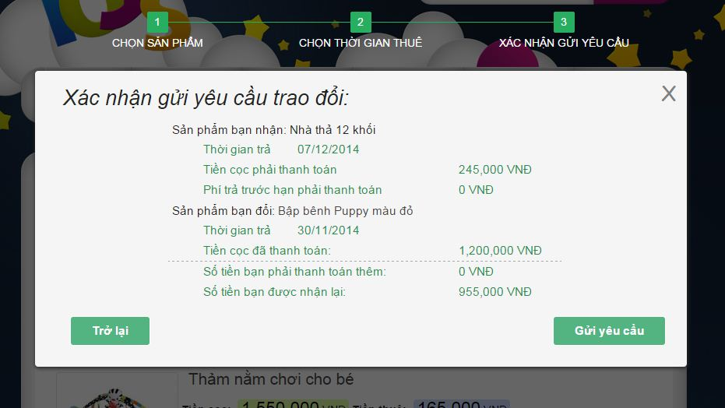

**Figure 187 : Exchange Request – step 3**

|  |  |
| --- | --- |
| **Step** | **Description** |
| 1 | Click “Trao Đổi Sản Phẩm” in menu bar |
| 2 | Click “Sản Phẩm Trao Đổi Của mọi người” |
| 3 | Click “Trao đổi” button |
| 4 | Click “Kế tiếp” button |
| 5 | Click “Kế tiếp” button |

**Table 118: Exchange Request – step 3**

#### **View Sent Exchange Request of Customer**

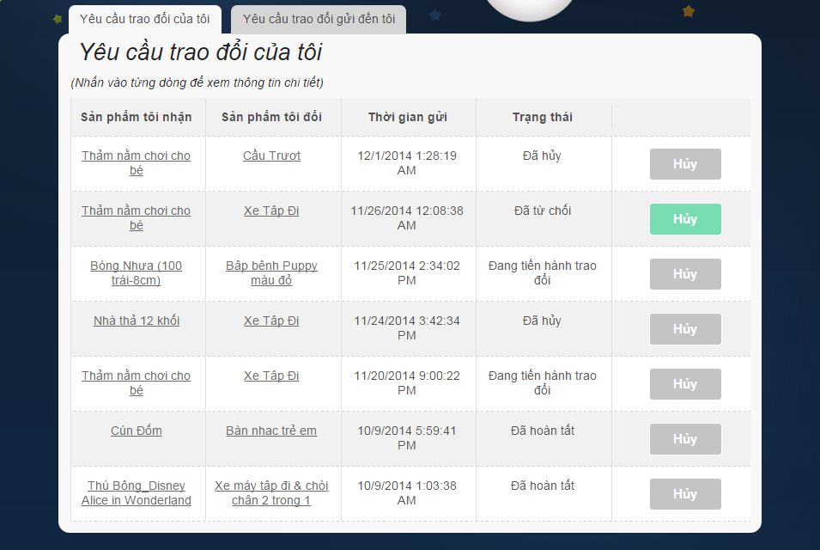

**Figure 188 : View Sent Exchange Request Of Customer**

|  |  |
| --- | --- |
| **Step** | **Description** |
| 1 | Click “Trao Đổi Sản Phẩm” in menu bar |
| 2 | Click “Yêu Cầu Trao Đổi” |

**Table 119: View Sent Exchange Request Of Customer**

#### **View Receive Exchange Request Of Customer**

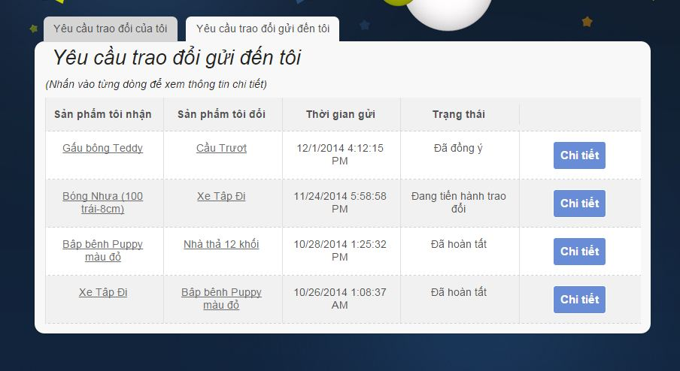

**Figure 189 : View Receive Exchange Request Of Customer**

|  |  |
| --- | --- |
| **Step** | **Description** |
| 1 | Click “Trao Đổi Sản Phẩm” in menu bar |
| 2 | Click “Yêu Cầu trao đổi” |
| 3 | Click tab “Yêu cầu trao đổi gửi đến tôi” |

**Table 120: View Receive Exchange Request Of Customer**

#### **View Detail Request**

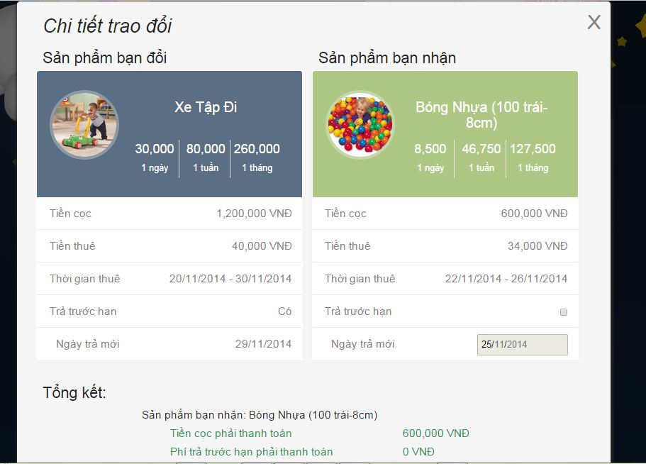

**Figure 190: View Exchange Request Details**

|  |  |
| --- | --- |
| **Step** | **Description** |
| 1 | Click “Trao Đổi Sản Phẩm” in menu bar |
| 2 | Click “Yêu Cầu trao đổi” |
| 3 | Click tab “Yêu cầu trao đổi gửi đến tôi” |
| 4 | Click “Chi Tiết” button |

**Table 121: View Exchange Request Details**